SYNTHESIS, CHARACTERIZATION AND CORROSION INHIBITION STUDIES OF o,m,p-DECANOYL THIOUREA DERIVATIVES ON MILD STEEL IN 0.1 M H₂SO₄ SOLUTIONS

(Sintesis, Pencirian dan Kajian Perencatan Kakisan Keluli Lembut oleh Terbitan o,m,p-Dekanoil Tiourea Dalam 0.1 M Larutan H₂SO₄ )

Noor Khadijah Mustafa Kamal¹, Adibatul Husna Fadzil^{1*}, Karimah Kassim^{1,2}, Shadatul Hanom Rashid¹, Mohd Sufri Mastuli¹

¹Faculty of Applied Sciences, Universiti Teknologi MARA, 40450 Shah Alam, Selangor, Malaysia
²Institute of Science, Universiti Teknologi MARA, 40450 Shah Alam, Selangor, Malaysia

*Corresponding author: adibatul@salam.uitm.edu.my

Abstract
A series of decanoyl thiourea derivatives, namely N-decanoyl-N’-2-pyridinethiourea (D1), N-decanoyl-N’-3-pyridinethiourea (D2) and N-decanoyl-N’-4-pyridinethiourea (D3) were successfully synthesized and were applied as corrosion inhibitors. The compounds were characterized via elemental analyser, Fourier Transform Infra Red (FTIR) and ¹H and ¹³C Nuclear Magnetic Resonance (NMR) spectroscopies. The inhibition efficiency of each compound was studied on the corrosion of mild steel in 0.1 M H₂SO₄ with different concentrations of the compounds by using weight loss method and linear polarization resistance technique. From both techniques the results indicate that the corrosion process was significantly reduced with the presence of such compounds. It shows that compound D3 has the highest efficiency which is 85.84% compared to D1 and D2. The effects of position of N atom located at ortho, meta and para in chemical structure of pyridine on the corrosion inhibition efficiencies of the compounds were also investigated.

Keywords: Corrosion inhibitor, spectroscopic studies, corrosion studies, inhibition efficiency

Abstrak
Siri terbitan dekanoil tiourea, iaitu N-dekanoil-N’-2-piridinatiourea (D1), N-dekanoil-N’-3-piridinatiourea (D2) and N-dekanoil-N’-4-piridinatiourea (D3) telah berjaya disintesis dan digunakan sebagai perencat kakisan. Sebatian tersebut dicirikan dengan penganalisis unsur, spektroskopi infra merah (IR) dan ¹H and ¹³C resonans magnet nukleus (NMR). Keberkesanan tindakan merencatkan kakisan oleh setiap sebatian telah diuji pada besi keluli di dalam larutan 0.1 M H₂SO₄ dengan kepekatan sebatian yang berbeza menggunakan teknik perubahan berat dan kaedah rintangan pengutuban linear. Daripada kedua-dua teknik, ia telah menunjukkan bahawa proses kakisan boleh direncatkan dengan adanya sebatian tersebut. Sebatian D3 mempunyai peratusan perencatan tertinggi sebanyak 85.84% berbanding D1 dan D2. Kajian ini juga termasuk kesan struktur kimia sebatian terhadap kebolehan merencat kerana sebatian yang disintesis mempunyai kedudukan atom N iaitu orto-, meta- dan para- dalam struktur piridina.

Kata kunci: Perencat kakisan, kajian spektorskopi, kajian kakisan, keberkesanan perencat.

Introduction
Corrosion is one of the biggest problems encountered by the industrial sector since it used acid as the main solution in the daily processes. The general aggressively of the acid solutions make it easy for the corrosive attack on the metallic materials [1]. Commonly, acid is widely used in the industry for acid pickling, industrial acid cleaning, acid descaling and oil well acidizing [2-3]. The use of organic inhibitors is the most practical methods to protect metals against corrosion. Organic inhibitors containing nitrogen (N), sulphur (S) and oxygen (O) atoms are capable of retarding metallic corrosion [4]. Thus, thiourea and its derivatives are the potential corrosion inhibitor because it contains one S and two N atoms [5]. The lone pair presence in these atoms makes it easily adsorbed on the metal surface by forming a protective layer and hence reduces the corrosion attack [6, 7]. Apart from that, the S atom have negative charge and the N atom have positive charge which able to enhance the adsorption of molecules by inducing additional charges of both atoms using electric field [8]. Others investigation states that heterocyclic ring structure which contains nitrogen and oxygen atoms can enhance greater adsorption on metal surface [9]. Therefore, cyclic structure of thiourea is the best organic compound that can be used as the corrosion inhibitor. The aim of this study is to investigate the inhibitory efficiency of decanoyl thiourea derivatives that were synthesized as in Figure 1 via substitution and addition reaction using decanoyl chloride, ammonium thiocyanate and o, m, p-aminopyridine.

Materials and Methods

Synthesis of N-decanoyl-N’-2-pyridinethiourea
5 mmol of decanoyl chloride in acetone was mixed with an equamolar of ammonium thiocyanate and stirred for 10 minutes. Then, an equamolar of 2-aminopyridine in acetone was added to the solution. The solution was refluxed for 3 hours and then poured into a beaker containing ice blocks. The solid product formed was filtered and finally recrystallized by using acetonitrile. Yield 70.7% ; white solid. IR (KBr pellet, cm⁻¹): ν(N-H) 3356.2, ν(C=O) 1664.1, ν(C-N) 1160.4, ν(C=S) 768.8. ¹H NMR δ 0.8 (s, 3H, CH₃); 1.2-1.4 (m, 2H, CH₂); 6.65-7.90 (m, Ar-H); 10.35, 9.1 (s, 2H, NH). ¹³C NMR δ 14.42 (CH₃); 22-31 (CH₂); 112-156 (aromatic ring); 171 (C=O); 177 (C=S). Anal. Calc. (%) For C₁₇H₂₅N₃OS: C, 62.50; H, 8.20; N, 9.14; S, 10.43. Found (%) : C, 61.27; H, 8.27; N, 9.07; S, 12.57.

Synthesis of N-decanoyl-N’-3-pyridinethiourea
This compound was prepared as above from equamolar of decanoyl chloride, ammonium thiocyanate and 3-aminopyridine. Yield 73.4 % ; brick-red solid. IR (KBr pellet, cm⁻¹): ν(N-H) 3354.1, ν(C=O) 1663.2, ν(C-N) 1174.6, ν(C=S) 789.2. ¹H NMR δ 0.85 (s, 3H, CH₃); 1.2-1.35 (m, 2H, CH₂); 6.65-8.00 (m, Ar-H); 10.25, 9.15 (s, 2H, NH). ¹³C NMR δ 14.41 (CH₃); 22-35 (CH₂); 126-149 (aromatic ring); 174 (C=O); 178 (C=S). Anal. Calc. (%) For C₁₇H₂₅N₃OS: C, 62.50; H, 8.20; N, 9.14; S, 10.43. Found (%): C, 62.78; H, 8.99; N, 9.88; S, 12.85.

Synthesis of N-decanoyl-N’-4-pyridinethiourea
This compound was prepared as above from equamolar of decanoyl chloride, ammonium thiocyanate and 4-aminopyridine. Yield 74.8%; yellowish-white solid. IR (KBr pellet, cm⁻¹): ν(N-H) 3353.7, ν(C=O) 1669.4, ν(C-N) 1187.7, ν(C=S) 796.1. ¹H NMR δ 0.85 (s, 3H, CH₃); 1.2-1.45 (m, 2H, CH₂); 6.65-7.95 (m, Ar-H); 10.25, 9.15 (s, 2H, NH). ¹³C NMR δ 14.41 (CH₃); 29-31 (CH₂); 110-165 (aromatic ring); 169 (C=O); 176 (C=S). Anal. Calc. (%) For C₁₇H₂₅N₃OS: C, 62.50; H, 8.20; N, 9.14; S, 10.43. Found (%): C, 61.45; H, 8.53; N, 9.37; S, 12.61.
.
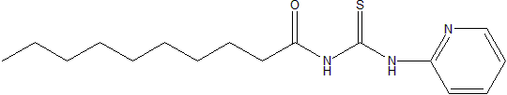
(a)
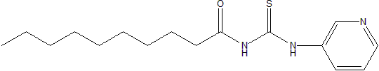
(b)
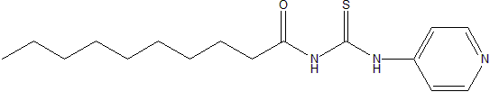
(c)
Figure 1: The chemical structure of the investigated compounds: (a) N-decanoyl-N’-2-pyridinethiourea (D1), (b) N-decanoyl-N’-3-pyridinethiourea (D2) and (c) N-decanoyl-N’-4-pyridinethiourea (D3)

Weight loss method
The mild steel coupons were used as the specimens with size of 2 x 2 cm. The coupons were abraded with emery paper and double washing using acetone and distilled water and finally dried at room temperature. The dried coupons were immersed in corrosion medium of 0.1 M H₂SO₄ solution for 3 days with and without inhibitors. The concentration of the inhibitors was varied from 1 x 10⁻⁵ M, 1 x 10⁻⁴ M to 1 x 10⁻³ M. The weight loss of the coupons was recorded.

Linear polarization resistance technique
This method was carried out in a three-electrode cells using AUTOLAB instrument equipped with NOVA software. A saturated calomel electrode (SCE) was used as a reference electrode and a graphite electrode as a counter. The working electrode was prepared by embedding a rod with mild steel coupon in epoxy resin, with an exposed surface area of 0.065 cm². The surfaces were polished with emery paper and washed with distilled water for electrochemical studies.

Result and Discussion
FTIR spectroscopy
The D1, D2 and D3 compounds show important stretching in the FTIR spectra such as ν(C=S), ν(C=O_{amide}), ν(C-N) and ν(N-H) which can be observed around 700 cm⁻¹, 1600 cm⁻¹, 1200 cm⁻¹, and 3000 cm⁻¹. This observation agrees very well with the values previously reported in [10, 11]. Meanwhile, the functional group related to the pyridine structure was observed at a wavelength range from 1360 to 1250 cm⁻¹. The absorption bands for N-H in all three compounds were observed around 3300 cm⁻¹ which is supported by the previous study [10], stating that the assymetric and symmetric stretching vibration of the absorption band for N-H bond in thioamide group were found in a range above 3200 cm⁻¹. As for the carbonyl band, ν(C=O), it was clearly observed at 1660 cm⁻¹. This is due to the presence of aromatic group and the existence of intramolecular hydrogen bonding. For C-N, the absorption band was observed lower than 1200 cm⁻¹ because the presence of C-N bond in aromatic ring. The N atom in the ring becomes electron donating group which is also an activating group. It pushes the electron clouds to the ring and increases the electron density in the ring causing the absorption band to be shifted to lower frequency region. The C=S absorption band was observed at a range between 760 cm⁻¹ to 796 cm⁻¹. This band was in good agreement with the previous study [12].which this type of band was observed at 700 cm⁻¹. However, the reading of the C=S band spectra is a bit higher due to the aromatic group which is describe as large double bond character and has lower nucleophilic character of the sulphur atom compared to alkylthioureas.

¹H NMR spectroscopy
For all of the compounds, a resonance was observed at a range of 0.8-0.85 ppm as singlet. This is due to the presence of methyl protons substituent attached to the aliphatic structure of the compounds. As for the methylene, the resonance was observed in the range of 1.2-1.45 ppm. Since the methylene presences in the compounds are in long chains, the absorption observed becomes overlapped in an unresolvable group. The resonance for aromatic group for the compounds was observed at 6.65-7.8 ppm. It was a distinctive multiplet resonance because of the unresolved aromatic protons. As for the N-H, there are two resonances, one for the proton near to the C=O and the other is for the C=S resonance. For C=O, the resonance was observed at a range of 9.1-9.15 ppm. Meanwhile, for the C=S, the ¹H shifts resonance was observed at 10.25-10.35 ppm. Theoretically, the resonance for this type of group should be observed at higher chemical shift which is 12 ppm, but in this experiment, it was observed at lower resonance because the presence of the aromatic group as the substituents in the thiourea compounds. The electrons on the aromatic ring deshield the hydrogen attached to N atom. Besides, the chemical shift of this group is variable. It is depends not only on the chemical environment in the molecule but also on the concentration, temperature and solvent.

¹³C NMR spectroscopy
The resonance of methyl and methylene were observed at 14.4 ppm and 22.0 – 35.0 ppm respectively. For aromatic rings, the carbon resonance was found at a range of 110-165 ppm which is corresponding to the pyridine in the compounds. The C=O and C=S carbon resonance were clearly observed in between 169-174 ppm and 176-178 ppm. There is slightly difference in the carbon resonance because they are slightly deshielded due to the formation of intramolecular hydrogen bonding, increasing electronegativity of oxygen and sulphur atoms and different environment and conformations.

Weight loss method
By using the weight loss method, the inhibition efficiency (IE%) of the three compounds synthesized and their respective corrosion rate has been calculated by using the formula equation (1) and (2) below and listed as in Table 1.

IE % = (W_{blank} – W_{inhibitor}) x 100% (1)
W_{blank}

Where, W_{blank} is the weight loss of mild steel without inhibitor and W_{inhibitor} is the weight loss of mild steel in with inhibitor.

Corrosion rate = ______Weight loss of mild steel (g) _____ (2)
Surface area of mild steel (cm²) x Time (h)

Table 1: Parameters of mild steel corrosion activities in 0.1 M H₂SO₄ solution with and without inhibitors

Compound | Concentration  (M) | Average weight loss (g) | Inhibition efficiency  (IE %) | Corrosion rate  (g/cm⁻² h⁻¹)
Blank | - | 0.1399 | - | 4.86 x 10⁻⁴
D1 | 1 x 10⁻⁵ | 0.0222 | 84.13 | 7.71 x 10⁻⁵
D1 | 1 x 10⁻⁴ | 0.0199 | 85.78 | 6.91 x 10⁻⁵
D1 | 1 x 10⁻³ | 0.0215 | 84.63 | 7.47 x 10⁻⁵
D2 | 1 x 10⁻⁵ | 0.0242 | 82.70 | 8.40 x 10⁻⁵
D2 | 1 x 10⁻⁴ | 0.0372 | 73.41 | 1.29 x 10⁻⁴
D2 | 1 x 10⁻³ | 0.0294 | 78.98 | 1.02 x 10⁻⁴
D3 | 1 x 10⁻⁵ | 0.0267 | 80.91 | 9.27 x 10⁻⁵
D3 | 1 x 10⁻⁴ | 0.0198 | 85.84 | 6.87 x 10⁻⁵
D3 | 1 x 10⁻³ | 0.0249 | 82.20 | 8.65 x 10⁻⁵

From Figure 2, it can be observed that all the compounds were able to decrease the corrosion process at any concentration of the inhibitors. This is because there are N, S and O atom present in the chemical structure of the inhibitor which acts as the center for the adsorption to the mild steel. It forms a film on the surface of mild steel via adsorption process by which it decreases the mild steel area from corrosion attack. Among the three concentrations tested for the studies, concentration of 1 x 10⁻⁴ M shows the best activity for the compounds to inhibit corrosion. This is because that at this concentration, the activity of the synthesized compound to slow down the corrosion rate is optimum. Since the compounds that were synthesized have ortho-, meta- and para- positions of N atom in the pyridine structure, they show different inhibitory activity towards the corrosion of mild steel. N atom in the pyridine structure is an electron donating group and the presence of it in different position of an aromatic structure affects the reactivity of the compound towards the inhibition. The compounds that have higher inhibitory efficiency are both compound D1 and D3 at concentration of 1 x 10⁻⁴ M in which the inhibitory efficiency is about 85%. This happens because ortho- and para- positions are more favoured by N atom due to the N atom can donate electron easily to the system and therefore enhances the stability of the compound. Thus, these two positions of N atom enhance the adsorption of thiourea derivatives compound on the metal surface. On the other hand, the meta- position is not favoured by the N atom because this position is favoured to electron withdrawing group or deactivating group. This is proved by inhibitory activity by compound D2 that shows it has the lowest IE % compared to the other two compounds.

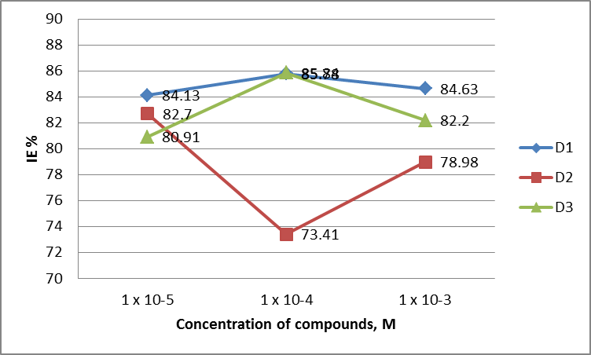
Figure 2: Graph of concentration of inhibitors versus inhibitory efficiency (IE%) by using weight loss method

Linear polarization resistance technique
This technique is used for further confirmation of the inhibitory efficiency at the best concentrations of the synthesized compounds. The corrosion of the mild steel was tested with the concentration of compound D1, D2 and D3 at 1 x 10⁻⁴ M in 0.1 M sulphuric acid. The linear polarization curves and its parameters such as current densities (i_{corr}), corrosion potential (E_{corr}), cathodic and anodic Tafel slopes (bc, ba) and inhibition efficiency (IE %) with the presence and absence of the inhibitors are given in Fig. 3 and Table 2 respectively.

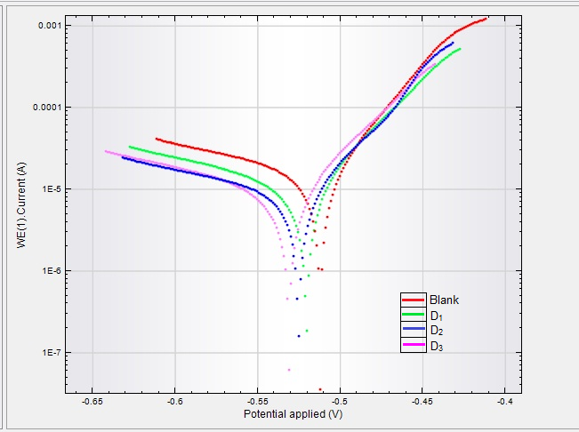
Figure 3: Polarization curves of 1 x 10⁻⁴ M D1, D2 and D3 in 0.1 M sulphuric acid

Table 2: Corrosion parameters for mild steel in 0.1 M sulphuric acid with and without inhibitor

Compound | i_{corr}  (µA cm⁻²) | E_{corr}  (V) | bc  (V/dec) | ba  (V/dec) | IE %
Blank | 386.75 | -513.69 | 60.47 | 1.22 | -
D1 | 314.91 | -519.91 | 71.90 | 3.46 | 18.6
D2 | 271.80 | -526.40 | 68.11 | -1.47 | 29.7
D3 | 139.46 | -532.43 | 47.51 | 240.08 | 63.9

From Table 2 the efficiency of inhibitors was calculated by using the formula equation (3) below:

IE% = (i_{corr(blank)} – i_{corr(inh)}) x 100% (3)
I_{corr(blank)}

Where i_{corr(blank)} is the current densities without inhibitor and i_{corr(inh)} is the current densities with inhibitors either D1, D2 and D3. It was found that the i_{corr} of mild steel in the presence of different type of inhibitor were smaller than without it. This implies that there is an adsorption on mild steel [13] and also the presence of aromatic group that have high electron density which suppressed the reactions [14]. The addition of the inhibitors also resulted in the shift of the corrosion potential (E_{corr}) to the left side as compared to corrosion potential without inhibitor. This shows that all inhibitors favour to cathodic reaction. From this technique, compound D3 has the highest IE% which is 63.9%. This results correlate with the weight loss method stating that D3 has is most potential corrosion inhibitor. Meanwhile, for compound D1 it does not shows that the results from LPR technique and weight loss method support each other as the compound to be the second best corrosion inhibitor. This may be due to external factor that affects the linear polarization resistance such as noise or any other factor that may interfere during the measurement.

Conclusion
N-decanoyl-N’-2-pyridinethiourea, N-decanoyl-N’-3-pyridinethiourea and N-decanoyl-N’-4-pyridinethiourea were successfully synthesized and characterized. The N-decanoyl-N’-4-pyridinethioureawith N atom located at para-position gave the best corrosion inhibition at optimum concentration of 1 x 10⁻⁴ M corrosion inhibitors in 0.1 M sulphuric acid. All the obtained compounds are cathodic type of inhibitors.

Acknowledgement
The authors are grateful to the Ministry of Higher Education of Malaysia for the research grant no. 600-RMI/RAGS 5/3 (3/2012) and the Faculty of Applied Sciences, Institute of Science and Universiti Teknologi MARA for providing research facilities.

References

- Bahrami M.J., Hosseini S.M.A. and Pilvar P. (2010). Experimental and theoretical investigation of organic compounds as inhibitors for mild steel corrosion in sulfuric acid medium, Corrosion Science, 5: 2793-2803.
- Ameer M.A. and Fekry A.M. (2010). Inhibition effect of newly synthesized heterocyclic organic molecules on corrosion of steel in alkaline medium containing chloride. International Journal of Hydrogen Energy, 35: 11387-11396.
- Amin M.A. and Ibrahim M.M. (2011). Corrosion and corrosion control of mild steel in concentrated solutions by a newly synthesized glycine derivative. Corrosion Science, 53: 873-885.
- Benali O., Larabi L. and Harek Y. (2009). Adsorption and inhibitive corrosion properties of thiourea derivatives on cold rolled steel in 1M HClO₄ solutions. J Appl Electrochem 39: 769-778.
- Shetty S.D. and Shetty P. (2008). Inhibition of mild steel corrosion in acid media by N-benzyl-N’-phenyl thiourea. Indian Journal of Chemical Technology, 15: 216-220.
- Edrah S. and Hasan S.K. (2010). Studies on thiourea derivatives as corrosion inhibitor for aluminium in sodium hydroxide solution. Journal of Applied Science Research, 6: 1045-1049.
- Shetty S.D. and Shetty P. 2008. Inhibition of mild steel corrosion in acid media by N-benzyl-N’-phenyl thiourea, Indian Journal of Chemical Technology, 15, 216-220.
- Shetty S.D., Shetty P. and Nayak V.S., (2006). The inhibition of N-furfuryl-N’- phenyl thiourea on the corrosion of mild steel in acid media, J. Serb. Chem. Soc., 71: 1073-1082.
- Chauhan J.S. and Gupta D.K. (2009). Corrosion inhibition of titanium in acidic media containing fluoride with bixin, E-Journal of Chemistry, 6, 975-978.
- Roslan R., Yusof M.S.M and Zin W.M.K.W.M. (2009). Synthesis and characterization studies of novel thiourea amino acid derivatives. Prosiding Seminar Kimia Bersama UKM-ITB VIII, Univsersiti Kebangsaan Malaysia, Bangi, 9-11 Jun.
- Yang W., Zhou W. and Zhang Z. (2007). Structural and spectroscopic study on N-2-fluorobenzoyl-N′-4-methoxyphenylthiourea. Journal of Molecular Structure, 828: 46-53.
- Yusof M.S.M., Jusoh R.H., Khairul W.M. and Yamin B.M. (2010). Synthesis and characterization of N-(3,4-dichlorophenyl)-N’-(2,3 and 4-methylbenzoyl) thiourea derivatives. Journal of Molecular Structure, 975, 280-284.
- Fouda A.E.E. and Hussein A. (2012). Role of some phenylthiourea derivatives as corrosion inhibitors for carbon steel in HCl solution. Journal of the Korean Chemical Society, 56(2), 264 – 273.
- Wang J., Cao C., Chen J., Zhang M., Ye G., Lin H. (1995). Anodic desorption of inhibitors. Journal Chinese Society Corrosion Protection, 15: 241-248.

