PHOSPHORYLATION OF GELATINE AND CHITOSAN AS AN EXCIPIENT FOR ASIATICOSIDE NANOFIBERS

(Pemfosforilan Gelatin dan Kitosan Sebagai Eksipien Bagi Penyediaan Nanofiber Asiatikosida)

Susana Elya Sudrajat^{1*}, Khairurrijal², Puspa DN Lotulung³, Effionora Anwar¹.

¹Faculty of Pharmacyst, Universitas Indonesia, Depok, Indonesia
²Department of Physics, Institut Teknologi Bandung, Indonesia
³Department of Chemistry, Lembaga Ilmu Pengetahuan Indonesia, Serpong, Indonesia

*Corresponding author: susanasudrajat_09@yahoo.com

Abstract
Asiaticoside has been widely used and is still studied for topical treatment of wounds, increased fibroblasts and collagen production are noted at the site of injury. Base on getting the optimal effect of wounds’ treatment, drug must be released and absorbed from the carrier/drug delivery media. In this research, nanofibers preparation is made using the model drug asiaticoside. The result indicated that gelatine-chitosan phosphorylation can be used as an excipient for asiaticoside nanofibers. In this research 3 formulas with varying concentrations of phosphorus are used. The release of asiaticoside was examined by dissolution in vitro. It was measured by high performance liquid chromatography (HPLC) and nanofibers morphology was measured by scanning electron microscopy (SEM). Phosphorylation chitosan tested by infra red spectrophotometry (FTIR) at wave numbers 1271, 1213, 1157, 1085, 1012 and 954 cm⁻¹ where as the phosphorylation of gelatine at 1257, 1026 and 900 cm⁻¹ . The characterization result indicates that the formula C was contains sodium tripolyphosphate 0.5% is the best with the release of asiaticoside 51% for 72 hours, compared to formula A(68%) and the formula B(62%). The percentage asiaticoside from nanofibers preparation is between 90%-100%.

Key Words: asiaticoside, nanofibers, phosphorylation, sodium tripolyphosphate, electrospinning, dissolution

Abstrak
Asiatikosida telah digunakan secara luas dan masih terus dikaji untuk rawatan topikal pengubatan luka dengan cara meningkatkan pembentukan fibroblas dan penghasilan kolagen pada kawasan tercedera. Untuk mendapatkan kesan optimal rawatan luka, ubatnya harus diletakkan dan diserap dari medium pembawa. Penyediaan nanofiber dilakukan dengan mengunakan model ubat asiatikosida. Hasil kajian menunjukkan bahawa kaedah pemfosforilan gelatin dan kitosan dapat digunakan sebagai eksipien nanofiber asiatikosida. Kajian ini mengunapakai variasi 3 formula kepekatan phosphorus. Asiatikosida diuji dengan cara pelarutan in vitro. Ia diukur mengunakan Kromatografi Cecair Prestasi Tinggi (HPLC) dan ujian morfologi nanofiber mengunakan Mikroskopi Elektron Pengimbasan (SEM). Pemfosforilan kitosan diuji dengan Spektrofotometri Infra Merah (FTIR) pada nombor gelombang 1271, 1213, 1157, 1085, 1012 dan 954 cm⁻¹ manakalan pemfosforilan gelatin pada 1257, 1026 dan 900 cm⁻¹. Hasil penyelidikan memperlihatkan bahawa formula C mengandungi sodium tripolifosfat 0.5% adalah yang terbaik dengan pelepasan 51 % asiatikosida selama 72 jam, dibandingkan formula A(68%) dan formula B(62%). Jumlah asiatikosida di dalam penyediaan nanofiber antara 90%-100%.

Kata Kunci: asiaticoside, serabut nano, phosphorilation, sodium tripolyphosphate, electrospinning, disolusi

Introduction

Asiaticoside is the most active component of the plant Centella asiatica that can be found in various parts of Indonesia, and it has been proven efficacious in improving wound healing by increasing fibroblast and collagen synthesis [1]. To deliver it, we need a dosage form that can support the release of asiaticoside, so that the work can be optimal [2]. Drug dosage form for topical wound usually in the form ointment, is generally given twice daily. It is also should be used with wound dressings that are usually change every day. The replacement of wound dressing can cause discomfort to the patient [3]. Therefore, the dosage form needs to be evaluated, to improve the comfort and effectiveness of wound healing. Meanwhile, the development of nanotechnology provides the opportunity to create and characterize drug in the nanometer scale. Biomaterials in the nanoscale have been used to controlled drug delivery and artificial matrices for tissue [4]. Drug delivery system can be engineered by controlling drug release, composition, shape, size and morphology [5]. Topical treatment requires a carrier/drug delivery media to maintain regular release. Carrier should be safe and not inhibit wound healing and will be better if the carrier can also be participate in accelerating wound healing, such as wide surface area, high porosity, interconnected pores, and the active ingredient allows it to enter the nanofibers. Drug release rate depends on the thickness and the degradation rate of polymer fibers, besides the how well the body is able to absorb the drug [3]. Therefore, electrospinning can be used to create nanoscale fibers and degradation rates in order to get the optimal delivery of the drugs into the body. Electrospinning is inexpensive, effective and a simple method to produce non-woven nanofibrous mats, which have intrinsically high surface to volume ratios to improve mechanical performances and have small pores [6]. The necessary components of an electrospinning aparatus include a high power voltage supply, a capillary tube with a needle, and a collector that consist of conducting materials. The solvent is the most important factor in electrospinning operation [7].

Basic selections gelatine and chitosan as a base material of nanofibers because biodegradable, biocompatible and non-toxic. In order to improve the biocompatibility and functions of biomaterials, it is essential for gelatin and chitosan blends to mimic the nanoﬁbrous structure of the native extra cellular matrixs (ECMs) [8]. Chitosan is a natural polysaccharide derived from waste Crustaceae and gelatine is a natural biopolymer that derived from partial hydrolysis of collagen. Cell attachment to chitosan is mainly attributed to electrostatic interactions between the chitosan cationic sites, and the negatively charged carboxylate and sulphate groups found in cell-surface [9]. Gelatine and chitosan nanofiber are soluble in water and they need to be modified with phosphorylation to improve the drug release profile. Sodium tripolyphosphate (TPP) was chosen as the material phosphorylation because it is non-toxic and has simple method to produce that is by dissolving into a gelatine-chitosan solution or dipping the nanofibers into a solution of TPP [10].

In this work, we developed a novel one-step process to fabricate phosphorilated gelatine-chitosan electrospun nano-fibers that was faster and more economical than the two-step method [11]. Phosphorilation of biodegradable polymers potentially is important to control swelling and degradation rates. Phosphorilated electrospun gelatine-chitosan nanofibers was produced by adding sodium tripolyphosphate (TPP) to the gelatine-chitosan solution. SEM morphology and FTIR demonstrated that phosphorilated gelatine-chitosan was succesfully fabricated by electrospinning using acetic acid as a solvent [2]

Materials and Methods
Material
Chitosan (degree of acetylation 75-85%, MW 50.000) and gelatin (from bovine skin, type B) was purchased from Sigma-Aldrich USA, sodium tripolyphosphate (TPP) and phosphate buffer solution (PBS pH 7.4) was purchased from Wako Japan, Asiaticoside was purchased from Guanyu China, and acetic acid solution (Merck, Germany).

Preparation of polymer solution
Solution was prepared by dissolving gelatine 22g, chitosan 50 mg and etylene glycol in 70% acetic acid until the solution 100 ml with constant overnight stirring. Gelatine and chitosan were completely disolved in acetic acid within 24 hours. TPP was then added to gelatine-chitosan solution. Then, the conductivity, viscosity, and pH solution were measured. Asiaticoside was added right before the electrospinning .

Electrospinning setting
Nanofibers were prepared by electrospinning apparatus [13]

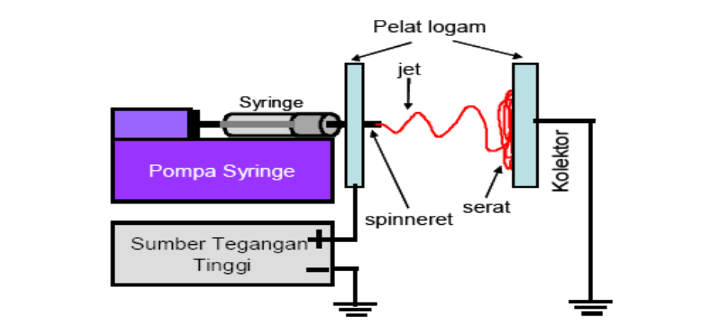
Syringe
Jet
Collector
Syringe pump
Voltage power suplly
Figure 1. Electrospinning setting

The solutions were placed in a plastic syringe with 0.8 mm tip diameter. The flow rate of the solutions (0.3 ml/h) was controlled using a syringe pump. The electrospinning voltage (7.5 kV) was supplied directly by a high DC voltage power supply. Aluminum foil located 10 cm away from the tip of the syringe needle was used to collect the nanofibers mats. It takes 10.7 minutes to obtain nanofiber containing 4 mg asiaticoside. The structure of the phosphorilated gelatine-chitosan nanofibers mats containing asiaticoside fabricated with acetic acid as a solvent was observed by scanning electron microscopy (SEM).

Characterizations

Microstructural Characterizations of Fibers
Microstructural of the fibers was examined using scanning electron microscopy (JSM, Jeol, Japan). Prior to observation, samples were arranged on metal grids, using double-sided adhesive carbon tape, and coated with gold under vacuum [2].

Fourier Transform Infrared Chitosan
The phosphorilated chitosan was characterized by Fourier Transform Infrared Spectra. The infrared spectra of samples were measured over a wavelength range of 4000-500 cm⁻¹. The FTIR spectra of pure chitosan, TPP powder, and chitosan TPP were recorded with KBr pellets on a FTIR spectrophotometer (Shimadzu, Japan).

Fourier Transform Infrared Gelatine
The phosphorilated gelatine was characterized by Fourier Transform Infrared Spectra. The infrared spectra of the samples were measured over a wavelength range of 4000-500 cm⁻¹. The FTIR spectra of pure gelatin, TPP powder, and gelatin TPP were recorded by FTIR spectrophotometer (Shimadzu, Japan).

Swelling Behavior of Nanofiber Mats
The swelling behavior of the nanofibers mats was carried out in phosphate buffer solution (PBS pH 7.4) until the fibers reached saturated condition, a constant wet weight. At different time intervals (30 mins, 1h, 2h and 3h), the fibers were weighed after wiping out the surface water with a tissue paper [10]. The degree swelling was calculated using the following formula Equation (1):

The degree of swelling$(\%)= \frac{(Ws-W0)}{W0}$ x 100 (1)

where $Ws$ is the weight of each specimen after submersion in the phosphate buffer solution for 30 mins, 1h, 2h, and 3h, and $Wo$ is the initial weight of the specimen in its dry state.

Water Retention Capacity of Nanofibers

The nanofibers were allowed to swell for 24 hours in phosphate buffer solution (PBS pH 7.4) and fully swollen fibers were centrifuged at 4000 rpm for 5 minutes to remove excess water among the spaces of the fibers, and weight was taken. The weight was considered as wet weight of the fibers (W₁). Then the fibers were dried at 105 ⁰C for 12 hours, then stored in a vacuum container until contant weight is achieved. The weight of fully dry fibers was taken and considered as dry weight (W₀). Number of samples was five for each case. Water retention capacity is calculated as follows Equation (2):

The water retention capacity $(\%) = \frac{(W1-W0)}{W0}$ x 100 (2)

Measuring Levels of Actual Asiaticoside
The nanofibers needs to be measured to determine the amount of the asiaticoside in it. The preparation of nanofibers (containing 4 mg asiaticoside) crushed and put into phosphate buffer with 10% methanol, stirring for 30 minutes, then it is added gradually up to 20 ml and dissolved for 24 hours, 2 ml of the solution was filtered through 0.2 µm microphore filter. Asiaticoside that is released was measured by HPLC (Shimadzu, Japan) at 220 nm.

Asiaticoside Release Assay
The release of asiaticoside from nanofibers was done by total immersion method . The medium used was phosphate buffer with 10% methanol, because it is more like the body fluids and the addition of methanol is to increase the solubility of asiaticoside. The fibers, that contain, 4 mg asiaticoside, were immersed in 20 ml of medium 37⁰C within 72 hours. 2 ml of medium were taken out ( the sample solution ) at various intervals of time at 1 hour, 2 hours, 3 hours, 6 hours, 12 hours, 48 hours, 72 hours and was immediately replaced with a new medium with the same amount. The amount of asiaticoside in the sample solution was determined by HPLC. The experiments were carried out in triplicate and the results were reported as average values.
.

Result and Discussion

Optimization of the Preparations of Nanofibers
In this study, chitosan nanofibers can not be created unless it is added with another polymer. Gelatine copolymer is the best choice, because it is non-toxic, biodegradable and biocompatible. So chitosan and gelatine are used together as polymer and copolymer. The solvent used is 70% acetic acid, because it can be used to produce a homogeneous nanofibers for gelatine-chitosan. Chitosan polymer has a rigid structure, in which the groups of NH₃⁺ and OH⁻ formulate the formation of hydrogen bonds. The addition of gelatine in to reduce intermolecular interaction of chitosan with hydrogen bonding.

The mixture of gelatine-chitosan solution obtained by dissolving gelatine and chitosan in 70% acetic acid using a magnetic stirrer. This solution has a slightly yellowish color, rather thick, and the flavor is typical acetic acid. The second solution is a solution obtained by dissolving sodium tripolyphosphate as much as 250 mg in 10 ml of 70% using a magnetic stirrer. The total volume of sodium tripoliphosphate to formulate the formulas of A, B and C respectively was 0.4 ml, 1 ml and 2 ml. This solution has no color and odor, TPP amount used in the solution was 0.1%, 0.25% and 0.5%. If the TPP amounts is more than 0.5%, the insoluble parts will clog the spinerette. It appears that the addition of TPP would increase the degree of the crosslink. The difference between phosphorylation of gelatine-chitosan formula can be seen in table I

Table 1. Phosphorylation formula gelatine and chitosan

F | Chitosan  (b/v) | Gelatine  (b/v) | TPP  (b/v) | EG  (v/v) | AA  (70%v/v) | Asiaticoside  (b/v) | Conductivity  μS cm⁻¹ | Viskosity  mPas | pH
A | 0.5 % | 22 % | 0.1% | 5 % | 70% | 7.5% | 2060 | 430 | 3
B | 0.5 % | 22 % | 0.25% | 5 % | 70% | 7.5% | 2260 | 455 | 3.2
C | 0.5 % | 22 % | 0.5% | 5 % | 70% | 7.5% | 2560 | 460 | 3.4
F=Formula, EG=etylene glycol, AA=acetic acid,

Gelatine and chitosan in this study (pH 3-3.4) is cationic polymer that can react with multivalent anions such as sodium tripolyphosphate. Chitosan with a pKa of 6.3 is polycationic when dissolved in acid and presents–NH₃⁺ sites, because the free amino groups give chitosan its positive charge. Sodium tripolyphosphate (Na₅P₃O₁₀) dissolved in water dissociates to give both hydroxyl and phosphoric ions. Since TPP ionization is controlled by the pH solution, whereas at acidic pH only forms ion P₃O₁₀⁻⁵, it will form a perfect crosslink that is normally used to regulate drug release [11]. Gelatine is cationic polymer because the isoelectric point of gelatin B at pH5. The phosphorylation procedure involves mixing the two solutions, the solution of gelatine-chitosan and TPP solution [12].

We use 22% gelatine, because the gelatine content of less than 22% lead viscoelastic force can not overcome the electrostatic force and the Coulomb force, forming a non-homogeneous fibers or bead-shaped particles. The mixture solution of gelatine-chitosan has lower viscosity than the solution that consist of chitosan only, that increasing the ability of electric fields to form a Taylor cone and jet polymer in manufacture of good and homogeneous nanofibers .

The addition of ethylene glycol as cosolvent to obtain a homogeneous nanofibers and no particles and its chosen because it has a high dielectric constant compared with acetic acid. The addition of ethylene glycol will increase the conductivity of the solution. The optimal concentration of ethylene glycol is 5% to obtain a clear solution and a homogeneous nanofibers [4]. Addition asiaticoside was done just before electrospinning, by stirring it with magnetic stirrer. Formulating 3 formulas are intended to compare the effectiveness respectively of the testing in vitro.

Preparation of Nanofibers
The addition of electric voltage is an important parameter in the electrospinning, because it relates to the speed of the jet stream. When an electric voltage is added, the electrical charge will add to the polymer solution, resulting in the release of the charged jet and form nanofibers. When the applied voltage is to low, it is not enough to overcome the repulsive force between the molecules of the polymer to resist the formulation Taylor cone [13]. While when the voltage is too high, it will cause the jet stream reaches the collector too fast, thus forming a droplet. If the diameter is smaller than 0.8 mm, it will cause the solution to dry quickly and the pinhole will block the flow of the solution. If the diameter is greater than 0.8 mm, it will produce imperfect nanofibers, this is because the solution has not enough time to evaporate the solvent.

The distance of the needle collector should be enough to evaporate the solvent from the Taylor cone to collector. If the flow rate of the solution is too high it will interfere the elongation of polymer and solvent evaporation, resulting in uncharged polymer and reaching the collector in the form of droplets [14].

Table 2. Diameter nanofibers

Formula | Diameter
A | 620±76 nm
B | 704± 90 nm
C | 760± 85 nm

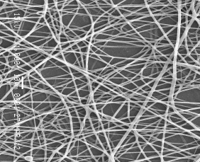  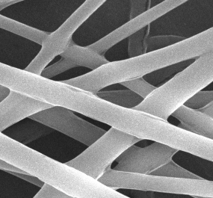  Formula A | 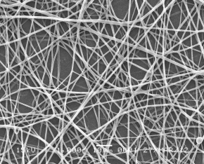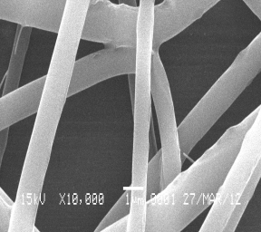  Formula B | 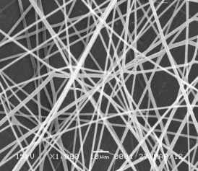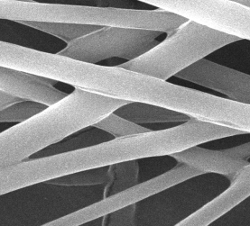  Formula C

Figure 2 : Morphology of nanofibers (1000 x and 10,000 x)

The diameter of the nanofibers produced is determined by the 2 step elongation (streching) during the process, which is at the disposal of Taylor cone and solvent evaporation during the process to reach the collector. The addition TPP to the formula A of 0.1%, formula B 0.25% and the formula C 0.5% turned out to affect the diameter of the fibers. It is because there is an increase of viscosity solution, there by of reducing the fiber elongation during spinning process [15].

Measurement of the Degree of Swelling
It can be seen from the graph that the elongation of the fiber began in the first 30 minutes, then was relatively stable after 90 minutes, where there is a balance solution. This shows the degree of the swelling of fibers ranging from 200% to 500%. Fibers with the addition of TPP 0.5% showed the lowest degree of swelling than others, due to the highest crosslinking density.

Figure 3. Degree of Swelling
Swelling is mainly influenced by ionic interactions, which depend on the crosslinking density during the formation of the network. An increase in crosslinking density induces a decrease in swelling, by improving the stability of the network, and results in decrease drug release [16].

Water Retention Capacity of the Nanofibres
Water retention capacity of fibers was shown in Figure 4. All fibers showed good water retention capacity after removing water by centrifugal force at 25 °C within the range 187 – 238 % of their dry weight. Nanofibers produced 0.5 % TPP showed more water retention capacity than 0.1 % and 0.25 %, may be due to higher crosslinked density in the former case.

Figure 4. Water Retention Capacity
Analysis of FT-IR (Fourier Transform Infra Red)
To compare unknown compounds, it should be done with the standard spectrum in the same condition. The absorbance of infrared radiation changes to the vibrational and rotational energy levels in a covalent bond dipole moment in the molecule. Molecular vibration only occurs when a molecule is composed of two or more atoms.

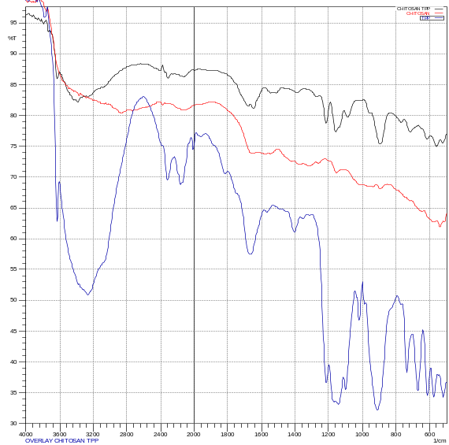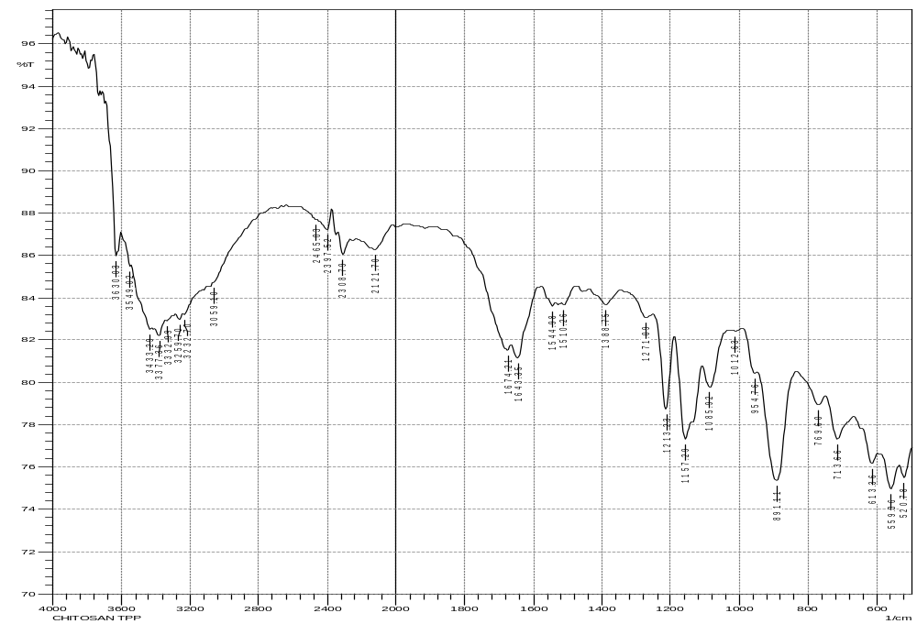

Figure 5. Overlay FTIR Chitosan, TPP and Chitosan TPP
To be able to absorb infrared radiation, vibration of the molecule must changed dipole moment. There are two types of molecular vibrations which can stretch and bend. Stretching vibration is an organized movement of atoms along the axis of bond between two atoms, so that the distance between atoms can be increased or decreased. The presence of phosphate in the compound can be compared with the absorption in the 1100 – 900 cm⁻¹ (P – O stretching) and 1300 – 1150 cm⁻¹ (P=O stretching) by using a infrared spectrophotometers [17]. From the results of the spectra as shown in Figure 5. we can see the change in the intensity of the peaks and transmittance chitosan. The peak that appears in the infrared spectra shown in wave numbers 1271, 1213 and 1157 cm⁻¹ shows the P = O stretching vibration and the peak at wave numbers 1085, 1012 and 954 cm⁻¹ shows the P – O stretching vibration. This is because the bond between the ionic charge of the TPP and the positive amino group (R-NH₃⁺) of chitosan.

From the results of the spectra asshown in Figure 6. there is a change in the intensity of the peaks and gelatin transmittance. The peak that appears in the infrared spectra shown in wave numbers 1257 cm⁻¹ shows the P = O stretching vibration and the peak at wave numbers 1026 and 900 cm⁻¹ shows the P – O stretching vibration. This is because the bond between the ionic charge of the TPP and the positive amino group (R-NH₃⁺) of gelatine.

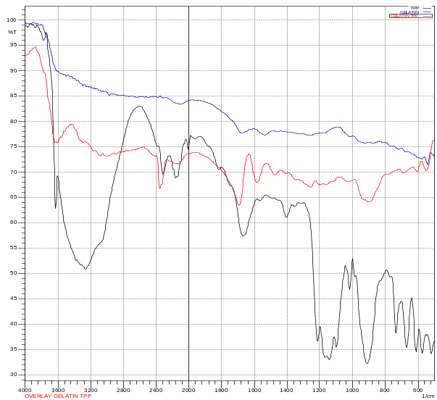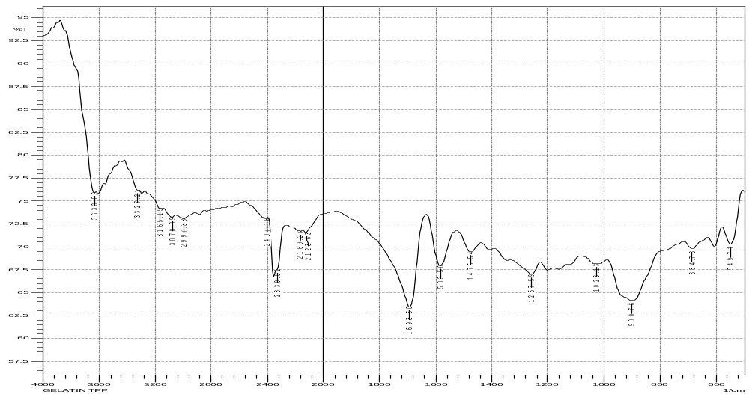

Figure 6. Overlay FTIR Gelatine, TPP and GelatineTPP

Measurement of the Release Asiaticoside
The most important thing that is the release of asiaticoside is according to the requirement of wound healing. Asiaticoside has the property to stimulate fibroblasts and synthesize collagen. The phase in which fibroblasts begin to synthesize collagen starts about 72 hours after injury (proliferative phase). Based on the characterization results indicate that the formula C is the best with the release of asiaticoside 51% for 72 hours, compared to formula A (68%) and formula B (62%). Besides that, formula C has morphology, fiber diameter and the actual content is meet the standard quality requirement of pharmacopoeia.

In this method is used methanol phosphate buffer pH 7.4, which resembles the body fluids. The amount of asiaticoside, obtained from the examination, are formula A 95%, formula B 94% and formula C 94%. From the data obtained, the amount of asiaticoside recovered is sufficiently high, this indicates fairly stable asiaticoside in the process of the manufacturing.

The amount of TPP which were added influences the phosphorylation, in which the degree of swelling, would effected the drug release. Asiaticoside that was release within 72 hours indicates that ph osphorylation gelatine-chitosan can be used to regulate the drug release. The asiaticoside release data can be seen in Figure 7.

Figure 7. Cumulative release of asiaticoside from nanofibers divided by the actual weight

Conclusion
Phosphorylation of gelatine and chitosan as an excipient for asiaticoside nanofibers were successfully prepared with the solvent 70% acetic acid using an electrospinning technique. The asiaticoside release from nanofibers in physiological conditions showed a prolonged release profile. The formula C is the best with the release of asiaticoside 51% for 72 hours, compared to formula A (68%) and the formula B (62%). The percentage asiaticoside from nanofibers preparation is between 90% - 100%.

References
- Lu, L., Ying, K., Wei, S., Fang, Y., Liu, Y., Lin, H., Ma, L., Mao, Y., (2004). Asiaticoside induction for cell-cycle progression, proliferation and collagen synthesis in human dermal ﬁbroblasts. International Journal of Dermatology, 43(11): 801-807.
- Sikareepaisan, P., Suksamrarn, A., Supaphol, P. (2008). Electrospun Gelatin Fiber Mats Containing a Herbal-Centella asiatica- Extract and Release Characteristic of Asiaticoside. Nanotechnology, 19(1): 015102.
- Boateng, JS., Matthews, K., Steven, HE., Eccleston, GM., (2008). Wound Healing Dressings and Drug Delivery Systems. Journal of Pharmaceutical Sciences, 97(8): 2892-2923
- Murugan, R., Ramakrishna, S., (2007). Design Strategies of Tissue Engineering Scaffolds with Controlled Fiber Orientation. Tissue Engineering,13(8): 1845-1866.
- Chew, SY., Wen, Y., Dzenis, Y., Leong, Y., (2006). The Role of Electrospinning in the Emerging Field of Nanomedicine: Current Pharmaceutical Design, 12(36): 4751-4770
- Choktaweesap, N., Arayanarakul, K., Aht-ong, D., Meechaisue, C., Supaphol, P. (2007). Electrospun Gelatin Fibers: Effect of Solvent System on Morphology and Fiber Diameters. Polymer Journal, 39(6): 622-631.
- Vrieze, S., Westbroek, P., Camp,T., Langenhove, L. (2007). Electrospinning of Chitosan Nanofibrous Structures: Feasibility Study. Journal Materials Sciences, 42: 8029-8034.
- Javari, J., Emami, SH., Samadikuchaksaraei, A., Bahar, M A., Gorjipour, F. (2011). Electrospun Chitosan Gelatin Nanofiberous Scaffold: Fabrication and In Vitro Evaluation. Bio-Medical Materials and Engineering, 21(2): 99-102.
- Amaral, IF., Granja, PL., Barbosa, MA., (2005). Chemical modiﬁcation of chitosan by phosphorylation: J. Biomaterials Science Polymer, 16(12): 1575–1593
- Pati, F., Datta, P., Chatterjee, J., Dhara, S. (2010). Development of Chitosan-Tripolyphosphate Fiber for Biomedical Application. IEEE Students' Technology Symposium,77-81
- Schiffman, JD., Schauer, CL. (2007). One-Step Electrospinning of Cross-Linked Chitosan Fibers: Biomacromolecules, 8(9): 2665-2667.
- Bhumkar, Devika R., Varsha B. Pokharkar. (2006). Studies on effect of pH on cross-linking of chitosan with sodium tripolyphosphate: A technical note. AAPS PharmSciTech,7 (2) Article 50.
- Khairurrijal ., Munir, MM., Saehana, S., Iskandar, F., Abdullah, M. (2009). Teknik pemintalan elektrik untuk pembuatan nanoserat dari pemodelan hingga eksperimen. Jurnal Nanosains & Nanoteknologi, edisi khusus.
- M. Pillai, CKS., Sharma, P. (2009). Electrospinning of Chitin and Chitosan Nanofibres. Trends Biomater. Artif. Organs, 22(3): 179-201.
- Suwantong, O., Ruktanonchai, U., Supaphol, P. (2008). Electrospun cellulose acetate fiber mats containing asiaticoside or Centella asiatica crude extract and the release characteristics of asiaticoside. Polymer, 49(19): 4239–4247
- Berger, J., Mayer, JM., Felt, O., Peppas, NA., Gurny, R. (2004). Structure and interactions in covalently and ionically crosslinked chitosan hydrogels for biomedical applications. European Journal of Pharmaceutics and Biopharmaceutics, 57(1): 19–34
- Silverstein, RM., Webster, FX., Kiemle, DJ., Spectrometric identification of organic compounds, Wiley, America (2005): 417

