THE IMPROVEMENT OF SCREENING THE SIGNIFICANT FACTORS OF OIL BLENDS AS BIOLUBRICANT BASE STOCK

(Penambahbaikkan Saringan Faktor Bererti Bagi Campuran Minyak Sebagai Stok Asas Biopelincir)

Noor Hajarul Ashikin Shamsuddin¹, Rozaini Abdullah^{2*}, Zainab Hamzah², Siti Jamilah Hanim Mohd Yusof¹

¹School of Bioprocess Engineering, Universiti Malaysia Perlis, Kompleks Pengajian Jejawi Utara,
²Faculty of Engineering Technology, Universiti Malaysia Perlis, Pusat Kejuruteraan, Kampus Pauh Putra,
02600 Arau Perlis.

*Corresponding author: rozainiabdullah@unimap.edu.my

Abstract
A new formulation biolubricant base stock was developed by blending of waste cooking oil (WCO) with Jatropha curcas oil (JCO). The objective of this research is to evaluate significant factors contributing to the production of oil blends for biolubricant application. The significant factors used in this study were oil ratio (WCO:JCO), agitation times (min) and agitation speed (rpm). The blended oil biobased lubricant was used to determine the saponification, acid, peroxide and iodine values. The experimental design used in this study was the 2 level-factorial design. In this experiment, it was found that the effect of oil ratio and interaction of oil ratio and agitation speed gave the most significant effect in oil blends as biolubricant base stock. The highest ratio of oil blend 80%:20% WCO:JCO, with low agitation speed of 300 rpm and low agitation time of 30 minutes gave the optimum results. The acid, saponification, peroxide and iodine values obtained were 0.517±0.08 mgKOH/g, 126.23±1.62 mg/g, 7.5±2.0 meq/kg and 50.42±2.85 mg/g respectively. A higher ratio of waste cooking oil blends was found to be favourable as biolubricant base stock.

Keyword: Waste cooking oil, Jatropha curcas oil, oil blend, 2-Level Factorial Design

Abstrak
Formulasi baru bagi stok asas biopelincir telah dibangunkan dengan campuran sisa minyak masak (WCO) dengan minyak Jatropha curcas (JCO). Objektif kajian ini adalah untuk menilai faktor-faktor penting yang menyumbang kepada pengeluaran minyak campuran untuk aplikasi biopelincir. Faktor-faktor penting yang digunakan dalam kajian ini ialah nisbah minyak (WCO: JCO), masa campuran (min) dan kelajuan percampurann (rpm). Campuran minyak pelincir asa bio digunakan untuk menentukan nilai saponifikasi, asid, peroksida dan nilai iodin. Reka bentuk eksperimen yang digunakan dalam kajian ini adalah reka bentuk 2 peringkat faktorial. Dalam eksperimen ini, didapati bahawa kesan nisbah minyak dan interaksi nisbah minyak dan kelajuan percampuran memberi kesan ketara dalam campuran minyak sebagai stok asa biopelincir. Nisbah tertinggi campuran minyak 80%: 20% WCO: JCO, dengan kelajuan percampuran yang rendah 300 rpm dan masa yang rendah 30 minit memberikan hasil yang optimum. Nilai-nilai asid, saponifikasi, peroksida dan iodin yang diperolehi ialah 0.517±0.08 mgKOH/g, 126.23±1.62 mg/g, 7.5±2.0 meq/kg dan 50.42±2.85 mg/g. Nisbah yang lebih tinggi daripada campuran sisa minyak masak adalah lebih baik untuk dijadikan sebagai stok asas biopelincir.

Kata kunci: Sisa minyak masak, Minyak Jatropha curcas, campuran minyak, Rekabentuk Faktorial 2 Peringkat

Introduction
Worldwide consumption of lubricants in 2005 was around 40 million metric tons and approximately 30 % of that ended up in the ecosystem. However, about 1 % of biodegradable lubricant was produced in the total production of lubricant. For over 100 years mineral oils have dominated lubrication and nowadays the environmental issue arises as mineral oil and synthetic oil is not readily biodegradable [1]. Due to the environmental awareness, the need for renewable and biodegradable lubricants is increasing. Therefore, the use of vegetable oil is gaining acceptance due to the significant advantage as it is environmentally friendly and it possessed adequate performance in a variety of applications [2].

However, vegetable oils are known for their poor oxidative stability as compared to petroleum-based lubricants. No single oil serves as the ideal lubricant for many modern types of machinery [3]. Nevertheless, through some modification, vegetable oils can be used as lubricant. Usually, vegetable oils are mainly used in the food industry, but current developments and environmental issues led to their economic usefulness in industrial application. Yet, the property use for production of edible oil for biolubricant feedstock competes with the use of property for food production. Hence, one way of reducing production costs is by using less expensive feedstock such as non-edible oils, animal fats and waste cooking oil [4]. The use of vegetable oil blends as biodiesel [5], fish diets [6] as well as cooking oil [7] are already well-known throughout the world. In contrast, its application as a part of biolubricant has not been explored thoroughly. Therefore, there is a great potential of blending vegetable oil (waste cooking oil) with non-edible oil such as jatropha oil as biolubricant base stock.

Nowadays, waste cooking oils (WCO) are illegally discarded into rivers and landfills, which resulted in environmental pollution [8]. Therefore removal and utilization of the WCO will reduce environmental pollution. WCO contains fatty acids that can be exploited for the production of biolubricant. The fatty acids contained in WCO are oleic (52.9%), linoleic (13.5%) and palmitic (20.4%) acids [8]. Some researchers also found that with some refining and modification process of used cooking oil also can be utilized as multipurpose lubricant. Recently, genetic modification, additive treatment and chemical modification, are applied to overcome the problems related to the use of vegetable oils in lubricants [9].

Furthermore, edible plant and vegetable oils is worth more than mineral lubricant. Therefore, the production of biolubricant would be cheap as it could be extracted from non-edible oil sources. Jatropha curcas oil (JCO) can be considered as a low-cost potential feedstock in comparison with refined and edible oils such as those obtained from rapeseed, soybean and sunflower. It is found that, Jatropha curcas, which is a non-edible oil-bearing and drought-hardy shrub with ecological advantages, belonging to the Euphorbiaceae family, to be the most suitable renewable alternative source of biolubricant [10]. Jatropha curcas is a multipurpose plant with many features and great potential. Various parts of the Jatropha curcas plants have many useful applications. All parts of Jatropha curcas plant have their own uses. The oil extracted from the seeds can be used as in biolubricant feedstock and the production of soap. Jatropha curcas oil contains a high percentage of unsaturated fatty acid, which is approximately 78- 84%. JCO contains three major long chain fatty acids, which are oleic (46%), linoleic (31.96%) and palmitic (13.89%) acids [11]. Lubrication characteristics such as pour point, viscosity and thermal oxidative stability for biolubricant production. Jatropha oil was found to be comparable to the other vegetable oil-based lubricants [12].

Several factors may affect the chemical properties, therefore, screening design will be carried out to determine which of the factors and their interactions will give optimum effects as a biolubricant base stock. A 2-level factorial design will be used as it is most economical experimental design for screening due to its flexibility and less experimental runs [13]. The three factors used in this study are oil ratio, agitation speed and agitation time. Saponification, acid, peroxide and iodine values were determined to evaluate the effectiveness of oil blends biolubricant as biolubricant base stock.

Materials and Methods

Sampling and materials
Jatropha curcas oil (JCO) was purchased from Bionas Sdn. Bhd. Waste cooking oil was collected from the selected food stall in Jejawi, Perlis. All chemicals used in the study were of analytical grades.

Blending Oil
Jatropha curcas oil (JCO) and waste cooking oil (WCO) were blended by using an overhead stirrer with different ratios of oil blend, agitation speed and agitation time. The experiment was conducted at room temperature and atmospheric pressure.

Chemical Analysis for Oil
Chemical analysis was carried out before and after blending of both oils. All chemical analysis was determined using the AOCS method such as saponification value (AOCS Method TI 1a-64 and Cd 3-25), acid value (AOCS 5a-40 (1989)), peroxide value (AOCS Cd 8-53 (1989) ISO 3960 (1977)) and iodine value (AOCS Method Cd 1d-92).

Design of Experiment: 2-Level Factorial Design
There were 3 major factors involved in the experimental design such as the ratio of oil blends (WCO: JCO), agitation speed and time agitation. Table 1 shows the experimental design used in this study. The oil ratio was adapted from Chen [14] while the other two factors (agitation speed and agitation time) were newly identified.

Table 1. Factors study in this experiment.

Factors | Units | Symbol | Low level (-1) | High level (+1)
Molar Ratio (WCO:JCO) | (%) | A | 20 | 80
Agitation speed | rpm | B | 300 | 2000
Agitation Time | min | C | 30 | 300

A multiple regression analysis was performed on a regression model which corresponds to the following first-order response function as equation (1) below:
$$y= β_{0}+ \sum_{i=1}^{K}{β_{i}X_{i}}+ \sum{\sum_{j<1}{β_{ij}X_{i}X_{j}}}+ ε$$
(1)
Where βo, βi and βij are the regression coefficients for the intercept, linear and interaction coefficients, respectively, y is the dependent variable or the response, x_{i}, and x_{j} are the independent variables or the factors in coded units, and ɛ is the error term.

Estimation of the regression coefficients that caused the model to best fit a set of collected response variable data was carried out by the least squares method. A reduced regression model, which involved only the significant variables, was produced after examining the significance of each individual regression coefficient by Student’s t-test at 5% significance level [15,16,17]. All analysis was performed with the Design-Expert Software version 7.1.5.
Results and Discussion
Table 2 shows all 26 experimental runs suggested by Design-Expert Software version 7.1.5 with their representative results. Experimental runs were randomized to minimize the effects of unexpected variability in the observed responses.

Table 2: Experimental runs suggested and its respective responses.

Run | Factors |  |  | Responses
Run | A:  Oil ratio (%) | B:  Speed (rpm) | C:  Time (min) | Acid Value (mgKOH/g) | Saponification Value  (mg/g) | Peroxide value  (meq/kg) | Iodine value  (mg/g)
1 | 20 | 300 | 30 | 0.85 | 138.85 | 16.50 | 33.50
2 | 20 | 2000 | 30 | 0.85 | 123.42 | 2.50 | 36.55
3 | 80 | 300 | 30 | 0.56 | 119.21 | 5.50 | 55.20
4 | 20 | 2000 | 300 | 0.56 | 119.21 | 3.00 | 44.54
5 | 80 | 300 | 30 | 0.56 | 122.02 | 9.50 | 55.33
6 | 80 | 300 | 300 | 0.42 | 129.03 | 8.50 | 49.24
7 | 80 | 2000 | 300 | 0.56 | 140.25 | 10.50 | 42.00
8 | 80 | 2000 | 300 | 0.42 | 134.64 | 12.50 | 40.35
9 | 80 | 2000 | 30 | 0.71 | 117.81 | 16.00 | 37.94
10 | 80 | 2000 | 300 | 0.42 | 129.03 | 9.50 | 43.78
11 | 20 | 300 | 30 | 0.85 | 138.85 | 15.50 | 45.94
12 | 20 | 2000 | 30 | 0.85 | 126.23 | 2.20 | 35.28
13 | 20 | 300 | 300 | 1.27 | 143.06 | 13.50 | 32.36
14 | 80 | 300 | 300 | 0.56 | 131.84 | 9.00 | 47.59
15 | 20 | 300 | 300 | 0.99 | 138.85 | 14.00 | 34.39
16 | 20 | 300 | 30 | 0.85 | 137.45 | 15.00 | 33.50
17 | 80 | 2000 | 30 | 0.71 | 120.62 | 13.00 | 39.09
18 | 20 | 2000 | 300 | 0.56 | 137.45 | 2.70 | 49.99
19 | 50 | 1150 | 165 | 0.71 | 137.45 | 24.50 | 39.59
20 | 50 | 1150 | 165 | 0.85 | 138.85 | 9.50 | 29.82
21 | 20 | 2000 | 300 | 0.56 | 154.28 | 2.20 | 44.03
22 | 50 | 1150 | 165 | 0.71 | 145.86 | 10.50 | 30.33
23 | 80 | 300 | 300 | 0.56 | 131.84 | 12.00 | 48.22
24 | 20 | 300 | 300 | 0.76 | 136.04 | 12.00 | 32.74
25 | 80 | 300 | 30 | 0.42 | 137.45 | 7.50 | 40.73
26 | 20 | 2000 | 30 | 0.56 | 144.46 | 2.90 | 36.17
The qualitative contribution of each factor and its respectively responses were analysed. Each response coefficient was studied for its statistical significance by Pareto charts [13] as shown in Fig. 1. Pareto charts establish t value of the effect by two limit lines, namely the Bonferroni limit line and t limit line. Coefficients with t value of effect above the Bonferroni line are designated as certainly significant coefficient, coefficients with t value of effect between Bonferroni line and t limit line are termed as coefficients likely to be significant, while t value of effect below the t limit line is statistically insignificant [13].

From the Fig. 1, for acid value, the effect of oil ratio (A), interaction of oil ratio and agitation speed (AB) and interaction of agitation speed and blending time (BC) exceeds the conservative Bonferroni limit, thus provides high confidence level. While the factor of agitation speed (B), was most likely to be significant as the value exceed the t limit line. Meanwhile, the effect of oil ratio (A) gave the most significant effect for response saponification value because the factor exceeds the conservative t line limit. For peroxide value, only agitation speed (B) and interaction of oil ratio and agitation speed (AB) exceed the conservative Bonferroni. While for iodine value, the effect of oil ratio (A) and interaction of oil ratio and agitation speed (AB) exceeds the conservative Bonferroni limit, thus provides the high level of confidence even greater than 95 %. While the interaction of agitation speed and time (BC) was significant since the effect exceed the t line limit. The Pareto Chart in Fig. 1 concluded that factors of A and AB gave the most significant effect in oil blends since this effect exceeded the Benferroni limit line in most of the responses. However, this conclusion needs further authentication by using ANOVA analysis.

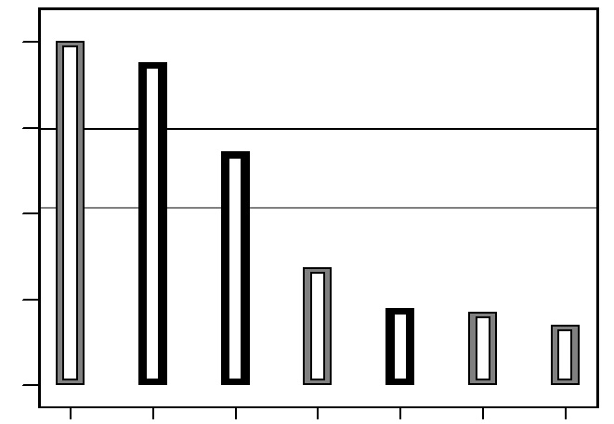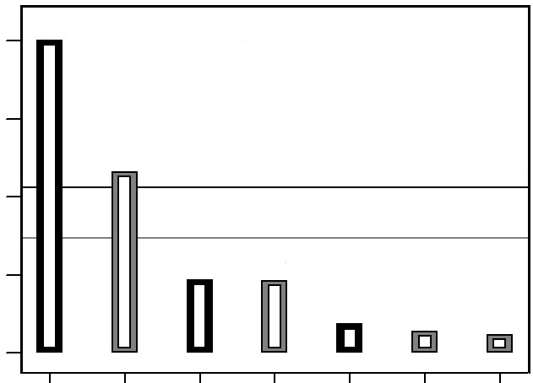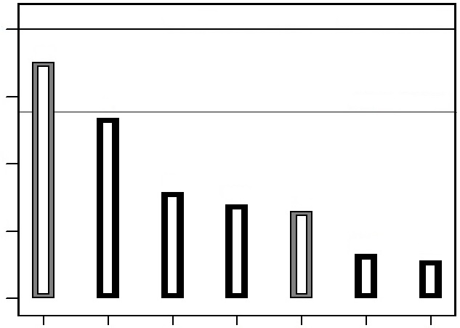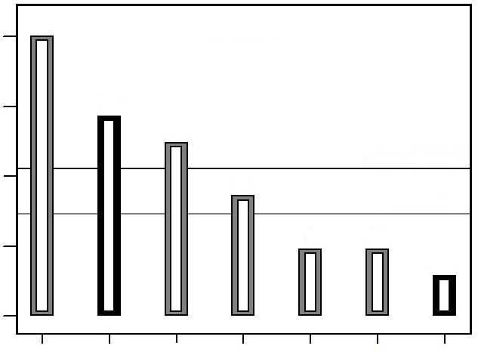
A
AB
BC
B
C
AC
ABC
IODINE VALUE
4.06
3.05
2.03
1.02
0.00
1
3
2
4
5
6
7
Rank
Bonferroni Limit 3.03363
t-Value Limit 2.10092
5.72
4.29
2.86
1.43
0.00
t value of effort
PEROXIDE VALUE
1
3
2
4
5
6
7
Rank
Bonferroni Limit 3.03363
t-Value Limit 2.10092
A
AB
BC
B
C
AC
ABC
SAPONIFICATION VALUE
Bonferroni Limit 3.03363
t-Value Limit 2.10092
3.03
2.28
1.52
0.76
0.00
1
3
2
4
5
6
7
Rank
A
AB
BC
B
C
AC
ABC
ACID VALUE
Bonferroni Limit 3.03363
t-Value Limit 2.10092
1
3
2
4
5
6
7
Rank
A
AB
BC
B
C
AC
ABC
5.75
4.31
2.88
1.44
0.00
t value of effort

Notes: Positive effects Negative effects

Figure 1: Pareto charts of 4 (acid, saponification, peroxide and iodine value) response coefficient study.

Table 3 shows the ANOVA analysis of four responses which were acid, saponification, peroxide and iodine value. To determine the significance of the model and the effect of was by calculating the probability P value express in (Prob> F). For p-values less than 0.05 which provided at least 95% confidence level for the model was significant to the process. In this study, for acid value response, the most significant factors were A (oil ratio), B (agitation speed), AB (interaction of oil ratio and agitation speed) and BC (interaction of agitation speed and agitation time). This is due to the p-value which was less than 0.05. Meanwhile, for saponification response, only factor A gave the significant effect. On the contrary, factor B and AB give the significant effects for peroxide value since the value did not exceed 0.05. With the value less than 0.05, factors A, AB and BC gave the significant effects for iodine value. From the ANOVA analysis and Pareto charts, it indicates that the effect of oil ratio (A) and interaction of oil ratio and agitation speed (AB) gave the most significant effect in oil blends as biolubricant base stock.

Table 3. Analysis of variance (ANOVA) for factorial model of iodine value

Model | Acid value |  | Saponification value |  |  | Peroxide value |  |  | Iodine value
Model | F-value | p-value | F-value |  | p-value | F-value | p-value |  | F-value | p-value
A- oil ratio | 30.97 | <0.0001 | 6.51 |  | 0.0175 | - | - |  | 14.55 | 0.0009
B- agitation speed | 5.69 | 0.0266 |  | - | - | 11.39 |  | 0.0026 | - |  | -
AB | 15.80 | 0.0007 | - |  | - | 34.12 | <0.0001 |  | 16.52 | 0.0005
BC | 11.87 | 0.0024 | - |  | - | - | - |  | 7.58 | 0.0116

Figure 2 showed the interaction of AB and BC on response acid value. For an interaction graph of AB, at a high level of WCO and low level of agitation speed and time of oil blends gave the lowest yield of acid value. But, if the agitation time was increased to the maximum level, the agitation speed at the high level of oil ratios gave the less significant effect. This is due to the interaction of AB was higher to the left compared to the right side of the graph. While, the interaction graph of BC indicates the same conclusion as the interaction graph of AB.

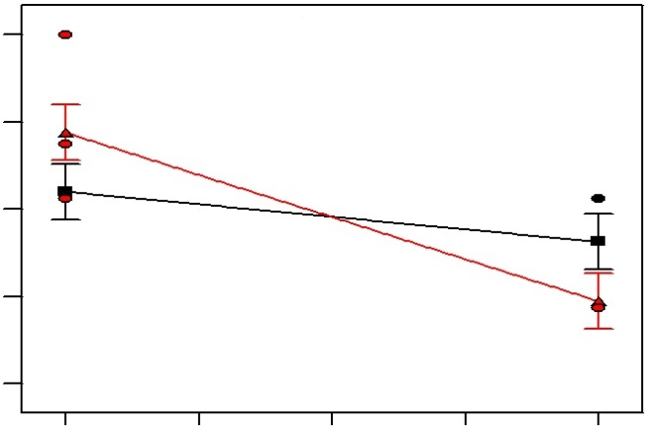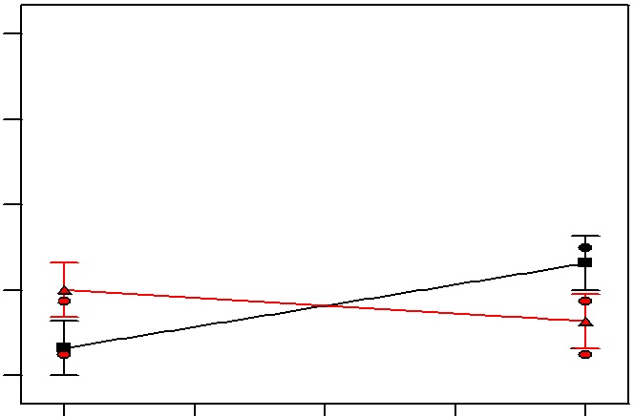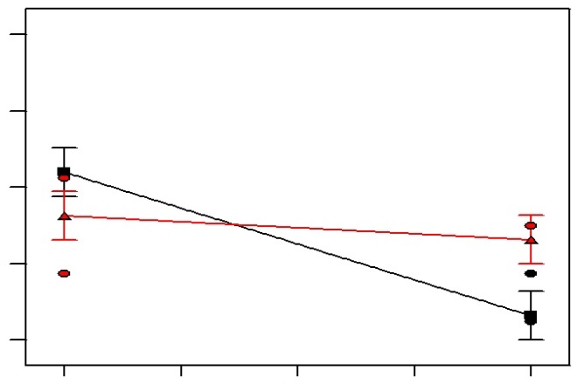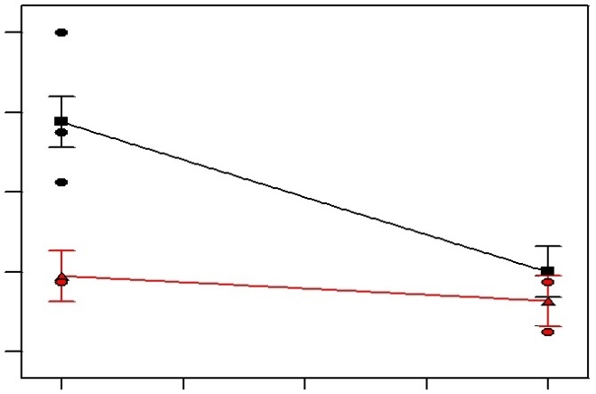
1.27
1.04
0.82
0.59
0.37
300
725
1150
1575
2000
C: Time
B: Speed
Acid Value
B: Speed
1.27
1.04
0.82
0.59
0.37
300
725
1150
1575
2000
C: Time
A: Oil Ratio

B: Speed
1.27
1.04
0.82
0.59
0.37
Acid Value
20
35
50
65
80
A: Oil Ratio
1.27
1.04
0.82
0.59
0.37
20
35
50
65
80
B: Speed

Notes : High Value Low Value

Figure 2: Interaction graph of AB (above) and BC (below) for response acid value
at minimum (left) and maximum (right) level

No interaction was observed for saponification value since the only oil ratio gave the most significant effect as shown in Fig. 1 and Table 1. However, Fig. 3 shows that agitation time gave no significant effect to oil ratio and agitation speed at low or high agitation time.

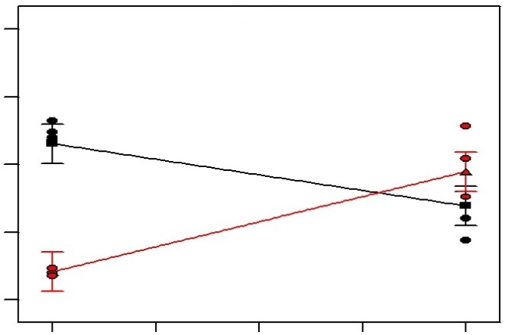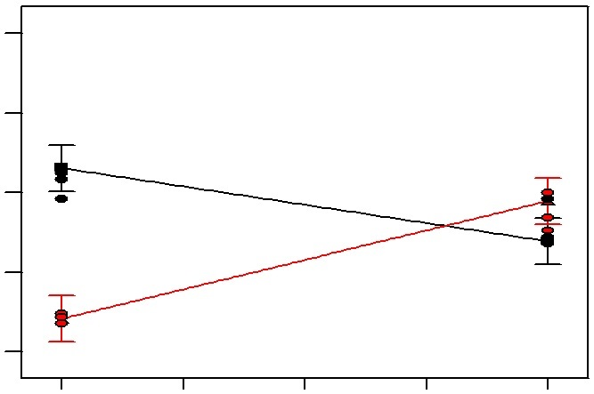
25
18.75
12.5
6.25
0
20
35
50
65
80
B: Speed
A: Oil Ratio
Peroxide Value
B: Speed
25
18.75
12.5
6.25
0
20
35
50
65
80
A: Oil Ratio
B: Speed

Figure 3: Interaction graph of AB for response peroxide value at minimum (left) and maximum (right) value

Figure 4 showed the interaction of AB and BC with respect to iodine value. The interaction of AB showed no significant effects neither at minimum nor maximum level of agitation speed as indicated by response in the left and right side of the graph. To obtain the highest iodine value, it was necessary to set the agitation speed and time at a minimum level while increasing the ratio of WCO:JCO. Similar interaction trends were found in BC. This shows that factor A was significant effect compared to factor B and C.

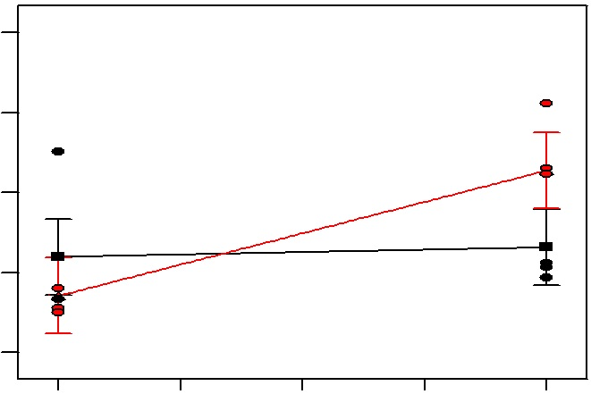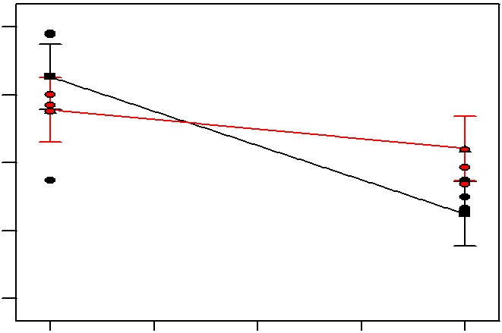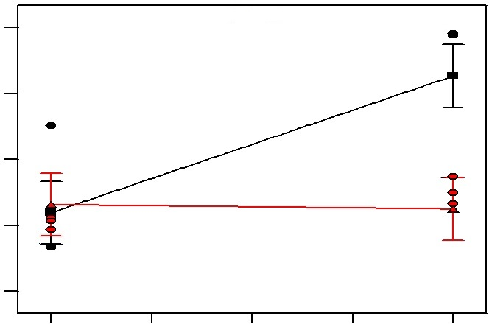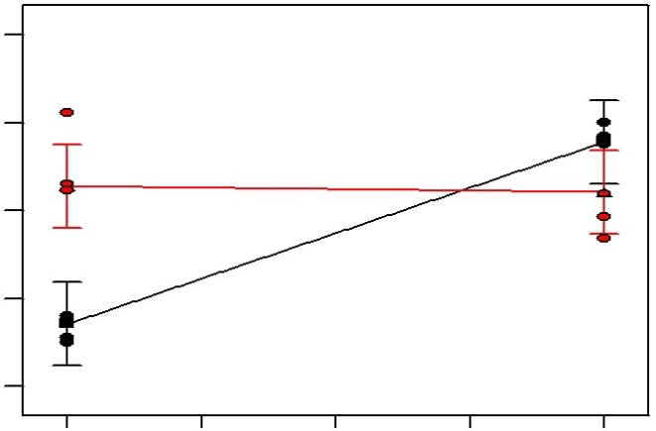
300
725
1150
1575
2000
B: Speed
56
49.25
42.5
35.75
29
Iodine Value
C: Time
B: Speed
300
725
1150
1575
2000
56
49.25
42.5
35.75
29
C: Time
A: Oil Ratio
56
49.25
42.5
35.75
29
Iodine Value
20
35
50
65
80
B: Speed
A: Oil Ratio
20
35
50
65
80
56
49.25
42.5
35.75
29
B: Speed

Figure 4. Interaction graph of AB (above) and BC (below) for response iodine value at minimum (left) and maximum (right) level
This study showed that, oil blends should have a high iodine value and low value of saponification, acid and peroxide to achieve the criteria as a biolubricant basestock. The high content of iodine value indicated the presence of high content of unsaturated fatty acids, containing more double bonds in the fatty acid chain. High iodine content will slow down the process of oil clotting. Furthermore, the double bonds are required in the oil blends in the esterification process. Meanwhile, biolubricant oil should have a low peroxide value since high peroxide will enhance the oxidation of the oil [18]. However, high saponification can lead to machine clogging, which consequently reduce the yields and increases the formation of emulsions in the products. This effect will make it difficult to separate the biolubricant from glycerine [19]. On the other hand, oil blends will be a good lubricating oil because of the low acid value which will prevent corrosion, gum and sludge formation [20].

Conclusion
The screening of 2-Level Factorial Design was determined by focusing on three major factors which are oil ratio (A), agitation speed (B) and agitation time (C) to evaluate the four responses of oil blends: saponification, acid, peroxide and iodine values. The overall analysis indicated that the ratio of waste cooking oil: Jatropha curcas oil (80:20) gave the highest significant effect compared to the agitation speed (300 rpm) and agitation time (30 minutes). While the responses showed the acid value (0.517±0.08 mgKOH/g), saponification value (126.23±1.62 mg/g), peroxide value (7.5±2.0 meq/kg) and iodine value (50.42±2.85 mg/g). In this study, the high ratio of waste cooking oil, minimum agitation speed and time gave significant effect for biolubricant production. The experimental design was helping to reduce environmental pollution cost and time. The results from the responses showed that oil blend of WCO and JCO can be used as biolubricant base stock. This will greatly reduce waste, improved environmental pollution and cost effective.

Acknowledgements
The authors would like to express their gratitude to MTUN-COE for funding the research via Grant No. 9016-00006 and the School of Bioprocess Engineering.

References

- Bartz, W.J. (2006). Ecotribology: Environmentally Acceptable Tribological Practices. Triboogy International, 39 (8): 728-733.
- Nizam, M.K. and Hayder, A.A.B. (2009). The Use Of Vegetable Oil In Lubricant As Base Oil: A Review. National Conference on Postgraduate Research (NCON-PGR).
- Talkit, K.M., Mahajan, D.T. and Masand, V.H. (2012). Physicochemical properties of soybean oil and their blends with vegetable oils for the evaluation of lubrication properties, Journal of Chemical, Biological and Physical Sciences, 3(1): 490–497.
- Berchmans, H.J. and Hirata, S. (2008). Biodiesel production from crude Jatropha curcas L. seed oil with a high content of free fatty acids. Bioresource Technology, 99(6): 1716–1721.
- Al-Hamamre, Z. And Al-Salaymeh, A. (2014). Physical properties of (jojoba oil + biodiesel), (jojoba oil + diesel) and (biodiesel + diesel) blends. Fuel, 123: 175-188.
- Mourenta, G. And Bell, J.G. (2006). Partial replacement of dietary fish oil with blends of vegetable oils (rapeseed, linseed and palm oils) in diets for European sea bass (Dicentrarchus labrax L.) over a long term growth study: Effects on muscle and liver fatty acid composition and effectiveness of a fish oil finishing diet. Comparative Biochemistry and Physiology Part B: Biochemistry and Molecular Biology, 145(3-4): 389-399.
- Mostafa, R.A., Moharram, Y.G., Attia, R.S. and El-Sharnouby, S.A. (2013). Formulation and characterization of vegetable oil blends rich in omega –3 fatty acids. Emir. J. Food Agric., 25(6): 426-433.
- Chhetri, A.B., Watts, K.C. and Rafiqul Islam M. (2008). Waste cooking oil as an alternate feedstock for biodiesel production. Energies, 1: 3-18.
- Valente, O.S., Pasa, V.M.D., Belchior, C.R.P. and Sodré, J.R. (2011). Physical–chemical properties of waste cooking oil biodiesel and castor oil biodiesel blends. Journal of Fuel, 90(4): 1700–1702.
- Kywe, T. T. and Oo, M. M. (2009). Production of biodiesel from jatropha oil (Jatropha curcas) in pilot plant. Proceedings of World Academy of Science, Engineering and Technology, 38: 2070-3740.
- Salimon, J. and Rozaini, A. (2008). Physicochemical properties of Malaysia Jatropha curcas seed oil. Sains Malaysiana, 37(4): 379-382.
- Gunam Resul, M. F. M., Mohd Ghazi, T. I., Muhammad Syam A. and Idris, A. (2008). Synthesis of Biodegradable Lubricant from Jatropha Oil with High Content of Free Fatty Acids. American Institute of Chemical Engineers, Environmental Division, 524-530.
- Shah, M. and Pathak, K. (2010). Development and Statistical Optimization of Solid Lipid Nanoparticles of Simvastatin by Using 23 Full-Factorial Design. AAPS PharmSciTech, 11 (2): 489-496.
- Chen, Y., Chen,J., Luo, Y., Shang, N., Chang, C. and Chiang, P. (2011). Property Modification of Jatropha Oil Biodiesel by Blending with Other Biodiesel or Adding Antioxidants. Energy, 36 (7): 4415-4421.
- Chang, S. H., Teng, T.T. and Norli Ismail. (2011). Screening of factors influencing Cu(II) extraction by soybean oil-based organic solvents using fractional factorial design. Journal of Environmental Management, 92: 2580-2585.
- Myers, R.H. and Montgomery, D.C. (2002). Response Surface Methodology e Process and Product Optimization Using Designed Experiments. Seconded. John Wiley & Sons Inc., Canada.
- Rozaini, A., Farizul Hafiz, K., Siti Nur Amalieya Syaza, M. Z. and Noor Hajarul Ashikin, S. (2014). Oil Blends as Biolubricant: Screening of Effect Factors Influence To Basestock. Key Engineering Materials, 594-595: 356-361.
- Wannahari, R. and Nordin, M. F. N. (2012). Reduction of Peroxide Value in Used Palm Cooking Oil Using Bagasse Adsorbent. American International Journal of Contemporary Research, 2 (1): 185-191.
- Chen Ching, T. (2008). Experimental Study for Developing the Base Oils of the U.S. Soybean Oil Based Biolubricants, Department of Mechanical Engineering. National Taipei University of Technology.
- Jen-Jie, H., Wen-Shing, L., Wen-Fang, W. and Sih-Li, C. (2001). Effect of Lubrication on the Performance and Dynamic Loads of Scroll Compressors. Journal of Mechanics, 17: 201-210.

