Optimization of the in situ Epoxidation of linoleic acid of Jatropha curcas oil with performic acid

(Pengoptimuman Tindakbalas Pengepoksidaan in situ Asid Linoleik Minyak Jatropha curcas dengan Asid Performik)

Kin Hong Liew, Rahimi M. Yusop, Nadia Salih and Jumat Salimon*

School of Chemical Sciences and Food Technology, Faculty of Science and Technology,
Universiti Kebangsaan Malaysia, 43600 Bangi, Selangor, Malaysia

*Corresponding author: jumat@ukm.edu.my

Abstract
The aim of this study is to optimise the epoxidation of linoleic acid of Jatropha curcas oil. This experiment was carried out with performic acid generated in situ by using hydrogen peroxide and formic acid. The method was evaluated on different parameters such as reaction temperature, mole ratios of formic acid to ethylenic unsaturation and hydrogen peroxide to ethylenic unsaturation. The optimum relative conversion into oxirane (80.4%) and conversion of iodine (94.7%) was achieved with ~70 % yield at the condition of 45°C reaction temperature, formic acid to ethylenic unsaturation mole ratio of 2.0, hydrogen peroxide to ethylenic unsaturation mole ratio of 12.0 for 2 hours of reaction time. The epoxidized linoleic acid was characterized by using Fourier transform infrared (FTIR) spectroscopy and NMR analysis. The result was also found that the formations of an epoxide and oxirane ring cleavage were both occurred at the same time if low amount of hydrogen peroxide was used.

Keywords: Epoxidation, linoleic acid, Jatropha curcus oil, performic acid.

Abstrak
Kajian pengoptimuman tindak balas pengepoksidaan asid linoleik minyak Jatropha curcas telah dilakukan. Tindak balas ini dijalankan menggunakan asid performik yang dijana secara in situ dengan menggunakan hidrogen peroksida dan asid formik. Kaedah ini telah dinilai dengan beberapa jenis parameter seperti suhu tindak balas, nisbah mol asid formik kepada etilenik taktepu dan nisbah mol hidrogen peroksida kepada etilenik taktepu. Penukaran relatif optimum kepada oksirana (80.4%) dan penukaran relatif nilai iodin (94.7%) telah dicapai dengan ~ 70 % hasil pada keadaan suhu tindak balas 45°C, nisbah mol asid formik kepada etilenik taktepu 2.0, nisbah mol hidrogen peroksida kepada etilenik taktepu 12.0 pada masa tindak balas selama 2 jam. Asid linoleik terepoksida dicirikan dengan menggunakan spektroskopi inframerah transformasi Fourier (FTIR) dan analisis spektroskopi resonans magnet nukleus (NMR). Hasil kajian juga mendapati bahawa pembentukan gelang oksirana dan pembukaan gelang oksirana telah berlaku serentak pada masa yang sama jika amaun hidrogen peroksida yang rendah telah digunakan.

Kata Kunci: Pengepoksidaan, asid linoleik, minyak Jatropha curcus, asid performik.

Introduction
In recent years, the attention to vegetable oil uses as alternative substitutes for petroleum-based products is increasing due to the rising concerns for the environment and rising cost of petroleum products. Vegetable oil and animal fat are concerned by public due to they are biorenewable sources that can be treated chemically and enzymatically to replace those materials that can be derived from petroleum [1-4].

Epoxidation of vegetable oil/ fatty acid is an important method for the formation of carbon–oxygen bonds. The existence of unsaturated C=C in vegetable oil such as linoleic acid and oleic acid that can be used to introduce functional group provides new materials that can replace petroleum-derived compounds, serve as valuable intermediates, or be utilized directly like epoxidized fatty acid and epoxidized vegetable oils. Epoxides not only used as plasticizer but also can be used in paint [5-8]. Because of high reactivity of oxirane ring, epoxides can also act as raw materials for alcoholysis, acidolysis and polymer [9-11]. Epoxidation of vegetable oil such as rapeseed, soybean, jatropha, karanja, mahua, cotton seed and canola oil were investigated [12-17].

Epoxidation of vegetable oils most commonly employed in industry is frequently carried out with peracids as oxidizing agents together with strong mineral acid as catalysts due to the low cost. However, these processes suffer from acid-catalyzed epoxy ring-opening reactions and the concentrated peroxyacid is unstable and explosive. For safety points of view, these epoxidation processes are usually carried out using peracids formed in-situ at low concentrations to minimise the unwanted epoxide ring opening occurred [18]. The kinetics of in situ epoxidation of jatropha oil by peroxyacids and the epoxidation of palm olein methyl ester by performic and peracetic acid, both carried out in the presence of sulfuric acid as a catalyst, conclude that the rate determining step was the formation of performic and peracetic acid [19,20]. The epoxidation reaction mechanism as suggested by Petrovic et al (2002) is shown in Figure 1 [21].

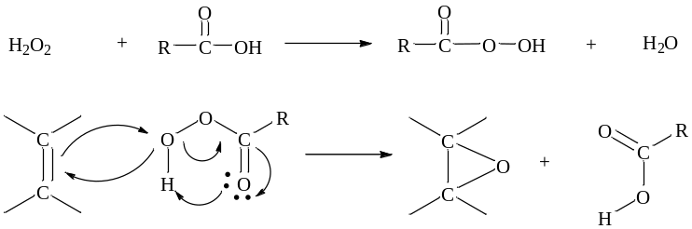

Figure 1. The mechanism of epoxidation reaction

But the oxirane ring cleavage was occurred in some critical condition to produce side product as below:

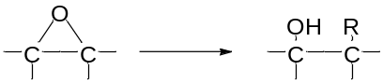
where R = -OH, -OCOH, -OOCOH

One of the promising candidates for oleochemical product is Jatropha curcas oil. Jatropha curcas oil is non-edible oil due to the high concentration of toxic ingredients of phorbol esters and it could lead to a lower consumption of edible oils for chemical purposes. In particular, the jatropha oil is a very interesting raw material for the production of oleochemicals because it has high content of unsaturated fatty acids. In this work, we studied the in situ epoxidation of linoleic acid that extracted from Jatropha curcas oil in the absence of conventional catalyst. For in situ epoxidation, hydrogen peroxide acted as oxygen donar and formic acid as oxygen carrier. The reaction is conducted with performic acid formed in situ from formic acid and hydrogen peroxide as showed in Figure 2 [17]. In the epoxidation reaction, the parameter has been investigated that included effect of temperature, formic acid to ethylenic unsaturation mole ratio and hydrogen peroxide to ethylenic unsaturation mole ratio to obtain an optimum condition.

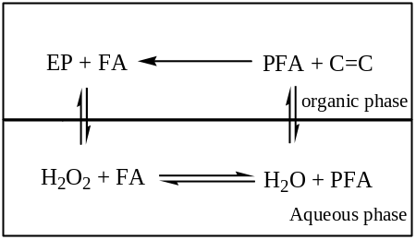

Figure 2. Epoxidation reaction in organic phase with performic acid (PFA) generated in the aqueous phase from hydrogen peroxide. The organic acid, PFA and formic acid (FA) were shuttled in both liquid phases. [17]

Materials and Methods
Materials
Linoleic acid (78.1%) was obtained from Jatropha curcus oil by using urea complex fractionation. Formic acid (≥98%), aqueous hydrogen peroxide (~30 wt%), diethyl ether (≥99.5%), Na₂SO₄, NaHCO₃, NaCl, KI and Wijs solution from SYSTERM, ChemAR. HBr, 33 wt% in acetic acid was obtained from Sigma Aldrich and then diluted with glacial acetic acid to prepare 0.1 N HBr.

Experimental setup and procedure
The epoxidation reaction was carried out in a three-necked round bottom reactor (250 ml capacity), equipped with a magnetic stirrer and placed on a water bath. The centre neck was connected to a reflux condenser and the thermometer was connected to another neck in order to record the reaction temperature that could be controlled within ±1ºC.

The epoxidation method was used according to Goud et al. [14]. Linoleic acid (LA) (2 g) was placed in the reactor. The calculated amounts of formic acid was added and then stirred for 30mins. Hydrogen peroxide was added to the mixture by dropwise at a rate to ensure it was completed in half an hour and the reaction was continued stirring further for 2 hours. The reaction was stirred continuously to avoid zones of high peroxide concentration that could lead to explosive mixtures. The completed of H₂O₂ addition as zero time. After that, the collected samples were then extracted with diethyl ether in a separating funnel. The epoxidized linoleic acid that remained in the organic phase was then washed by sodium bicarbonate (5 wt%), next with water until complete elimination of acidity in the organic phase. At last, the mixture wash with NaCl (5 wt%). The organic layers were then dried over, filtered, and concentrated under reduced pressure to yield the final product.

Analytical and Techniques
Iodine value was determined using the Wij’s method (PORIM Method) to measure the unsaturation of fats and oils. The percentage of oxirane oxygen was analyzed by the direct method with hydrobromic acid solution in acetic acid by an official method AOCS Cd 9-57 [22]. Fourier transforms infrared (FTIR) spectroscopy experiments were performed on linoleic acid and epoxidized linoleic acid using a Perkin Elmer Spectrum GX instrument. ¹H NMR and ¹³C NMR spectra were recorded using Bruker Advance 111 600MHz.

From the oxirane content values, the relative fractional conversion to oxirane was calculated using the following expression equation (1):

Relative conversion to oxirane (RCO) (%) = (OO_{exp}/OO_{th) ×}100, (1)

where OO_{exp} is the experimentally determined content of oxirane oxygen in 100g of oil. OO_{th} is the theoretical maximum oxirane oxygen in 100 g oil, which was determined to be 8.51% from the following expression equation (2) [21]:

$OOCth=\{(\frac{(IVo/2Ai )}{[100 + (IVo/2Ai)Ao]}\}×Ao × 100$ (2)

Where Ai (126.9) and Ao (16.0) are the atomic weights of iodine and oxygen respectively and IV_{o} is the initial iodine value of the oil sample.

Result and Discussion
Epoxidation reactions were carried out with three parameters in various ranges: temperature 35-60°C; formic acid-to-ethylenic unsaturation mole ratio 0.5-3.0 and hydrogen peroxide-to-ethylenic unsaturation mole ratio 3-18.

Effect of Temperature
The epoxidation reactions were carried out with 2 g of LA was treated with formic acid (formic acid-to-ethylenic unsaturation mole ratio 2.0) and hydrogen peroxide (H₂O₂-to-ethylenic unsaturation mole ratio 12.0) at various temperatures (Figure 3). The relative conversion to oxirane (%RCO) and iodine value (IV) was shown in Figure 3. As expected, the epoxidation rate was increased when increase the reaction temperature. The change in IV value displayed that it is influenced by the reaction temperature. The formation of oxirane ring in linoleic acid was increased when increased the reaction temperature from 35 until 45°C. However, the percentage of RCO was gradually decreased after attained a maximum relative conversion to oxirane at 45ºC. This indicates that reaction temperature increment not only resulted in higher epoxidation rates, but also leads to higher rate of hydrolysis (oxirane cleavage). Epoxidation rate is lowered at lower reaction temperature but gave more stable oxirane ring [23,24]. Based on these results, an optimum level of epoxidation could be obtained at reaction temperature range of 45 ºC at which epoxide degradation would be minimal. Moreover, higher operating temperatures are not preferred as the addition of hydrogen peroxide which is an exothermic reaction would lead to an explosion [17].

-

Figure 3. Effect of temperature on the relative conversion of oxirane and iodine value. Condition: Linoleic acid, 2 g; formic acid to-ethylenic unsaturation mole ratio, 2.0; hydrogen peroxide-to-ethylenic unsaturation mole ratio, 12.0; reaction time, 2 hours.

Effect of the Formic Acid to Ethylenic Unsaturation Mole Ratio
The effect of the formic acid to ethylenic unsaturation mole ratio is in the range of 0.5-3.0 and is shown in Figure 4. Double bond conversion was significantly increased when the formic acid mole ratio increased (IV value dropped). Formic acid is acted as an oxygen carrier in epoxidation reaction [25]. Formation of performic acid was increased when raised the formic acid mole ratio of same amount of hydrogen peroxide. Oxirane ring cleavage could perform by acid-catalyzed ring opening in the presence of water. During the epoxidation reaction, the presence of water in the aqueous phase owing to the reduction of hydrogen peroxide to water by in situ epoxidation [13]. Hence, an optimal formic acid mole ratio has to achieve to get a high %RCO product and minimize the oxirane ring cleavage. The epoxidation rate was increased when the formic acid molar ratio increased. However, the oxirane ring was not stable in high formic acid content and it tends to promote the hydrolysis of the epoxide, thereby decreasing the final yield. From the result, it showed that an optimal %RCO was achieved at formic acid-to-ethylenic unsaturation mole ratio, 2.0. After that, the %RCO was decreased and tends to destroy the oxirane ring.

Figure 4. Effect of formic acid to ethylenic unsaturation mole ratio on the relative conversion of oxirane and iodine value. Condition: Linoleic acid, 2g; hydrogen peroxide-to-ethylenic unsaturation mole ratio, 12.0; temperature, 45 ºC; reaction time, 2 hours.

Effect of Hydrogen Peroxide to Ethylenic Unsaturation Mole Ratio
The effect of hydrogen peroxide to ethylenic unsaturation mole ratio was investigated in the range of 3.0-18.0, as shown in Figure 5. It was observed from the experimental results that even a small amount of hydrogen peroxide was added to the reaction, the IV decreased rapidly. At the same time, the %RCO increased as the concentration of H₂O₂ in the system increased. But the stability of oxirane ring was very poor at low H₂O₂ concentration (3 and 6 mol). The oxirane ring cleavage was performed in the presence of formic acid and water (water produced by performic acid generated in situ reaction). The reaction environment contains water and organic acid which will cause the decomposition of the epoxy group as a result of the hydrolysis and acylation in acidic condition (Figure 6) [20]. The result was proved by using Fourier Transform Infrared Spectroscopy (FTIR) in Figure 7.

The reaction condition for A3 and A12 were linoleic acid, 2g; formic acid to ethylenic unsaturation mole ratio, 2.0 at 45 ºC for 2 hours. The only differences between A3 and A12 are hydrogen peroxide mole ratio 3.0 for A1 and 12.0 for A4. The disappearance of double bond peak at 3,009 cm⁻¹ and the formation of new epoxy peaks were shown at 833 and 819 cm⁻¹, as shown in A12 spectrum. For A3, the double bond peak was still remaining in the spectrum. Not only that, the broad hydroxyl peaks (3412 cm⁻¹ and 1,072 cm⁻¹) were clearly shown in A3 which indicated the formation of secondary alcohol in A3. Based on the results that shown in Figure 5 and Figure 7, the formations of epoxide and oxirane ring cleavage were occurred in low amount of hydrogen peroxide at the same time (low IV and low %RCO). The results also supported by NMR analysis.

Figure 5. Effect of hydrogen peroxide to ethylenic unsaturation mole ratio on the relative conversion of oxirane and iodine value. Condition: Linoleic acid, 2 g; formic acid-to-ethylenic unsaturation mole ratio, 2.0; temperature, 45 ºC; reaction time, 2 hours.

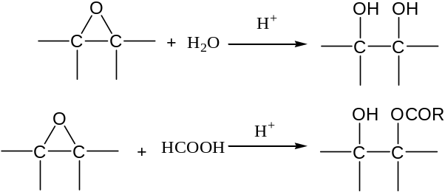

Figure 6. Side reaction of the epoxidation process

Figure 7. FTIR spectrum of (a) linoleic acid, (b) A3 (ring opening product)-hydrogen peroxide mole ratio, 3.0 and (c) A12 (epoxidized linoleic acid)-hydrogen peroxide mole ratio, 12.0. Condition for A3 and A12: linoleic acid, 2 g; formic acid to ethylenic unsaturation mole ratio, 2.0; temperature, 45 ºC; reaction time, 2 hours.

Fourier Transform Infrared (FTIR) Spectroscopy Analysis
The FTIR spectrometer was used to monitor the epoxidation reaction. The disappearance of double bond group peak at 3,009cm⁻¹ was demonstrated the conversion of double bond in linoleic acid to the epoxy group. Formation of epoxy group in the spectrum of fingerprint region was indicated by the peaks at 833 and 819 cm⁻¹. Vleck and Petrovic reported the presence of epoxy groups at 822 and 833 cm⁻¹ (doublet) which is well agrees with this study [26]. However, the hydroxyl peak at 3,412 and 1,072 cm⁻¹ were shown that oxirane ring cleavage was occurred in some conditions. To optimize the epoxidation reaction, the hydroxyl and double bond peak must be avoided to appear in FTIR spectrum.

NMR Spectrum Analysis
The comparison of ¹H and ¹³C NMR spectra between LA, ring cleavage product (A3) and epoxidized linoleic acid (A12) are show in Figure 8 and Figure 9. In Figure 8(a), the signal at 5.41-5.32 ppm (-CH=CH-) is corresponding to double bond peak in linoleic acid. We can clearly see a decrease of the peak area at 5.41-5.32 ppm (double bond), whereas new peaks are arising at 3.13-3.06 ppm and 3.00-2.96 ppm correspond to CH protons attached to the oxygen atoms of both the epoxy group in Figure 8(c). This result indicate that double bond in linoleic acid has been converted to epoxy group during epoxidation reaction. The appearance of a multiplet peak in 8.12-8.00 ppm region (HCOOC-) and disappearance peak at 3.13-2.96 ppm (–CHOCH–) is showing formation of new formate ester due to the ring cleavage by formic acid (Figure 8(b)).

As shown in Figure 9(a), the peaks at 130.21-129.73 ppm and 128.07-127.91 ppm are representing the double bond in linoleic acid. Compared to that of linoleic acid, the epoxy peaks in epoxidized linoleic acid were assigned at 57.30-57.02 ppm and 54.40-54.24 ppm. Moreover, the short peak at 132.74-123.74 ppm (correspond to double bond) also indicate the conversion of double bond in epoxidized linoleic acid compare with the linoleic acid spectrum. For the ¹³C NMR spectrum of ring cleavage product (A3), it shows only small amount of epoxy group has been form due to low signal intensity of epoxy peak (57.41-56.73 ppm and 54.47 ppm). The peak at 161.20-160.45 ppm has been attributed to carbon of new ester. Multiplet peak at 74.03-73.86 ppm and 65.77 ppm are the peaks of resulting by hydroxyl group. All these results show that formic acid was reacted with the epoxy group to produce an unwanted new ester in A3 product.

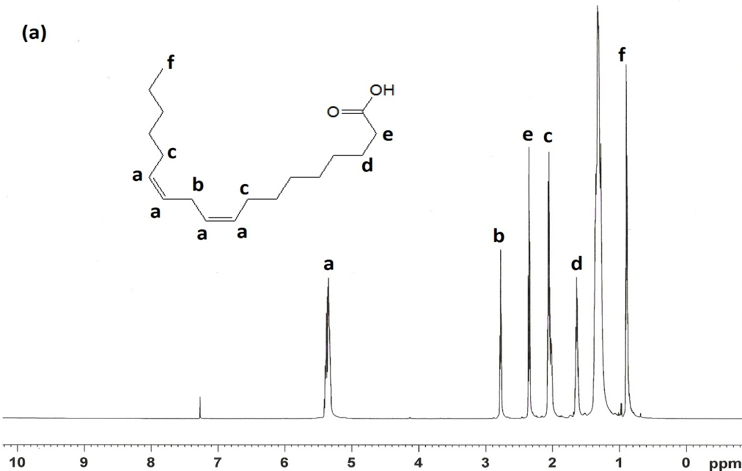
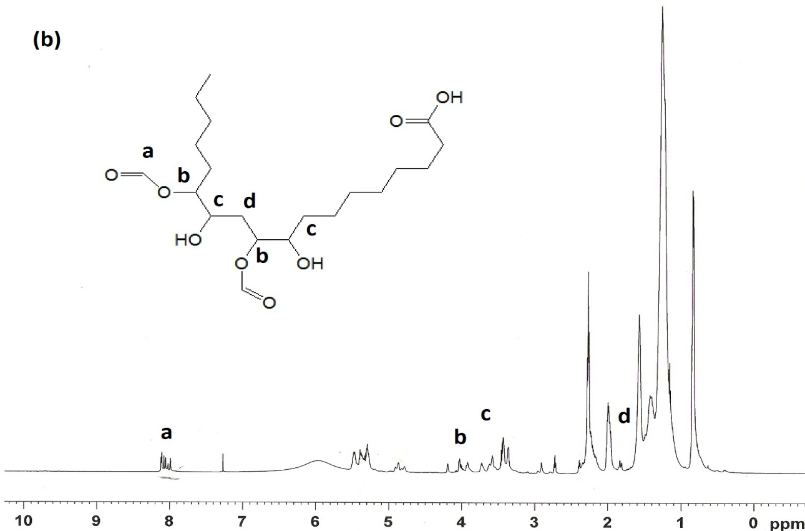

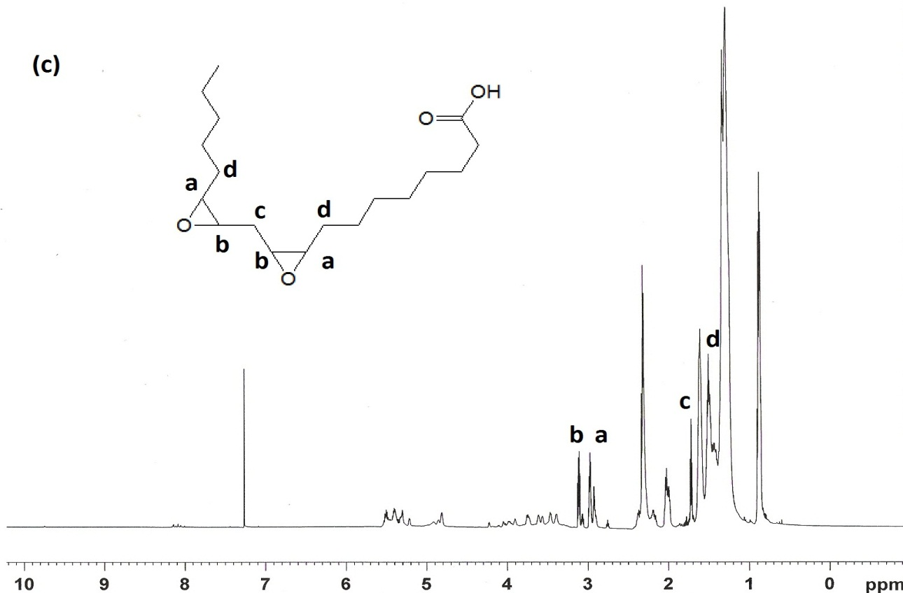

Figure 8. Spectrum ¹H-NMR for (a) linoleic acid (b) ring cleavage product (A3) and Epoxidized linoleic acid (A12)

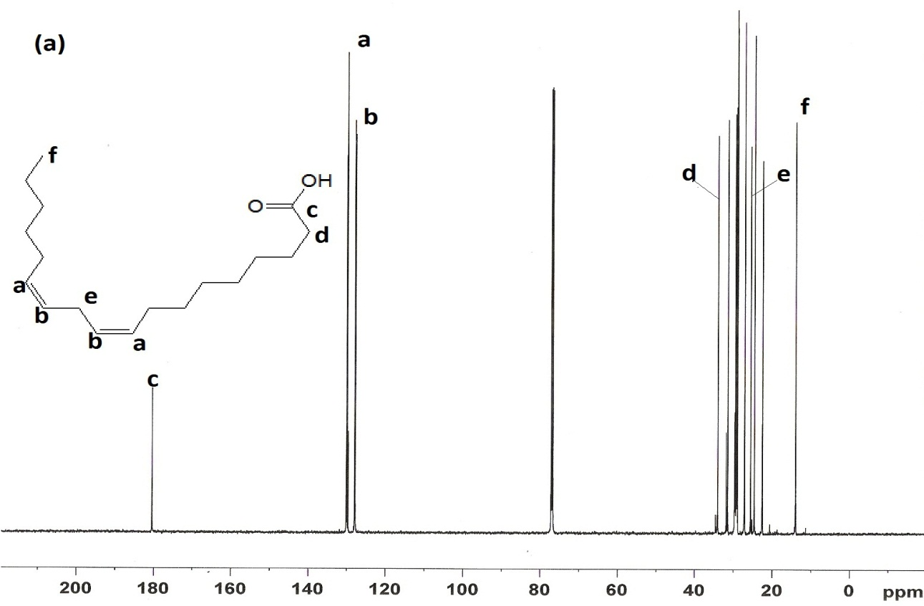

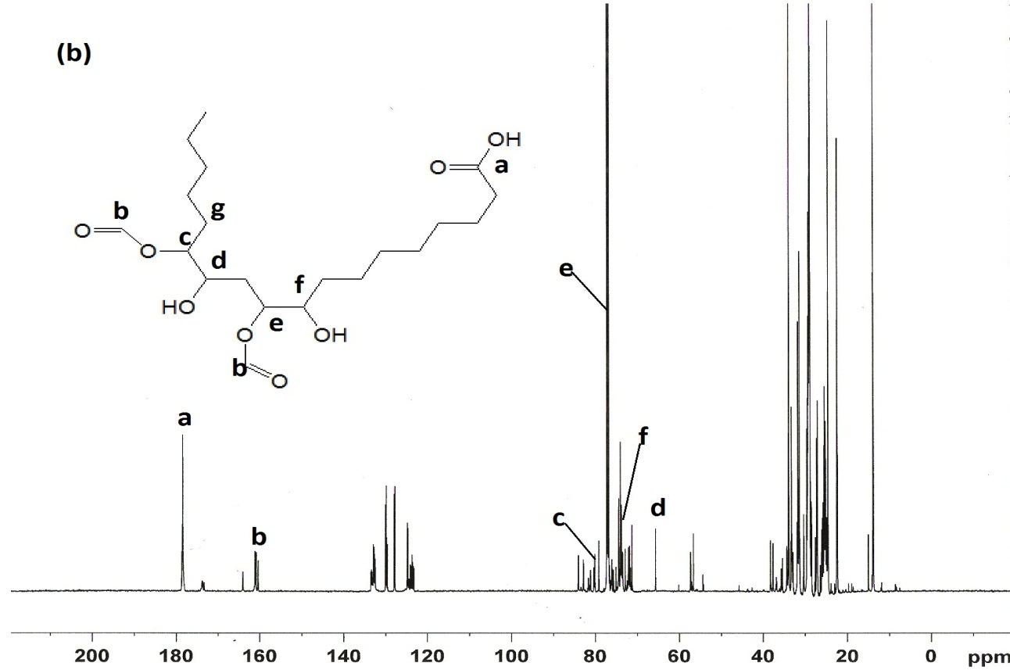

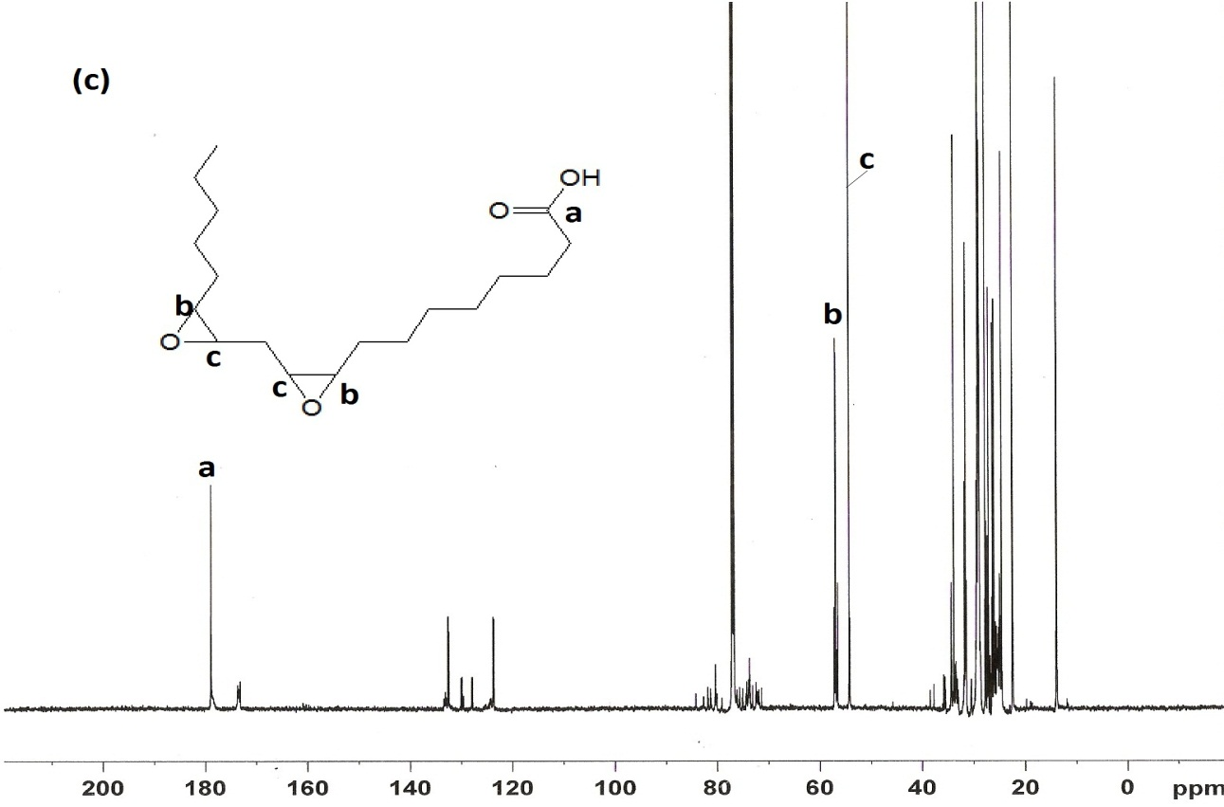

Figure 9. Spectrum ¹³C-NMR for (a) linoleic acid (b) ring cleavage product (A3) and Epoxidized linoleic acid (A12)

Conclusion
The epoxidation of linoleic acid of Jatropha curcus oil by using in situ generated performic acid was obtained at high relative conversion to oxirane and at low reaction temperature. It is clearly show that at low hydrogen peroxide mole ratio must be avoided to prevent the undesirable site reaction occurs during the epoxidation reaction. The higher formic acid mol per ethylenic unsaturation mole ratio was leading the reaction to the hydrolysis of oxirane ring.

Acknowledgement
The authors are gratefully acknowledged to Universiti Kebangsaan Malaysia for financial support for research grants DPP-2014-058, UKM-AP-2011-17 and UKM-AP-2012-017. The authors also thank the Ministry of Education Malaysia for providing Research Fellowships for the authors.

References
- No, S.Y. (2011). Inedible vegetable oils and their derivatives for alternative diesel fuels in CI engines: A review. Renewable and Sustainable Energy Reviews, 15: 131–149.
- Miao, S.D., Wang P, Su Z.G. and Zhang S.P. (2014). Vegetable-oil based polymers as future polymeric biomaterials. Acta Biomaterialia, 10: 1692–1704.
- Banković-Ilić, I.B., Stojković, I.J., Stamenković, O.S., Veljkovic, V.B. and Hung, Y.T. (2014). Waste animal fats as feedstocks for biodiesel production Renewable and Sustainable Energy Reviews, 32: 238–254.
- Kontkanen, H., Rokka, S., Kemppinen, A., Miettinen, H., Hellström, J., Kruus, K., Marnila, P., Alatossava, T. and Korhonen, H. (2011). Enzymatic and physical modification of milk fat: A review. International Dairy Journal, 21: 3-13.
- Gan, L.H., Ooi, K.S., Goh, S.H., Gan, L.M. and Leong, Y.C. (1995). Epoxidized ester of palm olein as plasticizer for poly(vinyl choride). European Polymer Journal, 81(8): 719-724
- Joseph, R., Alex, R., Vinod, V.S., Premalatha, C.K. and Kuriakose, B. (2003). Studied on epoxidized rubber seed oil as Plastizizer for acrylonitrile butadiene rubber. Journal of Applied Polymer Science, 89: 668-673.
- Chua, S.C., Xu, X.B. and Guo, Z. (2012). Emerging sustainable technology for epoxidation directed toward plant oil-based plasticizers. Process Biochemistry, 47: 1439–1451.
- Buisman, G.J.H., Overeem, A. and Cuperus, F.P. (1999). Synthesis of epoxidised novel fatty acids for use in paint application. Knothe G, Derksen JTP. Recent developments in the synthesis of fatty acid derivatives. AOCS Press, Champaign.
- Sharma, B.K., Adhvaryu, A., Liu, Z.S. and Erhan, S.Z. (2006). Chemical modification of vegetable oils for lubricants application. Journal of the American Oil Chemists' Society, 83: 129–136.
- Salimon, J., Salih, N. and Yousif, E. (2011). Chemically modified biolubricant basestocks from epoxidized oleic acid: Improved low temperature properties and oxidative stability. Journal of Saudi Chemical Society, 15: 195–201.
- Lathi, P.S. and Mattiasson, B. (2007). Green approach for the preparation of biodegradable lubricant base stock from epoxidised vegetable oil. Applied Catalysis B: Environmental, 69:207-212.
- Milchert, E. and Smagowicz, A. (2009). The influence of parameter on the epoxidation of rapeseed oil with peracetic acid. Journal of the American Oil Chemists' Society, 86:1227-1233.
- Meyer, P.P., Techaphattana, N., Manundawee, S., Sangkeaw, S., Junlakan, W. and Tongurai, C. (2008). Epoxidation of soybean and jatropha oil. Thammasat International Journal of Science and Technology, 13: 1-5.
- Goud, V.V., Pradhan, N.C. and Patwardhan, A.V. (2006). Epoxidation of Karanja (Pongamia glabra) oil by H₂O₂. Journal of the American Oil Chemists' Society, 83:635-640.
- Gound, V.V., Patwardhan, A.V. and Pradhan, N.C. (2005). Studies on the epoxidation of mahua oil (Madhumica indica) by hydrogen peroxide. Bioresource Technology, 97:1365-1371.
- Dinda, S., Patwardhan, A.V., Goud, V.V. and Pradhan, N.C. (2008). Epoxidation of cottonseed oil by aqueous hydrogen peroxide catalyzed by liquid inorganic acids. Bioresource Technology, 99: 3737-3744.
- Mungroo, R., Pradhan, N.C., Goud, V.V. and Dalai, A.K. (2008). Epoxidation of canola oil with hydrogen peroxide catalyzed by acidic ion exchange resin. Journal of the American Oil Chemists' Society, 85:887-896.
- Findley, T.W., Swern, D. and Scanlan, J.T. (1945). Epoxidation of unsaturated fatty materials with peracetic acid in glacial acetic acid solution. Journal of the American Oil Chemists' Society, 67:412–414.
- Daniel. L., Ardiyanti, A.R., Schuur, B., Manurung, R., Broekhuis, A.A. and Heeres, H.J. (2011). Synthesis and properties of highly branched Jatropha curcas L. oil derivatives. European Journal of Lipid Science and Technology, 113: 18–30.
- Gan, L.H., Goh, S.H. and Ooi, K.S. (1992). Kinetics studies of epoxidation and oxirane cleavage of palm olein methyl esters. Journal of the American Oil Chemists' Society, 69: 347–351.
- Petrovic, Z.S., Zlatanic, A., Lava, C.C. and Sinadinovic-fise, S. (2002). Epoxidation of soya bean oil in toluene with peroxoacetic acid and peroxoformic acids-kinetics and side reactions. European Journal of Lipid Science and Technology, 104(5):293-299.
- American Oil Chemists’ Society. (1997). Oxirane Oxygen: AOCS Cd 9-57, Champaing,lL, 1-2.
- Campanella, A., Rustoy, E., Baldessari, A. and Baltanás, A. (2010). Lubricants from chemically modiﬁed vegetable oils. Bioresource Technology, 101: 245–254.
- Cai, S.F. and Wang, L.S. (2011). Epoxidation of Unsaturated Fatty Acid Methyl Esters in the Presence of SO₃H-functional Brønsted Acidic Ionic Liquid as Catalyst. Chinese Journal of Chemical Engineering, 9(1): 57—63.
- Chua, S.C., Xu, X.B. and Guo, Z. (2012). Emerging sustainable technology for epoxidation directed toward plant oil-based plasticizers. Process Biochemistry, 47: 1439–1451.
- Vlcek, T. and Petrovic, Z.S. (2006). Optimization of the chemoenzymatic epoxidation of soybean oil. Journal of the American Oil Chemists' Society, 83:247–252.

