PRODUCTION OF HYPERBRANCHED NONAOLEATE TRIMETHYLPROPANE FOR BIOLUBRICANTS BASESTOCK

(Penghasilan Trimetilopropana Nonaoleat Hipercabang untuk Minyak Asas Biolubrikan)

Salma Samidin, Nadia Salih and Jumat Salimon*

School of chemical sciences and Food Technology, Faculty of Science and Technology, Universiti Kebangsaan Malaysia,
43600 Bangi, Selangor, Malaysia.

*corresponding author: jumat@ukm.edu.my
Abstract
In this study, trioleate trimethylolpropane was successfully converted into hyperbranched nonaoleate trimethylolpropane via epoxidation with formic acid and hydrogen peroxide followed by the esterification via the oxirane ring opening reaction with oleic acids (OA). Sulphuric acid (SA) was found to be an effective catalyst compared to paratoluene sulfonic acid (PTSA) in the reaction of oxirane ring opening. High yield was obtained at 95%. Structure elucidation of the functional ester groups in hyperbranched product was confirmed by Fourier Transform Infrared (FTIR) and Nuclear Magnetic Resonance (NMR), ¹H and ¹³C spectroscopy studies.

Keywords: Biolubricants, hiperbranch, modification, FTIR, NMR,

Abstrak
Dalam kajian ini, trimetilolpropana trioleat telah berjaya ditukarkan kepada hipercabang trimetilolpropana nonaoleat melalui tindak balas pengepoksidaan dengan asid formic dan hydrogen peroksida diikuti dengan tindak balas pengesteran melalui tindak balas pembukaan gelang oksirana dengan asid oleik (OA). Hasil kajian menunjukkan penggunaan asid sulfurik (SA) lebih berkesan sebagai mangkin berbanding dengan asid para toluena sulfonik (PTSA) dalam tindak balas pembukaan gelang oksirana. Peratusan hasil yang tinggi diperolehi pada 95%. Pencirian struktur kumpulan berfungsi ester dalam produk hipercabang ditentusahkan melalui kajian spektroskopi Fourier Transfomasi Inframerah (FTIR) dan ¹H dan ¹³C Resonans Magnet Nukleus (NMR).

Kata kunci: Biolubrikan, hipercabang, modifikasi, FTIR, NMR,

Introduction
Today, it is a growing concern about the future availability of petroleum-based lubricants [1]. However, the raw materials from petroleum have low performance in toxicity, and their application reduced the quality of the air, water and the environment [2]. The wastes from lubricants due to leakage and exhaust gas without any treatment affect the environmental quality. The lubricant’s performance is evaluated by their friction reduction, oxidation resistance, deposits formation minimization, corrosion and wear avoiding abilities.

The main problem with lubricants is related to the oil degradation and its contamination by the engine consumption by-products which are causing the engine bad in working and their application. The deposit formation occurs when the dispersion power of the lubricant is not enough to keep the contaminants in suspension. Formation of oil thickness results from the lubricant oxidation and insoluble material accumulation will cause the flow ability of lubricant low. Furthermore, the formation of oxidation compounds polymerization and the insoluble products in suspension will increase the viscosity of the lubricant that is derived from the irregular fuel burning [3]. To avoid this attack and to minimize such problem, modification of lubricants with the addition of additives of antioxidants, anti-wear and other functions should be obtained.

There are many researchers now days in order to produce better lubricants. The main option to produce better lubricants was by using raw materials that are renewable and product that is biodegradable. Raw materials from vegetable oil have been used and produced in many research, but their performance in lubricity was limited to high temperature due to low oxidative stability [4] and low flow ability due to low pour point [5]. This was because of the structure molecule which was the double bond of the vegetable oil, and the β-CH of the glycerol will lower their melting point and introduce instability and cause the oxygen attack especially for the typical polyunsaturated fatty acids. Double bonds are especially reactive and react immediately with the air oxygen while the hydrogen β atom is easily eliminated from the molecular structure. This weak point will produce olefins and acids due to the breakage of ester. A weak point of esters also is its trend to undergo hydrolysis in the presence of water. Therefore, chemical modification can reduce this weakness through reduction of microbial metabolisms or degradability [1]. The modification was through the addition of branching position to the double bond, molecular saturation degree and increased the ester molecular weight. With increasing the ester group on the lubricant, will decrease the volatility and increase the flash point. This is due to the strong dipole moment or London forces that keep the ester molecules together.

The chemical modification of lubricants through opening the oxirane ring has been done by several researches. Several researchers have been modified the epoxidized soybean oil for lubricant formulations with improved oxidative stability and low pour point through opening the oxirane ring with alcohol in the acid medium chain. In addition, further reaction with short chain acid anhydride in pyridine to obtain a heavily transesterified product where unsaturation have been substituted by vicinal ether-ester groups [6]. Erhan et al. [7, 8], have been prepared the processes for the preparation of fatty acid esters, wherein the unsaturation of the fatty acid have been functionalized by symmetric ester groups which is both vicinal esters have the same alkyl chain. The ring opening was done through the reaction with water to obtain a vicinal diol which is further reacted with an acid anhydride in pyridine. The other process in [8] was directly performed the oxirane ring opening in the presence of an acid anhydride and boron trifluoride etherate. Both processes yield fatty acid esters which are the olefins of the fatty acid have been functionalized by symmetric ester groups by the reaction of acid anhydride. However, the dangerous and toxic chemical such as pyridine makes the process troublesome for industrial application. Using pyridine in the process results in a product with ether substitutions, which is prone to forming hydrogen bonds and retaining moisture in the product.

Furthermore, the opening of the oxirane ring of the epoxidized fatty acid ester by reaction with carboxylic acid rendering the vicinal alcohol, and it will also give high content of free hydroxyl groups making it prone to the formation of intramolecular and intermolecular hydrogen bonds as well as water, adding moisture to the oil products. This moisture will affect the properties of oil when heating and directly affect the stability properties. Nonpolar interactions could also happen via the absorption of moisture, causing an undesirable effect that moisture could evaporate when temperature rise in applied, thus changing suddenly the properties of the oily product. Plus, the presence of moisture also can cause undesirable ester hydrolysis and metal corrosion. Through modification at the unsaturation of fatty acid chain by adding branching degrees of fatty acids to the double bond allows to modulate the fluid properties such as viscosity, pour point and oxidative stability.

A known process has been done to modify the double bond of fatty acids by attaining intermediate branching degrees by fixing one of the esters and then varying the second ester chain. Therefore in this paper, we reported the yield of product with intermediate symmetrical branching degrees to the vicinal ester groups by using sulphuric acid (SA) as a catalyst and oleic acid (OA) as nucleophiles in opening the oxirane ring of the epoxide to produce hyperbranched nonaoleate trimethylolpropane.

Materials and Methods
Materials
Trimethylolpropane (TMP) 97% (Sigma Aldrich) and oleic acid 90% were obtained from Aldrich (Merck, Germany). Formic acids 88% was obtained from Fisher Scientific (Pittsburgh, PA, USA) and hydrogen peroxide 30% was Merck, Germany.
Esterification Preparation
About 20 g of TMP and 100 g of oleic acid were both added to the 3 neck glass reactor completed with a magnetic stirrer and temperature on silicon oil heated to the hot plate at desired temperature. 1.5% sulphuric acid was added to the mixture as a catalyst and heated to 150°C for 5 hours. Toluene (100 mL) was added to the mixture of reaction as azeotrope agent. The flask mouth was fitted with a Dean-Stark cap in order to carry out the azeotropic distillation of water-toluene. Samples were extracted using ethyl acetate and wash with brine solution before drying with anhydrous sodium sulphate. Trioleate trimethylolpropane was dried using a vacuum rotary evaporator at 70°C and was analyzed by FTIR for the formation of functional groups intended.
Epoxidation Reaction
The epoxidation reactions were carried out with some modifications. Double bond equivalent (moles of unsaturation per gram of oil) was calculated for oils using respective iodine values. After optimizations had been done, the molar ratio between moles of double bonds to HCOOH to H₂O₂ peroxide was kept at 1:5:6 respectively. The reaction had undergone an isothermal studied; 15 g trioleate trimethylolpropane was added to the three neck flask with formic acid 88% equipped with a magnetic stirrer and a thermometer and heat for 3.5 hours. Hydrogen peroxide 30% was added slowly into the stirrer solution drop by drop about 60 minutes in total and the reaction was held at constant temperature and under stirring for several hours. At the end of the reaction, the product was extracted with ethyl acetate and the aqueous was eliminated, and the organic phase was then thoroughly washed with 5% NaHCO₃ and 5% saturated NaCl to neutral the acidity to pH 7 and dried with anhydrous sodium sulfate for a night. The end of the epoxidized product of oil was isolated by rotary evaporation to remove the solvent used at 40°C.

Oxirane Ring Opening
The oxirane ring opening reaction was carried out using oleic acid 90% as nucleophilic reagents and sulphuric acid (SA) as a catalyst to prepared modified hyperbranched nonaoleate trimethylolpropane. SA was added to the mixture of epoxidized oil (5g) and oleic acid 90% (2-5g). The mixture was heated with stirring 900 rpm at 120°C for 3-5 hours. When the reaction was complete, the products were purified with a base solution [9]. The organic layer was dried over anhydrous sodium sulfate, filter and the solvent was removed using a vacuum evaporator to give the desired product.

Instrumentation
The fourier transform infrared (FTIR) spectra were recorded on a Perkin Elmer GX FTIR Spectrophotometer (USA). The ¹H- and ¹³C spectra were recorded on a JEOL JNM-ECP 400 FTIR spectrometer (400MHz ¹H/100.61MHz ¹³C) using CDCl₃ as a solvent in all experiments.
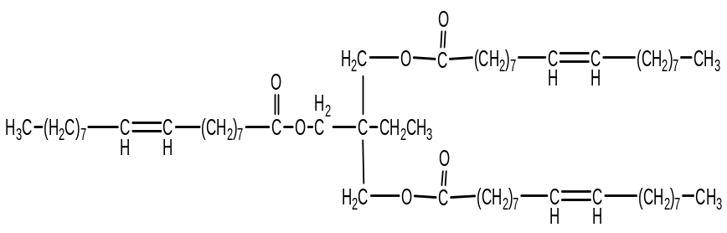
(A)
HCOOH/H₂O₂

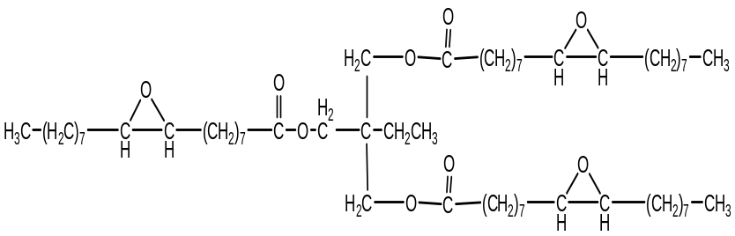
(B)
Oleic acid 90%

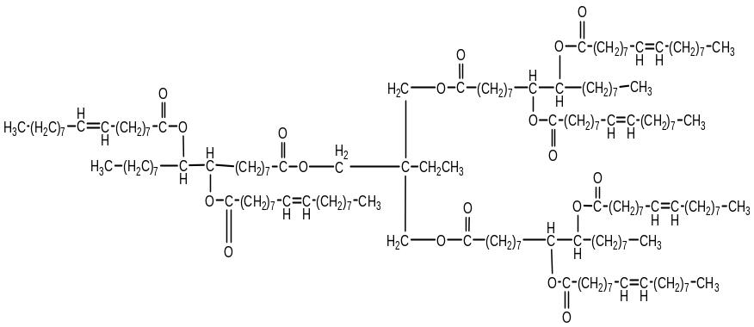
(C)
Figure 1. Reaction scheme for the formation of biolubricants basestock.

Results and Discussion
Synthesis
The synthesis of hyperbranched containing nonaoleate within the trimethylolpropane derivatives was outlined in Figure 1, with the esterification of TMP with oleic acid to yield trioleate trimethylolpropane, TOTMP (compound A). The reaction was done with the epoxidation of TOTMP to yield epoxidized trioleate trimethylolpropane, ETOTMP (compound B) followed by ring opening using oleic acid (1:1) and sulphuric acid which acts as a catalyst to yield nonaoleate trimethylolpropane, NOTMP (compound C) with 95% (w/w) yield obtained (Equation 1). The data obtained are shown in Table 1. The addition of branched to the core compound with a modification via epoxidation and the opening of the oxirane ring with sulfuric acid as a catalyst has been done.

Yield (%) =$\frac{mass of reactant consumed}{mass of reactant supplied }×100\%$ (1)

Table 1. The esterification optimization of the ring opening process

ID sample | Temperature (°C) | Ratio | Time(hr) | Catalyst H₂SO₄ (%) | Weight of epoxide oil(g) |  | Mass of oleic acid (g) | Mass of product obtained (g) | Percentage yield (%)
Or10 | 120 | 1:1 | 5 | 1.5 | 10.2 | 5.06 |  | 11.08 | 72
Or11 | 120 | 1:1 | 4 | 1.5 | 5.16 | 2.72 |  | 7.51 | 95
Or12 | 120 | 1:1 | 3 | 1.5 | 5.09 | 2.72 |  | 3.70 | 47
Or13 | 120 | 1:2 | 5 | 1.5 | 5.03 | 5.66 |  | 5.45 | 51
Or14 | 120 | 1:2 | 4 | 1.5 | 5.21 | 5.67 |  | 3.23 | 29
Or15 | 120 | 1:2 | 3 | 1.5 | 5.12 | 5.70 |  | 1.81 | 17

The opening oxirane ring reaction catalysed by PTSA has been reported [10]. To ensure the purity of the product (compound C), several steps were made. The process of esterification was catalyzed by H₂SO₄. Some of the acid was left unreacted and then neutralized by NaHCO₃. An excess of oleic acids were removed by ethanol and dried with sodium sulfate. The solvent was removed under reduced pressure. In this paper, sulphuric acid has been used as a catalyst. The data has shown that the oleic acid directly attached as an ester to the carbon position n9 and n10 after the oxirane ring opening of the compound B with no hydroxyl group has been formed. The detailed synthesis pathway and final products characterized using FTIR and ¹H and ¹³C NMR spectroscopies are discussed in this paper.
FTIR Spectra
The FTIR spectroscopy is a rapid technique and important for applying to any product lipids determinations in order to know the presents of the functional groups via characteristic absorption bands in the infrared region of the electromagnetic spectrum. The FTIR spectra of oleic acid and TMP show a C=O stretching band at 1710 and 1658 cm⁻¹ respectively. While after several modification reaction was done, compound A, B, and C show a C=O stretching band at 1744, 1743, and 1741 cm⁻¹ indicating the ester (C=O) functional groups. In the FTIR spectrum of epoxidized trioleate trimethylolpropane (compound B), C-H sp³ stretch is observed at 2856-2926 cm⁻¹, C-O-C from oxirane ring vibration appears at 824 cm⁻¹ and disappear after the opening ring oxirane by esterification with oleic acids. Some characteristic data are shown at Table 2. Figure 2 shows the comparison of spectra compound A and B. Meanwhile, Figure 3 shows the comparison of FTIR between ring opening reaction of compound B by using SA and PTSA as a catalyst. From spectra we found that, SA showed more effective in catalytic activity compared to the PTSA. The excess oleic acids continuously react to the second hydroxyl due to the strain of sulphuric acid. This confirmed by FTIR spectra that indicated no formation of OH groups. The benefit of sulphuric acid in esterification is that it acts as a proton donor, increasing the rate of reaction between an acid and the alcohol [10].

Compound | ν(C=C) | ν (C=O) | ν (C-H) aliphatic | ν (COC)
A | 3004 | 1744 | 2925, 2855 | -
B | - | 1743 | 2966,2855 | 824
C | 3003 | 1741 | 2926,2855 | -

Table 2. The main FTIR spectrum peaks for compound A, B and C

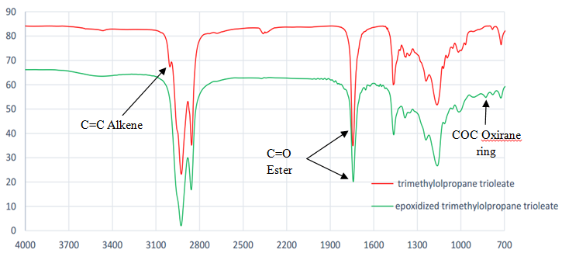

Figure 2. FTIR spectrum for compound A and B
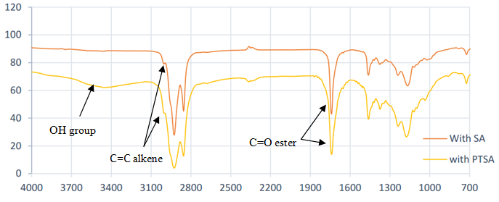
Figure 3. The FTIR spectrum of compound C catalysed by SA and PTSA

NMR Spectroscopy
The signals of compound B at 2.76 ppm correspond to protons on the oxirane ring (-CHOCH-), while formations of new signal 1.48 ppm and 1.51 ppm correspond to allylic epoxy protons (-CH₂CHOCH-CH₂) which were totally absent in compound A. From ¹H NMR spectra also show the disappearance of olefin protons at 5.3 ppm (CH₂=CH₂) and allylic protons at 1.9 ppm and 2.0 ppm (-CH₂-CH=CH-CH₂). The ¹³C NMR spectra of trioleate trimethylolpropane and its epoxidised derivatives indicate the disappearance of chemical shifts olefin at 129.7 ppm and 130.0 ppm. By comparing the spectra, the chemical shifts of carbon atoms of epoxy (COC) were readily visible at 57.03 ppm and 57.08 ppm and subsequently allylic carbons (-CH₂-CHOCH-CH₂) at 27.7 ppm and 27.8 ppm respectively. This confirmed the conversion of the double bonds to oxirane rings via epoxidation. Furthermore, the proton signals of hydroxyl and formate group not observed in both spectra epoxidised and unepoxidised trioleate trimethylolpropane which indicating no formation of side reaction during the main reaction.

For a signal ¹H NMR of ring opening the oxirane (nonaoleate trimethylolpropane) showed signals at chemical shift 5.31 ppm which indicated the presence of the alkene of oleic acid after reaction of opening ring with oleic acids. Disappearance of signal 2.76 ppm for proton oxirane ring (-CHOCH-) shows the conversion of oxirane to ring opening success.

Meanwhile, ¹³C NMR spectra of nonaoleate trimethylolpropane derivatives indicate the appearance of chemical shifts olefin (CH=CH) at 129.7 ppm and 130.2 ppm and invisible (COC) oxirane ring at signal 57.03 ppm and 57.08 ppm. Furthermore, the ¹H and ¹³C NMR spectra also no signals of the hydroxyl group which attach to the olefin or epoxide ring after reaction were done and this indicated the success of conversion to hyperbranched nonaoleate trimethylolpropane.
Table 3. The main signal presence in ¹H NMR and ¹³C NMR spectra for compound A, B and C

Compounds | Multiplet report
A | ¹H NMR (400 MHz, CHLOROFORM-d)  δ ppm 0.76 - 0.86 (m, 4 H) 1.25 (d, 23 H) 1.37 - 1.46 (m, 1 H) 1.49 - 1.59 (m, 2 H) 1.79 - 2.02 (m, 4 H) 2.10 - 2.33 (m, 2 H) 3.82 - 4.05 (m, 2 H) 5.17 - 5.40 (m, 2 H)  ¹³C NMR (101 MHz, CHLOROFORM-d)  δ ppm 7.37 (s, 1 C) 14.12 (s, 1 C) 22.72 (s, 1 C) 24.94 (s, 1 C) 27.19 (s, 1 C) 27.24 (s, 1 C) 29.15 (s, 1 C) 29.20 (s, 1 C) 29.37 (s, 1 C) 29.57 (s, 1 C) 29.73 (s, 1 C) 29.80 (s, 1 C) 31.95 (s, 1 C) 32.64 (s, 1 C) 34.17 (s, 1 C) 40.65 (s, 1 C) 63.64 (s, 1 C) 129.53 (s, 1 C) 129.65 (s, 1 C) 129.92 (s, 1 C) 173.18 (s, 1 C) 173.26 (s, 1 C) 173.28 (s, 1 C)
B | ¹H NMR (400 MHz, CHLOROFORM-d)  δ ppm 0.71 - 0.82 (m, 4 H) 1.08 - 1.44 (m, 28 H) 1.45 - 1.55 (m, 2 H) 2.19 (t, 2 H) 2.77 (s, 2 H) 3.90 (s, 2 H)  ¹³C NMR (101 MHz, CHLOROFORM-d)  δ ppm 7.35 (s, 1 C) 14.08 (s, 1 C) 22.65 (s, 1 C) 24.84 (s, 1 C) 26.57 (s, 1 C) 26.61 (s, 1 C) 27.78 (s, 1 C) 27.82 (s, 1 C) 29.01 (s, 1 C) 29.16 (s, 1 C) 29.21 (s, 1 C) 29.32 (s, 1 C) 29.52 (s, 1 C) 31.84 (s, 1 C) 34.11 (s, 1 C) 40.61 (s, 1 C) 57.07 (s, 1 C) 57.04 (s, 1 C) 57.09 (s, 1 C) 63.61 (s, 1 C) 173.21 (s, 1 C) 173.26 (s, 1 C) 173.28 (s, 1 C)
C | ¹H NMR (400 MHz, CHLOROFORM-d)  δ ppm 0.84 (t, 30 H) 0.95 - 1.75 (m, 222 H) 1.82 - 2.06 (m, 20 H) 2.11 - 2.42 (m, 20 H) 3.98 (s, 12 H) 5.09 - 5.53 (m, 4 H)  ¹³C NMR (101 MHz, CHLOROFORM-d)  δ ppm 7.42 (s, 1 C) 14.17 (s, 1 C) 14.30 (s, 1 C) 22.63 (s, 1 C) 22.74 (s, 1 C) 22.90 (s, 1 C) 23.07 (s, 1 C) 23.80 (s, 1 C) 23.86 (s, 1 C) 23.94 (s, 1 C) 24.79 (s, 1 C) 24.97 (s, 1 C) 25.06 (s, 1 C) 25.15 (s, 1 C) 25.21 (s, 1 C) 25.38 (s, 1 C) 25.59 (s, 1 C) 25.68 (s, 1 C) 27.23 (s, 1 C) 27.27 (s, 1 C) 28.79 (s, 1 C) 29.02 (s, 1 C) 29.06 (br. s., 1 C) 29.18 (s, 1 C) 29.22 (s, 1 C) 29.33 (s, 1 C) 29.38 (s, 1 C) 29.49 (s, 1 C) 29.59 (s, 1 C) 29.67 (s, 1 C) 29.71 (s, 1 C) 29.76 (s, 1 C) 29.83 (s, 1 C) 31.81 (s, 1 C) 31.97 (s, 1 C) 32.56 (s, 1 C) 32.66 (s, 1 C) 33.95 (s, 1 C) 34.07 (s, 1 C) 34.25 (s, 1 C) 34.43 (s, 1 C) 34.50 (s, 1 C) 34.76 (s, 1 C) 40.66 (s, 1 C) 42.75 (s, 1 C) 42.79 (s, 1 C) 42.88 (s, 1 C) 60.19 (s, 1 C) 63.73 (s, 1 C) 129.75 (s, 1 C) 130.02 (s, 1 C) 130.21 (s, 1 C) 130.29 (s, 1 C) 130.45 (s, 1 C) 130.50 (s, 1 C) 173.37 (s, 1 C) 173.43 (s, 1 C) 173.49 (s, 1 C)

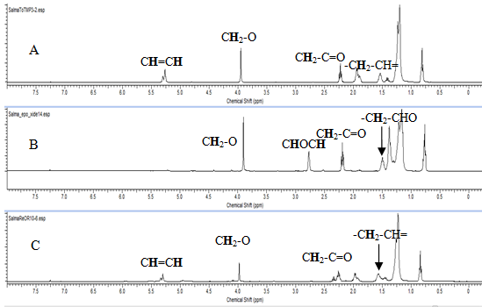
Figure 4. The ¹H NMR spectrum for compounds A, B and C

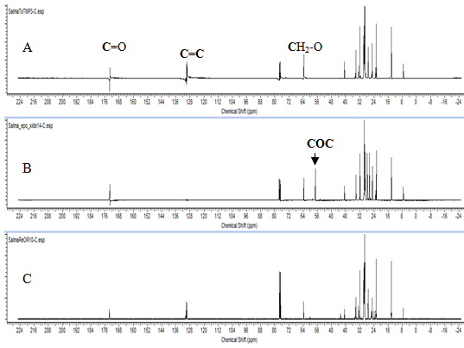
Figure 5. The ¹³C NMR comparison for Compounds A, B and C
Conclusions
Production hyperbranched nonaoleate trimethylolpropane was successfully synthesized by esterification with oleic acid with high yield percentage in shortest reaction time. The result showed that by using sulphuric acid can directly transform the epoxide to fully ester with no formation of the hydroxyl group.

Acknowledgement
The author acknowledges the Universiti Kebangsaan Malaysia for funding grant no. DPP-2014-058, UKM-AP-2011-17 and also direct contributions of the support staff from the School of Chemical Sciences and Food Technology, the Faculty of Science and Technology, Universiti Kebangsaan Malaysia and Ministry of Higher Education (MyBrain15).
References
- André, J. (2001). Biodegradable Lubricants and Their Production Via Chemical Catalysis pp 185 -201.
- Amit, K.J and Amit, S. (2012). “Research Approach & Prospects of Non Edible Vegetable Oil as a Potential Resource for Biolubricant - A Review. Advanced Enggeneering and Applied Sciences, 1(1):23-32
- Naidir, F., Yunus, R., Idaty, T., Ghazi, M. and Ramli, I. (2012). Synthesis of Epoxidized Palm Oil-Based Trimethylolpropane Ester. Science & Technology Journal. 20(2), 331–337.
- Naidir, F., Yunus, R., Rashid, U., Masood, H., Ghazi, T. I. M. and Ramli, I. (2012). The kinetics of epoxidation of trimethylolpropane ester. European Journal of Lipid Science and Technology, 114(7), 816–822.
- Kulkarni, R. D., Deshpande, P. S., Mahajan, S. U. and Mahulikar, P. P. (2013). Epoxidation of mustard oil and ring opening with 2-ethylhexanol for biolubricants with enhanced thermo-oxidative and cold flow characteristics. Industrial Crops and Products, 49, 586–592.
- Hwang, H.-S. and Erhan, S. Z. (2001). Modification of epoxidized soybean oil for lubricant formulations with improved oxidative stability and low pour point. Journal of the American Oil Chemists’ Society, 78(12), 1179–1184.
- Erhan, S. Z., Adhvaryu, A. and Liu, Z. (2003). Chemical Modification of Vegetable Oils for Lubricant Basestocks. Design, Application, Performance and Emissions of Modern Internal Combustion Engine Systems and Components, pp 369–380.
- Erhan, S. Z., Sharma, B. K., Liu, Z. and Adhvaryu, A. (2008). Lubricant base stock potential of chemically modified vegetable oils. Journal of Agricultural and Food Chemistry, 56(19), 8919–25.
- Aqueous, S. & Protocol, W. (n.d.). 8.4 - Extraction and Washing Guide 61–64.
- Salimon, J., Abdullah, B. M., Yusop, R. M., Salih, N. and Yousif, E. (2013). Synthesis and optimization ring opening of monoepoxide linoleic acid using p-toluenesulfonic acid. SpringerPlus, 2(1), 429.

