FORMULATION AND PHYSICAL CHARACTERIZATION OF MICROEMULSIONS BASED CARBOXYMETHYL CELLULOSE AS VITAMIN C CARRIER

(Formulasi dan Sifat Fizikal Mikroemulsi Berasaskan Karboksimetil Selulosa sebagai Pembawa Vitamin C)

Suria Ramli¹*, Safiah Mohd Ja’afar¹, Muhd Asri Abd Sisak¹, Norhidayu Zainuddin¹ and Irman Abdul Rahman²

¹School of Chemical Sciences and Food Technology,
²School of Applied Physics,
Faculty of Science and Technology,Universiti Kebangsaan Malaysia, 43600 Bangi, Selangor, Malaysia

*Corresponding author: su_ramli@ukm.edu.my

Abstract

The main purpose of this research is to develop a cellulose derivative based microemulsion for transdermal delivery system. In this research, cellulose derivative used is carboxymethyl cellulose (CMC) that was converted from cellulose by etherification reaction and analysed by FTIR instrument. The degree of substitution (DS) for carboxymethyl cellulose is 0.492. Microemulsion system consists of oleic acid as oil phase, Tween 20 as surfactant and propylene glycol as co-surfactant. The active ingredient used in this system is vitamin C. Determination of microemulsion area in the ternary phase diagram was done by titration method. From the result, microemulsion system with surfactant/co-surfactant ratio (K_{m}=3:1) produced the largest surface area in the ternary phase diagram. Microemulsions with and without vitamin C and CMC were characterized using dynamic light scattering (DLS), electrical conductivity and rheometer. For size particle analysis, system without vitamin C and CMC have microemulsion droplet size between 20-200 nm. Based on the electrical conductivity and viscosity test, phase transition occurred in the microemulsion system from water-in-oil (w/o) to bicontinuos phase at 20 wt. % water percentage. The stability test showed microemulsion systems with the percentage of water up to 30 wt. % were stable at temperatures 4 °C, 25 °C and 40 °C upon three weeks storage.

Keywords: Microemulsions, carboxymethyl cellulose, vitamin C, ternary phase diagram

Abstrak

Tujuan penyelidikan ini dijalankan adalah untuk menghasilkan sistem mikroemulsi berasaskan terbitan selulosa bagi sistem penghantaran transdermal. Dalam kajian ini, terbitan selulosa yang digunakan dalam sistem mikroemulsi adalah karboksimetil selulosa (CMC) yang dihasilkan melalui tindak balas pengeteran selulosa dan dicirikan menggunakan instrumen FTIR. Darjah penggantian (DS) bagi selulosa karboksimetil adalah sebanyak 0.492. Penghasilan sistem mikroemulsi pula terdiri daripada asid oleik sebagai fasa minyak, Tween 20 sebagai surfaktan dan propilena glikol sebagai ko-surfaktan. Bahan aktif yang dimuat dalam sistem mikroemulsi adalah vitamin C. Rajah fasa ternari dibina bagi menentukan rantau pembentukan mikroemulsi dengan menggunakan kaedah penitratan air. Hasil kajian menunjukkan sistem mikroemulsi dengan nisbah surfaktan/ko-surfaktan (K_{m}=3.1) membentuk rantau mikroemulsi yang paling luas dalam rajah fasa ternari. Mikroemulsi dengan dan tanpa vitamin C dan CMC telah dicirikan menggunakan serakan cahaya dinamik (DLS), konduktiviti elektrik dan reometer. Bagi analisis saiz partikel, sistem tanpa penambahan vitamin C dan CMC berada dalam sistem julat mikroemulsi iaitu antara 20-200 nm. Ujian konduktiviti dan kelikatan menunjukkan terdapat perubahan fasa mikroemulsi daripada fasa air-dalam-minyak (w/o) kepada fasa dwiselanjar pada peratusan air 20 wt. %. Mikroemulsi yang dihasilkan bagi keempat-empat sistem kekal jernih dan stabil selama tiga minggu pada peratusan air sehingga 30 wt. % pada suhu 4 °C, 25 °C dan 40 °C.

Kata kunci: Mikroemulsi, karboksimetil selulosa, vitamin C, rajah fasa ternari

Introduction

Pharmaceutical studies are conducted to transmit the active ingredients or drugs to the target organs while reducing side effects and discomfort to the patients [1]. Nowadays, users prefer on medication-based transmission medium that can provide a quick effect, easy and reduce side effects to the patients [2].

In the last two decades, microemulsion received an attention as a system that could improve drug delivery system because of its properties of interest [3]. Microemulsion is a single system that is transparent and optically isotropic phase consisting of oil, water and surfactants. It is seen as an ideal system for the delivery of active ingredients due to thermodynamically stable, low viscosity, easy to manufacture and has a small range of droplet sizes [3, 4]. Due to small size of droplet (20-200nm), microemulsion is able to enhance the penetration and absorption of drug or active ingredient into the skin. Besides that, microemulsion system could provide a higher degree of solubility of lipophilic and hydrophilic active ingredients and prevent them from degraded [5].

Cellulose is a biopolymer that is abundant in natural resources with formula (C₆H₁₀O₅)_{n}. Since cellulose is not water soluble, it should be modified to enable it to be applied in the industry as a thickener, a gel agent or a stabilizing agent [6]. To make water soluble cellulose, cellulose has to be modified through etherification process and will produce cellulose derivatives such as carboxymethyl cellulose (CMC), methyl cellulose (MC), hydroxypropyl cellulose (HPC) and hydroxypropyl methyl cellulose (HPMC). Carboxymethyl cellulose (CMC) used in this study is a cellulose ether derivative which is soluble in water and applied a lot in food, cosmetics, pharmaceuticals and detergent [7]. In pharmaceuticals, cellulose ether derivative is a type of polymer that popular and widely used for the formulation of the active ingredient in the form of dosage and pharmaceutical products. This derivative plays a big role in many types of pharmaceutical functions such as controlled-release (CR), sustained-released (SR) and enteric-coated (EC) [8, 9].

Vitamin C, in the form of L-ascorbic acid, is water soluble, an antioxidant and able to regulate the production of collagen in the skin. In addition, vitamin C can help the formation of stratum corneum barrier lipids where vitamin C acts to normalize the lipid profile epidermis (especially glucose, glycosphingolipid and ceramide) in the epidermis. In cosmetic formulation, vitamin C is usually used to prevent skin aging and environmental insults. [10]. Therefore, the selection of a very suitable carrier system to deliver it to the sites of action is very important [11].

In this study, formulation of microemulsions was developed by using oleic acid as the oil component, polysorbate 20 (Tween 20) as surfactant (S) and propylene glycol as cosurfactant (CoS). Such microemulsion were prepared with and without the active ingredient (Vitamin C) and/or CMC to investigate the effect of the components to the microemulsion system physically.

Materials and Methods
Ascorbic acid (Vitamin C), C₆H₈O₆ was purchased from Merck (Germany). Monolaurate polyoxyethylene (20) sorbit (Tween20), C₅₈H₁₁₄O_{26;} oleic acid, C₁₈H₃₄O_{2;} isopropanol, C₃H₈O; methanol, CH₃OH; nitric acid, HNO₃ (69 %); acetic acid, CH₃COOH; sodium hydroxide, NaOH and ethanol, C₂H₆O (95 %) were obtained from Systerma (Germany). Sodium monochloroacetate, ClCH₂COONa and cellulose, (C₆H₁₀O₅)_{n} were purchased from Sigma Aldrich (USA). Propylene glycol, C₃H₈O₂ from Fluka (Switzerland) and hydrochloric acid, HCl (37 %) from RCI Labscan (Thailand). All the chemicals were analytical grade and directly used without further purification. Distilled water was used throughout the experiments.

Carboxymethyl cellulose (CMC) was prepared reacting of 5 g cellulose with 15 % NaOH solution and isopropanol at 30 °C for 1 hour. Sodium monochloroacetate, was added into the mixture and reaction was leave for another 3 hours. Acetic acid was added to neutralize the mixture. The degree of substitution of CMC was determined from reverse titration method. 4 g of CMC was dissolved in ethanol and nitric acid under magnetic stirring. The mixture was filtered and washed with 8:2 (ethanol: water) for several times and followed by methanol. 0.3 N NaOH was used to dissolve CMC obtained and 0.3 N HCl to titrate the mixture. 2-3 drops of phenolphthalein indicator were added. The formula below was used in calculating degree of substitution,

Degree of Substitution (DS) = 0.162 x A (1)
1- (0.058 x A)

Where, 162 g/mol and 58 g/mol respectively, are the molecular weights of glucose unit and a single glucose unit substituted by carboxymethyl groups.

The value of an equivalent volume of acid per gram CMC (A) was calculated from the following relationship:

A = BC – DE (2)
F

Where, B = Volume of NaOH required, C = Concentration of NaOH in Normality, D = Volume of HCl required, E = Concentration of HCl in Normality and F = Mass of CMC used

In order to determine the concentration range of components for the formation of microemulsions, pseudo-ternary phase diagram were constructed using the water titration method at ambient temperature (25 °C). Phase diagram were prepared with fixed weight ratios of surfactant to cosurfactant (S/CoS) such as 3:1, 2:1 and 1:1. The surfactant/cosurfactant ratio was defined as K_{m} and it determines the extent of the microemulsion domain. For each phase diagram at a specific surfactant/cosurfactant were varied as 1:9, 2:8, 3:7, 4:6, 5:5, 6:4, 7:3, 8:2, and 9:1. The mixtures of oil, surfactant and cosurfactant at a specific weight ratio were heated to 70 – 80 °C for 10 minutes and then cooled at 25 °C before diluting with water dropwise under moderate magnetic stirring, followed by vigorous shaking for 2 minutes. After being equilibrated, the mixtures were assessed visually (fluidity, optically isotropy and the phase separation over 48 hours) and classified as being microemulsions, crude emulsion or gels. Microemulsions were protected from light by storing in the dark. The resultant phase behaviour was mapped on pseudo-ternary phase diagrams. The amount of Vitamin C (1 %), CMC (0.1 %) and 10 - 40 % wt. water content used in the formulations as described in Table 1.

Table 1. List of components in the microemulsions

System | Components of Microemulsion
M1 | OA/T20/PG/Water
M2 | OA/T20/PG/Water/Vitamin C
M3 | OA/T20/PG/Water/CMC
M4 | OA/T20/PG/Water/Vitamin C/CMC

The chemical and physical stability of microemulsions were studied via clarity and phase separation observation and determination of droplet size during a period of 3 weeks at different storage conditions at 4, 25 and 40 °C in the dark. The droplet sizes of microemulsions were determined by Photon Correlation Spectroscopy (PCS) Zeta-Sizer (Malvern Instrument, England). The samples of the same composition were tested and each measurement repeated three times.

Conductivity measurements were performed in triplicate at 25 ± 0.2 °C along the marked lines using a conductor meter (inoLab cond. Germany). A solution of 0.01 mM sodium chloride was used in the preparation of the microemulsion samples instead of distilled water for the electrical conduction. The viscosity of various microemulsions was measured using Anton Paar Rheometer (Physica MC. Austria). The measurements were performed for certain samples and no significant differences were observed.

Results and Discussion
Characterization of carboxymethyl cellulose
The IR spectra of both samples cellulose and its derivative carboxymethyl cellulose (CMC) are shown as in Fig. 1.

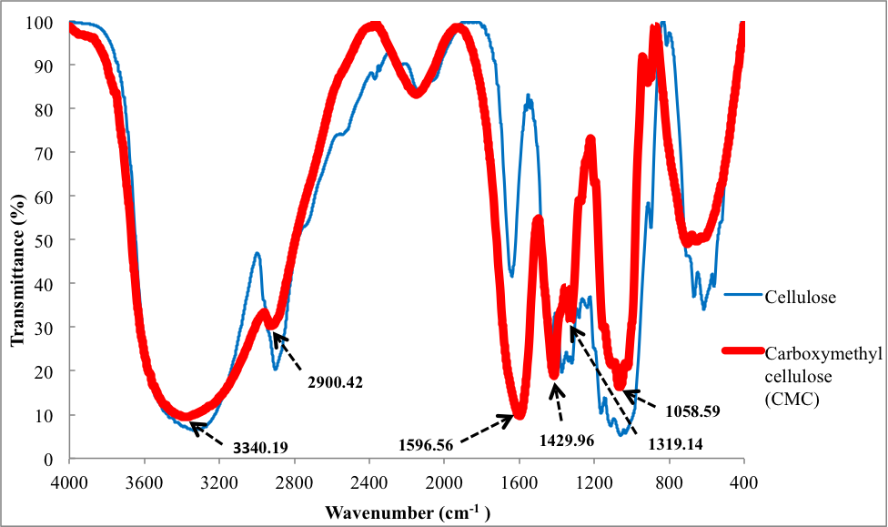

Figure 1. FTIR spectrum for cellulose and carboxymethyl cellulose

For cellulose sample (a), the broad absorption band at 3340.19 cm⁻¹ shows the stretching frequency of the –OH group due to intramolecular and intermolecular hydrogen bonds. The stretching vibration of C-H group at the band 2900.42 cm⁻¹ while the band at 1429.96 cm⁻¹ and 1319.14 cm⁻¹ are assigned to –CH₂ scissoring and –OH bending vibration, respectively. The band at 1058.59 cm⁻¹ show -CH-O-CH2 stretching [12].

For sample of carboxymethyl cellulose (b), the presence of a strong absorption band at 1596.56 cm⁻¹ shows the presence of carboxyl group –COO⁻. This is the proof that the hydroxyl group on cellulose has been substituted with carboxyl group during carboxylation reaction [6-7, 12]. The broad absorption band at 3364.65 cm⁻¹ shows the stretching frequency of the –OH group. The stretching vibration of C-H group shown at 2928.90 cm⁻¹. The band at 1415.66 cm⁻¹ and 1326.34 cm⁻¹ are assigned to –CH₂ scissoring and –OH bending vibration, respectively. The band at 1066.92 cm⁻¹ shows CH-O-CH2 stretching [12].

Degree of Substitution
Degree of substitution is the main factor of solubility of CMC in water. The DS value for CMC acquired through the process of cellulose alkalization followed by carboxylation process using sodium monochloroacetate are between 0.4 until 1.3. The CMC are completely soluble in water when the DS value is more than 0.4 which is the hydro affinity increased with increasing DS and vice versa [7, 12-13]. In this study, the DS obtained is 0.492 and shows the resulting CMC is water soluble and is in the range of 0.4 to 1.3. This is due to the use of isopropanol as a solvent in the reaction of carboxylation to allow etherification reagent react with cellulose chain.

Construction of Ternary Phase Diagram
The phase diagram was constructed based on ‘water dilution lines’ which demonstrated an increase of water content while decreasing surfactant/cosurfactant contents that is represented by the arrow line in Fig. 2. The water was titrated along the water dilution line that is drawn from the 100 % surfactant/cosurfactant to the opposite oil side of the triangle. When the mixture titrated resulted on clear and transparent after stirring, the samples were marked as points in the phase diagram. Fig. 2 represents the pseudo-ternary phase diagram of system Oleic Acid/Tween20/Propylene Glycol/Water (M1) with K_{m} 1:1, 1:2 and 1:3. However, system with ratio S/CoS, K_{m} = 3:1 able to produce largest microemulsion region compared to the other ratios. Stable microemulsions formed at Km = 1:1 for less than 40 wt. % oil, more than 40 wt. % S/CoS and 0 to 55 wt. % water, and at Km = 2:1 for less than 35 wt. % oil, more than 40 wt. % S/CoS and 0 to 50 wt. % water. At K_{m} = 3:1 and low ratios of S/CoS to oil, unstable systems were produced while at very high ratios two phase systems were obtained. It shows that the pseudo-ternary phase diagram that represent microemulsion were formed at less than 30 wt. % of oil, more than 40 wt. % S/CoS and between 10 to 40 wt. % water. Results obtained show that most formulations are suitable for further formulation since the area is not too small. However, only the system with ratio K_{m} = 3:1 and ratio of oil:S/CoS=1:9 was chosen for further formulation’s characterization.

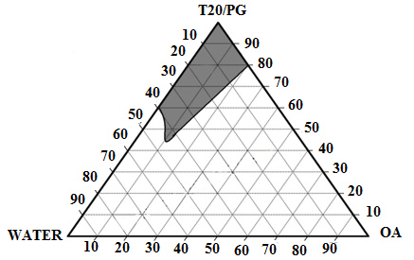
Water
(K_{m} = 1:1)

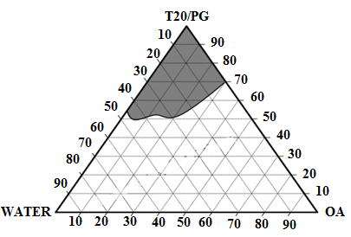
Water
(K_{m} = 2:1)

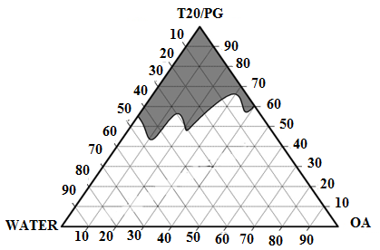
Water
(K_{m} = 3:1)

Fig. 2. Pseudo-ternary phase diagram of the system Oleic Acid/Tween20/Propylene Glycol/Water (K_{m} = 3:1; 2:1; 1:1). The shaded area represents the microemulsions existence field where stable, clear and transparent formulations are produced. Arrow in the shaded area shows the water dilution line that representing an increase of water content while decreasing surfactant/cosurfactant levels.

Particle Size
The mean particle diameter sizes are important characterization to determine the particle size distribution in a microemulsion. The mean particle diameters of microemulsions for system M1, M2, M3 and M4 are shown in Table 2. System M1 has particles sized between 49-178 nm which are in the range of microemulsion (20-200 nm) [14]. However, for system M2, M3 and M4, the size particles are beyond the range of microemulsion. This may be due to the addition of active ingredient (vitamin C) that disrupted the interaction between particles itself. Addition of CMC also affects the size of particle because CMC is a long chain molecule that normally produce particle size in the range of emulsion (>200 nm). According to Herrera and collaborators, the larger particle sizes is due to incompatibility between the surfactant and co-surfactant, and therefore caused particle coagulation [15].

Table 2. Particle diameter of oleic acid/Tween 20/Propylene glycol/Water for system M1, M2, M3 and M4 along the water dilution line

Water content (%) | Average Particle Size (nm)
Water content (%) | M1 | M2 | M3 | M4
10 | 177.5 | 3825.0 | 728.0 | 3249.5
20 | 143.5 | 1861.5 | 432.5 | 2547.5
30 | 76.2 | 981.5 | 241.5 | 794.1
40 | 49.4 | 533.1 | 446.5 | 632.1

Stability Studies
In stability studies, three different temperatures (4 °C, 25 °C and 40 °C) were imposed on microemulsion systems for 3 weeks. Based on the observation, the microemulsions at water percentage of 10 wt. %, 20 wt. % and 30 wt. % remain clear and stable for system M1, M2, M3 and M4 without phase separation for 3 weeks at 4 °C, 25 °C and 40 °C. System M2 with 40 wt. % of water is also remains clear after 3 weeks at 4°C. This shows that the system M2 consists of active ingredient is stable at low temperature. Unfortunately, system M1, M3 and M4 become precipitate and cloudy after 3 weeks of storage at 4 °C. This is due to changes on particles of microemulsion which an aggregation occur between particle and caused formulation instability when placed at low temperature [16]. At temperature of 25 °C and 40 °C, system M1 with 40 wt. % of water are cloudy and not stable after 3 weeks of storage, while systems M2, M3 and M4 are remain clear and stable. This shows that the addition of the active ingredient and CMC possibly increase the stability of basic microemulsion.

Conductivity
The effect of water content in the microemulsion along the water dilution line was monitored by measuring the electrical conductivity [17]. Electrical conductivity was measured to differentiate between water-in-oil (w/o), bicontinuous (BC) and oil-in-water (o/w) microemulsion. The conductivity tends to increase with an increase of water content, from (w/o) to (o/w) phase through bicontinuous phase [21]. This measurement was carried out in the presence of dissolved electrolyte, 0.01 M sodium chloride [18-20] to increase the conductivity of the aqueous phase instead of using pure water. Practically, sodium chloride presence may induce variations in the size and shape microemulsion regions in the phase diagram. However, these variations may be not significant if the amount of electrolyte is too small [22]. Fig. 3. shows the phase transitions of the microemulsion by electrical conductivity along water dilution line. All systems resulted in low conductivity at low water content (10 – 20 wt. %) and start to increase significantly up to 40 wt. % water. The low conductivity region with water content up to 20 wt. % represented w/o microemulsion. At this stage, water droplets were discreted in an oil continuum and possess weak interactions. Obviously, as the water content is raised up to 40 wt. %, the conductivity increasing due to increasing interactions between the aqueous domains forming interconnected conductive channels (BC phase). This is due to the attractive interaction between the spherical microdroplets of aqueous phase of w/o microemulsion [23, 24] as they changed from w/o microemulsion to the bicontinuous region. Therefore, systems M1, M2, M3 and M4 can be classified as water-in-oil (w/o) at range 10 – 20 wt. % water and bicontinuous (BC) at > 20 – 40 wt. % water.

The effect of the solubilised active ingredient and water-soluble polymer CMC on the microstructure and the structural transitions occurred upon dilution with aqueous phase was determined. These effects were determined by the conductivity test both of the Vitamin C-loaded and CMC-loaded microemulsions with the comparison of unloaded system (Fig. 3). Both Vitamin C and CMC increases the electrical conductivity of the microemulsion systems. However, the effect is not too significant when the water were entrapped in the oil phase, but it starts to become more significant when water content increase [17].

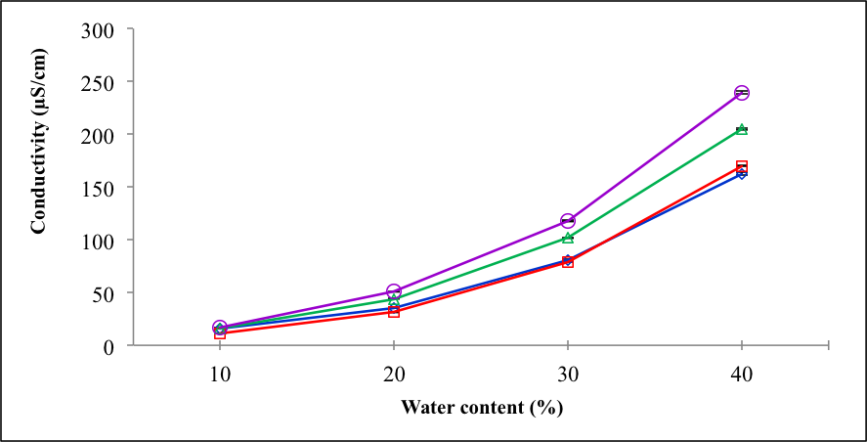
F
iFig. 3. Electrical conductivity vs. water content in system M1 (), M2 ( ), M3 () and M4 () along the water dilution line.

Viscosity
A phase transition from oil-in-water to water-in-oil and together with the changes in the microstructure of the microemulsion along with an increase of wt. % water was determined from the viscosity of the system. The viscosity profiles of the unloaded and loaded systems are shown in Fig. 4. Most systems resulted on low viscosity at low wt. % water content (10 – 20 wt. %) and start to increase as the water content increased (20 – 40 wt. %). At low water content (< 20 wt. %) region is represented the w/o microemulsion due to high content of oil and weak water interaction [25]. As the water content increased, the viscosity increased due to the changes in the shape of droplets, the transition from w/o to bicontinuous microemulsion or the fact that surfactant/cosurfactant moved from the bulk to interface that stabilize a bicontinuous structure [26]. The viscosity is higher at high water content also due to the swelling droplets phenomenon that will increase the interaction of particles [1].

System M2 (OA/T20/PG/Water/Vitamin C) resulted in the lowest viscosity. However, the viscosity starts to increase as the system changes to bicontinuous region, which is at > 30 wt. % water content as reported by Marta in 2005. This is due to the addition of vitamin C in the system which possibly change microstructure of the microemulsion [11].

System M3 (OA/T20/PG/Water/CMC) and M4 (OA/T20/PG/Water/Vitamin C/CMC), with the present of long polymer chain CMC shows high viscosity. This phenomenon is in agreement with a previous study reported by Shokri & Adibkia, incorporation of CMC slightly increased the viscosity of the system [9]. Additionally, CMC also able to lower the surface and interfacial tension due to their intrinstic amphihilic properties, however, their solutions showed higher viscosity. This is caused by their large molecular structures and the association of the hydrophobic groups [27]. These characteristics depend on the average chain length or degree of polymerization as well as the degree of substitution. Average chain length and the degree of substitution are important to determine the molecular weight of the polymer. As the molecular weight increases, the viscosity of CMC systems increases rapidly [28].

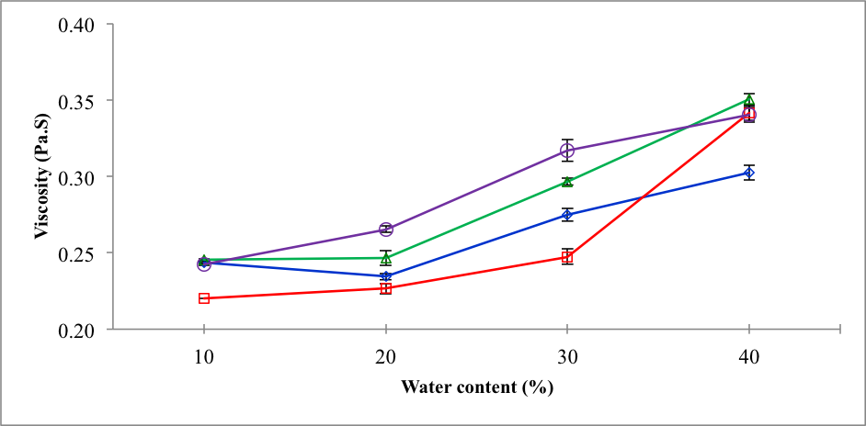
Fig. 4. Viscosity vs. water content in system M1 (), M2 ( ), M3 () and M4 () along the water dilution line.

Conclusion
The pseudo-ternary phase diagram and the region of all systems were constructed. Most systems show high stability in various temperatures (4°, 25° and 40 °C). Addition of Vitamin C and water-soluble polymer (CMC) slightly change the initial droplet size of system, however, this does not change the type of microemulsion. The electrical conductivity and viscosity measurement shows the transitions of these microemulsion systems from water-in-oil to bicontinuous phase without undergo phase separation.

Acknowledgement
The authors would like to thank the Ministry of Higher Education Malaysia and Universiti Kebangsaan Malaysia for supporting this work through the Fundamental Research Grant Scheme (FRGS/1/2013/SG01/UKM/03/1) and Young Researcher Incentive Grant (GGPM-2012-101).

References
- Kogan, A. and Garti, N. (2006). Microemulsions as Transdermal Drug Delivery Vehicles. Advances in Colloid and Interface Science 123–126(0): 369-385.
- Chin, C. C. (2013). Sistem Penghantaran Minyak Tea Tree Secara Transdermal Berasaskan Mikroemulsi. Tesis Ijazah Sarjana Muda, Fakulti Sains dan Teknologi, Universiti Kebangsaan Malaysia.
- Stubenrauch, C. (2009). Microemulsions: Background, New Concepts, Applications, Perspectives. United Kingdom: Blackwell Publishing.
- Lawrence, M. J. and Rees, G. D. (2000). Microemulsion-Based Media as Novel Drug Delivery Systems. Advanced Drug Delivery Reviews 45(1): 89-121.
- Alexander, A., Dwivedi, S., Ajazuddin, Giri, T. K., Saraf, S., Saraf, S. and Tripathi, D. K. (2012). Approaches for Breaking the Barriers of Drug Permeation through Transdermal Drug Delivery. Journal of Controlled Release 164(1): 26-40.
- Hutomo, G. S., Marseno, D. W., Anggrahini, S. and Supriyanto. (2012). Synthesis and Characterization of Sodium
Carboxymethylcellulose from Pod Husk of Cacao (Theobroma Cacao L.). African Journal of Food Science 6(6): 180-185.
- Bono, A., Ying, P., Yan, F., Muei, C., Sarbatly, R. and Krishnaiah, D. (2009). Synthesis and Characterization of Carboxymethyl Cellulose from Palm Kernel Cake. Advances in Natural & Applied Sciences 3(1).
- Rahman, A. F. A. (2006). Farmasi Dan Ubat-Ubatan. USM Pulau Pinang, Malaysia: Penerbit Universiti Sains Malaysia.
- Shokri, J. and Adibkia, K. (2013). Application of Cellulose and Cellulose Derivatives in Pharmaceutical Industries.
- Shapiro, S. S. and Saliou, C. (2001). Role of Vitamins in Skin Care. Nutrition 17(10): 839-844.
- Marta, S. (2005). The influence of ascorbic acid on the rheological properties of the microemulsion region of the SDS/pentanol/water system. Journal of Cosmetic Science 56: 267-277.
- Pushpamalar, V., Langford, S. J., Ahmad, M. and Lim, Y. Y. (2006). Optimization of Reaction Conditions for Preparing Carboxymethyl Cellulose from Sago Waste. Carbohydrate Polymers 64(2): 312-318.
- Toğrul, H. and Arslan, N. (2003). Production of Carboxymethyl Cellulose from Sugar Beet Pulp Cellulose and Rheological Behaviour of Carboxymethyl Cellulose. Carbohydrate Polymers 54(1): 73-82.
- Lawrence, M. J. and Rees, G. D. (2012). Microemulsion-Based Media as Novel Drug Delivery Systems. Advanced Drug Delivery Reviews 64, Supplement (0): 175-193.
- Herrera, J. R., Peralta, R. D., Lopez, R. G., Cesteros, L. C., Mendizabal, E. and Puig, J. E. (2003). Cosurfactant Effects on the Polymerization of Vinyl Acetate in Anionic Microemulsion Media. Polymer 44(6): 1795-1802.
- Constantinides, P. P. and Scalart, J.-P. (1997). Formulation and Physical Characterization of Water-in-Oil Microemulsions Containing Long- Versus Medium-Chain Glycerides. International Journal of Pharmaceutics 158(1): 57-68.
- Kantarci, G., Ozyguney, I., Karasulu, H. Y., Arzik, S. and Guneri, T. (2007). Comparision of different water/oil microemulsion containing diclofenac sodium: Preparation, characterization, release rate and skin irritation studies. AAPS Pharmaceutical Science & Tecchnology 8(4): 91.
- Suria, R., Benjamin, P. R. and Gentle, I., R. G. (2009). Formulation and physical characterization of microemulsions containing isotretinoin. International Conference on Biomedical and Pharmaceutical Engineering, ICBEP. 1-7.
- Metha, S. K., Dewan, R. K. and Bala, K. (1994). Percolation phenomenon and the study of conductivity, viscosity and ultrasonic velocity in microemulsion. Physical Review E. 50: 4759-4762.
- Weigert, S., Eicke, H. F. and Meier, W. (1997). Electric conductivity near the percolation transition of a non-ionic water-in-oil microemulsion. Physical A. 242: 95-103.
- Sripriya, R., Muthu Raja. K., Santhosh, G., Chandrasekaran, M. and Noel, M. (2007). The effect of structure of oil phase, surfactant and co-surfactant on the physicochemicals and electrochemical properties of bicontinuous microemulsion. Journal of Colloid and Interface Science 314: 712-717.
- Chen, C. M. and Warr, G. G. (1992). Rheology of ternary microemulsion. Journal of Physical Chemistry 96: 9492-9497.
- Djodrjevic, L., Primorac, M., Stupar, M. and Krajisnik, D. (2004). Characterization of caprycaproyl macrogolglycerides based microemulsion drug delivery vehicles for an amphiphilic drug. International Journal of Pharmacy 271: 11-19.
- Moulik, S. P. and Ray, S. (1994). Thermodynamics of clustering of droplets in water/AOT/heptanes microemulsion. Pure Application of Chemistry 66: 521-525.
- Garti, N. and Aserin, A. (2006). Microemulsions for Solubilization and Delivery of Nutraceuticals and Drugs. Taylor & Francais Group. 345-428.
- Bennet, K. E., Hatfield, J. C., Davis, H. T., W., M. C. and Seriven, L. E. (1982). Viscosity and Conductivity of Microemulsions. New York, Plenum Press: 65-84.
- Sun, W., Sun, D., Wei, Y. P., Liu, S. Y. and Zhang, S. Y. (2007). Oil-in-water emulsion stabilized by hydrophobically modified hydroxylehtyl cellulose: Adsorption and thickening effect. Journal of Colloid and Interfaces Science 311: 228-236.
- Aqualon, (1999). Sodium Carboxymethylcellulose: Physical and Chemical Properties. Hercules Inc.: USA. 5-7. Accesed from www. brenntagspecialties.com.

