INTERACTION OF HYALURONIC ACID (HA) WITH DIPALMITOYLPHOSPHATIDYLCHOLINE (DPPC) AND ITS EFFECT ON THE STABILITY OF HA-LIPID TO GAMMA IRRADIATION

(Interaksi Asid Hyaluronik (HA) dan Dipalmitoilfosfatidilkolina (DPPC) dan Kesan Penyinaran Gama ke atas Kestabilan HA-Lipid)

Ainee Fatimah Ahmad, Irman Abdul Rahman*, Hur Munawar Kabir Mohd, Faizal Mohamed, Shahidan Radiman and Muhamad Samudi Yasir

School of Applied Physics, Faculty of Science and Technology, Universiti Kebangsaan Malaysia, 43600 Bangi, Selangor, Malaysia

*corresponding author: irman@ukm.edu.my

Abstract
DPPC lipids are extensively utilized as a biomembrane model as they resembled biological cells and their significance in various physiological functions particularly in drug delivery system. The synovial joint fluid containing hyaluronic acid, proteins, proteoglycans and lipids. Hyaluronic acid (HA) is the most signified constituent in the synovial joint fluid and functions as lubricant, nutrient carrier and shock absorber. Gamma irradiation has also been discovered to be effeciently in depolymerizing and cleaving molecular chains which initiated changes in chemical composition as well as its physiological functions due to free radical. This research are conducted to investigate the hyaluronic acid (HA) with 1,2 -dipalmitoyl-sn-glycero-3-phosphatidylcholine (DPPC) interaction in form of vesicles and its effect on the stability of HA-DPPC structure to gamma radiation. The size distribution of DPPC vesicles measured by Dynamic Light Scattering (DLS) is between 100 to 200 nm in diameter. HA was added into the vesicles and characterized by using TEM to determine vesicle size distributions, fusion and rupture of HA-DPPC structure. The results demonstrated that the size of the vesicles approximately between 200 to 400 nm which caused by vesicles fusion with HA and formed even larger vesicles. After being irradiated by 0 to 200 Gy, the Z-average of DPPC vesicles decreased to 164.7 nm meanwhile for DPPC in presence of HA, the Z-average is 391.6 nm. FTIR spectra were carried out to clarified formation of double bonds at ~1700-1750 cm⁻¹ which leads to formation of pyrancarboxylic acid rings and modified the structure of HA, hence its effect the structure of the DPPC vesicles.

Keywords: Hyaluronic Acid (HA), Dipalmitoylphosphatidylcholine (DPPC), Gamma Irradiation

Abstrak
Lipid DPPC digunakan secara meluas sebagai model biomembran kerana mereka menyerupai sel-sel biologi dan kepentingannya dalam pelbagai fungsi fisiologi terutamanya dalam sistem penyampaian ubat. Cecair sendi sinovial mengandungi asid hyaluronik, protein, proteoglikan dan lipid. Asid hyaluronik (HA) adalah unsur yang penting di dalam cecair sendi sinovial dan berfungsi sebagai pelincir, pembawa nutrien dan penyerap hentakan. Sinaran gama telah ditemui sangat berkesan dalam dipolimerasikan dan memutuskan rantaian molekular yang telah menyebabkan perubahan dalam komposisi kimia serta fungsi fisiologi disebabkan radikal bebas. Kajian ini dijalankan untuk mengkaji interaksi asid hyaluronik (HA) dengan 1,2-dipalmitoil-sn-glicero-3-fosfatidilkolina (DPPC) dalam bentuk vesikel dan kesannya terhadap kestabilan struktur HA-DPPC terhadap sinaran gamma. Saiz vesikel DPPC adalah antara 100 hingga 200 nm diameter diukur dengan menggunakan Serakan Cahaya Dinamik (DLS). HA telah dicampurkan ke dalam vesikel dan dicirikan dengan menggunakan TEM untuk menentukan taburan saiz vesikel, gabungan dan pecahan struktur HA-DPPC. Hasil kajian menunjukkan bahawa saiz vesikel kira-kira antara 200 hingga 300 nm yang disebabkan oleh gabungan vesikel dan HA membentuk vesikel yang lebih besar. Setelah disinarkan pada 0-200 Gy, purata-Z vesikel DPPC menurun kepada 164.7 nm manakala untuk DPPC dalam kehadiran HA, purata-Z adalah 391.6 nm. Spektra FTIR telah dijalankan untuk menjelaskan pembentukan ikatan berganda pada ~1700-1750 cm-1 membawa kepada perubahan pembentukan cincin asid pyrancarboxylic acid dan mengubah struktur HA, oleh itu, struktur DPPC vesikel turut berubah.

Kata Kunci: Asid Hyaluronik, Dipalmitoilfosfatidilkolina (DPPC), Sinar Gama

Introduction
Hyaluronic Acid (HA) is naturally occurring polymer which composed of unbranched repeating units of β1-4-_{D}-glucuronic acid and β1-3N-acetyl-_{D}-glucosamine. HA potentially useful in the medical, food and cosmetic industries related to its unique properties including viscoelasticity, lubrication, hydration and biocompatibility [1]. HA associated with lipid form multilayered vesicular and tube-like structures filled with HA [2]. According to physicochemical studies, the inclusion of HA in vesicles or vice versa modifies the rheological behavior of HA in aqueous solution [3]. The role of membrane lipid constituent in signaling and protein functions has been well documented. Vesicles composed of a lipid bilayer with the hydrophobic chains of the lipids forming the bilayer and the polar head groups of the lipids leaning towards the inner cavity [4]. Vesicles structure imitate to the real cell membrane, thus can be used to characterize interactions between membrane lipids and biomolecules such as DNA [5], proteins [6], drugs [7] and antibiotic on target organisms [8].

Hyaluronic acid (HA) is a major component of synovial fluid was counted to be responsible for the synovial fluid lubricating abilities. Wear of the articular cartilage is one of the symptoms of osteoarthritis (OA). For the current treatment of OA, injections of HA into joints of patients, may reduce the cartilage wear and possibilities for joint replacement [9]. Previous studies reported that radiation given to the patients for purpose of diagnosis and therapy has triggered an onset of joint pain and loss of joint fluidity related to leakage of radiation from treatment joint [10]. Several studies proved that injecting a solution of the phospholipid of DPPC directly into the joint is effective in reducing cartilage wear. HA with DPPC liposomes proved they are more beneficial rather than HA alone [11]. Early studies have suggested formation of complexes between HA and phospholipids by ¹³C-NMR spectroscopy and laser light scattering studies, as the chain flexibility of HA was shown to increase when sonicated with DPPC. These concluded that DPPC competed for the hydrophobic centers along HA which are responsible for the interchain interactions [2,12].

Gamma irradiation has also been discovered to be effeciently in depolymerizing and cleaving molecular chains which initiated changes in chemical composition as well as its physiological functions due to free radical. Related studies proved gamma irradiation depolymerized structure and chemical composition of cellulose [13], starch [14], pectin [15] and chitosan [16]. This research is conducted to study the hyaluronic acid-lipid interaction and its stability due to the effect of gamma irradiation at predetermined dose since hyaluronic acid particularly important to function as a lubricant in synovial joint fluid. Lipid models systems were chosen in this research to allow investigations on a molecular level.

Materials and Methods
1,2-dipalmitoyl-sn-glycero-3-phosphocholine was purchased from Avanti Polar Lipids (Alabaster, AL, USA). DPPC stock was dissolved into chloroform to make a lipid solution at 10 mg/ml. 0.1 ml of the DPPC solution in a glass test tube was dried at 45°C overnight in an oven to eliminate the chloroform and resulting thin lipid film. The lipid was then prehydrated with deionised water and incubated at 45°C for another 20 to 30 minutes. After that, 0.1M sucrose solution was added to the lipid suspension as an internal medium. When the lipid being incubated, thin lipid film gradually isolated from the glass tube surface and formed cloudy white solutions which contained vesicles [18]. Hyaluronic acid sodium salt from rooster comb (Sigma Aldrich) was added to the DPPC suspension, mixed by vortex for about 60 seconds and incubated at 50°C for overnight.

DPPC with different concentrations of HA was irradiated for 0, 10, 50, 150 and 200 Gray with Co-60 from Gamma Cell at 4.20 kGy/h. Transmission Electron Microscopy (TEM) images were taken in bright field mode on Tecnai Spirit BioTwin microscope using an accelerating voltage of 120kV to confirm the formation of vesicles. Samples were prepared by staining with 1% uranyl acetate and dropping a small amount of each suspension onto Formvar grids. The size distribution of DPPC vesicles and HA were measured by DLS (Malvern Instruments, UK). FTIR (Perkin Elmer BX Spectrophometer) showed absorption bond between DPPC and HA before and after irradiation.

Result and Discussion
Figure 1 displays the top-view of bright-field transmission electron microscopy (TEM) images of DPPC vesicles with presence of HA in diameter about 100-200 nm. DPPC vesicles stained with 1% uranyl acetate so the vesicle image can be viewed against the background. Image of HA molecules could not be obtained since their molecular dimensions were small [2]. The edge of vesicles enunciated almost slightly circular and well dispersed in the solutions (a). Internal medium condition of vesicles was darker than external medium as a result of fragments of the dye used [17]. After incubation at 50°C for 4 hours, size of vesicles in the presence of HA increased (200-300 nm) and tends to aggregate among themselves (b). The new structures consequent from the fusion between DPPC vesicles and HA showed that lipid organisation was affected by the presence of HA [2]. However, after the irradiation at dose 50 Gy, some of the vesicles structure with absence of HA changed due to isolated vesicles and the size became smaller into 100-200 nm (c). In contrast, the structure of HA vesicles in the presence of HA seems to be more stable and the edge of vesicles still clearly to be pronounced.

These results supported by the previous studies indicating that ionizing radiation induced structural and chemical modification in liposomal membranes due to oxidative damage. Peroxidative damage to unsaturated acyl residues by gamma radiation in the presence of oxygen, resulting in the formation of hydroperoxide and acyl chain cross linkage in phospholipids membranes [18-19]. Unsaturated fatty acids in lipids reacted with radiation generated primary water radicals and in aerated conditions caused radical chain reactions which lead to initial damage and modifications of membrane fluidity [20]. Hence, the structure of DPPC vesicles alone were ruptured and modified by the free radical mechanism.

Literature proposes that gamma irradiation caused the depolymerisation of HA and these results presumed the mechanism of a cleavage of the glycosidic bonds between β1-4-_{D}-glucuronic acid and β1-3N-acetyl-_{D}-glucosamine repeat units [21-22]. The H• and •OH radicals formed by the radiolysis during irradiation of water accelerated the molecular chain scission of HA and DPPC bonds. Free radicals and HA molecules reacted and lead to rapid degradation of HA in an aqueous solution. However, after irradiation at 50 Gy, DPPC vesicles in the presence of HA were more stable compared to vesicles in absence of HA. These findings demonstrated as DPPC competed for the hydrophobic centers along HA which are responsible for the interchain interactions, hence the structure of vesicles form stable complexes by the strong tendency to interact each other [2].

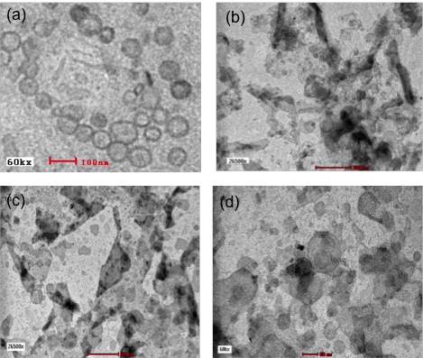

Figure 1. Bright field TEM images of (a) DPPC vesicles, (b) DPPC with hyaluronic acid, (c) DPPC irradiated at 50 Gy, and (d) DPPC with hyaluronic acid irradiated at 50 Gy

Figure 2 shows size distribution for gamma irradiated DPPC vesicles and HA at 50 Gy using Dynamic Light Scattering (DLS). Quasi-elastic laser light scattering technique has been used to accurately and quantitatively measure the average vesicle diffusion coefficient and the relative dispersion in the diffusion coefficient about this average for dilute polydisperse vesicle suspensions. This technique depends on a theoretical analysis of a modified form of the Z-averaged diffusion coefficient. This modified Z-averaged diffusion coefficient includes vesicle size, structure, and polydispersity derived from the scattered light autocorrelation spectrum as simplified in equation 1 which Z-averaged diffusion coefficient, <D>_{Z} and its relative dispersion, δ_{Z} was presented [23]. For DPPC, the Z-average vesicle was 491.2 nm. After HA was added to the DPPC vesicles, the size distribution was drastically increased to 725.8 nm. However after irradiation at 50 Gy, the Z-average for DPPC was 164.7 nm but for DPPC in presence of HA the Z-average was 391.6 nm. These size distributions indicate that the size distribution of DPPC vesicles in presence of HA make the structure of vesicles more stable even after irradiation compared to DPPC alone. Since the vesicles structure was ruptured after irradiation, the number and size of vesicles was decreased due to the free radical mechanism.

$<R>_{N}≅ \frac{A}{<D>_{Z}(1+3δ_{Z })}$ (1)

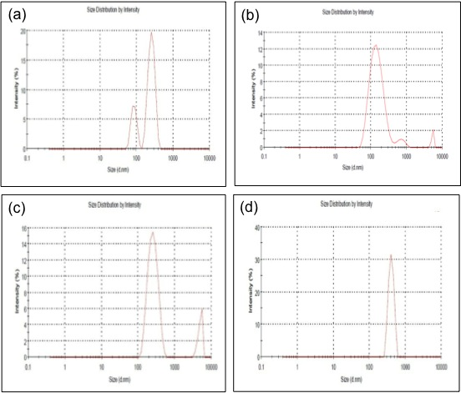

Figure 2. Size distribution of a) DPPC (Z-average = 491.2 nm), b) DPPC+ HA ( Z-average = 725.8 nm), DPPC irradiated at 50 Gy (Z-average = 164.7 nm) and c) DPPC and HA after irradiated at 50 Gy (Z-average = 391.6 nm)

Figure 3 shows FTIR spectrum in the spectral range 4000-1000 cm⁻¹ for DPPC vesicles and HA irradiated at 50 Gy. The main bands indicate a C=O stretching at 1653 and 1617 cm⁻¹ corresponding to amide I and acid group, respectively [24]. From the spectra, the pattern showed slightly changes when DPPC and HA after irradiation. There were some differences in the shape and height of certain absorption bands at 1700-1750 cm⁻¹ due to formation of carboxylic acid according to Alkrad et al. [35]. The absorption band resulted to the cleavage of the glycosidic bond in HA and the formation of double bonds and carboxylic acid groups. Double bond presence in the pyrancarboxylic acid ring after the enzymetic digestion of HA. Hence, gamma irradiation may produce pyrancarboxylic acid rings by modified the structure of HA and effect the structure of the DPPC vesicles.

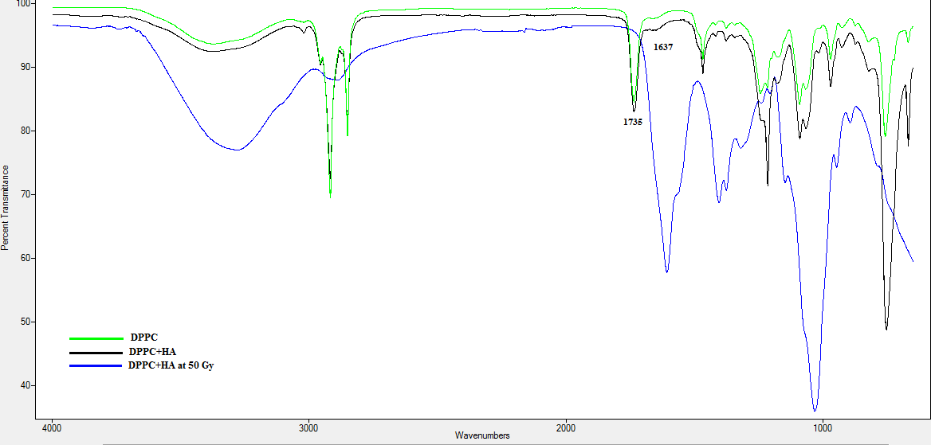

Figure 3. FTIR spectra of DPPC vesicles and hyaluronic acid.

Conclusions
From the results obtained, DPPC vesicles in presence of HA effect the lipid structure organisation. Furthermore, the structure of HA vesicles in the presence of HA seems to be more stable and the edge of vesicles still clearly to be pronounced even though after irradiation at 50 Gy compared to DPPC vesicles only. However, gamma irradiated DPPC and HA at certain doses caused depolymerisation of HA and due to cleavage of glycosidic bond in HA and modified the DPPC vesicles structure. To elucidate the mechanism of these effects FTIR spectra were carried out and have shown that at absorption bands at 1700-1750 cm⁻¹ due to formation of carboxylic acid. The obtained results have significant biomedical impact, since the combination of DPPC and HA provided an increase in its ability to lubricate in synovial fluid joint. Hence, this study could prove DPPC and HA interaction plays an important role in our joint systems.

Acknowledgments
The authors would like to acknowledge the financial support from UKM in this study, through grants ERGS/1/2012/STG02/UKM/02/01 and DLP-2013-037.

References
- Garg, H.G. and Hale, C.A. (2004). Chemistry and Biology of Hyaluronan. London.
- Pasquali-Ronchetti, I., Quaglino, D., Mori, G., Bachelli B. and Ghosh, P. (1997). Hyaluronan-Phospholipids Interactions Journal of Structural Bioogy. 120(1): 1 – 10.
- Crescenzi, V., Taglienti, A. and Pasquali-Ronchetti, I. (2004). Supramolecular Structures Prevailing in Aqueous Hyaluronic Acid and Phospholipid Vesicles Mixtures: An Electron Microscopy and Rheometric Study. Colloids and Surfaces A: Physicochemical. Engineering Aspects 245(1-3): 133- 135.
- Edwards, K.A. and Baeumner, A.J. (2006).Analysis of Liposomes. Talanta 68 (5): 1432-1441.
- Angelova, M., and Tsoneva, I. (1999).Interactions of DNA with Giant Liposomes. Chemistry and Physics of Lipids 101 (1): 123–137.
- Fischer, A., Oberholzer, T and Luisi, P. (2000). Giant Vesicles as Models to Study the Interactions between Membranes and Proteins. Biochemica et Biophysica Acta 1467 (1): 77–188.
- Romanowski, M., Zhu, X., Ramaswami, V., Misicka, A., Lipkowski, A., Hruby,V and O’Brien, D. (1997). Interaction of a Highly Potent Dimeric Enkephalin Analog, Biphalin, with Model Membranes. Biochemica et Biophysica Acta 1329 (2): 245–258.
- Trombetta, D., Arena, S., Tomaino,A., Tita, B., Bisignano,.G, Pasquale, A. ans Saija, A. (2001). Effect of the Exposure to Gentamicin and Diltiazem on the Permeability of Model Membranes. Il Farmaco 56 (5): 447–449.
- Grainger, R. and Cicuttini, F.M. (2004). Medical Management of Osteoarthritis of the Knee and Hip Joints. The Medical Journal of Australia 180 (5): 232–236.

Wang, S.J., Lin, W.Y., Chen, M.N., Chen, J.T., Ho, W., Hsieh, B.T., Huang, H., Shen, L.H., Ting, G. and Knapp Jr. F.F. (2001). Histologic Study of Effects of Radiation Synovectomy with Rhenium-188 Microsphere. Journal of Nuclear Medicine Biology 28(6): 727-732.

Kawano, T., Miura, H., Mawatari, T., T. Moro-Oka, T., Nakanishi, Y., Higaki, H. and Iwamoto, Y. (2003). Mechanical Effects of the Intraarticular Administration of High Molecular Weight Hyaluronic Acid plus Phospholipid on Synovial Joint Lubrication and Prevention of Articular Cartilage Degeneration in Experimental Osteoarthritis. Arthritis Rheumatology 48 (7): 1923–1929.
- Ghosh, P., Hutadolik, N., Adam, N. and Lentini, A. (1994). Interactions of Hyaluronan (Hyaluronic Acid) with Phospholipids as Determined by Gel Permeation Chromatography, Multi-Angle Laser-Light-Scattering Photometry and ¹H-NMR Spectroscopy. International Journal of Biological Macromolecules 16(5): 237-244.
- Charlesby, A. (1982). Crosslinking and Degradation of Polymers. Radiatian Physics and Chemistry 18(1-2): 59-66.
- Sokhey, A.S. and Chinnaswamy, R. (1992). Physicochemical Properties of Irradiation Modified Starch Extrudates. Food Structure 11(4): 361–371.
- Zegota, H. (1999). The Effect of γ-Irradiation on Citrus Pectin in N₂O and N₂O/O₂ Saturated Aqueous Solutions. Food Hydrocolloids 13(1): 51–58.
- Choi, W.S., Ahn, K. J., Lee, D.W., Byun, M.W. and Park, H.J.. (2002). Preparation of Chitosan Oligomers by Irradiation. Polymer Degradation and Stability 78(3): 533–538.
- Bibi, S., Kaur, R., Henriksen-Lacey, M.E., McNeil, S., Wilkhu, J., Lattmann, E., Christensen, D.R., Mohammed, A. and Perrie, Y. (2001). Microscopy Imaging Of Liposomes: From Coverslips to Enviromental SEM. International Journal of Pharmaceutics 417(1-2): 138 – 150.
- Sultanov, K. and Turaev, A.S.. (1996). Mechanism of the Radiolytic Transformation of Cellulose. Chemistry of Natural Compound 32(5): 728-733
- Miller, R.J. and Shiedlin, A. (2002). Molecular Weight Reduction of Polymer Using Irradiation Treatment. United States Patent No.6,383,344b1.
- Trommer, H., Bottcher, R., Poppl, A., Hoentsch, J., Wartewig, S. and Neubert, R.H.H. (2002). Role of Ascorbic Acid in Stratum Corneum Lipid Models Exposed to UV Irradiation. Pharmaceutical Research 19(7): 982 – 990.
- Konings, A.W.T. (1984). Lipid Peroxidation in Liposomes. In: G. Gregoriadis (Ed.). Liposome Technology, Vol. I. Crc Press, Florida, pp. 139 – 161.
- Chatterjee, S.N. and Agarwal, S. (1988). Liposomes as Membrane Model for Study of Lipid Peroxidation. Free Radical Biology and Medicine 4(1): 51–72.
- Selser, J.C., Yeh, Y. and Baskin, R.J. A . (1976).Light Scattering Characterization of Membrane Vesicles. Biophysical Journal 16 (4): 337 -356.
- Kim, J.K., Srinivasan, P., Kim, J.H., Choi, J.I., Park, H.J., Byun, M.W., and Lee, J.W. (2008). Structural and Antioxidant Properties of Gamma Irradiated Hyaluronic Acid. Food Chemistry 109(4): 763-770.

