SYNTHESIS AND CHARACTERIZATION OF COPPER(II) CARBOXYLATE WITH PALM-BASED OLEIC ACID BY ELECTROCHEMICAL TECHNIQUE

(Sintesis dan Pencirian Kuprum (II) Karboksilat dengan Asid Oleik Berasaskan Sawit Menggunakan Teknik Elektrokimia)

Norazzizi Nordin, Wan Zurina Samad, Muhammad Rahimi Yusop, and Mohamed Rozali Othman*

School of Chemical Sciences and Food Technology,
Faculty of Science and Technology,
Universiti Kebangsaan Malaysia, 43600 Bangi, Selangor, Malaysia.

*Corresponding email: rozali@ukm.edu.my

Abstract
Cu(II) oleate (Cu(II)Ol) complexes were synthesized using an electrochemical technique in the presence of palm-based oleic acid as the ligand and Cu ions from the released of anode material through the electrochemical oxidation of Cu foil. The system consisted of Cu foil and a graphite rod as the anode and cathode, respectively, while ammonium acetate (CH₃COONH₄) was used as a supporting electrolyte. The optimal parameters to synthesis of Cu(II) oleate complexes from 0.1 M oleic acid are using 10 V of applied voltage in the presence of 0.5 M CH₃COONH₄ for 2 hours of electrolysis time at room temperature (~27 °C). The results from spectroscopic studies using FTIR, XPS and UV-Vis confirms the existence of bonding between the coordinated carboxylate group of oleic acid with Cu(II) ions. This proved that the desired Cu(II) oleate complexes were successfully synthesized using electrochemical techniques. The surface morphology of the complex was analyzed using FESEM, and the micrograph obtained showed that the synthesized complexes formed thread-like structures.

Keywords: Copper complexes; oleic acid, electrochemical synthesis

Abstrak
Kompleks Cu(II) oleat telah disintesis menggunakan teknik elektrokimia dalam kehadiran asid oleik berasaskan sawit sebagai ligan dan ion Cu daripada pelepasan bahan anod melalui pengoksidaan elektrokimia kepingan Cu. Sistem sintesis elektrokimia terdiri daripada kepingan Cu dan rod grafit masing-masing bertindak sebagai anod dan katod manakala larutan ammonium asetat (CH₃COONH₄) digunakan sebagai elektrolit penyokong. Parameter optimum untuk sintesis kompleks Cu(II) oleat daripada 0.1 M asid oleik adalah dengan menggunakan keupayaan 10 V dalam kehadiran 0.5 M CH₃COONH₄ selama 2 jam masa sintesis pada suhu bilik (~27 °C). Keputusan yang diperolehi daripada kajian spektroskopi menggunakan FTIR, UV-Nampak dan XPS mengesahkan kewujudan ikatan antara kumpulan karboksilat pada asid oleik dengan ion Cu(II). Ini membuktikan bahawa kompleks Cu(II) oleat yang diingini telah berjaya disintesis menggunakan teknik elektrokimia. Morfologi permukaan kompleks tersebut telah dianalisis menggunakan FESEM dimana mikrograf yang diperolehi menunjukkan kompleks yang disintesis membentuk struktur seakan bebenang.

Kata kunci: Kompleks kuprum; asid oleik; sintesis elektrokimia

Introduction
Copper (II) carboxylates have been extensively studied over the latest few decades due to their special features in geometrical structures and physicochemical properties, and they have many applications in biochemistry and in industry. In 1953, the first copper (II) carboxylate dimer ie copper (II) acetate hydrate [Cu₂(MeCO₂)₄(H₂O)₂] have been reported by van Niekerk and Schoening [1]. Since the discovery of the first copper (II) carboxylate, there has been an increasing interest in these kind of compounds. Copper (II) carboxylates have been applied in various areas including as anticorrosive materials [2,3], precursors in the synthesis of metal-organic frameworks [4], and as molecular templates in the synthesis of semiconductor nanorods [5]. Furthermore, in recent years, there has been an increasing interest in the use of these complexes to get well dispersed copper nanoparticles by thermal decomposition [6,7].

In the recent decades, copper(II) carboxylates have been one of the major interesting research subjects due to the diversity of its structure, as it can contain two or more antiferromagnetically coupled metal centers [8,9]. Each carboxylate oxygen atom in the complex has two lone electron pairs. The structural formation of the complex depends on the utilization of one or two lone electron pairs on the oxygen of the carboxylate group for bonding to the Cu(II) ion. If only one lone electron pair is involved, the result is a paddle-wheel dimer structure (Figure 1a). A polymeric structure (Figure 1b) may form if the second lone pair is donated to the Cu(II) ion of another paddle-wheel dimer structure.

In such a dinuclear dimer (Figure 1a), two Cu(II) ions are bridged by four carboxylate groups of ligands. The coordination geometry around copper atoms in the paddle-wheel dimer Cu(II) carboxylate is square pyramidal with D_{4h} symmetry [10]. There are two axial positions in the paddle-wheel dimer pairs. The common axial ligands most reported in the literature are water [11], urea [12], pyridine-carboxylates [13], and organic acid [14]. In many cases, axial ligation of the paddle-wheel dimer prevents formation of inter-dimer bridges, due to donation of the lone electron pair of carboxylate oxygen to the Cu(II) ions of the neighboring paddle-wheel dimer. Consequently, formation and precipitation of a paddle-wheel dimer with polymeric behavior can be avoided [15].

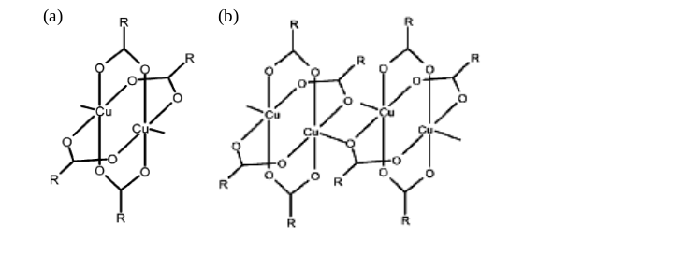
Figure 1. Structure of (a) paddle-wheel dimer and (b) a polymeric dimer of Cu(II) carboxylates.

Previous studies have reported that most of the complexes are synthesized using chemical methods [2,8,9,10,12). In the current paper, Cu(II)Ol complexes were prepared using an electrochemical technique based on the reaction between Cu(II) ions from the anode with palm-based HOl to produce Cu(II)Ol. The mechanism for the formation Cu(II)Ol complexes using an electrochemical technique is as equation 1- 4 follows:

Anode: Cuº → Cu²⁺ + 2 e⁻ (1)
Cathode: 2 e⁻ + 2 H₂O → H₂ + 2 OH⁻ (2)
2 OH⁻ + 2 CH₃(CH₂)₇CH=CH(CH₂)₇COOH →
2 H₂O + 2 CH₃ (CH₂)₇CH=CH(CH₂)₇COO⁻ (3)
Overall reaction: Cuº + 2 CH₃(CH₂)₇CH=CH(CH₂)₇COOH → Cu[CH₃(CH₂)₁₆COO]₂ + H₂ (4)

From the previous mechanism, Cu(II) ions (Eq.1) were generated in aqueous phase solution from the corroded anode. Formation of Cu(II)Ol occurred in the organic phase (Eq. 4). This electrochemical technique offers several advantages in inorganic synthesis: (1) the selectivity of the reaction can be influenced by the applied electrode potential; (2) the reaction rate can be controlled by the current density; (3) the electrode material and the electrolyte composition can be used as parameters for controlling the selectivity and reaction rate, and (4) the electrons are reagent free [16]. The aim of the present work is to determine the optimal parameter to synthesize Cu(II)Ol complex. The paper also investigates the spectroscopic and surface morphology properties of the electrochemically synthesized complex.

Materials and Methods
Chemicals
All chemicals used were analytical grade and used without further purification. Oleic acid (HOl) with 99% purity was purchased from Sigma-Aldrich. Copper plate with 99% purity and ethanol was from Sigma-Aldrich. Ammonium acetate (CH₃COONH₄) was purchased from Hamburg Chemical GmbH while toluene was purchased for Dulab.

Synthesis of Cu(II) Oleate
The electrolysis system consisted of a Cu foil (3x1 cm, 0.1 cm thickness) as the anode and graphite rod (6.5 mm diameter, Johnson Matthey Chemicals Ltd.) as the cathode in the presence of ammonium acetate (CH₃COONH₄) as the supporting electrolyte solution. Prior to synthesis, both anode and cathode were rinsed with distilled water and small amount of acetone to remove any trace organic materials on their surface. A DC power supply (TTi PSU Bench CPX400A) was used throughout the electrochemical synthesis. The acid solution (in ethanol) was mixed with CH₃COONH₄ solution with the ratio of 1:1 into the electrochemical cell. The electrochemical cell used was a simple and undivided cell with the capacity of 100 mL. The reaction was performed at room temperature (~27°C) for 4 hours. Strong stirring (900 rpm) was kept throughout the synthesis process. The resulting complex in blue precipitate was then filtered and washed with distilled water and ethanol to remove the impurities. The precipitate was then dried in a desiccator for 24 hours. Analysis of electrochemically synthesized Cu(II)Ol: m.p = 55-58 °C, yield = 98%, elemental analysis for CuC₃₂H₆₂O₄ (626.45 g/mol) (calculated): C (69.01%), H (10.64%), O (10.21%), Cu (10.14%); (found): C (68.75%), H (10.67%), O (10.29%), Cu (10.29%).

Instrumentation
The concentration of Cu(II) in the Cu(II)Ol complex was measured by Inductively Coupled Plasma-Optical Emission Spectrometry (ICP-OES), Perkin Elmer Optima 4300DV model using 6 series of standard solutions (0.1, 0.3, 0.5, 1.0, 2.0 and 5.0 ppm) as the calibration method. The spectroscopic studies were carried out using several instruments including X-ray Photoelectron Spectroscopy (XPS) (AXIS Ultra DLD) completed second edition of Kratos software, Fourier Transform Infrared Spectroscopy (FTIR) (Perkin Elmer 1310) in the range of 4000-400 cm⁻¹ and UV-Vis spectrophotometer (UV-Vis) (Shimadzu UV-2450) in the range of 300-900 nm using 10 mm quartz cuvettes. For surface morphology, the synthesized complex was characterized using Merlin Compact model of Field Emission Scanning Electron Microscopy (FESEM) with platinum coating by sputtering.

Results and Discussion

Optimization of Operating Parameter
Effect of Supporting Electrolyte Concentration
In the current study, CH₃COONH₄ solution has been used as a supporting electrolyte to increase the electrolytic conductivity of the electrochemical system, which in turn affects the current efficiency, cell voltage, and energy consumption in the electrolytic cell [17]. From Figure 2a (square symbol), increases in concentration of CH₃COONH₄ generally resulted in increased corrosion of the anode which produced more Cu(II) ions in the aqueous phase solution. Furthermore, increasing the concentration of CH₃COONH₄ from 0.01 M to 0.5 M in Figure 2a (red triangle symbol) showed no significant increase in Cu(II) concentration. It shows that in this range of concentration, all of the generated Cu(II) ion from the anode material has been used in the formation of the Cu(II)Ol complexes from 0.1 M HOl. Application of higher concentration of CH₃COONH₄ (e.g., >0.5 M) increases the production of Cu(II) ion in aqueous solution. Since no more free fatty acid was available in the organic phase, an excess of available Cu(II) ions was created in solution. Since unnecessarily higher concentration of CH₃COONH₄ will result in wasted metal species in the aqueous phase, a 0.5 M of supporting electrolyte concentration was considered to be the ideal concentration to completely react the fatty acid with Cu(II) ions. Electrolysis of CH₃COONH₄ without oleic acids (Figure 2a blue triangle symbol) was performed as a control experiment to prove that increasing the supporting electrolyte concentration produced more Cu(II) ions in the aqueous phase solution.

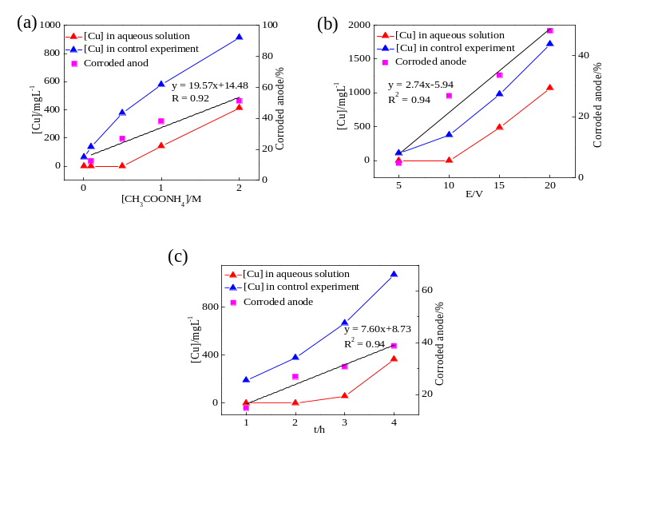
Figure 2. Effects of (a) supporting electrolyte concentrations; (b) applied voltages and (c) reaction times on Cu(II) ion concentration in aqueous solution during electrochemical synthesis of Cu(II)Ol complexes. [HOl]_{o} = 0.1 M (a-c); [CH₃COONH₄] = 0.1 M (a & b); E = 10 V (a & c); t = 4 h (b & c).

Effect of Applied Voltage
High cell voltages should not be used during electrochemical synthesis to avoid losses of energy, high temperatures, and electrode damage [18]. Selection of the correct supporting electrolyte at an appropriate concentration can assist in minimizing the applied voltage for the electrochemical synthesis process. In the current study, increases in the applied voltage were observed to increase the corrosion percentage of the Cu anode (Figure 2b square symbol). In the synthesis of Cu(II)Ol (Figure 2b red triangle symbol), full utilization of fatty acids was achieved with the use of 10 V of applied voltage after 2 hours, without formation of excess Cu(II) ions. At 5 V, no excess Cu(II) ions formed in solution, but higher concentrations of oleic acids were still present, and thus the total reaction time at 5 V would possibly be greater than 2 hours. Application of even higher voltages (>10 V) may reduce the total reaction time but also increase the potential to form certain by-products such as Cu(II) oxides [19]. Therefore, we concluded that 10 V was the ideal applied voltage for the synthesis of Cu(II)Ol to prevent the formation of undesired compounds.

Effect of Electrolysis Time
Reaction time is one of the major concerns in chemical synthesis, since longer times may lead to higher energy consumption [20]. Increasing the electrolysis time in the current work was observed to increase the corrosion percentage of Cu anode (Figure 2c square symbol), which resulted in an increase in the Cu(II) concentration. For 0.1 M of HOl, the Cu(II) concentration was generally very low for the first 2 hours due to being utilized in the formation of the Cu(II)Ol complex (Figure 2c red triangle symbol). After 2 hours, no more free fatty acid was available in the organic phase and an excess of available Cu(II) ions was created in solution. Based on our results, the ideal reaction time was 2 hours for 0.1 M HOl. Further increases in reaction time (> 2 hours) produced excess Cu(II) ions. In order to reduce the wasted Cu species in the solution, a 2-hour reaction time was considered to be the ideal duration to completely react the 0.1 M HOl with Cu(II) ions.

Characterization of Electrochemically Synthesized Cu(II) Oleate
FTIR spectroscopy
A peak at 1709 cm⁻¹ was observed on the IR spectrum of HOl (Figure 3), and this was assigned to the stretching vibration of the carboxylate group of HOl [2]. For both spectra, the presence of peaks at wavenumbers 2800-3000 cm⁻¹ represented the asymmetric and symmetric stretching vibrations of the methyl and methylene groups of fatty acid ligands, v_{as} and v_{s} (CH₃ and CH₂) [8]. The asymmetric and symmetric stretching vibrations of the coordinate carboxylate groups (v_{COO, as} and v_{COO, s}) appeared at 1590 and 1432 cm⁻¹, respectively. These bands are characteristic of dicopper tetracarboxylate complexes [8].

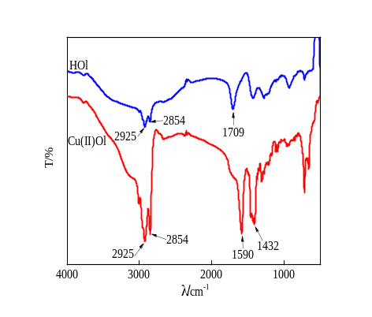
Figure 3. The IR spectra of HOl and Cu(II)Ol.

Several authors [8,10] have proposed that the positions of asymmetric (v_{as}) and symmetric (v_{s}) stretching vibrations of carboxylate groups (Δv_{COO} = v_{COO, as}- v_{COO, s}) can be used to distinguish the type of carboxylate-to-metal complexation structure of copper(II) carboxylates. A value of Δv_{COO} in the range of 150-170 cm⁻¹ corresponds to a bridging bidentate Cu(II) coordination, while Δv_{COO} > 200 cm⁻¹ is an indication for complexes with monodentate carboxylic groups [10]. In the IR spectrum in Figure 3, v_{COO, as} = 1590 cm⁻¹ while v_{COO,s} = 1432 cm⁻¹, giving the value of Δv_{COO} = 158 cm⁻¹. This value corresponded to a bridging bidentate mode of coordination and was in agreement with the results from previous studies.

XPS Spectroscopy
From the XPS spectrum in Figure 4a, the synthesized complex was composed of carbon, oxygen and copper element. The content of carbon is very high (about 69.48%) compared to other elements due to the presence of carbon chain of oleic acid. The binding energies were referenced to the C1s line at 284.5 eV from adventitious carbon. Deconvolution of C1s peaks showed the existence of different carbon species in the electrochemically synthesized Cu(II)Ol complexes. The XPS spectrum of C1s (Figure 4b) shows that there are three types of carbon in the synthesized complex which are fitted to the –C=O (288.2 eV) and –C-C (285.5 eV) while peak at 284.5 eV corresponds to carbon of oleic acid chain (–C-H) [22, 23].

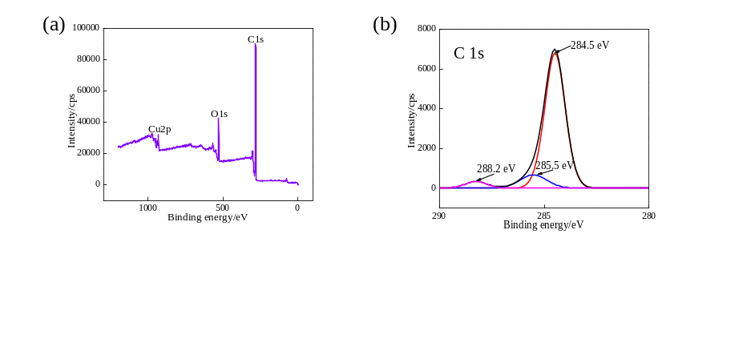
Figure 4. XPS spectra of Cu(II)Ol complexes (a) wide scan and (b) C1s peaks.

UV-Vis Spectroscopy
The toluene solution of Cu(II)Ol complexes (Figure 5) showed a broad absorption band in the visible region of the UV-Vis spectrum at λ_{max}= 675 nm, which represents the d→d transition of Cu(II) [21]. The band intensity was observed to increase with increasing complex concentration from 0.1 mM to 2 mM.

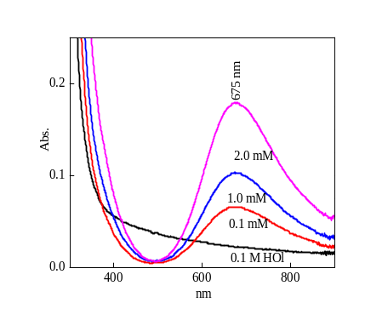
Figure 5. UV-Vis spectra of HOl and Cu(II)Ol with different concentrations in toluene.

Surface Morphological Analysis
Surface analysis studies of the electrochemically synthesized complex were performed using Field Emission Scanning Electron Microscopy (FESEM) and Energy Dispersive Analysis of X-ray (EDX) Based on the FESEM micrographs in Figure 6a, the Cu(II)Ol complexes formed thread-like structures. EDX analysis was performed to determine the distribution of elements on the surface of the complex. The result obtained in Figure 6b proved that the synthesized complex composed of Cu, C and O. This result was in agreement with the result
obtained by XPS analysis.

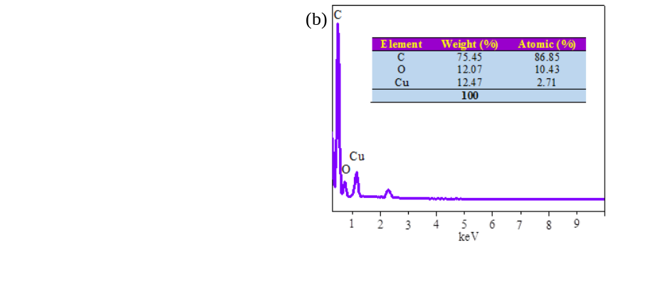
Figure 6. (a) FESEM micrograph of electrochemically synthesized Cu(II)Ol with 20000x magnification; (b) EDX spectrum of electrochemically synthesized Cu(II)Ol.
Conclusion
The release of Cu(II) ions into the aqueous solution depended on the type and concentration of supporting electrolytes, reaction times, and applied voltages. Based on the results obtained, the optimum condition to synthesize Cu(II)Ol by electrochemical technique from 0.1 M HOl are using 10 V of applied voltage in the presence of 0.5 M CH₃COONH₄ for 2 hours of electrolysis time at room temperature (~27 °C).The characterization using FTIR, XPS and UV-Vis proved that the synthesized complex was the desired Cu(II)Ol complex. The surface morphological study was performed using FESEM and the results showed that the synthesized complexes formed thread-like structures. The results of this study can potentially be used to investigate the synthesis of other divalent metal complexes of interest to chemistry, biochemistry, and industry.

Acknowledgement
The funding from Universiti Kebangsaan Malaysia through grants AP/2012/017, DLP-2013-002 and DPP-2013-045 are gratefully acknowledged. We wish to express special thanks to Centre for Research & Instrumentation Management (CRIM) UKM for XPS and surface morphological analysis.

References
- Van Niekerk, J.N. and Schoening, F.R.L. (1953). A new type of copper complex as found in the crystal structure of cupric acetate, Cu₂(CH₃COO)₄.2H₂O. Acta Crystallogr., 6: 227-232.
- Chen, L., Meng, H., Jiang, L. and Wang, S. (2011). Fatty-acid-metal-ion complexes as multicolor superhydrophobic coating materials. Chem.–Asian J., 6: 1757-1760.
- Wang, S., Feng, L. and Jiang, L. (2006). One-step solution-immersion process for the fabrication of stable bionic superhydrophobic surfaces. Adv. Mater., 18: 767-770.
- Papaefstathiou, G.S. and MacGillivray, L.R. (2003). Inverted metal-organic frameworks: solid-state hosts with modular functionality. Coordin. Chem. Rev., 246: 169-184.
- Mao, G., Dong, W., Kurth, D.G. and Mohwald, H. (2004). Synthesis of copper sulfide nanorod arrays on molecular templates. Nano Lett., 4: 249-252.
- Kim, Y.H., Kang, Y.S. Lee, W.J., Jo, B.G. and Jeong, J.H. (2006). Synthesis of Cu nanoparticles prepared by using thermal decomposition of Cu-oleate complex. Mol. Cryst. Liq. Cryst., 445: 231-238.
- Nasibulin, A.G., Kauppinen, E.I., Brown, D.P. and Jikiniemi, J.K. (2001). Nanoparticle formation via copper (II) acetylacetonate vapor decomposition in the presence of hydrogen and water. J. Phys. Chem. B, 105: 11067-11075.
- Doyle, A., Felcman, J., Teresa, M. and Braganc, M.L. (2000). Anhydrous copper (II) hexanoate from cuprous and cupric oxides. The crystal and molecular structure of Cu₂(O₂CC₅H₁₁)₄. Polyhedron, 19: 2621–2627.
- Iqbal, M., Ali, S., Muhammad, N. and Sohail, M. (2013). Synthesis, crystal structures and electrochemical characterization of dinuclear paddlewheel copper(II) carboxylates. Polyhedron, 57: 83–93.
- Wojciechowski, K., Bitner, A., Bernardinelli, G. and Brynda, M. (2009). Azacrown ether – copper (II)– hexanoate complexes. From monomer to 1-D metal organic polymer. Dalton T., 7: 1114-1122.
- Vaughan, G.B.M., Sghmidt, S. and Poulsen, H.F. (2004). Multicrystal approach to crystal structure solution and refinement. Z. Kristallogr., 219: 813-825.
- Kozlevcar, B., Leban, I., Petric, M., Petricek, S., Roubeau, O., Reedijk, J. and Segedin, P. (2004). Phase transitions and antiferromagnetism in copper(II) hexanoates: a new tetranuclear type of copper carboxylate paddle-wheel association. Inorg. Chim. Acta, 357: 4220–4230.
- Jaskova, J., Miklos, D., Korabik, M., Jorik, V., Segl’a, P., Kalinakova, B., Hudecova, D., Svorec, J., Fischer, A., Mrozinski, J., Lis, T. and Melnik, M. (2007). Synthesis, spectral and magnetic properties and crystal structures of copper(II) pyridinecarboxylates as potential antimicrobial agents. Inorg. Chim. Acta, 360: 2711-2720.
- Goto, M., Kani, Y., Tsuchimoto, M., Ohba, S., Matsushima, H. and Tokii, T. (2000). Dimeric copper(II) 3,3-dimethylbutyrate adducts with ethanol, 2-methylpyridine, 3-methylpyridine, 4-methylpyridine and 3,3-dimethylbutyric acid. Acta Crystallogr. C, 56: 7-11.
- Wojciechowski, K., Kucharek, M. and Buffle, J. (2008). Mechanism of Cu(II) transport through permeation liquid membranes using azacrown ether and fatty acid as carrier. J. Membrane Sci., 314: 152-162.
- Kissinger, P.T. and Heineman, W.R. (1996). Laboratory Techniques in Electroanalytical Chemistry. Marcel Dekker Inc., New York.
- Sengil, I.A. and Ozacar, M. (2009). The decolorization of C. I. Reactive Black 5 in aqueous solution by electrocoagulation using sacrificial iron electrodes. J. Hazard. Mater., 161: 1369-1376.
- Sakalis, A., Fytianos, K., Nickel, U. and Voulgaropoulos, A. (2006). A comparative study of platinised titanium and niobe/synthetic diamond as anodes in the electrochemical treatment of textile wastewater. Chem. Eng. J., 119: 127-133.
- Mahoney, D.M. and Mossaad, G.S. (1995). Electrosynthesis of Metal Carboxylate. United States Patent US5443698 A.
- Wang, J. (2001). Analytical Electrochemistry. John Wiley & Sons Inc., New York.
- Kozlevcar, B., Lah, N., Makuc, S. and Segedin, P. (2000). Copper(II) carboxylate- synthesis, structure and biological activity. IV. fatty acid copper(II) carboxylates with urea. Acta Chim. Slov., 47: 421–434.
- Deng, D., Qi, T., Cheng, Y., Jin, Y. and Xiao, F. (2014). Copper carboxylate with different carbon chain lengths as metal-organic decomposition ink. J. Mater. Sci.: Mater. Electron., 25: 390-397.
- Zhu, X., Zhang, Z., Xu, X., Men, X., Yang, J., Zhou, X. and Xue, Q. (2012). Facile fabrication of a superamphiphobic surface on the copper substrate. J. Colloid Interf. Sci., 367: 443-339.

