

MALAYSIAN JOURNAL OF ANALYTICAL SCIENCES
ISSN 1394 - 2506

Published by The Malaysian Analytical Sciences Society

Ba-SAPO-34 ZEOLITE MEMBRANE FOR CO₂ AND N₂ PERMEATION

(Resapan Gas CO₂ dan N₂ Melalui Membran Zeolit Ba-SAPO-34)

Thiam Leng Chew¹*, Jun Wei Lim², Abdul Latif Ahmad³

¹Department of Chemical Engineering, Faculty of Engineering

²Department of Fundamental and Applied Sciences

Universiti Teknologi PETRONAS, 32610 Bandar Seri Iskandar, Perak Malaysia

³School of Chemical Engineering, Engineering Campus,

Universiti Sains Malaysia, 14300 Penang, Malaysia

*Corresponding author: thiamleng.chew@utp.edu.my

Received: 21 October 2015; Accepted: 14 June 2016

Abstract

Membrane separation technology is gaining importance nowadays in reducing the emission of carbon dioxide (CO₂) as greenhouse gas due to the global climate change. Gas permeation studies play significant role in reflecting the potential of the membranes in separating the gas mixtures. In this study, Ba-SAPO-34 zeolite membrane was formed by membrane synthesis process using microwave (MW) heating and followed by membrane ion-exchange process with Ba²⁺ cation. The Ba-SAPO-34 zeolite membrane was investigated for its performance in the CO₂ and N₂ gases permeation studies. The effects of permeation temperature (30 – 180 ºC) and pressure difference (100 – 500 kPa) across the membrane on the gas permeation performance of the Ba-SAPO-34 membrane were studied. CO₂ single permeance of ~9.4-19.5 x 10⁻⁸ mol/m².s.Pa and N₂ single permeance of ~0.635-0.694 x 10⁻⁸ mol/m².s.Pa were obtained for gases permeation through Ba-SAPO-34 membrane performed under the range of permeation temperature and pressure difference across the membrane studied. Maximum CO₂/N₂ ideal selectivity of 29.6 was obtained for gases permeation through Ba-SAPO-34 membrane at 30 ºC and 100 kPa pressure difference.

Keywords: Ba-SAPO-34, membrane, gas permeation

Abstrak

Teknologi membran pemisahan adalah semakin penting pada masa kini dalam mengurangkan pelepasan karbon dioksida (CO₂) sebagai gas rumah hijau disebabkan oleh perubahan iklim sejagat. Kajian resapan gas memainkan peranan yang penting dalam mencerminkan potensi membran dalam pemisahan campuran gas. Dalam kajian ini, membrane zeolit Ba-SAPO-34 telah dibentuk melalui proses sintesis membran dengan menggunakan pemanasan gelombang mikro dan diikuti oleh proses pertukaran ion membran dengan kation Ba²⁺. Membran zeolit Ba-SAPO-34 tersebut telah dikaji untuk prestasinya dalam kajian resapan gas CO₂ dan N₂. Kesan suhu resapan (30 – 180 ºC) dan perbezaan tekanan (100 – 500 kPa) merentasi membrane terhadap prestasi resapan gas membrane Ba-SAPO-34 telah dikaji. Ketelapan tunggal CO₂ sebanyak ~9.4-19.5 x 10⁻⁸ mol/m².s.Pa dan ketelapan tunggal N₂ sebanyak ~0.635-0.694 x 10⁻⁸ mol/m².s.Pa telah diperolehi bagi resapan gas melalui membran Ba-SAPO-34 di bawah julat suhu resapan dan perbezaan tekanan merentasi membran yang dikaji. Kememilihan CO₂/N₂ sebanyak 29.6 (maksimum) telah diperolehi bagi resapan gas melalui membran Ba-SAPO-34 pada 30 ºC dan perbezaaan suhu sebanyak 100 kPa.

Kata kunci: Ba-SAPO-34, membran, resapan gas

Introduction
Reduction in emissions of greenhouse gases is becoming one of the major environmental issues due to the increase in global temperature, which is likely to bring several drawbacks such as disturbance in ecosystems and rise in sea levels. The increasing concentration of greenhouse gas, in particular carbon dioxide (CO₂), in the atmosphere in recent years has drawn attention of many researchers around the globe. The CO₂ separation from nitrogen (N₂) is among the worldwide concern nowadays in restricting the emission of CO₂ from large emission sources, i.e. flue gas from power plants. In the industrial post-combustion capture for fossil fuel combustion process, CO₂/N₂ separation remains an engineering challenge in removing the CO₂ from the flue gas emitted. In view of this issue, there are increasing number of articles published by the researchers with the aim to explore potential processes for separation and recovery of CO₂ from different sources [1-5]. Conventional technologies used for CO₂ separation from gas mixtures includes absorption using amine based solvents and pressure swing adsorption [6, 7]. However, the drawbacks of these conventional technologies are complexity of the system, high energy consumption for solvent regeneration, equipment corrosion and flow problems caused by viscosity of solvent [8, 9].

Membrane processes appear to be a promising alternative for gas permeation and separation. Polymer membranes, which have been widely investigated for gas permeation and separation, offer advantages such as low cost and ease of preparation. However, the disadvantages of polymer membranes, such as possible occurrence of plasticization due to high CO₂ partial pressure, poor chemical, thermal and mechanical strength, limit their performance in the application [10–12]. Zeolite membranes are gaining increasing interest for gas permeation and separation, in view of their uniform pore structure, high chemical, thermal and mechanical stability [13,14].

There have been extensive studies on different zeolite membranes for gas permeation and separation [12,15 – 19]. Silicoaluminophosphate, SAPO-34 membrane has been studied extensively for gas permeation and separation due to its small pore structure [6,17, 20,21]. Conventionally, the SAPO-34 membranes were prepared by hydrothermal synthesis method. Microwave (MW) heating emerged as a potential technology offering number of advantages against conventional hydrothermal heating such as shorter synthesis time, rapid heating rate and production of small zeolite crystals with narrow size distribution [22–24]. To our best knowledge, our group has been the first to report synthesis of SAPO-34 zeolite membrane using MW heating [25].

In the present study, Ba-SAPO-34 membrane was prepared using MW heating followed by ion-exchange process. In our previous work reported [26], the CO₂/CH₄ gas separation of Ba-SAPO-34 membrane was investigated. In the present study, the Ba-SAPO-34 membrane was tested for single gas permeation of CO₂ and N₂. The effects of permeation temperature and pressure difference across the membrane on the CO₂ and N₂ single gas permeation performance of the Ba-SAPO-34 membrane were studied.

Materials and Methods

Ba-SAPO-34 membrane preparation

-alumina disc with thickness of 3 mm and diameter of 25 mm was used as the support where the membrane was deposited on. The Ba-SAPO-34 membrane was prepared according to the procedures described in our previous work [26].

Gas permeation studies
Figure 1 show the setup diagram of the gas permeation studies. The disc-shaped Ba-SAPO-34 membrane was placed in a stainless steel module and the module was sealed using silicone gaskets in order to avoid any gas leakage from the module during gas permeation studies. Total feed flow of 60 ml/min was applied for single gas permeation of CO₂ and N₂ through Ba-SAPO-34 membrane. Pure CO₂ or N₂ gas was fed to the membrane using a mass flow controller. By closing the end of the retentate side of the membrane module, the feed pressure was controlled while the permeate pressure was kept at atmospheric pressure in order to vary the pressure difference between 100 and 500 kPa across the membrane. The temperature of the gas permeation was controlled between 30 and 180 ºC by using an oven where the stainless steel module was placed.

Permeate
Feed gas
Oven
Stainless Steel Membrane Module
Mass flow controller
Flow meters

Figure 1. Setup diagram of the gas permeation studies

Flux, 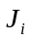 (mol/m².s) of component gas i was calculated as shown in Equation (1).
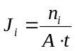 (1)
where 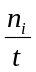 is the molar flow rate of component i (mol/s), is the effective permeation area of the membrane (m²), the component i may refer to CO₂ or N₂.

Permeance, (mol/m².s.Pa) of component gas i was calculated as shown in Equation (2).
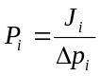 (2)
where 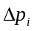 is the pressure difference of component i across the membrane (Pa).

The ideal selectivity of the membranes, 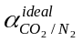 was calculated from the ratio of single gas permeance as shown in Equation (3).

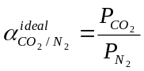 (3)

Results and Discussion

Gas permeation studies
Figure 2 presents the effect of pressure difference on the single gas fluxes through Ba-SAPO-34 membrane. The single gas flux of CO₂ and N₂ increased linearly with increase in pressure difference across the membrane. In the range of temperature (30 – 180 ºC) and pressure difference (100 – 500 kPa) studied in current study, CO₂ displayed higher single gas fluxes even though CO₂ possess higher molecular weight than N₂. The gas flux is the sum of micropore diffusion and surface diffusion [27]. It was relatively easier for CO₂ diffusion through the micropore framework of Ba-SAPO-34 due to smaller kinetic diameter of CO₂ compared to N₂. In addition, Li et al. [28] reported that the strength of adsorption of CO₂ gas molecules on SAPO-34 framework was higher than those of N₂ gas molecules. Owing to larger quadruple moment of CO₂, CO₂ was more strongly adsorbed on Ba-SAPO-34 pore framework and followed by stronger surface diffusion through the pore framework compared to N₂. The combination effect of micropore diffusion and surface diffusion explains the higher CO₂ single gas flux compared to N₂ in the present study.

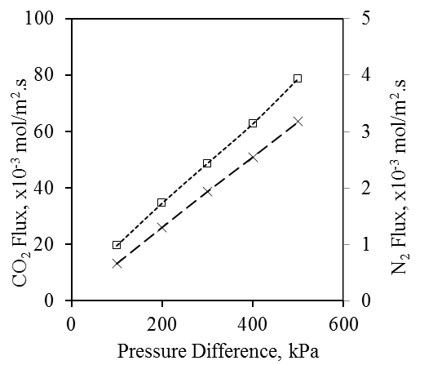

Figure 2. Single gas fluxes of CO₂ and N₂ through Ba-SAPO-34 membrane as a function of pressure difference at 30 ºC.

Figure 3 shows the effect of pressure difference on the single gas permeances through Ba-SAPO-34 membrane at 30 ºC. Gas permeance was calculated by dividing the gas flow with pressure difference of that respective gas. The CO₂ single gas permeance decreased from ~19.5 to ~15.710⁻⁸ mol/m².s.Pa and the N₂ single gas permeance decreased from ~0.659 to ~0.63510⁻⁸ mol/m².s.Pa when the pressure difference increased from 100 to 500 kPa at 30 ºC. The drop in CO₂ gas permeance was a result of adsorption-controlled permeation mechanism reported by Bernal et al. [29]. Owing to high adsorption strength of CO₂ on Ba-SAPO-34 pore framework, feeding pure CO₂ to the membrane at temperature as low as 30 ºC brought the surface coverage of CO₂ on the retentate side of the membrane close to saturated level. Further increase in the CO₂ pressure difference increased the CO₂ single gas flux, but the increase was not adequate to compensate for the higher increase of pressure difference, which resulted in decrease in CO₂ single gas permeance (flux per pressure difference).

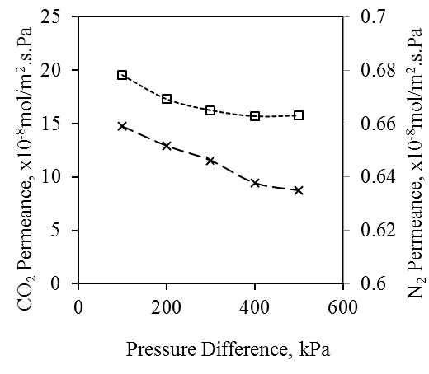
Figure 3. Single gas permeances of CO₂ and N₂ through Ba-SAPO-34 membrane as a function of pressure difference at 30 ºC
Figures 4 and 5 shows the effect of temperature on the single gas fluxes and single gas permeances, respectively through Ba-SAPO-34 membrane at 100 kPa pressure difference. Generally, surface diffusion decreases but micropore diffusion increases with increase in temperature. In present study, the CO₂ single gas flux and permeance dropped with increase in permeation temperature from 30 to 180 ºC due to reduction of surface coverage of CO₂ on the Ba-SAPO-34 pore framework with increase in temperature [6]. N₂ exhibited trend of rise in single gas flux and permeance with increase in temperature. This indicated that the micropore diffusion dominated the diffusion of N₂ through Ba-SAPO-34 pore framework instead of surface diffusion.

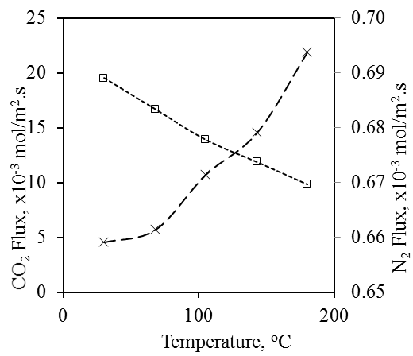
Figure 4. Single gas fluxes of CO₂ and N₂ through Ba-SAPO-34 membrane as a function of temperature at 100 kPa pressure difference across the membrane

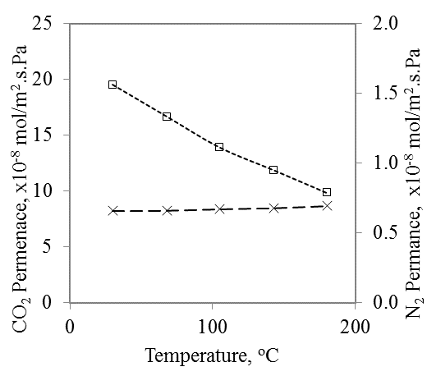

Figure 5. Single gas permeances of CO₂ and N₂ through Ba-SAPO-34 membrane as a function of temperature at 100 kPa pressure difference across the membrane

Figure 6 presents the effect of pressure difference on the CO₂/N₂ ideal selectivities through Ba-SAPO-34 membrane at different temperatures. The CO₂/N₂ ideal selectivity decreased from ~29.6 to ~24.8 with increase in pressure difference from 100 to 500 kPa at 30 ºC. This phenomenon was due to higher extent of drop in CO₂ single gas permeance compared to N₂ single gas permeance when the pressure difference was increased from 100 to 500 kPa as shown in Figure 3.

Figure 6. Ideal selectivities of CO₂/N₂ through Ba-SAPO-34 membrane as a function of pressure difference for different temperatures

As shown in Figure 6, it was found that the extent of drop in CO₂/N₂ ideal selectivities at higher temperature of 68 ºC was lesser than the decline at 30 ºC. As temperature was further increased to 180 ºC, there was nearly no change in all the ideal selectivities with increase in pressure difference. This was due to the lower surface coverage of CO₂ on the membrane at higher temperature [28], which led to lower decrease in CO₂ permeances with increase in pressure difference at higher temperature. Therefore, increase in temperature from 30 to 180 ºC resulted in the gradually dropped CO₂ adsorption strength on the membrane, and hence led to the reduced extent of change in the ideal selectivities with the change of pressure difference from 100 to 500 kPa in present study. Overally, maximum CO₂/N₂ ideal selectivity of 29.6 was obtained for gases permeation through Ba-SAPO-34 membrane at 30 ºC and 100 kPa pressure difference.

Conclusion

Ba-SAPO-34 zeolite membrane was successfully formed by membrane synthesis process using microwave (MW) heating and followed by membrane ion-exchange process with Ba²⁺ cation. The Ba-SAPO-34 zeolite membrane was investigated for its gas permeations of CO₂ and N₂ under varying permeation temperature (30 – 180 ºC) and pressure difference (100 – 500 kPa) across the membrane. In all of the range of permeation temperature and pressure difference studied in current study, CO₂ displayed higher single gas fluxes than N₂ due to (1) smaller kinetic diameter of CO₂ compared to N₂ and (2) stronger adsorption of CO₂ on Ba-SAPO-34 pore framework and subsequently followed by surface diffusion through the pore framework compared to N₂. Both CO₂ and N₂ single gas fluxes were found to increase with increase of pressure difference from 100 to 500 kPa. The N₂ single flux increased but the CO₂ single flux decreased with increase in permeation temperature from 30 to 180 ºC, indicating that micropore diffusion dominated N₂ diffusion but surface diffusion dominated CO₂ diffusion through the Ba-SAPO-34 membrane in present study. CO₂ single permeance of ~9.4-19.5 x 10⁻⁸ mol/m².s.Pa and N₂ single permeance of ~0.635-0.694 x 10⁻⁸ mol/m².s.Pa were obtained for gases permeation through Ba-SAPO-34 membrane performed under the range of permeation temperature and pressure difference across the membrane studied. Maximum CO₂/N₂ ideal selectivity of 29.6 was obtained for gases permeation through Ba-SAPO-34 membrane at 30 ºC and 100 kPa pressure difference.

Acknowledgement

The authors gratefully acknowledge the financial support received under LRGS grant (grant number: 304/PJKIMIA/6050296/U124). The financial and technical support from Universiti Teknologi PETRONAS, STIRF grant (cost centre: 0153AA-D64) and Carbon Dioxide-Mission Oriented Research (CO₂-MOR) in Universiti Teknologi PETRONAS are also acknowledged. The author thanks the guidance provided by Prof. Subhash Bhatia.

References
- Bredesen, R., Jordal, K. and Bolland, O. (2004). High-temperature membranes in power generation with CO₂ capture. Chemical Engineering and Processing, 43: 1129 – 1158.
- Favre, E. (2007). Carbon dioxide recovery from post-combustion processes: Can gas permeation membranes compete with absorption? Journal of Membrane Science, 294: 50 – 59.
- Granite, E. J. and O'Brien, T. (2005). Review of novel methods for carbon dioxide separation from flue and fuel gases. Fuel Processing Technology, 86: 1423 – 1434.
- Lin, H. and Freeman, B. D. (2005). Materials selection guidelines for membranes that remove CO₂ from gas mixtures. Journal of Molecular Structure, 739: 57 – 74.
- Yang, H., Xu, Z., Fan, M., Gupta, R., Slimane, R. B., Bland, A. E. and Wright, I. (2008). Progress in carbon dioxide separation and capture: A review. Journal of Environmental Sciences, 20: 14 – 27.
- Li, S. and Fan, C.Q. (2010). High-flux SAPO-34 membrane for CO₂/N₂ separation. Industrial and Engineering Chemistry Research, 49: 4399 – 4404.
- Lu, G.Q., Diniz da Costa, J. C., Duke, M., Giessler, S., Socolow, R., Williams, R. H. and Kreutz, T. (2007). Inorganic membranes for hydrogen production and purification: A critical review and perspective. Journal of Colloid Interface Science, 314: 589 – 603.
- Gray, M. L., Soong, Y., Champagne, K. J., Pennline, H., Baltrus, J. P., Stevens Jr, R.W., Khatri, R., Chuang, S. S. C. and Filburn, T. (2005). Improved immobilized carbon dioxide capture sorbents. Fuel Processing Technology, 86: 1449 – 1455.
- Zheng, F., Tran, D. N., Busche, B. J., Fryxell, G. E., Addleman, R. S., Zemanian, T. S. and Aardahl, C. L. (2005). Ethylenediamine-modified SBA-15 as regenerable CO₂ sorbent. Industrial and Engineering Chemistry Research, 44: 3099 – 3105.
- Fang, M., Wu, C., Yang, Z., Wang, T., Xia, Y. and Li, J. (2015). ZIF-8/PDMS mixed matrix membranes for propane/nitrogen mixture separation: Experimental result and permeation model validation. Journal of Membrane Science, 474: 103 – 113.
- Shirazian, S. and Ashrafizadeh, S. N. (2015). LTA and ion-exchanged LTA zeolite membranes for dehydration of natural gas. Journal of Industrial and Engineering Chemistry, 22: 132 – 137.
- Wu, T., Wang, B., Lu, Z., Zhou, R. and Chen, X. (2014). Alumina-supported AlPO-18 membranes for CO₂/CH₄ separation. Journal of Membrane Science, 471: 338 – 346.
- Lee, I. and Jeong, H.-K. (2011). Synthesis and gas permeation properties of highly b-oriented MFI silicalite-1 thin membranes with controlled microstructure. Microporous and Mesoporous Material, 141: 175 – 183.
- Michalkiewicz, B. and Koren, Z. C. (2015). Zeolite membranes for hydrogen production from natural gas: State of the art. Journal of Porous Materials, 22: 635 – 646.
- Das, N., Kundu, D. and Chatterjee, M. (2010). The effect of intermediate layer on synthesis and gas permeation properties of NaA zeolite membrane. Journal of Coatings Technology and Research, 7: 383 – 390.
- Himeno, S., Tomita, T., Suzuki, K., Nakayama, K., Yajima, K. and Yoshida, S. (2007). Synthesis and permeation properties of a DDR-type zeolite membrane for separation of CO₂/CH₄ gaseous mixtures. Industrial and Engineering Chemistry Research, 46: 6989 – 6997.
- Li, S., Zong, Z., James Zhou, S., Huang, Y., Song, Z., Feng, X., Zhou, R., Meyer, H. S. and Carreon, M.A. (2015). SAPO-34 membranes for N₂/CH₄ separation: Preparation, characterization, separation performance and economic evaluation. Journal of Membrane Science, 487: 141 – 151.
- Sato, K., Sugimoto, K., Sekine, Y., Takada, M., Matsukata, M. and Nakane, T. (2007). Application of FAU-type zeolite membranes to vapor/gas separation under high pressure and high temperature up to 5 MPa and 180 °C. Microporous and Mesoporous Materials, 101: 312 – 318.
- Sebastián, V., Kumakiri, I., Bredesen, R. and Menéndez, M. (2007). Zeolite membrane for CO₂ removal: Operating at high pressure. Journal of Membrane Science, 292: 92 – 97.

- Hong, M., Li, S., Falconer, J. L. and Noble, R. D. (2008). Hydrogen purification using a SAPO-34 membrane. Journal of Membrane Science, 307: 277 – 283.
- Tian, Y., Fan, L., Wang, Z., Qiu, S. and Zhu, G. (2009). Synthesis of a SAPO-34 membrane on macroporous supports for high permeance separation of a CO₂/CH₄ mixture. Journal of Material Chemistry, 19: 7698 – 7703.
- Motuzas, J., Julbe, A., Noble, R. D., van der Lee, A. and Beresnevicius, Z. J. (2006). Rapid synthesis of oriented silicalite-1 membranes by microwave-assisted hydrothermal treatment. Microporous and Mesoporous Materials, 92: 259 – 269.
- Li, Y. and Yang, W. (2008). Microwave synthesis of zeolite membranes: A review. Journal of Membrane Science, 316: 3 – 17.
- Zhu, G., Li, Y., Zhou, H., Liu, J. and Yang, W. (2008). FAU-type zeolite membranes synthesized by microwave assisted in situ crystallization. Material Letters, 62: 4357 – 4359.
- Chew, T., Ahmad, A. L. and Bhatia, S. (2011). Rapid synthesis of thin SAPO-34 membranes using microwave heating. Journal of Porous Materials, 18: 355 – 360.
- Chew, T. L., Ahmad, A. L. and Bhatia, S. (2011). Ba-SAPO-34 membrane synthesized from microwave heating and its performance for CO₂/CH₄ gas separation. Chemical Engineering Journal, 71: 1053 – 1059.
- Poshusta, J. C., Noble, R. D. and Falconer, J. L. (1999). Temperature and pressure effects on CO₂ and CH₄ permeation through MFI zeolite membranes. Journal of Membrane Science, 160: 115 – 125.
- Li, S., Falconer, J. L. and Noble, R. D. (2008). SAPO-34 membranes for CO₂/CH₄ separations: Effect of Si/Al ratio. Microporous and Mesoporous Materials, 110: 310 – 317.
- Bernal, M. P., Coronas, J., Menéndez, M. and Santamaría, J. (2004). Separation of CO₂/N₂ mixtures using MFI-Type zeolite membranes. AIChE Journal, 50: 127 – 135.

