MITIGATION OF TOXIC Alexandrium tamiyavanichii

USING CHITOSAN-SILICA COMPOSITE

(Mitigasi Alexandrium tamiyavanichii Bertoksik

Menggunakan Komposit Kitosan-Silika)

Anwar Iqbal^{1*}, Najwa Ahmad², Normawaty Mohammad Noor², Lee D. Wilson³, Nur Hanisah Ibrahim¹

¹School of Chemical Sciences,
Universiti Sains Malaysia, 11800, Penang, Malaysia

² Department of Marine Science, Kulliyyah of Science, International Islamic University Malaysia,

Jalan Sultan Ahmad Shah, Bandar Indera Mahkota, 25200, Kuantan, Pahang Malaysia
³Department of Chemistry, 110 Science Place, Room 156 Thorvaldson Building,
University of Saskatchewan, Saskatoon, S7N 5C9 Canada

*Corresponding author: anwariqbal@usm.my

Abstract
The harmful algal bloom (HABs) phenomena affects human health, ecosystems, fishing, and tourism industries. In a single occasion, the loss due to HABs can reach thousands of Ringgit Malaysia. In this study, a chitosan-silica composite (RHA-CHi) was synthesized via sol-gel technique for the mitigation of Alexandrium tamiyavanichii, a toxic HAB species isolated from Malaysian waters. Rice husk ash silica was used as the silica precursor in the composite synthesis. The FT-IR spectroscopy suggests that the chitosan was covalently bonded with the surface silanol groups. Light microscope analysis showed that the algal cells were stuck on the surface of the composite and underwent lysis. The incorporation of chitosan decreased the surface negative charge of the silica, hence, increasing the electrostatic attraction between the cells and RHA-Chi. The removal efficiency of A. tamiyavanichii was 75% using 0.1 mg/mL of RHA-Chi in 2 hours, increasing to 85% after 24 hours. Reduced removal efficiency (16%) was observed using silica alone. The findings show that the chitosan-silica composite has high potential to be used in the mitigation of A. tamiyavanichii.

Keywords: toxic algae, flocculate, silica, chitosan, rice husk

Abstrak
Fenomena ledakan alga-bahaya mengancam kesihatan manusia, industri perikanan dan pelancongan. Dalam satu kejadian, kerugian boleh mencecah ribuan Ringgit Malaysia. Dalam kajian ini, komposit kitosan-silika (RHA-CHi) telah disintesis melalui kaedah sol-gel untuk mitigasi Alexandrium tamiyavanichii, spesis bertoksik HAB yang dipencilkan dari perairan Malaysia. Abu sekam padi telah digunakan sebagai pelopor silika dalam sintesis komposit. Spektroskopi FT-IR menunjukkan kitosan terikat secara kovalen dengan kumpulan silanol permukaan. Analisis mikroskopi cahaya menunjukkan sel alga melekat pada permukaan komposit dan mengalami lisis. Penggabungan kitosan telah mengurangkan cas negatif permukaan silika lalu meningkatkan tarikan elektrostatik antara sel dan RHA-Chi. Kecekapan penyingkiran A. tamiyavanichii dalam masa 2 jam apabila 0.1 mg/ml RHA-Chi digunakan adalah 75% dan meningkat ke 85% selepas 24 jam manakala pengurangan kecekapan penyingkiran (16%) diperhatikan bagi silika sahaja. Penemuan ini menunjukan komposit kitosan-silika mempunyai potensi yang tinggi untuk digunakan dalam mitigasi ledakan alga-bahaya terutamanya A. tamiyavanichii.

Kata kunci: alga beracun, mengumpal, silika, kitosan, sekam padi

Introduction
Climate change has an adverse effect on aquatic environment. Variation in water condition may cause transformation in phytoplankton community structure and composition, including a greater prevalence and geographical spread of harmful algal blooms (HABs) [1]. Under the right conditions (salinity, temperature, and nutrients) some algae tend to grow in a higher number to form a bloom. Most algal blooms are not harmful, but they do cause serious problems such as discoloration of water, produce a smelly odor or bad water taste. Besides, the algal bloom depletes the concentration of oxygen available in the water through respiration. As a result, many organisms particularly caged fishes (relevant to fish farms) will die. The problem does not stop there. At the end of the blooming season and as the algae begins to die, more oxygen will be used by the microbes to decompose the algae cells creating an oxygen-deprived zone known as hypoxic dead zones. In this zone, neither fish nor plants can survive.

Alexandrium tamiyavanichii is a toxic dinoflagellate that causes paralytic shellfish poisoning (PSP). The first case of PSP by this species was recorded in Sebatu, Malacca whereby mussels were banned from being consumed. This caused an economic problem for the breeders [2]. The second case was in Kuantan Port, Pahang where ten people were hospitalized [3]. The occurrence of this species and other HAB species indicate that HABs are a serious problem that require further attention, especially as it affects human and the ecosystem, as evidenced by the negative impact to fisheries and tourism industries.

Mitigation is a term used to describe the actions taken to deal with an existing or ongoing bloom by taking necessary precautions to reduce the negative impact of the bloom. To date, many physical [4-6], chemical [7,8] and biological approaches have been proposed for the mitigation of HABs [9-10].

Although these approaches may be effective, some methods have certain drawbacks. The chemical approach is not selective towards certain HAB species and may affect other parts of the aquatic ecosystem. The chemical compounds can eliminate or negatively impact organisms that are required to balance the aquatic ecosystem [11]. The biological approach is considered safe and often species selective [12], but its efficiency depends on many biotic and abiotic factors. In comparison to chemical and biological approaches, physical methods often pose fewer threats to aquatic environment.

The objective of this research is to mitigate toxin producing HAB species, A. tamivanichii using a physical approach based on the properties of a chitosan-silica composite. The chitosan-silica composite was prepared using a one-pot synthesis via a sol-gel method. This research will contribute towards new knowledge for mitigating HAB species and help to minimize the impact of HABs on human health, particularly in Malaysia.

Materials and Methods
Preparation of rice husk ash
The preparation of rice husk ash (RHA) was carried out according to the reported method by Adam et al. [13]. Dirt and other water-soluble impurities were removed from the rice husk (RH) by washing it with copious amount of water and dried in the oven at 70 °C overnight. The clean and dried RH was stirred for 24 hours in 1.0 M HNO₃ to remove metallic impurities. The acid treated RH was then filtered using 8” sieve with mesh size 125 mm - 20 μm and washed with distilled water until the pH of the filtrate became constant. The acid treated RH was dried in the oven at 70 °C overnight. The RH was then pyrolyzed in a furnace at 600 °C for 6 hours to produce RHA.

Preparation of silica from RHA
Sodium silicate solution was prepared by dissolving 3 g of RHA in 350 mL of 1.0 M NaOH for 24 hours. The sodium silicate solution was titrated with 3.5 M HCl with constant stirring until pH 3. As the solution reached pH 10, gel started to form. The gel was aged for 24 hours in the mother liquor in a closed plastic container. The gel was separated using centrifugation (HETTICH® Rotina 38) at 7000 rpm for 9 minutes. The recovered gel was dried at 70 °C for 24 hours. The dried xerogel was weighed before grinding with a mortar and pestle into a fine powder. The resulting white powder (RHA- SiO₂) was stored in a glass bottle for use in this study.

Synthesis of chitosan-silica composite
The composite was prepared similarly to the preparation method of sodium silicate with some modification. Chitosan (1 g) (Sigma-Aldrich, 75-85% deacetylated) was dissolved in 3.5 M HCl. The sodium silicate solution was titrated with the aqueous chitosan solution until pH 3. The yellow colored gel was aged for 24 hours before separation by centrifugation at 7000 rpm. The gel was dried at 70 °C for 24 hours. The yellow colored xerogel was ground to a fine powder and labeled as RHA-Chi.

Characterization
The FTIR spectra of the materials were obtained using a Perkin Elmer System 2000 spectrophotometer. Approximately 0.1 to 1.0 wt.% sample was mixed with 200-250 mg of fine potassium bromide powder by grinding in a mortar and pestle. The samples were prepared in pellet form and then analyzed in transmission mode over a wavelength range (500-4000 cm⁻¹) at a resolution of 4 cm⁻¹.

Culture of Alexandrium tamiyavanichii
The subculture of A. tamiyavanichii was prepared from the stock culture (f/2 medium) obtained from the Phycology Laboratory, Kulliyyah of Science, International Islamic University Malaysia. The culture was maintained in f/2 medium, at 12:12 light and dark cycle and temperature of ± 27 °C.

Algal mitigation and flocculation
For the algal mitigation and flocculation tests, three concentrations (0.01 mg/mL, 0.1 mg/mL and 1.0 mg/mL) of RHA-SiO₂ and RHA-Chi were used against 15 mL of A. tamiyavanichii culture containing ±1000 cells/mL. The control culture was conducted without any addition of RHA-SiO₂ or RHA-Chi. The experiments were carried out in triplicate in 60 ×10 mm petri dish. After the addition of RHA-SiO₂ or RHA-Chi, the pH of the medium was measured using a pH meter with a glass electrode. At variable intervals of 0, 1, 2, 6, 12 and 24 hours, after the addition of RHA-SiO₂ or RHA-Chi, 1.0 mL of sample aliquots were taken using micropipette. The cells were counted in a Sedgewick-Rafter cell after being fixed with Lugol’s solution. The effectiveness of this method is determined by the value of Removal Efficiency (RE). Equation (1) was used to calculate the RE of the cells. The accumulated algae flocs were taken using a pipette and observed under a light microscope (Olympus CH30 Light microscope). Pictures were taken using Dino Capture 2.0 at a total magnification of 400×.

(RE) = 1-Number of live cells in test x 100% (1)
Number of live cells in control

Results and Discussion
Characterization of the composite
The FTIR spectrum of chitosan is shown in Figure 1(a). The stretching vibration of –OH groups of chitosan show a broad band at 3470 cm⁻¹, that may include contributions of N-H symmetrical stretching vibration of amine [14]. The –CH symmetric and asymmetric vibrations give rise to the transmission bands at 2919 and 2960 cm⁻¹, respectively. The band at 1598 cm⁻¹ is due to the stretching vibration of amino groups. The weak bands at 1380 and 1421 cm⁻¹ are due to the bending vibration of –CH₂ and symmetry deformation of –CH₃, respectively [15]. The FTIR band located at 1154 cm⁻¹ is due to the asymmetric vibration of C-O in the oxygen bridge resulting from deacetylation of chitosan [16]. The bands within 1080–1025 cm⁻¹ are attributed to the stretching vibration of C-O of the ring, COH, COC, and CH₂OH. The wagging of the saccharide structure of chitosan is characterized by the band around 890 cm⁻¹ [17].
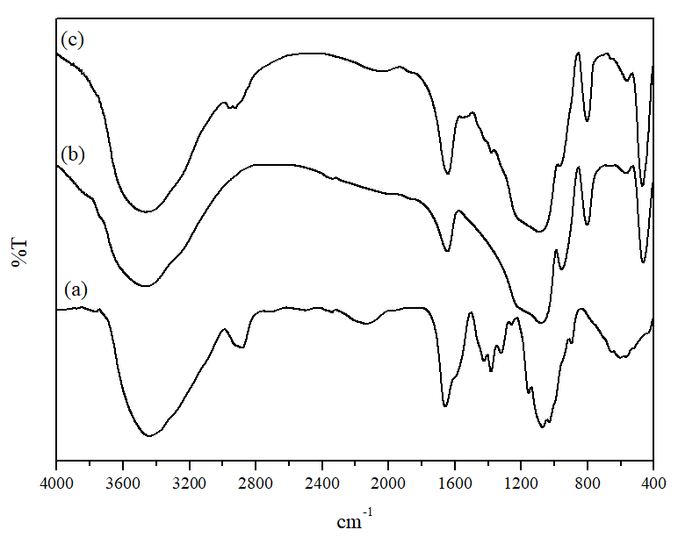

Figure 1. The transmission FTIR spectra of (a) chitosan, (b) RHA-SiO₂ and (c) RHA-Chi

The FTIR spectrum of RHA-SiO₂ is shown in Figure 1(b). The stretching vibration of SiO–H bond and adsorbed water (HO-H) on the silica surface yields a broad peak with an envelope-like appearance around 3469 cm⁻¹[18]. The sharp band at 1639 cm⁻¹ is attributed to the bending mode of absorbed water molecules on the silica, while the stretching vibration of Si-O-Si bond reveals a band observed at 1080 cm⁻¹[19]. The band at 968 cm⁻¹ is due to the stretching vibration of the Si-OH bonds [20]. The symmetric stretching and bending modes of the bulk Si-O-Si bond is indicated by the bands at 801 and 467 cm⁻¹, respectively [21].

The FTIR spectrum of RHA-Chi is shown in Figure 1(c), where many of the bands related to the functional groups of silica and chitosan are extensively overlapped, and only a few prominent bands are resolved. The prominent bands are indicated using red boxes. The –CH symmetric and asymmetric vibrations of the chitosan can still be seen ∼2900 and 1300 cm⁻¹. However these bands appears weaker compared to chitosan. Bands related to the stretching vibration of Si-OH, symmetric stretching and bending modes of bulk Si-O-Si bond can be seen at 968 cm⁻¹ and 463 cm⁻¹, respectively. However, the intensity of the stretching vibration of Si-OH bond seems to be drastically reduced as compared to RHA-SiO₂ which indicates that bond formation occurs between the surface silanol groups of silica with the hydroxyl group of chitosan. The appearances of these bands indicated that chitosan had bonded onto silica forming a new composite.

The interaction between the hydroxyl groups of chitosan with the surface silanol groups of silica may have formed covalent bond via a condensation reaction shown by the reaction scheme in Figure 2 [22-24].
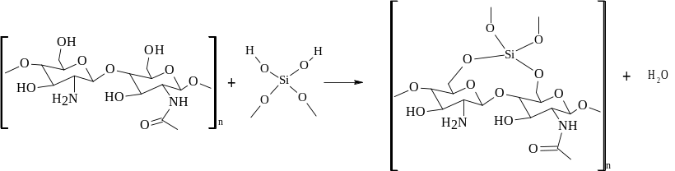

Figure 2. The condensation of the hydroxyl group of chitosan with the surface silanol groups of silica

In acidic condition, the amino groups of chitosan will be protonated, where the –NH₃⁺ group has a high affinity for the negatively charged silicate species [25]. The –NH₃⁺ group can form a more stable hydrogen bond with the silanol groups as compared to an uncharged NH₂ group. The electrostatic interaction between the protonated amino group of chitosan with the negatively charged dissociated hydroxyl silica is shown in Figure 3.

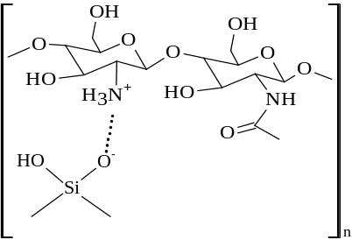

Figure 3. The interaction scheme between the protonated amine of chitosan with the negatively charged dissociated hydroxyl silica

The application of chitosan in seawater are limited due to the high alkalinity and ionic strength of seawater. The high alkalinity and ionic strength of seawater will prevent the polymer chitosan chain from unfolding. This will weaken the netting and the bridging properties of the chitosan [26]. The chitosan-silica linkages is expected to create a net-like structure that is flexible yet rigid. The macromolecular structure is expected to remain unfolded in seawater, resulting in more adsorption sites for the alga cells to be bound to the composite material.

Light microscopy analysis
The physical appearances of RHA-SiO₂ and RHA-Chi under a light microscope at a magnification of 400x are shown in Figures 4(a) and (b), respectively. Based on these optical images, RHA-SiO₂ has the appearance of transparent glass-like particles, while RHA- Chi is opaque and porous. The change in morphology and the physical appearance indicate the formation of a unique composite between chitosan and the silica matrix.
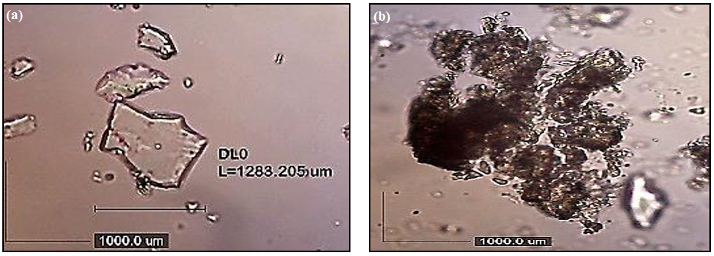

Figure 4. The micrographs of (a) transparent glass-like RHA-SiO₂ and (b) opaque and porous RHA-Chi composite material
Removal efficiency of A. tamiyavanichii using RHA-SiO₂
The HAB cells were observed to be immediately attracted to the RHA-SiO₂ when it was added. The RE values at different concentrations of RHA-SiO₂ is shown in Figure 5. The use of a concentration of 0.01 mg/mL and 0.1 mg/mL gave a RE value of 36% and 64%, respectively, in the first 2 hours. After 24 hours, the RE value dropped to 6% and 16%, respectively. This effect indicates that the RHA-SiO₂ is only able to temporarily trap the algal cell but did not kill them. The pH_{ZPC} of silica is around 2.0. Above the pH_{ZPC} value, the surface of the silica will be negatively charge and will repel the negatively charged algal cells. Throughout the experiment, the algal cells were not seen to be fully attached to the material as observed under the light microscope (Figure 6(a)). This finding is similar to that reported by Pan et al. [6], where the addition of unmodified beach sand was ineffective in removal of algal cells from the water column. The RE values were below 10% after 4 hours, indicating that sand alone did not have any flocculation ability. Instead, may act as a mass provider or ballast to carry flocs formed by modifiers to the bottom of the water column [6]. The initial pH of the medium containing A. tamiyavanichii was pH 8.22 prior to the addition of RHA-SiO₂, where a decrease to pH 8.01 occurred in the presence of the composite (0.01 mg/mL) and to pH 7.44 at a higher composite dosage (0.1 mg/mL). Within 2 hours after the addition of 1.0 mg/mL of RHA-SiO₂, the calculated RE value was 70%. After 24 h, the RE was at a favorable value of 84%. However, the medium became acidic (pH 6.18) at this condition. The mortality of A. tamitayavanichii may relate to the acidic pH conditions and not because of mitigation. Since the pH of the medium became acidic in the presence of excess RHA-SiO₂, the data suggest that it may not be safe to other aquatic environments. Most marine phytoplankton can only adapt to pH conditions near 7.8 [27]. Statistical analysis revealed that there were significant differences between each concentration tested (p <0.05).

Figure 5. Time dependent Removal Efficiencies (REs) for variable dosage of the RHA-SiO₂ composite material

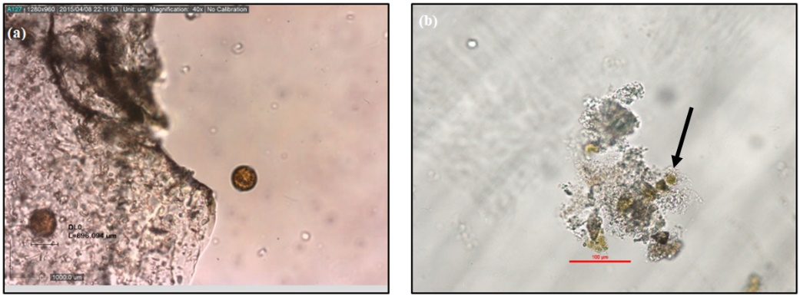

Figure 6. Micrographs showing the attachment of algae cells on (a) RHA-SiO₂ and (b) RHA-Chi

Removal efficiency of A. tamiyavanichii using RHA-Chi
The HAB cells immediately got attracted to the RHA-Chi as well when it was added. The RE values of A. tamiyavanichii using RHA-Chi are shown in Figure 7. Similar trends for all three dosages tested on A. tamiyavanichii with significant differences between these conditions (p <0.05) were observed. The RE achieved when 1.0 mg/mL of RHA-Chi was used after 2 hours was 100%, however, the pH of the medium dropped to 5.42. Most of the algal cells were dead after 24 hours but not many were attached to RHA-CHi when viewed under a light microscope (image is not shown).

For the dosages of 0.01 and 0.1 mg/mL, the calculated RE values were 45% and 75% after 2 hours, respectively. By comparison, the RE values reached 85% at 24 hours for 0.1 mg/mL and 75 % for 0.01 mg/mL. The pH of the culture medium was 7.40 and 7.86 when 0.1 mg/mL and 0.01 mg/mL RHA-Chi composite was added. The pH is at an acceptable range and deemed safe to other aquatic animals [27]. As seen in Figure 6(b), the algal cells are attached strongly to the surface of the composite. The interaction between the algal cells and chitosan is proposed to take place through electrostatic interactions between the composite and the algal cells. The incorporation of chitosan may have reduced the surface negative charge of the silica. As a result, the electrostatic attraction between the algal cells and the composite increased. The electrostatic interaction may cause internal osmotic imbalance leading to the lysis of the cell wall [28, 29]. As a result of cell wall lysis, leakage of intracellular content takes place as indicated by the arrow in Figure 6(b). The leaked intracellular content is still attached to the composite.

Figure 7. Time dependent Removal Efficiencies (REs) for different concentrations of RHA-Chi
The use of RHA-Chi for the mitigation of HABs offers a few advantages compared to several other current mitigation techniques. Firstly, this hybrid material displayed less environmental issues as both raw materials, i.e. rice husk ash (RHA) and chitosan are biocompatible and biodegradable. By comparison with the study by Pan et al. [6], PAC was used as a critical component in their mitigation of HAB, where this approach raised environmental concerns related to the balance of seawater. Secondly, the use of RHA-Chi is more cost effective since rice husk can be easily acquired free or at a low price from the rice milling industry and chitosan is a low-priced commercially available biomaterial.

Conclusion
RHA-Chi has been successfully deployed to capture, mitigate and flocculate the algal cells of A. tamiyavanichii as compared with RHA-SiO₂. The optimal concentration of RHA-Chi identified to mitigate A. tamiyavanichii was 0.1 mg/mL with an immediate effect of 50% RE in 2 h, where the dosage does not cause significant change on the pH of the algal culture. The algal cells are proposed to be attached to the the composite via electrostatic attraction, whereas silica alone acted as a ballast to carry the formed flocks. RHA-Chi is suitable for application as a material for mitigation of A. tamiyavanichii because of its biocompatibility, biodegradability, and cost-effectiveness. The findings from this research can be used as a platform to further optimize and scale-up the study.

Acknowledgement
This study was supported by Universiti Sains Malaysia Short Term Grant (304/PKIMIA/6313215), Universiti Sains Malaysia Research University Grant (RUI) (1001/PKIMIA/8011083) and Fundamental Research Grant Scheme (FRGS-13-035-0276), Ministry of Higher Education (MOHE) Malaysia.

References

- Wells, M. L., Trainer, V. L., Smayda, T. J., Karlson, B. S. O., Trick, C. G., Kudel, R. M., Ishikawa, A., Bernard, S., Wulfi, A., Anderson, D. M. and Cochlan, W. P. (2015). Harmful algal blooms and climate change: learning from the past and present to forecast the future. Harmful Algae, 49: 68-93.
- Usup, G., Leaw, C. P., Asmat, A. and Lim, P. T. (2002). Alexandrium (Dinophyceae) species in Malaysian waters. Harmful Algae, 1: 265-75.
- Mohammad-Noor, N., Aimimuliani A., Po T. L., Chui P. L. , Winnie L. S. L., G. R. Liow, Noraslinda M. B., Nurul A. H., Azlan M. N., Norazizah, K. and Devaraj, M. (2017). First report of paralytic shellfish poisoning (PSP) caused by Alexandrium tamiyavanichii in Kuantan Port, Pahang, East Coast of Malaysia. Phycological Research, 66:37-44.
- Liu, Y., Cao, X., Yu, Z., Song, X. and Qiu, L. (2016). Controlling harmful algae blooms using aluminum-modified clay. Marine Pollution Bulletin, 103: 211-219.
- Hao, H., Wu, M., Chen, Y., Tang, J. and Wu, Q. (2004). Cavitation mechanism in cyanobacterial growth inhibition by ultrasonic irradiation. Colloids and Surfaces B: Biointerfaces, 33: 151-156.
- Pan, G., Jin, C. and Anderson, D. M. (2011). Modified local sands for the mitigation of harmful algal blooms. Harmful Algae, 10: 381-387.
- Laue, P., Bährs, H., Chakrabarti, S. and Christian, S. E. W. (2014). Natural xenobiotics to prevent cyanobacterial and algal growth in freshwater: Contrasting efficacy of tannic acid, gallic acid, and gramine. Chemosphere, 104: 212-220.
- Fan, J., Ho, L., Hobson, P. and Brookes, J. (2013). Evaluating the effectiveness of copper sulphate, chlorine, potassium permanganate, hydrogen peroxide and ozone on cyanobacterial cell integrity. Water Research, 47: 5153-5164.
- Ying, Z. T., Yoonja K., Dianna B. and Christopher J. G. (2015). The ability of the red macroalga, Porphyra purpurea (Rhodophyceae) to inhibit the proliferation of seven common harmful microalgae. Journal of Applied Phycology, 27:531–544.
- Marcoval, M. A., Pan, J., Tang, Y. and Gobler, C. J. (2013). The ability of the branchiopod, Artemia salina, to graze upon harmful algal blooms caused by Alexandrium fundyense, Aureococcus anophagefferens, and Cochlodinium polykrikoides. Estuarine, Coastal Shelf Science, 131: 235-244.
- Jančula, D. and Maršálek, B. (2011). Critical review of actually available chemical compounds for prevention and management of cyanobacterial blooms. Chemosphere, 85: 1415-1422.
- Shao, J., Li, R., Lepo, J. E. and Gu, J. D. (2013). Potential for control of harmful cyanobacterial blooms using biologically derived substances: Problems and prospects. Journal of Environmental Management, 125: 149-155.
- Adam, F., H. Osman, and Mohammed, H. K. (2009). The immobilization of 3-(chloropropyl)triethoxysilane onto silica by simple one pot synthesis. Journal of Colloid and Interface Science, 331:143-147.
- Ramya, R., Sudha, P. N. and Mahalakshmi, J. (2012). Preparation and characterization of chitosan binary blend. International Journal of Scientific and Research Publications, 2(10): 1-9.
- Mano, J. F., Koniarova, D. and Reis, R. L. (2003). Thermal properties of thermoplastic starch/synthetic polymer blends with potential biomedical applicability. Journal of Materials Science: Materials in Medicine, 14: 127-135.
- Xu, Y., Kim, K., Hanna, M. and Nag, D. (2005). Chitosan-starch composite film: Preparation and characterization. Industrial Crops and Products, 21: 185-192.
- Paluszkiewicz, C., Stodolak, E., Hasik, M. and Blazewicz, M. (2011). FT-IR study of montmorillonite–chitosan nanocomposite materials. Spectrochimica Acta, 79: 784-788.
- Vetrieval, S. and Pandurangan, A. (2004). Vapour-phase oxidation of ethylbenzene with air over mn-containing MCM-41 mesoporous molecular sieves. Applied Catalysis A: General, 264: 243-252.
- Adam, F. and Iqbal, A. (2011). The oxidation of styrene by chromium-heterogenous catalyst prepared from rice-husk. Chemical Engineering Journal, 160(2): 742-750.
- Ibrahem, S. and Ibrahem, H. (2013). Preparation and study properties of silica using sol-gel method. International Journal of Application or Innovation in Engineering & Management, 12: 111-116.
- Cruz, R. S. D., Silva, J. M. S. D., Arnold, U. and Schuchardt, U. (2001). Catalytic activity and stability of a chromium containing silicate in liquid phase cyclohexane oxidation. Journal of Molecular Catalysis A: Chemical, 171: 251-257.
- Chassary P, Vincent, T. and Guibal, E. (2004). Metal anion sorption on chitosan and derivative materials: A strategy for polymer modification and optimum use. Reactive and Functional Polymers, 60:137-149.
- Kavitha, K, Sutha, S., Prabhu, M., Rajendran, V. and Jayakumar, T. (2013). In situ synthesized novel biocompatible titania–chitosan nanocomposites with high surface area and antibacterial activity. Carbohydrate Polymers, 93: 731-9.
- Budnyak , T. M., Pylypchuk, I.V., Tertykh, V. A., Yanovska, E. S. and Kolodynska, D. (2015). Synthesis and adsorption properties of chitosan-silica nanocomposite prepared by sol-gel method. Nanoscale Research Letters, 10: 87: 1-10.
- Budnyak, T., Tertykh, V. and Yanovska, E. (2014). Chitosan immobilized on silica surface for wastewater treatment. Materials Science (Medžiagotyra), 20: 177-182.
- Qun, G. and Ajun, W. (2006). Effects of molecular weight, degree of acetylation and ionic strength on surface tension of chitosan in dilute solution. Carbohydrate Polymer, 64(1): 29-36.
- Berge, T., Daugbjerg, N., Andersen, B. B. and Hansen, P. J. (2010). Effect of lowered pH on marine phytoplankton growth rates. Marine Ecology Progress Series, 416: 79-91.
- Rejane C. G., Douglas de, B. and Odilio, B. G. A. (2009). A review of the antimicrobial activity of chitosan. Polímeros: Ciência e Tecnologia, 19(3): 241-247.
- Jiexia, L., Yi, Z., Yujun T., Yuanming Z., Li, A., Li, T., Ming, S. and Chengwu, Z. (2013). Freshwater microalgae harvested via flocculation induced by pH decrease. Biotechnology for Biofuels, 6(98): 1-11.

