OPTIMIZATION OF HYDROGEN PRODUCTION FROM FRUIT WASTE THROUGH MESOPHILIC AND THERMOPHILIC DARK FERMENTATION: EFFECT OF SUBSTRATE-TO-INOCULUM RATIO

(Pengoptimuman Penghasilan Hidrogen dari Buangan Buah melalui Fermentasi Tanpa Cahaya pada Kondisi Mesofilik dan Termofilik: Pengaruh Nisbah Substrat-Inokulum)

Khamdan Cahyari^{1,2*}, Muslikhin Hidayat¹, Siti Syamsiah¹, Sarto¹

¹Department of Chemical Engineering,
Faculty of Engineering, Gadjah Mada University, Indonesia
²Dept. of Chemical Engineering,
Faculty of Industrial Technology, Universitas Islam Indonesia, Indonesia

*Corresponding author: cahyari.khamdan@yahoo.com

Abstract
This research was aimed to optimize hydrogen production from fruit waste, particularly on the effect of the substrate-to-inoculum ratio (SIR). Production of hydrogen was carried out through dark fermentation process both in mesophilic (30 °C, 1 atm) and thermophilic (55 °C, 1 atm) condition. Fermentation was conducted at SIR value ranging from 0.800 to 174 VS_{substrate}/g VS_{inoc}. In mesophilic fermentation, the highest cumulative total gas yield was achieved at SIR value of 19 corresponding total gas yield of 113 ml STP/g VS (5%v of H₂). In thermophilic condition, the highest H₂ yield was obtained at SIR value of 0.800 VS_{substrate}/g VS_{inoc} with H₂ yield of 294 mL STP/g VS (50 – 60%v of purity). It was noticed that the lower SIR value, the higher hydrogen yield. In summary, it is concluded that substrate-to-inoculum ratio (SIR) plays important role in dark fermentation process to produce renewable energy of hydrogen fuel.

Keywords: hydrogen, fermentation, substrate-to-inoculum ratio, fruit waste, renewable energy

Abstrak
Kajian ini merupakan langkah pengoptimuman penghasilan hidrogen dari bahan buangan buah, khususnya pada pengaruh nisbah substrat-inokulum (NSI). Penghasilan hidrogen dilakukan melalui proses fermentasi tanpa cahaya pada kondisi mesofilik (30 °C, 1 atm) dan termofilik (55 °C, 1 atm). Fermentasi dilakukan dengan variasi nilai NSI antara 0,800 dan 174 g VS_{substrate}/g VS_{inoc}. Pada fermentasi mesofilik, hasil gas total kumulatif tertinggi diperoleh pada nilai NSI 19 g VS_{substrate}/g VS_{inoc} dengan nilai penghasilan gas sebesar 113 ml STP/g VS (5%v/v gas H₂). Sedangkan proses fermentasi termofilik, hasil hidrogen kumulatif tertinggi dicapai pada nilai RSI 0,800 VS_{substrate}/g VS_{inoc} sebesar 294 ml STP H₂/g VS (ketulenan H₂ 50-60%v/v). Hal ini menunjukkan bahawa semakin kecil nilai NSI, hasil gas hidrogen menjadi semakin besar. Sehingga dapat disimpulkan bahawa faktor nisbah substrat terhadap inokulum (NSI) memiliki peranan penting dalam proses fermentasi tanpa cahaya untuk menghasilkan sumber tenaga baharu hidrogen.

Kata kunci: hidrogen, fermentasi, nisbah substrat-inokulum, bahan buangan buah, tenaga baharu

Introduction
Indonesia is one of the developing countries with significant economic growth and social development in South East Asia (SEA) region nowadays. Consequently, the Indonesian Government need to secure its energy supply to support this growth. For this purpose, the country relies mainly on fossil fuel in term of oil, coal, and gas accounting for approximately 96% of total primary energy consumption or equivalent to 1,358 million BOE in 2014 [1]. The high dependence on this fuel has led to many occurring environmental impacts during the last few decades such as depletion of natural resources (oil, coal and gas reserves), increases of CO₂ and particulate matter concentration in many cities, water contamination and climate changes [2]. To mitigate those impacts, the Indonesian Government has made some efforts to leverage the use of renewable energy sources for fulfilling energy demand in the future [3]. The Government Regulation No. 5/2006 states that the national energy share in the year 2025 is oil < 20%, gas 30%, coal 33%, renewable energy > 17% consisting of biofuel (5%), geothermal energy (5%), biomass, nuclear power, hydropower, solar energy (5%) and coal liquefaction (2%) [4]. The share of biofuel refers to biodiesel, bioethanol, biogas, and also biohydrogen which has a huge potential generation from renewable sources. Therefore, the government has made many efforts to implement strategies in developing renewable energy production efficiently.

Hydrogen fuel is one of the most promising fuels to mitigate major environmental impacts of fossil fuel. It is a clean energy carrier i.e. carbon free, emits only water vapor, has high energy density (142 kJ/g), has less emission of greenhouse gasses i.e.CO₂, and has better energy conversion in fuel cell up to 50% efficiency. Hydrogen production is conducted generally through water splitting when there is sufficient input of free excess energy, otherwise, it is uneconomically feasible to establish. Hydrogen production with the involvement of microbial activity to grow and generate hydrogen become more attractive to elaborate further due to its convenient process condition. For example, mesophilic dark fermentation of organic substrate is able to occur at ambient condition (35 °C, 1 atm, pH 5) with practical yield of 1-3 mol H₂/mol glucose [5]. In addition, utilization of organic waste as a substrate to generate this hydrogen provide simultaneous solution between mitigating waste problems and renewable energy production. One of these organic wastes available in abundant quantities from the agricultural sector in Indonesia is fruit waste.

The waste originates from a fragment of harvested fruits which turned into non-economically value products due to deterioration, market off-specs, and physical damages during agricultural production, post-harvesting handling and storage, processing, distribution, and consumption pattern. According to Central Bureau of Statistics of Indonesia, it was reported that there were more than 17.500 million tons of total edible fruits harvested throughout Indonesia in 2014. Apart from this quantity, the fruits turned into waste at particular percentages depending on cultivation, processing, and distribution technologies. For example, fruit and vegetable waste was estimated approximately 55% of total harvested in South and South East Asia region [6]. Global fresh fruit losses were estimated at least 6.800% of total harvested through region worldwide [7]. Local grocery fruit market in Yogyakarta Province, Indonesia threw away up to 10 tons/day i.e. 10% of incoming fruits due to deterioration during transportation [8]. The majority of these wastes were untreated prior to open dumping area which potentially causes severe environmental problems such as water and soil contamination, emission of methane, diseases, and other health-related problems.

Hydrogen production through dark fermentation is limited to low hydrogen yield and gas production rate due to non-optimized operational condition, of which is the substrate-to-inoculum ratio (SIR). When SIR is low, the fermentation occurs at the limited source of the substrate which potentially prevents the optimum growth of microorganisms. On the contrary, higher SIR indicates an overwhelming substrate which may cause inhibition of substrates, indigenous volatile compounds (e.g. limonene, eugenol, phloretin) and by-products (volatile fatty acids). Cappai et al. [9] reported that the optimum SIR was achieved at 0.140 g VS_{inoc}/g VS_{substrate} (equivalent to SIR 7.140) with H₂ yield of 88.800 liters STP/kg VS of food waste). When peach pulp waste as a substrate, the optimum ratio was found at 0.009 VS_{inoc}/g VS_{substrate} (SIR 111) [10]. This indicates that optimum SIR is affected by the type of substrate. Therefore, this research was meant to investigate the optimum condition of SIR on dark fermentation of fruit waste.

Materials and Methods
Source of inoculum and fruit waste
Source of mesophilic inoculum was originated from the residual sludge of cow dung-to-biogas plant. The thermophilic inoculum was collected from the residual sludge of organic fraction of municipal solid waste (OFMSW) to biogas plant. Both sludges passed through sub-sequential acid treatment (pH 5, 24 hours’ exposure time) and heat-shock treatment (95 °C, 45 minutes).

Fruit waste i.e. Apple (Malus pumila), citrus (Citrus grandis (L.) Osbeck), and melon (Cucumis melo) was collected from the local grocery market. The waste was individually chopped and grounded using kitchen blender with the addition of tap water to ease the blending operation. It was then stored at cold room (5 °C, 1 atm) prior to being used in the experiment, thereafter called as feedstock.

Experimental set up
Dark fermentation of fruit waste was conducted using 120 mL serum vial injection bottles as a bioreactor for batch assays assessment. Each digester was filled out with 20 mL of inoculum seed, 15 mL of distilled water, 5 mL of macronutrients, and 2.500 mL of micronutrients and feedstock. The volume of feedstock added to bioreactor was adjusted to meet the substrate-to-inoculum ratio of each fruit waste within the range between 0.800 and 174 g VS_{substrate}/g VS_{inoc}. Each bioreactor was then closed and sealed using butyl rubber stopper and aluminum cap followed with flushing of N₂ gas for 3 minutes. The experimental run was performed in triplicate. A solution of macro- and micro-nutrients were also prepared by addition of 11.400 g FeCl₂.4H₂O, 4.681 g KH₂PO₄, 0.814 g NH₄Cl and 3 g NaHCO₃, 0.320 g MgSO₄.7H₂O, 32 mg NiSO₄.6H₂O, 50 mg CaCl₂, 7 mg Na₂B₄O₇.10H₂O, 14 mg (NH₄)₆Mo₇O₂₄.4H₂0, 23 mg ZnCl₂, 21 mg CoCl₆.H₂O, 10 mg CuCl₂.2H₂O into 1000 mL of DW respectively

Analysis
Total gas production during dark fermentation process was conducted through measurement of bioreactor’s headspace pressure. Analysis of hydrogen content was performed using a gas chromatography unit (Auto System Perkin Elmer, Waltham, MA) equipped with Perkin Elmer packed column, 6’x 1.8” OD, 8-/100 mesh and thermal conductivity detector with oven, injection and detector temperatures as 75 °C, 150 °C, and 200 °C, respectively. Analysis of limonene concentration was performed using GC-MS (HP G1800C, Agilent, Palo Alto CA) with helium as a carrier gas with initial temperature of 50 °C and temperature increasing the rate of 15 °C/min up to 250 °C and it was maintained at this temperature for 3 minutes. Extraction of limonene in citrus was conducted using n-heptane (25 mL, 99% purity) to 14 mL of citrus juice and centrifugation at 3500 g (30 minutes). Nitrogen was used as carrier gas operating at 40 mL/min flow rate at 60 °C. Analysis of monosaccharide was carried out using HPLC-based on reference [11]. Analysis of moisture, total solid (TS), volatile solid (VS), and ash was carried out according to the standard method of water and wastewater analysis of American Public Health Association (APHA) procedures [12]. The degree of acidity (pH) was measured using digital pH meter (Jenway, UK).

Results and discussion
Characteristics of selected fruit waste
Global fruit production was recorded nearly 400 million metric tons in 2014 [13]. It was comprised of bananas, watermelons, apples, grapes, citrus, mangoes, plantain, and melons as the top ten global fruit harvested as shown in Figure 1. Accordingly, most of the fruit waste consists of these sorts of fruits which may be found in any region. Valorization of these waste through fermentation to produce hydrogen is a promising method to mitigate environmental impacts and generating renewable energy sources on a global scale. Apple (Malus pumila), citrus (Citrus grandis (L.) Osbeck), and melon (Cucumis melo) waste was estimated to be the highest waste composition due to physical damage and deterioration during cultivation to transportation considering their soft peel structure compare to the other fruits. Global apple production was more than 84 million tons spread out throughout many regions, except for the small quantity in Southeast Asia (4.8 MMT). Therefore, this research was focused on the utilization of the three fruits as representative of global fruit waste and only citrus and melon as representative of SEA region.

Figure 1. Fruit Production in Global region, Southeast Asia region (SEA), and Indonesia [13]

Table 1. Characteristics of fruit waste

Parameters | Citrus  (Citrus grandis L.) | Apple  (Malus pumila) | Melon  (Cucumis melo) | Refs.
Total Solid (%) | 6.020 (0.000) | 5.040 (0.570) | 6.720 (0.220)
Volatile Solid (%) | 96.810 (0.140) | 97.690 (0.250) | 90.630 (0.680)
Ph | 4.050 (0.040) | 3.370 (0.010) | 5.970 (0.060)
Limonene (mg/L juices) | 0.125 (0.010) | - | -
Phloretin (mg/kg) | - | 1,674 | - | [14]
Total Dietary Fiber  (g/100 g dried base) | 63.240(1.430) | 76.840(1.240) | 41.690 | [15 – 18]
Eugenol ($μ$g/kg) | 379 | 239 | 2302.400 | [19]
Soluble Glucose (g/L) | 5.110 | 7.180 | 6.960
Soluble Fructose (g/L) | 0.270 | 12.390 | 4.860
Total Soluble Sugar (g/L) | 5.380 | 19.570 | 11.820

Apple (Malus pumila), citrus (Citrus grandis (L.) Osbeck), and melon (Cucumis melo) were characterized by their physicochemical properties as shown in Table 1. More than 90% of total fruit weight is composed of water and soluble sugars. Total and volatile solid of both citrus and apple are similar accounting for 5-6% and 97% respectively, except that of melon. The volatile solid content of melon is lower due to the higher content of ashes. It was reported that melon peels contain 69.770% of carbohydrate and 3.670% of Ashes [17]. Limonene was found in citrus fruit at 0.125 mg/L of whole citrus fruit juice. Phloretin was reported as a major component in apple seed at concentration 1,674 mg/kg. Although eugenol could be found in each of the fruit, the highest concentration was exhibited in melon fruit. These three volatile compounds are known as an antimicrobial agent. The previous experiments demonstrated that methane production was interrupted due to the presence of limonene with half maximum inhibitory concentration, IC₅₀ was 669 mg/kg [20]. Phloretin in Apple was also reported to cause growth inhibition of some Gram positive and Gram-negative bacteria such as Staphylococcus aureus and Salmonella typhimurium, respectively with a MICs 125 μg/mL [21]. In addition, eugenol was shown to inhibit the activation and maturation of dendritic cells of microorganisms with IC₅₀ approximately at 50 μM [22]. This indicates that optimization of hydrogen production from the fruit waste is also related to inhibition or retardation of these three volatile compounds. In addition, total soluble sugar was found higher in apple and melon compared to that in citrus indicating that the two fruits have higher readily available substrate for the fermentation process.

Mesophilic dark fermentation
Mesophilic fermentation of fruit waste was conducted at temperature of 30 °C, pressure 1 bar and pH 5.0. Five SIR values were investigated to evaluate its effect toward total gas yield of biohydrogen production. The previous reports state that optimum hydrogen production from ground waste paper was achieved at a substrate concentration of 18.58 ±2.45 g/L and biomass concentration of 0.5 g/L which is equivalent to SIR of 42. On the other hand, optimum SIR value of 111 and 7.140 was obtained from fermentation of peach pulp and food waste respectively. Since there is various optimum value for the particular type of substrate, this experiment investigated SIR value ranging from 19 – 174 g VS_{substrate}/g VS_{inoc}.

A time course of total gas yield and hydrogen percentages during fermentation of citrus and melon waste at the SIR values is illustrated in Figure 2. The highest total gas yield was obtained from citrus and melon fermentation at SIR value of 19 g VS_{substrate}/g VS_{inoc} corresponding to 113 and 98 ml STP/g VS respectively. Increasing SIR value to 174 g VS_{substrate}/g VS_{inoc} caused significant reduction of the yield up to 76%. A similar pattern of the yield was noticed for both citrus and melon.

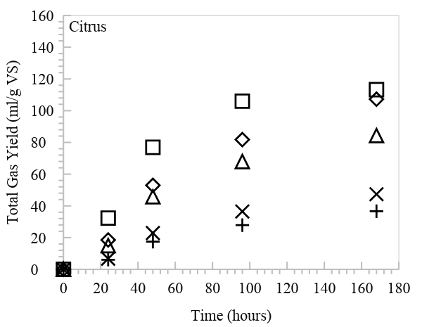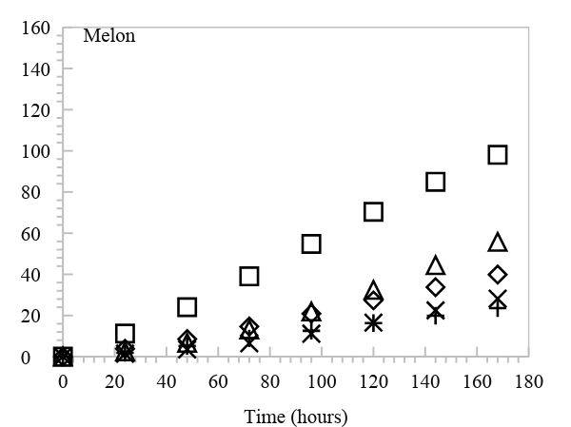

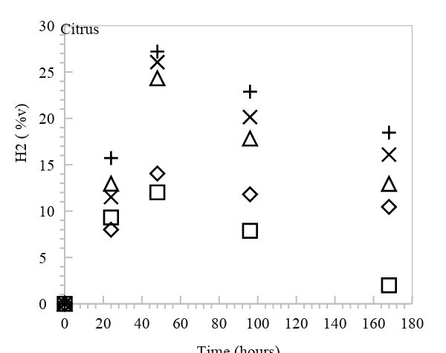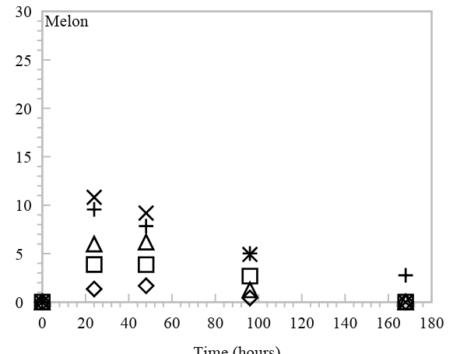

Figure 2. Total gas yield and percentages of hydrogen during mesophilic fermentation (30 °C, 1 atm) at various SIR values (□ SIR 19, ◊ SIR 29, $∆ SIR 58, ×SIR 116,+SIR 174$)

The lower SIR value which implies an ideal ratio of carbon sources to the microorganism population, the higher total gas yield. High SIR may lead to the overwhelming food supply to the limited population of the microorganisms leading to substrate inhibition or by-products retardation such as volatile fatty acids accumulation (pH decrease) [5]. This result was in agreement with the previous report that higher substrate concentration (0.5 to 2 g/L) led to a reduction of hydrogen production from 105 to 50 ml STP H₂ (appx. 50% reduction) [23].

It was also exhibited that type of fruits does not affect the yield pattern towards SIR, except for its quantitative values. Citrus waste could generate higher total gas yield which might be due to high IC₅₀ (669 mg/kg) and lower content of limonene (0.125 mg/L) compare to that of melon i.e. IC₅₀ of 50 μM and eugenol content of 2302.400 μg/kg. Eugenol concentration at SIR of 174 was estimated to value of 41.760 mg/kg or 254 μM (5 times of IC₅₀). Meanwhile, limonene concentration at the same SIR was only 2.25 mg/kg (0.336% of IC₅₀). In addition, total dietary fiber (TDF) in citrus waste which mainly consists of cellulose, hemicellulose, pectin, lignin is higher (63.240%) compare to that of melon (41.690%). Higher TDF content provides more potential substrate to produce hydrogen at the same SIR, whereas it can decrease the gas yield at the increasing SIR due to recalcitrant properties of the fiber.

The highest hydrogen percentages of citrus and melon fermentation were achieved at the value of 27%v at 48 hours and 10.8%v at 24 hours, respectively. In Figure 1, it was noticed that this percentage declined after the 48 and 24 hours of citrus and melon fermentation respectively because of pH decreases thereby microbial activity to generate more hydrogen was retarded. The addition of buffer solution (NaHCO_{3(aq)}) could be the solution to improve the H₂ percentage by increasing the buffering capacity of the fermentation process. As a result, the hydrogen yield from the citrus and melon fermentation was approximately 14.333 and 4.900 mL H₂/g VS_{added} respectively. Although this result is considered low to the maximum achievable yield i.e. 4 mol H₂/mol glucose (497 mL H₂/g glucose), it is quite reasonable at mesophilic condition using fruit waste containing high TDF. As a comparison, hydrogen yield value of 0.02 mmol H₂/g cellulose (0.448 mL H₂/g cellulose) was obtained from fermentation of cellulose at 4.7 g/L and 26 °C. At higher temperature (37 °C), the yield increased to 3.66 mmol H₂/g cellulose (75 ml H₂/g cellulose) [24].

Thermophilic dark fermentation
Biohydrogen production from citrus, apple, and melon waste which was conducted in thermophilic condition is depicted in Figure 3. In this fermentation, Apple was also investigated as a substrate to accommodate the high global production of this fruit. Due to low H₂ yield during mesophilic fermentation, it was decided to conduct thermophilic one at 55 °C, 1 atm and pH 5.0. In addition, a lower SIR values of 0.800 and 1.500 g VS_{substrate}/g VS_{inoc} was also selected based on previous report that the optimum substrate (food waste) to inoculum ratio was 2 g VS_{substrate}/g VS_{inoc} [25]. The SIR value in this experiment was selected to even lower in order to authenticate whether or not similar pattern of gas yield will occur.

Hydrogen yield profile during fermentation of citrus, melon and apple is depicted in Figure 3. It was observed that a similar pattern of hydrogen gas yield occurred that the lower SIR of any fruit waste, the higher H₂ yield. The highest H₂ yield was obtained from apple waste at SIR 0.800 corresponding to H₂ yield of 294 mL STP/g VS (50-60%v of purity). This might be due to high content of TDF and total soluble sugars in apple waste compare to that of citrus and melon. It was also demonstrated that an increase in SIR value of 1.500 g VS_{substrate}/g VS_{inoc} could decrease H₂ yield up to 38%v. Whereas, the lower H₂ yield was attained from fermentation of melon waste at SIR of 1.500 corresponding to 133 mL STP H₂/g VS. This result is comparable to some previous report on thermophilic dark fermentation. As a comparison, a similar result was demonstrated from immobilized system of dark fermentation using glucose as substrate i.e. 1.9 mol H₂/mol glucose (244 mL H₂/g glucose) [26]. A lower yield was also reported when starch and cellulose was utilized as substrate with corresponding yield of 92 mL H₂/g starch and 102 mL H₂/g cellulose [5].

Effect of inhibition due to the presence of volatile compounds (limonene, eugenol and phloretin) was not observed significantly in comparison to that of mesophilic condition. Both lower SIR values and higher temperature provide concentration of these compounds significantly below inhibition concentration (IC₅₀). Low SIR implies less quantity of substrate addition to fermentation so that there is only limited concentration in the same population of microorganism. Whereas, higher temperature (55 °C) condition could induce evaporation of these compounds and decrease the solubility in water. The hydrogen yield is 20-fold in thermophilic fermentation compare to that of mesophilic one. Therefore, combination of these SIR and temperature results in optimum condition for improving H₂ yield in this fermentation.

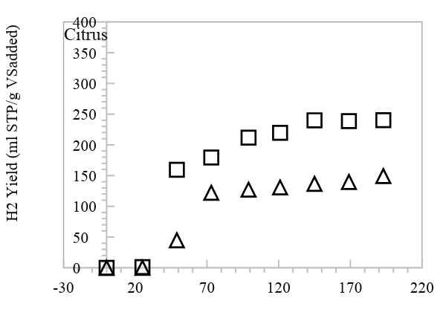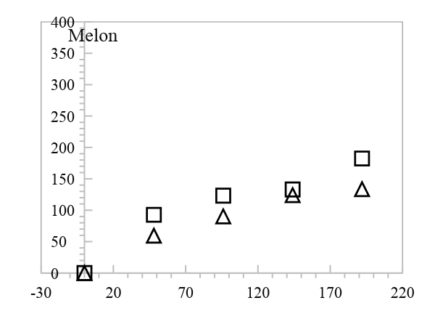

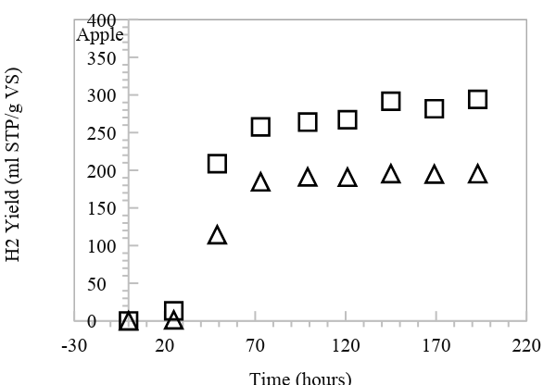

Figure 3. Profile of hydrogen yield during thermophilic fermentation (55 °C,1 atm) at various SIR values
(□ SIR 0.800, $∆ SIR 1.500$)

Conclusion
Optimization of hydrogen production from fruit waste through dark fermentation was achieved through adjustment of the substrate-to-inoculum ratio (SIR). It was demonstrated that the lower SIR value, the higher total gas yield. The highest one was achieved from fermentation of apple waste at thermophilic condition (55$℃$) and SIR of 0.800 g VS_{substrate}/g VS_{inoc} corresponding to H₂ yield of 294 ml STP/g VS_{added} (50-60%v of H₂). It was noticed that there is the consistency of SIR effect toward hydrogen production regardless the type of fruit waste. This optimized condition may be implemented to improve the renewable energy of hydrogen production for better environment.

Acknowledgements
Authors extend their gratitude to Swedish International Development Cooperation Agency (SIDA), Sweden and Ministry of Research and Higher Education of Indonesia for financially supporting this research.

References

1. Sugiawan, Y. and Managi, S. (2016). The environmental Kuznets curve in Indonesia: Exploring the potential of renewable energy. Energy Policy, 98: 187–198.
2. Alam, M. S. and Paramati, S. R. (2015). Do oil consumption and economic growth intensify environmental degradation? Evidence from developing economies. Applied Economics, 47: 5186–5203.
3. Kumar, S. (2016). Assessment of renewables for energy security and carbon mitigation in Southeast Asia: The case of Indonesia and Thailand. Applied Energy, 163: 63–70.
4. Mujiyanto, S. and Tiess, G. (2013). Secure energy supply in 2025: Indonesia’s need for an energy policy strategy. Energy Policy, 61: 31–41.
5. Elbeshbishy, E., Dhar, B. R., Nakhla, G. and Lee, H.-S. (2017). A critical review on inhibition of dark biohydrogen fermentation. Renewable and Sustainable Energy Reviews, 79: 656–668.
6. Gustavsson, J., Cederberg, C. and Sonesson, U. (2011). Global food losses and food waste. Food Agricultural Organization of United Nation. Access from http://www.fao.org/3/a-i2697e.pdf
7. Sanjaya, A., Cahyanto, M. and Millati, R. (2016). Mesophilic batch anaerobic digestion from fruit fragments. Renewable Energy, 98: 135–141.
8. Millati, R., Nurrihadini, O. D., Suroto, D. A. and Cahyari, K. (2009). Waste refinery program in Indonesia: Characterization of waste from “gemah ripah” fruit market as a feedstock for biogas production. Department of Chemical Engineering, Universitas Gadjah Mada, Indonesia.
9. Cappai, G., Gioannis, G. De and Muntoni, A. (2015). Effect of inoculum to substrate ratio (ISR) on hydrogen production through dark fermentation of food waste. In Proceeding Sardinia, 15th International Waste Management and Landfill Symposium. Cagliary, Italy: CISA Publisher.
10. Argun, H. and Dao, S. (2017). Bio-hydrogen production from waste peach pulp by dark fermentation: Effect of inoculum addition. International Journal of Hydrogen Energy, 42: 2569–2574.
11. Jeihanipour, A., Karimi, K. and Taherzadeh, M. J. (2010). Enhancement of ethanol and biogas production from high-crystalline cellulose by different modes of NMO pretreatment. Biotechnology and Bioengineering, 105: 469–476.
12. APHA (2012). Standard methods for the examination of water and wastewater. American Public Health Association, DC.
13. FAOUN. (2014). Data of Production Quantity of Crops. Access from http://www.fao.org/faostat/en/#data/QC [May 31, 2017].
14. Górnaś, P., Mišina, I., Olšteine, A., Krasnova, I., Pugajeva, I., Lācis, G., Siger, A., Michalak, M., Soliven, A. and Segliņa, D. (2015). Phenolic compounds in different fruit parts of crab apple: Dihydrochalcones as promising quality markers of industrial apple pomace by-products. Industrial Crops and Products, 74: 607–612.
15. Wang, L., Xu, H., Yuan, F., Pan, Q., Fan, R. and Gao, Y. (2015). Physicochemical characterization of five types of citrus dietary fibers. Biocatalysis and Agricultural Biotechnology, 4: 250–258.
16. Raji, Z., Khodaiyan, F., Rezaei, K., Kiani, H. and Hosseini, S. S. (2017). Extraction optimization and physicochemical properties of pectin from melon peel. International Journal of Biological Macromolecules, 98: 709–716.
17. Mallek-Ayadi, S., Bahloul, N. and Kechaou, N. (2017). Characterization, phenolic compounds and functional properties of Cucumis melo L. peels. Food Chemistry, 221: 1691–1697.
18. Macagnan, F. T., Santos, L. R. dos, Roberto, B. S., de Moura, F. A., Bizzani, M. and da Silva, L. P. (2015). Biological properties of apple pomace, orange bagasse and passion fruit peel as alternative sources of dietary fibre. Bioactive Carbohydrates and Dietary Fibre, 6: 1–6.
19. Atkinson, R. G. (2017). Phenylpropenes: Occurrence, distribution, and biosynthesis in fruit. Journal of Agricultural and Food Chemistry, 66(10): 2259-2272.
20. Ruiz, B. and Flotats, X. (2016). Effect of limonene on batch anaerobic digestion of citrus peel waste. Biochemical Engineering Journal, 109: 9-18.
21. Barreca, D., Bellocco, E., Laganà, G., Ginestra, G. and Bisignano, C. (2014). Biochemical and antimicrobial activity of phloretin and its glycosilated derivatives present in apple and kumquat. Food Chemistry, 160: 292–297.
22. Lin, C.-H., Lin, S. H., Lin, C.-C., Liu, Y.-C., Chen, C.-J., Chu, C.-L., Huang, H-C. and Lin, M.-K. (2016). Inhibitory effect of clove methanolic extract and eugenol on dendritic cell functions. Journal of Functional Foods, 27: 439–447.
23. Eker, S. and Sarp, M. (2017). Hydrogen gas production from waste paper by dark fermentation: Effects of initial substrate and biomass concentrations. International Journal of Hydrogen Energy, 42: 2562–2568.
24. Saratale, G. D., Chen, S.-D., Lo, Y.-C., Saratale, R. G. and Chang, J.-S. (2008). Outlook of biohydrogen production from lignocellulosic feedstock using dark fermentation - a review. Journal of Scientific and Industrial Research, 67: 962–979.
25. Laothanachareon, T., Kanchanasuta, S., Mhuanthong, W., Phalakornkule, C., Pisutpaisal, N. and Champreda, V. (2014). Analysis of microbial community adaptation in mesophilic hydrogen fermentation from food waste by tagged 16S rRNA gene pyrosequencing. Journal of Environmental Management, 144: 143–151.
26. Gokfiliz, P. and Karapinar, I. (2017). The effect of support particle type on thermophilic hydrogen production by immobilized batch dark fermentation. International Journal of Hydrogen Energy, 42: 2553–2561.

