

EXTRACTION AND ISOLATION OF HIGH QUANTITIES OF CANNABIDIOL, CANNABINOL, AND DELTA-9-TETRAHYDROCANNABINOL FROM Cannabis sativa L.

(Pengekstrakan dan Pengasingan Kuantiti Tinggi bagi Cannabidiol, Cannabinol dan Delta-9-Tetrahidrocannabinol dari Cannabis sativa L.)

Fameera Madaka^{1,2}*, Natawat Chankana^{2,3}, Nanthaphong Khamthong⁴, Athip Maha², Thanapat Songsak^{2,5}

¹Drug and Herbal Product Research and Development Center
²Medicinal Cannabis Research Institute
³Sun Herb Thai-Chinese Manufacturing
⁴College of Oriental Medicine
⁵Department of Pharmacognosy
College of Pharmacy, Rangsit University, Thailand

*Corresponding author: fameera.m@rsu.ac.th

Received: 4 August 2021; Accepted: 7 October 2021; Published: xx October 2021

Abstract
This study aimed to develop the extraction and isolation methods of cannabinoids including cannabidiol (CBD), cannabinol (CBN), and delta-9-tetrahydrocannabinol (THC), from Cannabis sativa L. using supercritical fluid extraction (SFE) and flash chromatography, respectively. SFE was performed at different pressures (190-300 bar), temperatures (42-50 ºC), and ethanol as co-solvent (0-4%). The effect of SFE parameters on the yield, and the contents of CBD, CBN, and THC in the crude extracts were investigated. Among the seventeen samples, the highest extraction yields of 7.02, 6.90, and 4.61% were obtained, respectively. Under the setting pressure of 250 bar, the temperature of 50 ºC, and the co-solvent of 1-2%, high- performance liquid chromatography (HPLC) analysis showed the highest contents of CBD (14.53% w/w), CBN (26.75% w/w), and THC (3.21% w/w). Three extracts with high CBD, CBN, and THC contents were selected and further purified by flash chromatography, and the three isolated cannabinoids were analyzed by nuclear magnetic resonance (NMR) and HPLC. Our sequential SFE and flash chromatography process could be employed to obtain a high quantity of cannabinoids which proved that a high purity could be achieved for CBD, CBN, and THC.

Keywords: Cannabis sativa L., cannabidiol, cannabinol, delta-9-tetrahydrocannabinol, supercritical fluid extraction

Abstrak
Kajian ini bertujuan untuk mengembangkan kaedah pengekstrakan dan pengasingan kanabinoid termasuk cannabidiol (CBD), cannabinol (CBN), dan delta-9-tetrahidrocannabinol (THC), dari Cannabis sativa L. menggunakan masing-masing pengekstrakan cecair supergenting (SFE) dan kromatografi kilat. SFE dilakukan pada tekanan yang berbeza (190-300 bar), suhu (42-50ºC), dan etanol sebagai pelarut bersama (0-4%). Pengaruh parameter SFE terhadap hasil, dan kandungan CBD, CBN, dan THC dalam ekstrak mentah disiasat. Di antara tujuh belas sampel, hasil pengekstrakan tertinggi masing-masing adalah 7.02, 6.90, dan 4.61%. Di bawah tekanan penetapan 250 bar, suhu 50ºC, dan pelarut bersama 1-2%, analisis kromatografi cecair berprestasi tinggi (HPLC) menunjukkan kandungan CBD tertinggi (14.53% w/w), CBN (26.75% w/w), dan THC (3.21% w/w). Tiga ekstrak dengan kandungan CBD, CBN, dan THC yang tinggi dipilih dan selanjutnya dimurnikan dengan kromatografi kilat, dan tiga kanabinoid yang diasingkan dianalisis mengunakan magnetic resonan nukleus (NMR) dan HPLC. Proses kromatografi kilat dan SFE berurutan kami dapat digunakan untuk mendapatkan jumlah kanabinoid yang tinggi yang membuktikan bahawa kemurnian tinggi dapat dicapai untuk CBD, CBN, dan THC.

Kata kunci: Cannabis sativa L., cannabidiol, cannabinol, delta-9-tetrahidrocannabinol, pengekstrakan cecair supergenting

Introduction
There is a growing interest in herbal compounds in medicine. Cannabis (Cannabis sativa L.) belongs to the Cannabaceae family and is one of the most popular known medicinal plants. In Thailand, Cannabis is illegal. However, there are limited laws that allow the use of hemp (Cannabis sativa subsp. sativa) containing high cannabidiol (CBD) and low delta-9-tetrahydrocannabinol (THC). Cannabis contains over 60 cannabinoids [1]. It is well known that THC and CBD are the most prevalent cannabinoids as well as those with the most useful medicinal properties in the cannabis plant and its associated products [2]. CBD is a non-psychoactive cannabinoid with antiepileptic properties. THC, however, is predominantly known for its psychotropic effects [3]. Prior to quality control of high quantities of active compounds from Cannabis, crude plant material must undergo effective extraction. Several methods for the extraction of cannabinoids from cannabis have been reported in numerous studies, such as ultrasonic-assisted solvent extraction, soxhlet extraction, derivatization, and microwave-assisted extraction. Each method requires an appropriate selection of specific conditions, such as type of the solvent, temperature, pressure, and some of the methods require long extraction times or large volumes of flammable solvents, many of which are toxic. Recently, supercritical fluid extraction (SFE) with carbon dioxide (CO₂) has been presented as a good alternative for the extraction-separation of cannabinoids, which utilizes an inexpensive GRAS (generally recognized as safe) solvent with very well-known physicochemical properties. CO₂ reaches a supercritical state at 304.25 K and 7.39 MPa and returns to a gas state under an ambient condition, allowing a simple solute to recover, thus providing a solvent-free product. Besides, sensitive changes in pressure and temperature the CO₂ solvent strength can be tuned, this change in the medium provides to some extent, selectivity to the extraction process [4]. However, the low polarity of supercritical carbon dioxide requires that small amounts of alcohol, water, and acids be used in SFE to improve the yields and in some cases the selectivity of the extraction. For example, ethanol (EtOH) can be used in SFE to increase extraction yield for some cannabinoids.

Also, several analytical techniques have been developed for the identification, quantification, and isolation of the extracted cannabinoids, which include a screening test based on colorimetric reactions, like the Fast Blue salt test and the Duquenois-Levine test, radioimmunoassay (RIA), ion mobility mass spectrometry (IMS), thin-layer chromatography (TLC), high-performance liquid chromatography (HPLC), gas chromatography (GC), infrared spectroscopy (IR), mass spectrometry (MS), and nuclear magnetic resonance spectroscopy (NMR) [5]. Some of these have disadvantages such as the need for multiple isolation steps, the use of toxic and polluting organic solvents, and the low purity of obtained substances. In this study, the researchers aimed to develop SFE process (e.g. pressure, temperature, and ethanol as co-solvent) to obtain a high quantity of cannabinoids, including CBD, CBN, and THC from Cannabis sativa L., as well as a means to develop the isolation method using flash chromatography to obtain a high purity of CBD, CBN, and THC.

Materials and Methods
Chemicals
Cannabinoid standards (CBD, CBN, and THC) with a purity of over 98% were isolated and purified from the Medicinal Cannabis Research Institute, College of Pharmacy, Rangsit University, Thailand. They were prepared by flash chromatography and prep-HPLC and certificated through spectroscopy. Carbon dioxide was supplied by Lor Ching Tong Oxygen & Acetylene Co. Ltd. Hexane (AR grade), dichloromethane (AR grade), ethyl acetate (AR grade), methanol (AR grade), 2-propanol (AR grade), methanol (HPLC grade), water (HPLC grade), and ethanol (commercial grade) were purchased from RCI Labscan Ltd. FlashPure Silica and C18 (ID 40 and 120 g; 40 μm) were supplied by Buchi (Thailand) Ltd. TLC Silica gel 60 F₂₅₄ and TLC Silica gel 60 RP-18 F₂₅₄S were purchased from Merck (Germany). P-Anisaldehyde (98%, 100 g) was obtained from Sigma-Aldrich Chemical Co. (Seelze, Germany).

Sample preparation
An amount 12 kg of dried cannabis samples (Cannabis sativa L.) were supplied from illegal narcotic drugs in Thailand arrested by the Narcotics Suppression Bureau and legally authorized representatives in research by the Office of the Narcotics Control Board and the Food and Drug Administration, Thailand. They were deposited at the College of Pharmacy, Rangsit University, Thailand. The samples of cannabis were pulverized with the water content controlled at 5-10% and then kept in a desiccator cabinet at room temperature until they were used for extractions.

Supercritical fluid extraction
A 5L*1Supercritical CO₂ Machine (Model HA120-50-05-C) from Nantong Huaan Supercritical Extraction Co. Ltd. was used in these experiments and is represented schematically in Figure 1. The main technical parameters included the highest extraction pressure (50MPa) possible with a single-cylinder extraction volume (5L), a normal extraction temperature of ~75 ºC, a maximum flow of 0∼50 L/h adjustable, and a three-phase five-wire system, 380 V/50HZ, 10KW power supply. Ethanol as a co-solvent was supplied by a liquid pump and mixed with the main CO₂ stream before at the extraction kettle. The researchers optimized process parameters including sample particle size, pressure, temperature, co-solvent, and extraction time. The particle sizes of the sample were set at 14 and 20-40 mesh, with the amount ranging from 420 to 920 g within a 5-L material tank. The samples were loaded into the barrel such that each was not too full, 2-3 cm away from the filter. SFE was performed at different pressures and temperatures of extraction kettle (190-300 bar and 42-50 ºC), separation kettle I (80-90 bar and 55 ºC), and separation kettle II (40-50 bar and 35-40 ºC), co-solvent (0-4%), and extraction times (60-120 min) according to the experiment design outlined in Table 1. Following the extraction, ethanol was removed under vacuum and the extracts were weighed and analyzed using HPLC to quantify their cannabinoid (CBD, CBN, and THC) content.

HPLC analysis of cannabinoids from cannabis extract
Analysis of cannabinoids and the quantification of CBD, CBN, and THC were carried out using an HPLC instrument (Agilent 1260 Infinity, Agilent, USA). The methodology followed Saingam and Sakunpak [6]. A reverse-phase Zorbax C-18 column of 4.6 mm × 100 mm and 3.5 μm was used for the isocratic separation. It was eluted by using a mixture (85:15) of methanol and ultrapure water as the mobile phase with the flow rate set to 1.0 mL/min and an injection volume of 10 μL. The column temperature was controlled at 25 ± 0.5 ºC. The response signal was coupled to a UV detector set to 220 nm. UV spectra scanning from 190 to 400 nm were recorded online for peak identification. The total analysis time for each injection was 10 min. Peak identification was carried out by comparing the retention times and UV absorption spectra of the samples with those of the standard solutions of CBD, CBN, and THC.

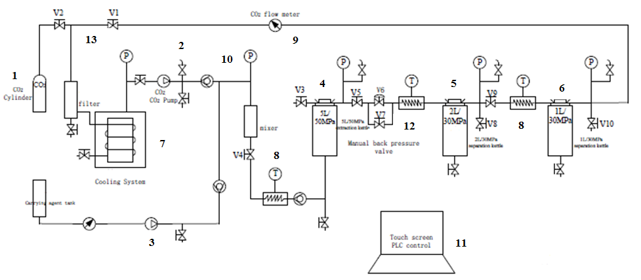
Figure 1. Schematic diagram of SFE (Model HA120-50-05-C) apparatus. (1) CO₂ cylinder, (2) CO₂ pump, (3) carrying agent pump, (4) extraction kettle, (5) separation kettle I, (6) separation kettle II, (7) cooling system, (8) temperature control, (9) CO₂ flow meter, (10) pressure control measurement system, (11) touch screen PLC control, (12) manual back pressure valve, (13) valves

Table 1. Parameters for the extraction of SFE from Cannabis sativa L.
Samples  (g) | Sieve (Mesh) | Extraction  Kettle |  |  | Co-Solvent (%) |  | Separation  Kettle I |  |  | Separation  Kettle II |  |  | Extraction Time  (min)
Samples  (g) | Sieve (Mesh) | Pressure (Bar) | Temp.  (°C) |  |  | Pressure (Bar) |  | Temp.  (°C) | Pressure (Bar) |  | Temp.  (°C) | Separation Kettle I |  | Separation Kettle II
1. 750 | 14 | 290-300 | 50 | - |  | 60-70 |  | 55 | 40-50 |  | 35-40 | 60 |  | -
2. 750 | 14 | 290-300 | 50 | 1% |  | 60-70 |  | 55 | 40-50 |  | 35-40 | 60 |  | -
3. 480 | 20-40 | 250 | 50 | 1% |  | 80-90 |  | 55 | 40-50 |  | 35-40 | 60 |  | -
3a. 480 | 20-40 | 250 | 50 | 1% |  | 80-90 |  | 55 | 40-50 |  | 35-40 | - |  | 60
3b. 480 | 20-40 | 250 | 50 | 1% |  | 80-90 |  | 55 | 40-50 |  | 35-40 | - |  | 60
4. 900 | 20-40 | 190-200 | 50 | 1% |  | 80-90 |  | 55 | 40-50 |  | 35-40 | 60 |  | -
4a. 900 | 20-40 | 190-200 | 50 | 1% |  | 80-90 |  | 55 | 40-50 |  | 35-40 | - |  | 110
4b. 900 | 20-40 | 190-200 | 50 | 1% |  | 80-90 |  | 55 | 40-50 |  | 35-40 | - |  | 110
5. 920 | 20-40 | 250 | 50 | 2% |  | 80-90 |  | 55 | 40-50 |  | 35-40 | 60 |  | -
5a. 920 | 20-40 | 250 | 50 | 2% |  | 80-90 |  | 55 | 40-50 |  | 35-40 | - |  | 120
5b. 920 | 20-40 | 250 | 50 | 2% |  | 80-90 |  | 55 | 40-50 |  | 35-40 | - |  | 120
6. 420 | 20-40 | 250 | 42 | 3% |  | 80-90 |  | 55 | 40-50 |  | 35-40 | 60 |  | -
6a. 420 | 20-40 | 250 | 42 | 3% |  | 80-90 |  | 55 | 40-50 |  | 35-40 | - |  | 90
6b. 420 | 20-40 | 250 | 42 | 3% |  | 80-90 |  | 55 | 40-50 |  | 35-40 | - |  | 90
7. 500 | 20-40 | 250 | 42 | 4% |  | 80-90 |  | 55 | 40-50 |  | 35-40 | 60 |  | -
7a. 500 | 20-40 | 250 | 42 | 4% |  | 80-90 |  | 55 | 40-50 |  | 35-40 | - |  | 60
7b. 500 | 20-40 | 250 | 42 | 4% |  | 80-90 |  | 55 | 40-50 |  | 35-40 | - |  | 60

Isolation of cannabinoids and the purification process

The SFE result was used to analyze, using the previously described HPLC method, and select the extract with a good extraction yield and the highest CBD, CBN, and THC content. 30 g of the extract (sample no. 5) from separation kettle I in 90% methanol was partitioned with hexane. Each partition and the obtained extracts (samples no. 4b and 5b) from separation kettle II were evaporated to dryness in a vacuum to produce residues of hexane, methanol, and ethanol, respectively. These extracts underwent isolation and purification by flash chromatography in the Reveleris®PREP Purification System. The normal-phase and reverse-phase flash chromatography methods were used to purify CBD, CBN and, THC within the range of parameters presented in Tables 2 and 3. 13.70 g of the methanol extract (sample no. 5) were dissolved in dichloromethane, sonicated for 10 minutes then filtered through 0.45 µm pore-size filters and separated by an approach that used normal-phase flash chromatography. The parameters of the flash purification of CBD, CBN, and THC from other substances were optimized on a cartridge (FlashPure ID Silica120 g; 40 µm and 40 g respectively). The fractions were collected, by which each was analyzed by thin-layer chromatography (TLC) and separated by an approach that used reverse-phase flash chromatography with a cartridge (FlashPure ID C18 120 g; 40 µm). Finally, three major peaks were collected and identified by nuclear magnetic resonance (NMR) to confirm the purity of the CBD, CBN, and THC. Other extracts (samples no. 5, 4b, and 5b) were separated for each run. The parameters used were similar to sample no. 5 but used multiple isolation steps. The methodology of the isolation and purification of CBD, CBN, and THC are shown in Figures 2-4.

Table 2. Parameters of normal-phase flash chromatography
Cartridge | FlashPure ID Silica 40 g and 120 g
Particle size | 40 μm
Sample loader | Liquid sample
Sample loop | 5-10 mL
Mobile phase | Dichloromethane/hexane gradient (70-50%)  Hexane/ethyl acetate isocratic (95:5%)
Flow rate | 5-50 mL/min
Detector | UV detector: 254, 220 and 280 nm  ELSD
Collect | Peaks
Pre-vial volume | 7-25 mL

Table 3. Parameters of reverse-phase flash chromatography
Cartridge | FlashPure ID C18 120 g
Particle size | 40 μm
Sample loader | Liquid sample
Sample loop | 5-10 mL
Mobile phase | Methanol /water isocratic (90:10%)
Flow rate | 10-30 mL/min
Detector | UV: 254, 220, and 280 nm  ELSD
Collect | Peaks
Pre-vial volume | 10-25 mL
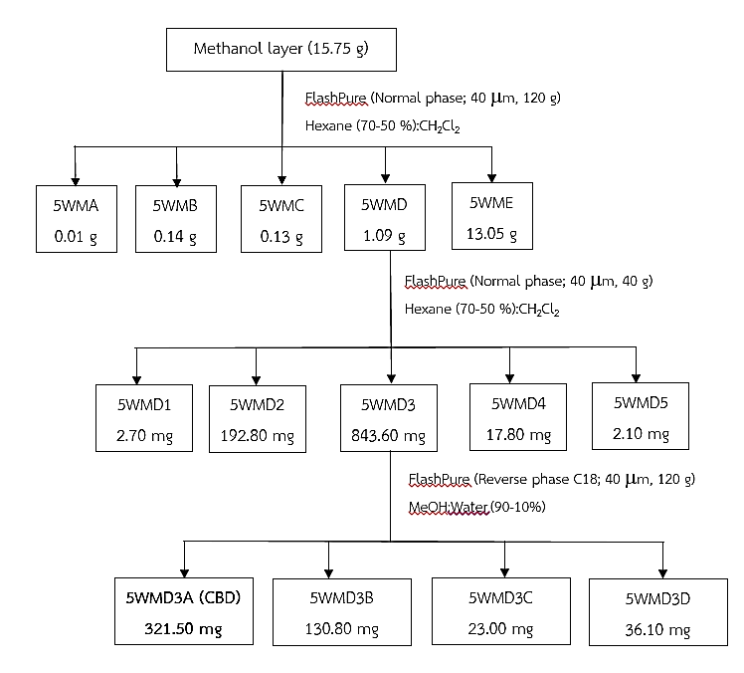
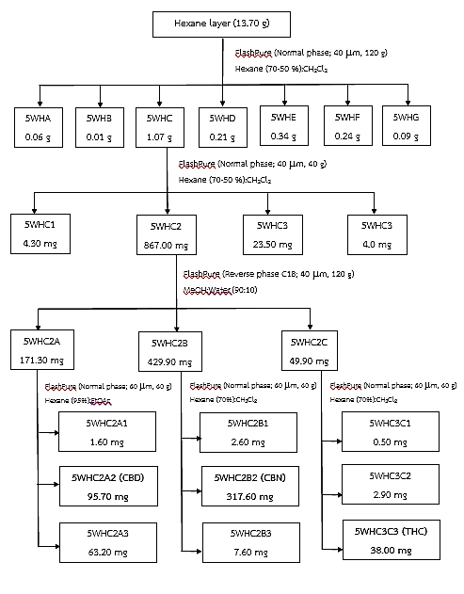
Figure 2. The methodology employed for the purification of the methanol layer (sample no. 5) using flash chromatography

Figure 3. The methodology employed for purification of the hexane layer (sample no. 5) using flash chromatography
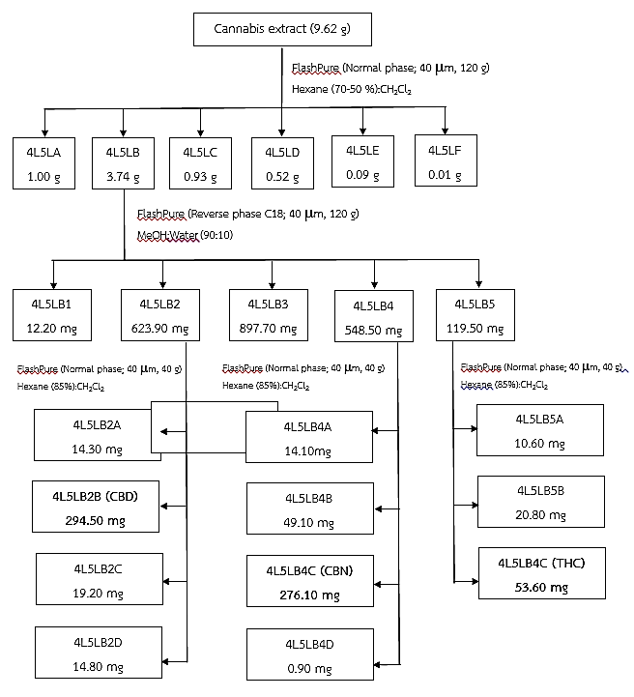
Figure 4. The methodology employed for the purification of the cannabis extract (samples no. 4b and 5b) using flash chromatography

Results and Discussion
Extraction yield
The development of the SFE extraction method was carried out by examining several factors, including pressure, temperature, co-solvent, and extraction time, together with sample particle size. The results of the extraction are shown in Table 4. Among the seventeen samples, the highest extraction yield was 7.02% (sample no. 3), followed by sample no. 5 (6.90%). Each was obtained with the pressure and temperature of the extraction kettle, separation kettle I, and separation kettle II set at 250 bar and 50 ºC, 80-90 bar and 55 ºC, and 40-50 bar and 35-40 ºC, respectively, with the co-solvent of 1-2% and the extraction time (60 min). The third highest is sample no. 4 (4.61%), obtained at 190-200 bar and 50 ºC, 80-90 bar and 55 ºC, and 40-50 bar and 35-40 ºC, respectively, with the co-solvent (1%) and extraction time (60 min). Other extracts with a low extraction yield below 4.61% were samples no.1, 2, 3a-3b, 4a-4b, 5a-5b, 6, 6a-6b, 7, and 7a-7b (between 0.34-3.24%). These factors directly affect the yield of cannabinoid compounds at the end of the extraction process. It is worth noting that similar results were previously reported by Richard [7]. These results suggest that the pressure and temperature of the extraction kettle (250 bar and 50 ºC), co-solvent (1-2%), and extraction time (60 min) favor the highest extraction yield from the dried cannabis plant. Moreover, Gallo-Molina et al. [8] reported a maximum extraction yield of 26.36%, which was obtained at 330 bar, 80 ºC, and 5% EtOH (extract number 6) using the highest levels of extraction pressure, temperature, and co-solvent. At these conditions, the high pressure and temperature can enhance the extraction yield. Another extract with a high yield was number 4 (23.36%) that was obtained at 150 bar, 40 ºC, and 5% EtOH using the lowest levels of extraction pressure, temperature, and co-solvent. Extract numbers 4 and 6 showed a higher extraction yield than those from samples no. 3, 5, and 4. However, these extracts were obtained using different levels of pressure and temperature. Omar et al. [9] reported that for SFE with CO₂/EtOH the extraction of cannabinoids from the cannabis plant was better at low temperatures.

HPLC analysis
In the HPLC analysis, the retention times of CBD, CBN, and THC were observed at 3.18, 5.42, and 6.80 minutes, respectively (Figure 5). The HPLC chromatograms of samples no. 5, 4b, and 5b in the extracts showed that CBD, CBN, and THC eluted at the same retention time as those of the standards (Figure 6). Table 4 shows the results of the experiment. The CBD content of extracts ranged from 4.03 to 14.53% w/w, with the highest at 14.53, 12.51, and 10.43 % w/w (samples no. 4b, 4, and 5 respectively). CBN content ranged from 4.32 to 26.75% w/w, with the highest at 26.75, 25.22, and 23.58 % w/w (samples no. 5b, 1, and 2 respectively). Finally, THC content ranged from 0.55 to 3.21% w/w, with the highest at 3.21, 2.14, and 1.96% w/w (samples no. 3, 5b, and 1 respectively). In the present study, the THC content of extracts is lower compared with those of Gallo-Molina et al., Omar et al., and Rovetto and Aieta (24.73- 37.85%, 0.45-32.4%, and 64.2-76.2%) [4, 8, 9]. The cannabis raw material used in this study was supplied from illegal narcotic drugs in Thailand arrested by the Narcotics Suppression Bureau. Further, degradation of THC will result in CBN. These results showed the cannabinoid content of the CBN is also higher than that of the THC. Therefore, the THC content of extracts can thus be very different despite using the same extraction method, co-solvent, and similar conditions. Previously, Rovetto and Aieta reported that the addition of ethanol as a co-solvent in SFE enhanced the cannabinoids extraction efficiency, including THC. Gallo-Molina et al. also suggested that the co-solvent levels between 2-5% favor the extraction of THC from the cannabis plant. It is worth mentioning that a similar result in this study was obtained using the concentration of the co-solvent of between 1-4%.

Table 4. Extraction yields and the CBD, CBN and THC content of SFE extracts from Cannabis sativa L.
Samples | Separation  Kettle I | Separation  Kettle II | Separation  Kettle I | Separation  Kettle II | Cannabinoid Content ^{B}
Samples | Extracts  (g) |  | Extraction Yields ^{A}  (% w/w) |  | CBD  (% w/w) | CBN  (% w/w) | THC  (% w/w)
1. | 17.20 | - | 2.29 | - | 7.68 ± 0.01 | 25.22 ± 0.01 | 1.96 ± 0.01
2. | 5.30 | - | 0.71 | - | 5.30 ± 0.00 | 23.58 ± 0.02 | 1.43 ± 0.01
3. | 33.69 | - | 7.02 | - | 8.44 ± 0.01 | 19.28 ± 0.01 | 3.21 ± 0.02
3a. | - | 6.47 | - | 1.35 | 1.53 ± 0.00 | 6.81 ± 0.02 | 0.55 ± 0.01
3b. | - | 5.68 | - | 1.18 | 4.58 ± 0.01 | 15.63 ± 0.01 | 1.81 ± 0.02
4. | 41.49 | - | 4.61 | - | 12.51 ± 0.06 | 18.83 ± 0.03 | 1.82 ± 0.01
4a. | - | 3.66 | - | 0.41 | 8.13 ± 0.14 | 18.93 ± 0.01 | 1.36 ± 0.02
4b. |  | 3.44 | - | 0.38 | 14.53 ± 0.00 | 22.40 ± 0.25 | 1.90 ± 0.02
5. | 63.44 | - | 6.90 | - | 10.43 ± 0.00 | 19.67 ± 0.01 | 1.81 ± 0.01
5a. | - | 4.70 | - | 0.51 | 5.52 ± 0.01 | 11.34 ± 0.00 | 0.84 ± 0.00
5b. | - | 8.60 | - | 0.93 | 10.30 ± 0.01 | 26.75 ± 0.01 | 2.14 ± 0.01
6. | 16.85 | - | 4.01 | - | 4.03 ± 0.01 | 13.33 ± 0.02 | 0.89 ± 0.02
6a. | - | 1.49 | - | 0.35 | 6.21 ± 0.02 | 16.11 ± 0.01 | 1.00 ± 0.02
6b. | - | 6.57 | - | 1.56 | 7.18 ± 0.02 | 18.41 ± 0.01 | 1.08 ± 0.01
7. | 16.18 | - | 3.24 | - | 5.91 ± 0.01 | 21.75 ± 0.01 | 1.41 ± 0.01
7a. | - | 3.34 | - | 0.67 | 7.49 ± 0.01 | 4.38 ± 0.00 | 1.23 ± 0.02
7b. | - | 1.72 | - | 0.34 | 7.39 ± 0.01 | 4.32 ± 0.01 | 1.09 ± 0.01
ª in dry cannabis samples
^{b} in dry extracts

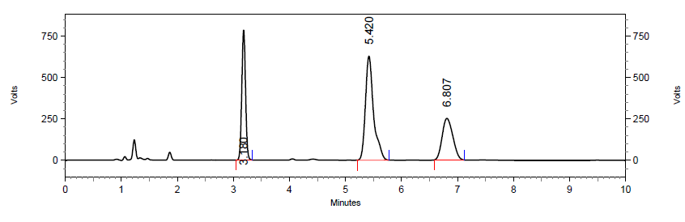
(c)
(a)
(b)
Figure 5. HPLC chromatogram of standard solution (a) CBD, (b) CBN, and (c) THC at a concentration of 100 μg/mL

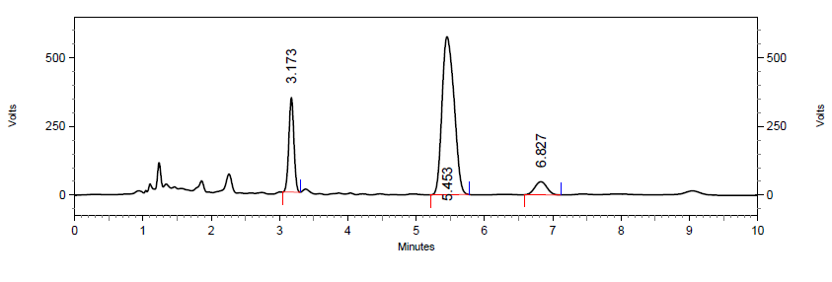
Sample no. 3

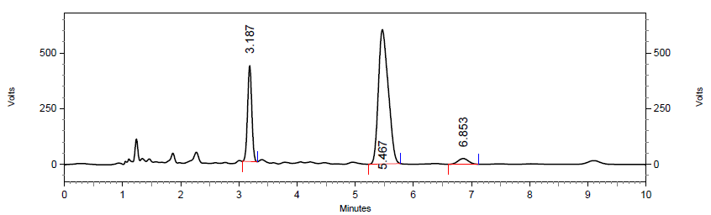
Sample no. 5

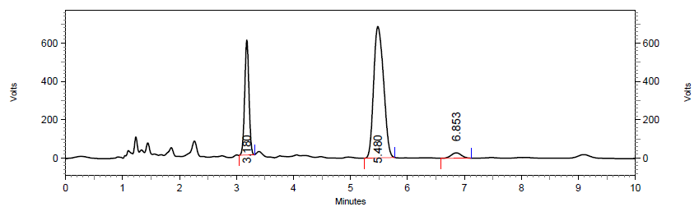
Sample no. 4b

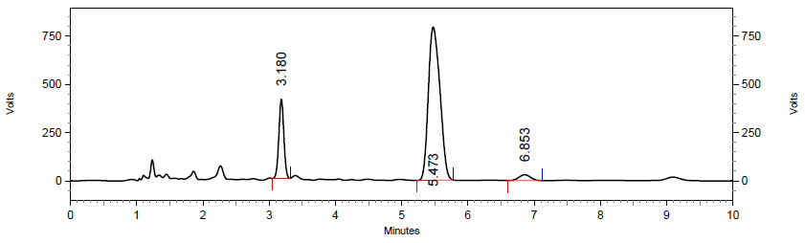
Sample no. 5b
Figure 6. HPLC chromatogram of the cannabis extracts

Isolation and purification of cannabinoids
The results shown in the previous section indicated that samples no. 5, 4b, and 5b are candidates for further purification. These extracts underwent isolation and purification by flash chromatography in the Reveleris®PREP Purification System. The results from the normal-phase flash chromatography method with a 70-50% dichloromethane/hexane gradient showed a good separation with one major peak, which was cannabinoids, and a few minor peaks (Figure 7). After evaporation, each normal-phase fraction was dissolved in MeOH, which was then injected on the reverse-phase flash cartridge. The reverse-phase purification of normal-phase fractions with a methanol/water isocratic (90:10%) was performed on each fraction composing the three major peaks (Figure 8), a much cleaner chromatogram than that in Figure 6. Each one was analyzed by TLC to detect the purity and presence of CBD, CBN, and THC. The dried final fractions thus obtained were weighed and subjected to NMR analysis to confirm the purity of CBD, CBN, and THC. Tables 5-7 compare the ¹H-NMR and ¹³C-NMR signals of the final fractions with CBD, CBN, and THC signals reported in the literature. The ¹H-NMR and ¹³C-NMR signals observed for the final fractions are very similar to those reported for CBD, CBN, and THC by Choi et al. [10] and Leite et al. [11]. The ¹H-NMR signals of CBD were observed in the final fraction 1 spectra (Figure 9): the aromatic protons H-2′ and H-3′ of two distinct broad singlets at 5.99 and 6.27 ppm, respectively. The multiplet centered at 3.87 ppm was assigned to the H-1 proton. The singlet at 5.57 ppm was generated by terpenic H-2 and the other broad singlet at 4.85 ppm resulted from the resonance of the aromatic OH groups. The ¹H-NMR spectrum of final fraction 2 showed a signal at 8.19 ppm (singlet) due to aromatic hydrogen H-2 of CBN, and two other characteristic signals of CBN appear at 7.07 ppm (doublet, J = 8.0 Hz) and 7.15 ppm (doublet, J = 8.0 Hz). They are due to aromatic hydrogens H-4 and H-5, (Figure 10) respectively. The ¹H-NMR spectrum confirmed that final fraction 3 was THC, showing signals due to the olefinic H-2 proton at 6.31 ppm; H-9 and H-8 protons of angular methyl groups at 1.09 and 1.41 ppm (singlet), respectively; H-6 proton at 1.68 ppm; the aromatic H-5′ proton at 6.27 ppm (doublet, J = 1.5 Hz); and the H-5a and H-5b proton at 1.91 and 1.40 ppm (Figure 11), respectively.

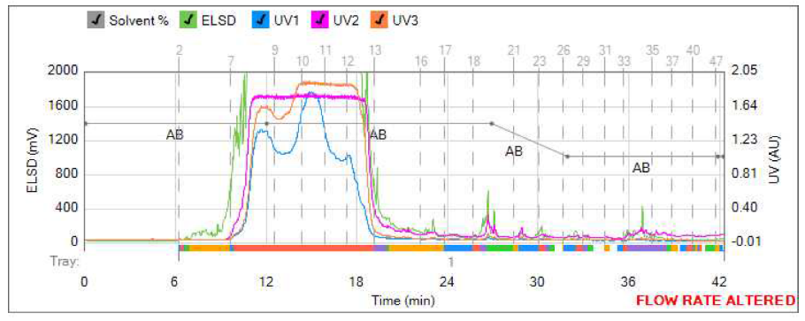
Figure 7. Separation of the extracted cannabinoids using the normal-phase flash chromatography

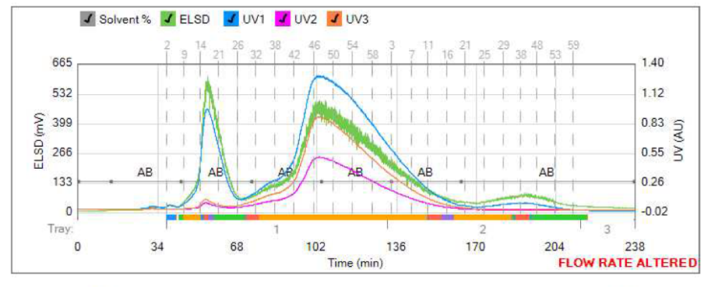
(c)
(a)
(b)
Figure 8. Separation of (a) CBD, (b) CBN, and (c) THC using the reverse-phase flash chromatography

Table 5. ¹H-NMR and ¹³C-NMR spectroscopy data for final fraction 1 and CBD
Position | ¹H-NMR (δ ppm, J Hz) |  | ¹³C-NMR (δ ppm)
Position | Final Fraction (1)  (500MHz) | CBDª  [10] | Final Fraction (1) (100MHz) | CBD^{b} [10]
1 | 3.87 (1H, dm, J = 10.5 Hz) | 3.90 (1H, dm, J = 11.1 Hz) | 37.14 | 37.50
2 | 5.57 (1H, s) | 5.57 (1H, s) | 124.12 | 127.30
3 | - | - | 139.98 | 134.20
4 | 2.23 (1H, m, H_{a}-4), 2.09 (1H, m, H_{b}-4) | 2.21 (1H, m), 2.09 (1H, m) | 30.36 | 30.70
5 | 1.83 (1H, m) | 1.84 (m) | 28.36 | 31.70
6 | 2.40 (1H, td, J = 11.0, 3.0 Hz) | 2.40 (m) | 46.14 | 46.40
7 | 1.79 (3H, s) | 1.79 (3H, s) | 23.63 | 23.70
8 | - | - | 149.25 | 150.3
9 | 4.65 (1H, m, H_{a}-9), 4.55 (1H, m, H_{b}-9) | 4.64 (trans, 1H, m), 4.54 (cis, 1H, m) | 110.81 | 110.50
10 | 1.66 (3H, s) | 1.66 (3H, s) | 20.39 | 19.50

Table 5 (cont’d). ¹H-NMR and ¹³C-NMR spectroscopy data for final fraction 1 and CBD
Position | ¹H-NMR (δ ppm, J Hz) |  | ¹³C-NMR (δ ppm)
Position | Final Fraction (1)  (500MHz) | CBDª  [10] | Final Fraction (1) (100MHz) | CBD^{b} [10]
1' | - | - | 113.75 | 115.90
2'-OH | 5.99 (1H, brs) | 5.99 (1H, s) | 156.08 | 157.50
3' | 6.27 (1H, brs, H-3') | 6.26 (1H, brs, H-3') | 107.95 | 108.30
4' | - | - | 142.99 | 142.70
5' | 6.17 (1H, brs, H-5') | 6.16 (1H, brs, H-5') | 109.67 | 108.30
6'-OH | 4.85 (1H, brs) | 5.02 (1H, s) | 153.90 | 150.30
1'' | 2.43 (2H, t, J = 7.5 Hz) | 2.43 (2H, t, J = 7.5 Hz) | 35.45 | 36.60
2'' | 1.55 (2H, q, J = 7.5 Hz) | 1.55 (2H, q, J = 7.6 Hz) | 30.60 | 32.00
3'' | 1.29 (4H, m, H₂-3'') | 1.29 (4H, m) | 31.46 | 32.60
4'' | 1.29 (4H, m, H₂-4'') | 1.29 (4H, m) | 22.50 | 23.60
5'' | 0.88 (3H, t, J = 7.0 Hz) | 0.88 (3H, t, J = 6.8 Hz) | 14.00 | 14.40
δ (ppm): Chemical shift.
J (Hz): Nuclear spin-spin coupling constant.
ª Reported data obtained using 400 MHz NMR equipment
^{b} Reported data obtained using 100 MHz NMR equipment

Table 6. ¹H-NMR and ¹³C-NMR spectroscopy data for final fraction 2 and CBN
Position | ¹H-NMR (δ ppm, J Hz) |  | ¹³C-NMR (δ ppm)
Position | Final Fraction (2)  (500MHz) | CBNª  [11] | Final Fraction (2)  (100MHz) | CBN^{b}  [10]
1 | - | - | 108.67 | 108.70
2 | 8.19 (1H, s) | 8.16 (1H, s) | 126.41 | 126.30
3 | - | - | 136.85 | 136.90
3-Me | 2.39 (3H, s) | 2.38 (3H, s) | 21.50 | 21.50
4 | 7.07 (1H, d, J = 8.0 Hz) | 7.07 (1H, d, J = 7.9 Hz) | 127.54 | 127.60
5 | 7.15 (1H, d, J = 8.0 Hz) | 7.14 (1H, d, J = 7.9 Hz) | 122.56 | 122.60
6 | - | - | 136.81 | 136.90
7 | - | - | 77.30 | 77.50
8 | 1.61 (6H, s,) | 1.60 (6H, s,) | 27.08 | 27.10
9 | 1.61 (6H, s) | 1.60 (6H, s) | 27.08 | 27.10
1' | - | - | 110.67 | 110.80
2' | - | - | 154.57 | 154.70
3' | 6.29 (1H, d, J = 1.5 Hz) | 6.29 (1H, d, J = 1.1 Hz) | 109.84 | 109.80
4' | - | - | 144.49 | 144.50
5' | 6.44 (1H, d, J = 1.5 Hz) | 6.44 (1H, d, J = 1.1 Hz) | 110.67 | 110.80
6' | - | - | 153.11 | 153.00
1'' | 2.50 (2H, t, J = 7.5 Hz) | 2.50 (2H, t, J = 7.5 Hz) | 35.58 | 35.60

Table 6 (cont’d). ¹H-NMR and ¹³C-NMR spectroscopy data for final fraction 2 and CBN
Position | ¹H-NMR (δ ppm, J Hz) |  | ¹³C-NMR (δ ppm)
Position | Final Fraction (2)  (500MHz) | CBNª  [11] | Final Fraction (2)  (100MHz) | CBN^{b}  [10]
2'' | 1.63 (2H, m) | 1.63 (2H, m) | 30.43 | 30.40
3'' | 1.32 (4H, m) | 1.32 (4H, m) | 31.45 | 31.50
4'' | 1.32 (4H, m) | 1.32 (4H, m) | 22.51 | 22.50
5'' | 0.90 (3H, t, J = 7.0 Hz) | 0.89 (3H, t, J = 6.8 Hz) | 14.00 | 14.00
2'-OH | 5.47 (1H, s) | 5.13 (1H, s) | - | -
δ (ppm): Chemical shift.
J (Hz): Nuclear spin-spin coupling constant.
ª Reported data obtained using 400 MHz NMR equipment
^{b} Reported data obtained using 100 MHz NMR equipment

Table 7. ¹H-NMR and ¹³C-NMR spectroscopy data for final fraction 3 and THC
Position | ¹H-NMR (δ ppm, J Hz) |  | ¹³C-NMR (δ ppm)
Position | Final Fraction (3)  (500MHz) | THCª [11] | Final Fraction (3)  (100MHz) | THC^{b}  [10]
1 | 3.21 (1H, d, J = 11.5 Hz) | 3.20 (1H, dm, J = 10.9 Hz) | 33.56 | 33.60
2 | 6.31 (1H, brs) | 6.31 (1H, q, J = 16.0 Hz) | 123.73 | 123.70
3 | - | - | 134.34 | 134.30
3-Me | 1.68 (3H, s) | 1.68 (3H, s) | 23.35 | 23.40
4 | 2.16 (2H, m) | 2.16 (2H, m) | 31.15 | 31.20
5 | 1.91(1H, m), 1.40 (1H, m) | 1.90 (1H, m), 1.40 (1H, m) | 25.00 | 25.00
6 | 1.68(1H, m) | 1.69 (1H, m) | 45.79 | 45.80
7 | - | - | 77.19 | 76.70
8 | 1.41 (3H, s) | 1.41 (3H, s) | 27.55 | 27.60
9 | 1.09 (3H, s) | 1.09 (3H, s) | 19.25 | 19.30
1' | - | - | 110.04 | 110.80
2' | - | - | 154.74 | 154.70
3' | 6.14 (1H, d, J = 1.5 Hz) | 6.14 (1H, d, J = 1.6 Hz) | 107.53 | 107.50
4' | - | - | 142.78 | 142.80
5' | 6.27 (1H, d, J = 1.5 Hz) | 6.27 (1H, d, J = 1.6 Hz) | 109.02 | 110.10
6' | - | - | 154.18 | 154.20
1'' | 2.43 (2H, td, J = 7.5, 2.5 Hz) | 2.42 (2H, td, J = 7.3, 1.6 Hz) | 35.46 | 35.50
2'' | 1.56 (2H, q, J = 7.5 Hz) | 1.55 (2H, q, J = 7.8 Hz) | 30.63 | 30.60
3'' | 1.30 (4H, m) | 1.29 (m) | 31.50 | 31.50
4'' | 1.30 (4H, m) | 1.29 (m) | 22.52 | 22.50
5'' | 0.88(3H, t, J = 7.0 Hz) | 0.87 (3H, t, J = 7.0 Hz) | 13.99 | 14.00
2'-OH | 4.88 (1H, brs) | 4.87 (1H, s) | - | -
δ (ppm): Chemical shift.
J (Hz): Nuclear spin-spin coupling constant.
ª Reported data obtained using 400 MHz NMR equipment
^{b} Reported data obtained using 100 MHz NMR equipment

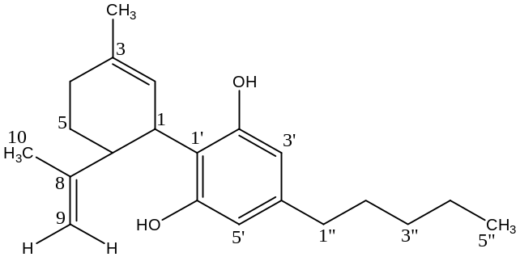

Figure 9. The structure of cannabidiol (CBD)

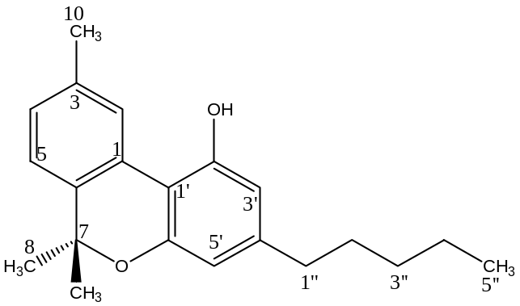
Figure 10. The structure of cannabinol (CBN)

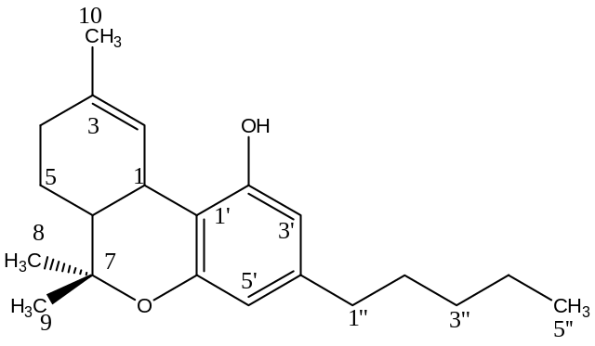
Figure 11. The structure of delta-9-tetrahydrocannabinol (THC)

Conclusion
The researchers developed SFE process, which is a viable technology for the extraction of cannabinoids from Cannabis Sativa L., with high yield. Additionally, the chosen operation parameters (e.g. pressure, temperature, and co-solvent) need to be safe, efficient, and capable of maximizing the yield (minimum CBD, CBN, and THC loss). SFE provided one with the highest
extraction yield, sample no. 3 obtained at 250 bar and 50 ºC of pressure and temperature of the extraction kettle, co-solvent (1-2%), and extraction time (60 min). Additionally, using this optimal condition with the pressure and temperature of the extraction kettle (190-200 bar and 50 ºC), co-solvent (1%), and extraction time (110 min) gave the highest amount of CBD at 14.53% w/w. However, the highest amounts of CBN (26.75% w/w, sample no. 5b) and THC (3.21% w/w, sample no. 3) were obtained when the pressure and temperature of the extraction kettle, separation kettle I, and separation kettle II were set to 250 bar and 50 ºC, 80-90 bar and 55 ºC, and 40-50 bar and 35-40 ºC, respectively, with co-solvent of 1-2%. Samples no. 5, 4b, and 5b were selected and further purified by flash chromatography in the Reveleris®PREP Purification System, which together with the structural elucidation of isolated cannabinoids by spectroscopy gave three cannabinoids including CBD, CBN, and THC. The researchers have shown that the usefulness of combining SFE and flash chromatography process could be yield a high quantity of cannabinoids, which proved that a high purity could be achieved for CBD, CBN, and THC. Finally, the cannabinoid extracts and active compounds (CBD, CBN, and THC) produced in our study could be used for ongoing research at the College of Pharmacy, Rangsit University, for future medical benefits.

Acknowledgment
We are grateful to the Research Institute of Rangsit University (Grant No. 106/2561) for financial support. We also wish to thank the Medicinal Cannabis Research Institute of the College of Pharmacy, Rangsit University, Thailand, for providing laboratory facilities.

References
- Elsohly, M. A. (2007). Marijuana and the Cannabinoids. Totowa, New Jersey, Humana Press Inc: pp. 17-27.
- Gaoni, Y. and Mechoulam, R. (1964). Isolation, structure, and partial synthesis of an active constituent of Hashish. Journal of the American Chemical Society, 86: 1646-1647.
- Ben Amar, M. (2006). Cannabinoids in medicine: a review of their therapeutic potential. Journal of Ethnopharmacol, 105: 791-802.
- Rovetto, L. J. and Aieta, N. V. (2017). Supercritical carbon dioxide extraction of cannabinoids from Cannabis sativa L. The Journal of Supercritical Fluids, 129: 16-27.
- Hazekamp, A., Peltenburg, A., Verpoorte, R. and Giroud, C. (2005). Chromatographic and spectroscopic data of cannabinoids from Cannabis sativa L. Journal of Liquid Chromatgraphy, 28: 2361-2382.
- Saingama, W. and Sakunpak, A. (2008). Development and validation of reverse phase high performance liquid chromatography method for the determination of delta-9-tetrahydrocannabinol and cannabidiol in oromucosal spray from cannabis extract. Brazilian journal of Pharmacognosy, 28: 669-672.
- Richard, P. F. (1982). Carbon dioxide as a solvent application of fat, oil and other materials. Chemistry and Industry, 20 (12): 394.
- Gallo-Molina, A. C., Castro-Vargas, H. I., Garzon-Mendez, W. F., Garzon-Mendez, J. A., Martinez Ramirez., Rivera Monroy, Z. J., King, J. W. and Parada-Alfonso, F. (2019). Extraction, isolation and purification of tetrahydrocannabinol from the Cannabis sativa L. plant using supercritical fluid extraction and solid phase extraction. The Journal of Supercritical Fluids, 146: 208-216.
- Omar, J., Olivares, M., Alzaga, M. and Etxbarria, N. (2013). Optimisation and characterisation of marihuana extracts obtained by supercritical fluid extraction and focused ultrasound extraction and retention time locking GC-MS. Journal of Separation Science, 36: 1397-1401.
- Choi, Y. H., Hazekamp, A., Peltenburg-Looman, A. M. G., Frederich, M., Erkelens, C., Lefeber, A.W. M. and Verpoorte, R. (2004). NMR Assignments of the major cannabinoids and cannabiflavonoids isolated from flowers of Cannabis sativa. Phytochemical analysis, 15: 345-354.
- Leite, J. de A., Oliveira, M. V. L, Conti, R., Borges, W. de S., Rosa, T. R., Filgueiras, P. R. and Alvaro, C. N. (2018). Extraction and isolation of cannabinoids from marijuana seizures and characterization by ¹H NMR allied to chemometric tools. Science & Justice, 58: 355-365.

