

A FACILE SYNTHESIS OF N-ALKYLATED DAIBUCARBOLINE A DERIVATIVES VIA PICTET-SPENGLER CONDENSATION OF TRYPTAMINE

(Sintesis Mudah Terbitan Daibukarbolin A Melalui Kondensasi Pictet-Spengler Daripada Triptamin)

Nur Ain Nabilah Ash’ari¹, Noor Hidayah Pungot¹*, Zurina Shaameri¹, Nor Akmalazura Jani²

¹Organic Synthesis Laboratory, Institute of Science,

Universiti Teknologi MARA, 43200 Bandar Puncak Alam, Selangor, Malaysia

²Faculty of Applied Sciences,

Universiti Teknologi MARA, 72000 Kuala Pilah, Negeri Sembilan, Malaysia

*Corresponding author: noorhidayah977@uitm.edu.my

Received: 27 July 2021 ; Accepted: 31 August 2021 ; Published: xx October 2021

Abstract

A brief and facile approach towards β-carboline and its derivatives is described through a simple three step synthesis. The key reaction involves the construction of β-carboline framework by Pictet-Spengler condensation of tryptamine with various substituted aldehydes. Subsequent aromatization of the resulting tetrahydro-β-carboline intermediates is achieved via iodine-mediated oxidative dehydrogenation reaction. Thereafter, insertion of alkyl subunit at N-1 position afforded a series of corresponding N-alkylated β-carboline derivatives. The structures of all synthesized intermediates and derivatives of β-carboline, including three new structures (2k, 2l and 3e), were confirmed by NMR, FTIR and GC-MS spectroscopy.

Keywords: β-carboline, Pictet-Spengler condensation, tetrahydro-β-carboline

Abstrak

Pendekatan ringkas dan mudah terhadap β-karbolin dan derivatifnya dijelaskan melalui sintesis tiga langkah mudah. Tindak balas utama melibatkan pembinaan kerangka β-karbolin daripada triptamin melalui kondensasi Pictet-Spengler dengan pelbagai aldehid yang diganti. Aromatisasi seterusnya dari tetrahidro-β-karbolin yang dihasilkan dicapai melalui tindak balas dehidrogenasi oksidatif yang dimediasi iodin. Selepas itu, penyisipan subunit alkil pada kedudukan N-1 menghasilkan satu siri turunan N-alkilasi β-karbolin yang sepadan. Struktur semua perantara yang disintesis dan turunan β-karbolin disahkan oleh spektroskopi NMR, FTIR dan GC-MS dan tiga kompaun (2k, 2l, dan 3e) adalah baru.

Kata kunci: β-karbolin, kondensasi Pictet-Spengler, tetrahidro-β-karbolin

Introduction

Over the past few decades, wild Syrian rue (Peganum harmala) from the family Zygophyllaceae, which is common in Iran, has elicited much interest due to its wide pharmaceutical and biological applications. Discoveries in the past few decades have demonstrated different pharmacological and therapeutic effects associated with various parts of this plant including the seed, bark, and root [1]. Extensive studies on Peganum harmala confirm that the most essential constituent in its chemical composition is the β-carboline alkaloid [2], which is responsible for the pharmacological diversity of neuroprotection [3], antiviral [4], anti-allergic [5], antimalarial [6], anti-leishmania [7], antitumor [8], antiplasmodial [9] and anti-HIV [10]. This bioactive β-carboline is widely distributed in human tissues and body fluids, marine creatures, insects, mammalians and plants. Thus, its potential therapeutic activities are very much aligned with the varied health benefits as described [11].

Of the many β-carboline derivatives, daibucarboline A (Figure 1) is recognized as a potential anti-inflammatory agent. This tetracyclic compound is originally isolated from the roots of Neolitsea daibuensis by Wong and co-workers, which also led to the isolation of daibucarboline B, C and 20 other known compounds. Anti-inflammatory assessment using inducible nitric oxide synthase (iNOS) assay revealed that daibucarboline A exhibited moderate inhibitory activity with IC₅₀ values of 18.41 μM [12]. Jani and co-workers later isolated trace amounts of daibucarboline A from the stems of Neolitsea kedahensis [13]. The aromatic β-carboline scaffolds are important synthetic intermediates in the total synthesis of many natural products, including the daibucarboline A and compounds exhibiting strong bioactivities. Their importance demands efficient synthetic methodologies, both for the construction of the heterocyclic system and its functionalization [14].

Owing to the diversity in the field of biology, numerous efforts have been devoted to prepare simple β-carbolines as well as a range of synthetic β-carboline derived compounds. Pictet-Spengler is one of the prominent reactions reported to synthesize β-carboline. In brief, it is a chemical reaction in which a β-arylethylamine undergoes condensation with an aldehyde or a ketone followed by ring closure [15]. Strong Brønsted acids are most commonly employed to promote the Pictet-Spengler reaction [16], involving the cyclization of an electron-rich aromatic ring onto an imine. The few recent examples of Lewis acid catalyzed Pictet-Spengler reaction involved highly reactive species such as nitrone [17], or ionic liquid and microwave irradiation [18] to enhance the reactivity. However, in this study, the researchers attempted a more practical and convenient synthesis of the aromatic β-carbolines using tryptamine and various substituted aldehydes for the desired Pictet-Spengler reaction, followed by oxidative dehydrogenation reaction using molecular iodine under simple reaction conditions. Hence, this report details the efficient Pictet-Spengler condensation catalyzed by TFA, without the use of expensive metal catalysts, prolonged reaction hours or critical reaction conditions.

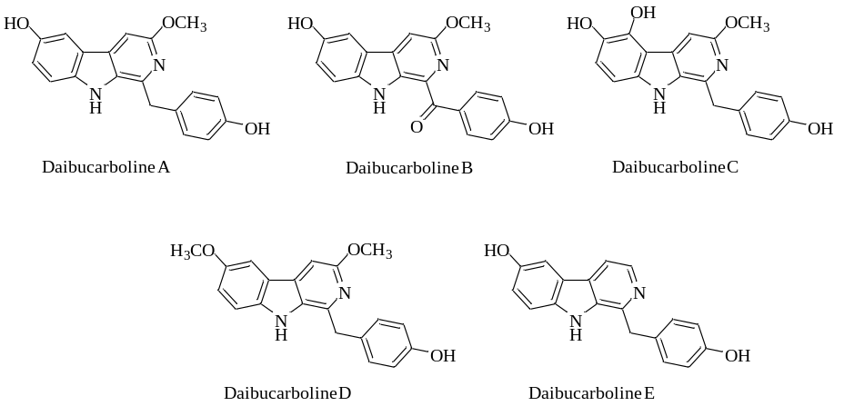

Figure 1. The structures of daibucarboline A analogue

Materials and Methods

General procedure for the synthesis of compounds 2a-n:

Phenylglyoxal monohydrate (0.657 mmol, 1.0 equiv.) was added to a stirred suspension of tryptamine (0.854 mmol, 1.0 equiv.) and TFA (0.657 mmol, 1.5 equiv.) in MeOH. The resulting solution was stirred for 24 hours, and the phenylglyoxal was shown by TLC analysis to be completely consumed. The reaction mixture was added with 10% K₂CO₃ and extracted with EtOAc. The combined organic layer was concentrated and purified by silica gel column chromatography eluted with a gradient of n-hexane and EtOAc (20:80) to afford compounds 2a-n.

General procedure for the synthesis of compounds 3a-e:

To a solution of compounds 2a-e (1.0 equiv.) in DMSO, iodine, I₂ (0.5 equiv.) was added followed by H₂O₂ (1.0 equiv.) and the resulting mixture was stirred at 60°C. Once TLC analysis confirmed a complete consumption of the starting material, the reaction mixture was quenched with cold sodium thiosulfate and extracted with EtOAc. The organic layer was evaporated and purified by silica gel column chromatography eluted with a gradient of n-hexane and EtOAc (20:80) to obtain compounds 3a-e.

General procedure for the synthesis of compounds 4a-b:

NaH (60% dispersion in mineral oil, 75 mmol, 1.5 equiv.) was added to a solution of compounds 3a-b (50 mmol, 1.0 equiv.) in THF at 0°C. The heterogeneous mixture was stirred at 0°C for 15 minutes and 1 hour at room temperature. The mixture was then cooled to 0°C, treated with iodomethane (65 mmol, 1.3 equiv.), and allowed to warm to room temperature. After 30 minutes, the reaction mixture was cooled to 0°C, quenched with saturated NH₄Cl, and extracted with ether. The combined organic layer was washed with brine, dried over anhydrous Na₂SO₄, concentrated and purified by column chromatography eluted with a gradient of n-hexane and EtOAc (30:70) to provide derivatives 4a-b.

Results and Discussion
1-phenyl-2,3,4,9-tetrahydro-1H-pyrido[3,4 b]indole (2a). Yield: 517 mg (90% yield, dark brown solid). IR v cm⁻¹: 3475, 3354, 2483, 1612 cm⁻¹. ¹H NMR (400 MHz, MeOD) δ (ppm): 7.63 (d, 1H, J = 7.9 Hz), 7.54-7.49 (m, 3H), 7.43-7.40 (m, 2H), 7.32 (d, 1H, J = 7.9 Hz), 7.19 (td, 1H, J = 7.9 Hz, 1.1 Hz), 7.09 (td, 1H, J = 7.9 Hz, 1.1 Hz), 5.79 (s, 1H), 3.65-3.58 (m, 1H), 3.55-3.48 (m, 1H), 3.29-3.22 (m, 1H), 3.15 (dt, 1H, J = 8.1 Hz, 5.5 Hz). ¹³C NMR (CDCl₃, 100 MHz): 142.3, 137.2, 134.7, 129.9, 128.1, 127.0, 123.1, 120.8, 118.2, 111.9, 105.4, 65.2, 43.4, 22.6. MS m/z: 248.1.

1-(4-methoxyphenyl)-2,3,4,9-tetrahydro-1H-pyrido[3,4-b]indole (2b). Yield: 336 mg (73% yield, yellow solid). IR v cm⁻¹: 3400, 3356, 2835, 2664, 1635 cm⁻¹. ¹H NMR (400 MHz, CDCl₃) δ (ppm): 7.52 (d, 1H, J = 7.8 Hz), 7.47 (br s, 1H), 7.28-7.21 (m, 2H), 7.20-7.11 (m, 2H), 6.95-6.87 (m, 3H), 5.18 (s, 1H), 3.73 (s, 3H), 3.43-3.35 (m, 1H), 3.18-3.11 (m, 1H), 2.98-2.91 (m, 1H), 2.86-2.78 (m, 1H). ¹³C NMR (CDCl₃, 100 MHz): 158.4, 138.2, 135.8, 133.3, 129.4, 127.1, 123.9, 120.0, 118.1, 114.8, 112.3, 105.7, 64.1, 55.4, 43.7, 22.9. MS m/z: 278.1.

4-(2,3,4,9-tetrahydro-1H-pyrido[3,4-b]indol-1-yl)phenol (2c). Yield: 148 mg (25% yield, light yellow solid). IR v cm⁻¹: 3535, 3474, 3339, 2483, 1742 cm⁻¹. ¹H NMR (400 MHz, CDCl₃) δ (ppm): 7.55 (d, 1H, J = 7.8 Hz), 7.52 (br s, 1H), 7.29-7.22 (m, 2H), 7.16-7.09 (m, 2H), 6.92-6.86 (m, 3H), 5.16 (s, 1H), 4.33 (br s, 1H), 3.43-3.38 (m, 1H), 3.19-3.12 (m, 1H), 2.98-2.90 (m, 1H), 2.85-2.79 (m, 1H). ¹³C NMR (CDCl₃, 100 MHz): 157.9, 137.4, 135.2, 133.8, 129.4, 127.4, 122.7, 119.9, 118.2, 115.5,111.6, 105.8, 64.8, 44.1, 23.8. MS m/z: 264.1.

1-(3,4-dimethoxyphenyl)-2,3,4,9-tetrahydro-1H-pyrido[3,4-b]indole (2d). Yield: 366 mg (65% yield, brown solid). IR v cm⁻¹: 3445, 3351, 2869, 2672, 1634 cm⁻¹. ¹H NMR (400 MHz, CDCl₃) δ (ppm): 7.54 (d, 1H, J = 7.8 Hz), 7.46 (br s, 1H), 7.27-7.22 (m, 2H), 7.16-7.09 (m, 2H), 6.93-6.85 (m, 3H), 5.18 (s, 1H), 3.79 (s, 3H), 3.73 (s, 3H), 3.43-3.35 (m, 1H), 3.18-3.11 (m, 1H), 2.98-2.91 (m, 1H), 2.86-2.78 (m, 1H). ¹³C NMR (CDCl₃, 100 MHz): 158.4, 138.2, 135.8, 133.3, 129.4, 127.1, 123.9, 120.0, 118.1, 114.8, 112.3, 105.7, 64.1, 56.9, 55.4, 43.7, 22.9. MS m/z: 308.1.

2-bromo-4-(2,3,4,9-tetrahydro-1H-pyrido[3,4-b]indol-1-yl)phenol (2e). Yield: 68 mg (20% yield, light brown solid). IR v cm⁻¹: 3475, 3379, 2513, 1622, 535 cm⁻¹. ¹H NMR (400 MHz, CDCl₃) δ (ppm): 7.58-7.55 (m, 1H), 7.52 (br s, 1H), 7.36-7.33 (m, 2H), 7.30-7.27 (m, 2H), 7.26-7.24 (m, 1H), 7.20 (qd, 2H, J = 7.1 Hz, 1.4 Hz), 5.17 (s, 1H), 3.40-3.34 (m, 1H), 3.20 (ddd, 1H, J = 12.5 Hz, 8.8 Hz, 4.8 Hz), 3.02-2.91 (m, 1H), 2.87-2.81 (m, 1H). ¹³C NMR (CDCl₃, 100 MHz): 141.6, 138.0, 134.6, 133.1, 130.4, 129.4, 127.8, 124.6, 123.7, 119.6, 117.7, 113.8, 105.5, 61.0, 42.5, 24.1. MS m/z: 326.0.

4-(2,3,4,9-tetrahydro-1H-pyrido[3,4-b]indol-1-yl)benzonitrile (2f). Yield: 732 mg (91% yield, dark brown solid). IR v cm⁻¹: 3475, 3379, 2513, 2234, 1622 cm⁻¹. ¹H NMR (400 MHz, CDCl₃) δ (ppm): 7.56-7.54 (m, 1H), 7.53 (br s, 1H), 7.33-7.29 (m, 3H), 7.27-7.21 (m, 2H), 7.18 (dtd, 1H, J = 15.8 Hz, 7.1 Hz, 1.4 Hz), 5.15 (s, 1H), 3.38-3.33 (m, 1H), 3.18-3.11 (m, 1H), 3.00-2.89 (m, 1H), 2.85 (dtd, 1H, J = 15.3 Hz, 4.5 Hz, 1.9 Hz). ¹³C NMR (CDCl₃, 100 MHz): 147.9, 138.5, 135.7, 134.8, 129.3, 128.3, 122.1, 120.8, 119.3, 111.5, 106.8, 65.2, 43.3, 21.6. MS m/z: 273.1.

1-(2-fluorophenyl)-2,3,4,9-tetrahydro-1H-pyrido[3,4-b]indole (2g). Yield: 238 mg (55% yield, light yellow solid). IR v cm⁻¹: 3443, 3385, 2518, 2255, 1676 cm⁻¹. ¹H NMR (400 MHz, CDCl₃) δ (ppm): 7.52 (br s, 1H), 7.50 (d, 1H, J = 7.0 Hz), 7.37 (dd, 1H, J = 8.0 Hz, 1.2 Hz), 7.29-7.19 (m, 2H), 7.14-7.10 (m, 4H), 5.90 (s, 1H), 3.26-3.23 (m, 1H), 3.18-3.15 (m, 1H), 2.81-2.76 (m, 2H). ¹³C NMR (CDCl₃, 100 MHz): 160.5, 137.2, 134.1, 129.7, 128.8, 127.2, 125.6, 123.8, 119.0, 118.1, 117.2, 115.9, 106.9, 58.9, 43.2, 22.6. MS m/z: 266.1.

1-(2-Chlorophenyl)-2,3,4,9-tetrahydro-1H-β-carboline (2h). Yield: 329 mg (57% yield, dark brown solid). IR v cm⁻¹: 3475, 3379, 2513, 1622, 826 cm⁻¹. ¹H NMR (400 MHz, MeOD) δ (ppm): 7.63 (br s, 1H), 7.57 (d, 1H, J = 7.0 Hz), 7.47 (dd, 1H, J = 8.0 Hz, 1.2 Hz), 7.27-7.23 (m, 2H), 7.18-7.10 (m, 4H), 5.70 (s, 1H), 3.29-3.23 (m, 1H), 3.18-3.12 (m, 1H), 2.95-2.81 (m, 2H). ¹³C NMR (CDCl₃, 100 MHz): 138.2, 136.4, 134.4, 129.7, 128.6, 127.4, 126.7, 122.1, 119.1, 117.2, 113.1, 107.4, 59.9, 45.9, 23.7. MS m/z: 282.0.

1-(3-bromophenyl)-2,3,4,9-tetrahydro-1H-pyrido[3,4-b]indole (2i). Yield: 371 mg (74% yield, yellow solid). IR v cm⁻¹: 3436, 3378, 2513, 1622, 541 cm⁻¹. ¹H NMR (400 MHz, MeOD) δ (ppm): 7.58-7.55 (m, 1H), 7.55 (br s, 1H), 7.36-7.33 (m, 2H), 7.30-7.23 (m, 2H), 7.28-7.24 (m, 1H), 7.25 (qd, 2H, J = 7.1 Hz, 1.4 Hz), 5.19 (s, 1H), 3.34-3.24 (m, 1H), 3.25 (ddd, 1H, J = 12.5 Hz, 8.8 Hz, 4.8 Hz), 3.14-2.98 (m, 1H), 2.83-2.78 (m, 1H). ¹³C NMR (CDCl₃, 100 MHz): 142.6, 138.5, 134.8, 132.1, 130.4, 129.2, 127.6, 125.6, 124.7, 119.8, 117.9, 113.1, 107.5, 66.0, 42.7, 24.4. MS m/z: 326.0.

1-(4-Nitrophenyl)-2,3,4,9-tetrahydro-1H-β-carboline (2j). Yield: 369 mg (95% yield, light yellow solid). IR v cm⁻¹: 3478, 3372, 2516, 1622, 1509 cm⁻¹. ¹H NMR (400 MHz, CDCl₃) δ (ppm): 8.21 (d, 2H, J = 8.8 Hz), 7.58 (d, 1H, J = 8.5 Hz), 7.53 (d, 2H, J = 8.8 Hz), 7.49 (br s, 1H), 7.27-7.24 (m, 1H), 7.20 (dtd, 2H, J = 8.5 Hz, 7.0 Hz, 1.5 Hz), 5.28 (s, 1H), 3.34 (dt, 1H, J = 8.8 Hz, 5.1 Hz), 3.21 (ddd, 1H, J = 12.7 Hz, 7.8 Hz, 4.8 Hz), 2.98-2.90 (m, 1H), 2.88 (dtd, 1H, J = 7.8 Hz, 4.8 Hz, 1.6 Hz). ¹³C NMR (CDCl₃, 100 MHz): 148.5, 146.6, 136.2, 134.7, 129.7, 128.5, 124.5, 122.3, 118.5, 117.8, 115.2, 109.6, 65.9, 43.5, 25.6. MS m/z: 293.1.

3-(2,3,4,9-tetrahydro-1H-pyrido[3,4-b]indol-1-yl)benzoic acid (2k). Yield: 68 mg (69% yield, brown solid). IR v cm⁻¹: 3374, 2925, 2849, 1629 cm⁻¹. ¹H NMR (400 MHz, CDCl₃) δ (ppm): 7.62 (s, 2H), 7.58-5.53 (d, 1H, J = 7.8 Hz), 7.42-7.40 (d, 2H, J = 8.8 Hz), 7.24-7.22 (m, 1H), 7.16-7.12 (m, 2H), 5.21 (s, 1H), 3.28-3.15 (m, 1H), 3.14-3.13 (m, 1H), 2.93-2.89 (m, 1H), 2.84-2.83 (m, 1H). ¹³C NMR (CDCl₃, 100 MHz): 192.9, 162.4, 151.4, 137.1, 136.7, 136.1, 135.8, 133.5, 131.4, 128.7, 121.2, 118.7, 117.7, 114.6, 112.6, 105.5. MS m/z: 292.1.

1-(4-ethylphenyl)-2,3,4,9-tetrahydro-1H-pyrido[3,4-b]indole (2l). Yield: 165 mg (54% yield, yellow solid). IR v cm⁻¹: 3013, 2949, 2842, 1572 cm⁻¹. ¹H NMR (400 MHz, CDCl₃) δ (ppm): 8.16 (s, 1H), 7.57 (br s, 1H), 7.16 (s, 4H), 7.14-7.10 (m, 4H), 5.05 (s, 1H), 3.31-3.26 (m, 1H), 3.08-3.04 (m, 1H), 2.91-2.89 (m, 1H), 2.83-2.82 (m, 1H), 2.70-2.64 (q, 2H), 1.25 (t, 3H). ¹³C NMR (CDCl₃, 100 MHz): 144.1, 138.7, 136.5, 133.6, 128.5, 127.7, 127.0, 120.8, 118.3, 117.3, 110.5, 108.6, 57.1, 41.4, 28.2, 21.4, 14.9. MS m/z: 276.1.

1-(4-ethoxyphenyl)-2,3,4,9-tetrahydro-1H-pyrido[3,4-b]indole (2m). Yield: 148 mg (33% yield, yellow solid). IR v cm⁻¹: 3400, 3356, 2835, 2664, 1635 cm⁻¹. ¹H NMR (400 MHz, CDCl₃) δ (ppm): 7.64 (br s, 1H), 7.58-7.55 (m, 1H), 7.27-7.16 (m, 4H), 7.15-7.10 (m, 3H), 5.37 (s, 1H), 4.44 (q, 2H), 3.46-3.38 (m, 1H), 3.16-3.12 (m, 1H), 2.99-2.89 (m, 1H), 2.87-2.81 (m, 1H), 2.41 (t, 3H). ¹³C NMR (CDCl₃, 100 MHz): 144.1, 139.7, 137.4, 133.2, 127.6, 126.8, 119.5, 116.2, 113.7, 105.8, 67.27, 42.3, 28.9, 21.7, 15.4. MS m/z: 292.1.

2,3,4,9-tetrahydro-1H-pyrido[3,4-b]indole (2n). Yield: 229 mg (56% yield, yellow solid). IR v cm⁻¹: 3474, 3329, 2801, 1681 cm⁻¹. ¹H NMR (400 MHz, MeOD) δ (ppm): 10.08 (br s, 1H), 7.31 (d, 1H, J= 7.8 Hz), 7.37 (d, 1H, J=7.8 Hz), 7.04-6.99 (m, 1H), 6.95-6.87 (m, 1H), 3.29 (s, 2H), 3.11 (t, 2H), 2.67 (t, 2H). ¹³C NMR (CDCl₃, 100 MHz): 135.9, 134.2, 127.6, 120.7, 118.6, 117.6, 111.2, 107.3, 43.7, 42.9, 22.4. MS m/z: 172.1.

1-phenyl-9H-pyrido[3,4-b]indole (3a). Yield: 243 mg (72% yield, dark brown solid). IR v cm⁻¹: 3474, 2361, 1623, 1559, 1233, 736 cm⁻¹. ¹H NMR (400 MHz, MeOD) δ (ppm): 10.54 (s, 1H), 8.44 (d, J = 4.8 Hz, 1H), 8.29 (d, J = 7.8 Hz, 1H), 8.12 (d, J = 4.8 Hz, 1H), 8.07−7.98 (m, 2H), 7.67 (d, J = 8.4 Hz, 1H), 7.52 (t, J = 7.8 Hz, 2H), 7.31 (dt, J = 14.8, 7.8 Hz, 2H), 7.24 (t, J = 7.2 Hz, 1H). ¹³C NMR (CDCl₃, 100 MHz): 142.5, 141.7, 138.1, 133.6, 129.5, 128.1, 127.2, 126.4, 125.2, 121.8, 120.5, 119.1, 113.7, 111.4. MS m/z: 244.1.

1-(4-methoxyphenyl)-9H-pyrido[3,4-b]indole (3b). Yield: 156 mg (54% yield, yellow solid). IR v cm⁻¹: 3474, 2361, 1623, 1559, 1233, 736 cm⁻¹. ¹H NMR (400 MHz, MeOD) δ (ppm): 11.27 (s, 1H), 8.32 (d, J = 4.8 Hz, 1H), 8.19 (d, J = 4.8 Hz, 1H), 8.10−8.02 (m, 2H), 7.64 (d, J = 8.4 Hz, 1H), 7.48 (t, J = 7.8 Hz, 2H), 7.31 (dt, J = 14.8, 7.8 Hz, 2H), 7.22 (t, J = 7.2 Hz, 1H), 3.73 (s, 3H). ¹³C NMR (CDCl₃, 100 MHz): 158.2, 138.8, 135.8, 133.3, 129.1, 127.1, 123.9, 120.9, 118.1, 114.8, 112.3, 104.7, 64.5, 52.4, 44.6, 22.7. MS m/z: 274.1.

4-(9H-pyrido[3,4-b]indol-1-yl)phenol (3c). Yield: 124 mg (43% yield, yellow solid). IR v cm⁻¹: 3535, 3474, 3339, 2483, 1742 cm⁻¹. ¹H NMR (400 MHz, CDCl₃) δ (ppm): 10.63 (s, 1H), 7.55 (d, 1H, J = 7.8 Hz), 7.52 (br s, 1H), 7.29-7.22 (m, 2H), 7.16-7.09 (m, 2H), 6.92-6.86 (m, 3H), 5.16 (s, 1H), 4.33 (br s, 1H). ¹³C NMR (CDCl₃, 100 MHz): 156.6, 135.4, 134.7, 133.8, 130.7, 127.4, 122.7, 119.9, 118.2, 115.9,111.4, 103.8, 64.8, 43.9, 22.5. MS m/z: 260.0.

1-(3,4-dimethoxyphenyl)-9H-pyrido[3,4-b]indole (3d). Yield: 87 mg (22% yield, light brown solid). IR v cm⁻¹: 3445, 3351, 2869, 2672, 1634 cm⁻¹. ¹H NMR (400 MHz, CDCl₃) δ (ppm): 9.46 (s, 1H), 7.54 (d, 1H, J = 7.8 Hz), 7.27-7.22 (m, 2H), 7.16-7.09 (m, 2H), 6.93-6.85 (m, 3H), 5.18 (s, 1H), 3.77 (s, 3H), 3.72 (s, 3H). ¹³C NMR (CDCl₃, 100 MHz): 159.4, 138.7, 135.8, 133.3, 130.6, 127.1, 125.3, 120.0, 117.6, 114.1, 112.3, 104.8, 64.1, 56.9, 55.4, 43.5, 21.5. MS m/z: 304.1.

3-(9H-pyrido[3,4-b]indol-1-yl)benzoic acid (3e). Yield: 76 mg (19% yield, dark brown solid). IR v cm⁻¹: 3456, 3263, 1640, 1465 cm⁻¹. ¹H NMR (400 MHz, CDCl₃) δ (ppm): 7.54 (d, 2H, J = 7.8 Hz), 7.32 (d, 2H, J = 4.8 Hz), 7.08-7.04 (m, 4H), 6.99-6.95 (m, 2H). ¹³C NMR (CDCl₃, 100 MHz): 194. 8, 151.5, 137.7, 137.0, 136.2, 136.1, 132.0, 131.7, 130.6, 127.2, 121.1, 118.8, 118.3, 112.7, 105.5. MS m/z: 288.0.

1-phenyl-9H-pyrido[3,4-b]indole (4a). Yield: 132 mg (81% yield, dark brown solid). IR v cm⁻¹: 3474, 2361, 1623, 1559, 1233, 736 cm⁻¹. ¹H NMR (400 MHz, MeOD) δ (ppm): 8.47 (d, J = 4.8 Hz, 1H), 8.35 (d, J = 7.8 Hz, 1H), 8.28 (d, J = 4.8 Hz, 1H), 8.07−7.98 (m, 2H), 7.69 (d, J = 8.4 Hz, 1H), 7.56 (t, J = 7.8 Hz, 2H), 7.31 (dt, J = 14.8, 7.8 Hz, 2H), 7.24 (t, J = 7.2 Hz, 1H), 3.82 (s, 3H). ¹³C NMR (CDCl₃, 100 MHz): 142.5, 141.1,
138.6, 133.8, 129.2, 128.6, 127.8, 126.3, 125.6, 121.8, 120.5, 118.6, 115.3, 112.8. MS m/z: 258.1.

1-(4-methoxyphenyl)-9H-pyrido[3,4-b]indole (4b). Yield: 99 mg (79% yield, light brown solid). IR v cm⁻¹: 3474, 2361, 1623, 1559, 1233, 736 cm⁻¹. ¹H NMR (400 MHz, MeOD) δ (ppm): 8.32 (d, J = 4.8 Hz, 1H), 8.19 (d, J = 4.8 Hz, 1H), 8.10−8.02 (m, 2H), 7.64 (d, J = 8.4 Hz, 1H), 7.48 (t, J = 7.8 Hz, 2H), 7.31 (dt, J = 14.8, 7.8 Hz, 2H), 7.22 (t, J = 7.2 Hz, 1H), 3.85 (s, 3H), 3.84 (s, 3H). ¹³C NMR (CDCl₃, 100 MHz): 158.2, 138.8, 135.8, 133.3, 129.1, 127.1, 123.9, 120.9, 118.1, 114.8, 112.3, 104.7, 64.5, 52.4, 44.6, 22.7. MS m/z: 288.1.

The synthetic studies described in this paper were directed at a series of β-carboline derivatives in which tetrahydro-β-carboline (THβC) was the key intermediate. In order to explore the reactivity of different substituted aldehydes towards the efficiency of Pictet-Spengler reaction, a series of compounds containing different electron-donating and electron-withdrawing substituents attached to the β-carboline skeleton, starting from tryptamine, were synthesized. The reaction was carried out in the presence of acid catalyst TFA, under 24 hours of stirring to give the THβC intermediates in their corresponding yields (Scheme 1).

This approach is concise and yet most preferred due to its simplicity since no heat is involved to drive the reaction. The yields vary accordingly due to inductive and resonance effects of the substituents attached to the benzaldehyde (2a-2m) and aliphatic aldehyde (2n). Having electron-donating groups as the substituents (2b, 2c, 2l, 2m) activated the ring, making the carbonyl carbon less electrophilic, which resulted in a weaker reactivity and gave lower product yields than that of using standard benzaldehyde (2a). Using dimethoxy-substituted benzaldehyde (2d), the yield is much reduced. On the contrary, benzaldehyde bearing electron-withdrawing group (2f, 2j, 2k) gave much higher product yields as anticipated. Despite being an inductively electron-withdrawing group, halogens are activators since their ability to donate electrons into the aromatic ring via resonance is much greater. Thus, as expected, halogenated derivatives (2g, 2h, 2i) were obtained in much lower yields.

The reaction mechanism occurs by the initial formation of iminium ion followed by electrophilic addition at the C-2 position to directly yield the six-membered ring intermediate. However, both carbon-2 and -3 of tryptamine are nucleophilic. Therefore, the reaction can also proceed by the attack of carbon-3 to yield a spiroindolenine intermediate that would then undergo a 1,2-alkyl shift to form the product as depicted in Scheme 2. Both mechanisms have been proven to be true, yet the prevailing mechanism is still unknown [19].

The pathway proceeded with removal of hydrogen on the B-ring by oxidative dehydrogenation reaction to promote both aromatization and construction of the β-carboline frameworks. Literature survey outlined a few methods for the aromatization of THβC, which generally involve the following drawbacks in driving the reaction; (i) palladium-mediated reactions need high temperature, long reaction hours, along with the possibility of C-N bond cleavage [20], (ii) sulphur-mediated reactions deliver aromatized product in two days with low yields [21], and (iii) selenium-mediated reactions require large quantity of SeO₂ (10 equiv.) offering less yield [22]. It is also reported that peroxide promotes dehydrogenation reaction [23]. Therefore, we employed the THβC and H₂O₂ along with 25 mol% I₂ in DMSO, resulting in 19-91% yields of the oxidized products (3a-e) as summarized in Scheme 3.

The reaction occurs by the initial formation of imine intermediate through N-iodination of THβC, followed by dehydroiodination of the N-iodotetrahydro-β-carboline. Further N-iodination of the imine gives ammonium intermediate. Subsequent deprotonation and dehydro-iodination afforded the targeted β-carboline derivatives (3a-e). The purpose of employing DMSO in this reaction is to regenerate the molecular iodine, along with dimethyl sulfide (DMS) by further reaction with the generated HI. The regeneration of molecular I₂ is important to maintain the cycle and the formed DMS is oxidized to DMSO in the presence of H₂O₂ to speed up the reaction time [24]. The mechanism of reaction is as depicted in Scheme 4.
In the final step, β-carbolines (3a-b) were converted to N-alkyl derivatives by the reaction of alkylating reagents, R₂-I with indole moiety in the presence of sodium hydride as the base. The use of sodium offers the advantage of the reaction being carried out in a non-hydrolytic solvent. It was thought that the employment of sodium hydride would also offer this advantage and at the same time would be safer and easier to handle than the metal. With this in mind, the preparation of N-substituted β-carbolines by the general reaction shown in Scheme 5 was undertaken.

Scheme 1. Scope of the reaction of tryptamine with different substituted aldehydes
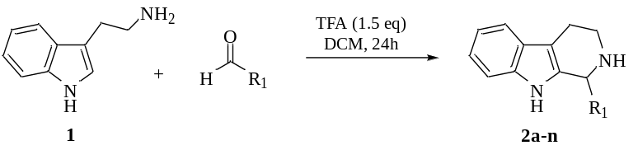
Entry | R₁ | Yield (%)
2a | Phenyl | 90
2b | p-methoxyphenyl | 73
2c | p-hydroxyphenyl | 25
2d | m, p-dimethoxyphenyl | 65
2e | m-bromo-p-hydroxyphenyl | 20
2f | p-cyanophenyl | 91
2g | o-flurophenyl | 55
2h | o-chlorophenyl | 57
2i | m-bromophenyl | 74
2j | p-nitrophenyl | 95
2k | m-carboxyphenyl | 69
2l | p-ethylphenyl | 54
2m | p-ethoxyphenyl | 33
2n | H | 56

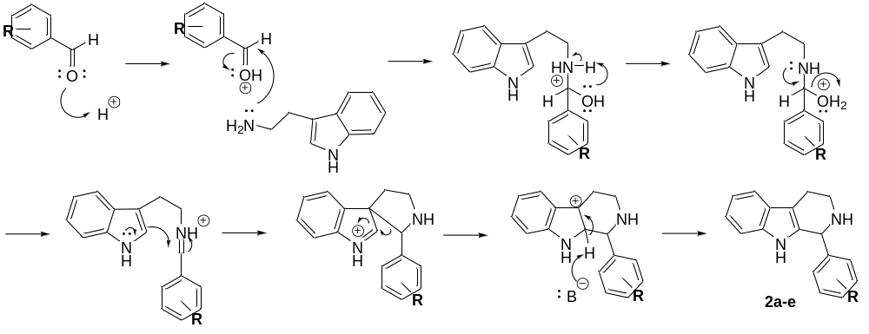

Scheme 2. Mechanism of Pictet-Spengler reaction with electrophilic addition at carbon-3

Scheme 3. Aromatization of tetrahydro-β-carboline intermediates
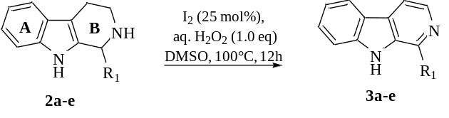
Entry | R₁ | Yield (%)
3a | Phenyl | 72
3b | p-methoxyphenyl | 54
3c | p-hydroxyphenyl | 43
3d | m, p-dimethoxyphenyl | 22
3e | m-carboxyphenyl | 19

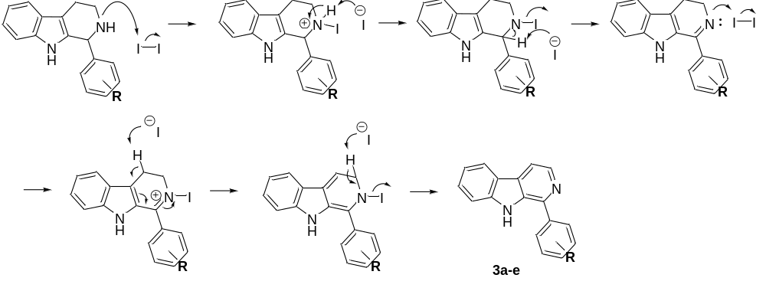

Scheme 4. Mechanism of oxidative dehydrogenation

Scheme 5. N-alkylation of β-carboline derivatives
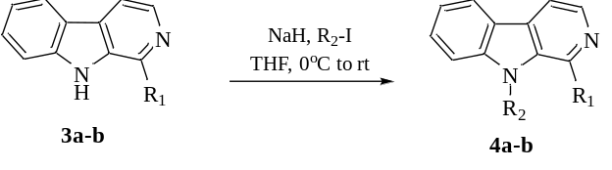
Entry | R₁ | R₂ | Yield (%)
3a | Phenyl | methyl | 81
3b | p-methoxyphenyl | methyl | 79

Conclusion

In summary, we have successfully synthesized a series of β-carboline derivatives using simple, metal-free iodine-mediated method. In this reaction, the β-carboline skeleton is constructed by cyclization and a subsequent oxidation reaction, followed by N-alkylation reaction. Further application of the scope and mechanism of reaction in the study towards total synthesis of daibucarboline A and other additional biologically active natural products is currently in progress.

Acknowledgement

The authors acknowledge the generous support of Institute of Science, Universiti Teknologi MARA in providing required chemicals and instrumentations, as well as the financial support of Ministry of Higher Education Malaysia (FRGS grant 600-IRMI/FRGS 5/3 (399/2019).

References
- John, A. J., George, V., Pradeep, N. S. and Sethuraman, M. G. (2008). Chemical composition and antibacterial activity of the leaf, bark and fruit oils of Neolitsea fischeri Gamble. Journal of Essential Oil Research, 20(3): 279-282.
- Jin, H., Zhang, P., Bijian, K., Ren, S., Wan, S., Alaoui-Jamali, M. A. and Jiang, T. (2013). Total synthesis and biological activity of marine alkaloid Eudistomins Y1–Y7 and their analogues. Marine drugs, 11(5): 1427-1439.
- Maria Miranda Santos, C. (2012). New agents promote neuroprotection in Parkinson's disease models. CNS & Neurological Disorders-Drug Targets, 11(4): 410-418.
- Rinehart Jr, K. L., Kobayashi, J., Harbour, G. C., Gilmore, J., Mascal, M., Holt, T. G. and Lafargue, F. (1987). Eudistomins A-Q, beta.-carbolines from the antiviral Caribbean tunicate Eudistoma olivaceum. Journal of the American Chemical Society, 109(11): 3378-3387.
- Sun, B., Morikawa, T., Matsuda, H., Tewtrakul, S., Wu, L. J., Harima, S. and Yoshikawa, M. (2004). Structures of new β-carboline-type alkaloids with antiallergic effects from Stellaria dichotoma. Journal of Natural Products, 67(9): 1464-1469.
- Ashok, P., Ganguly, S. and Murugesan, S. (2013). Review on in-vitro anti-malarial activity of natural β-carboline alkaloids. Mini Reviews in Medicinal Chemistry, 13(12): 1778-1791.
- Rahimi-Moghaddam, P., Ebrahimi, S. A., Ourmazdi, H., Selseleh, M., Karjalian, M., Haj-Hassani, G. and Shafiei, M. (2011). In vitro and in vivo activities of Peganum harmala extract against Leishmania major. Journal of Research in Medical Sciences, 16(8): 1032.
- Dong, X. C., Wen, R. and Zheng, J. B. (2004). Synthesis of 1-indole substituted beta-carboline alkaloid and its derivatives and evaluation of their preliminary antitumor activities. Acta Pharmaceutica Sinica, 39(4): 259-262.
- Gorki, V., Singh, R., Walter, N. S., Bagai, U. and Salunke, D. B. (2018). Synthesis and evaluation of antiplasmodial efficacy of β-carboline derivatives against murine malaria. ACS omega, 3(10): 13200-13210.
- Wang, Y. H., Tang, J. G., Wang, R. R., Yang, L. M., Dong, Z. J., Du, L. and Zheng, Y. T. (2007). Flazinamide, a novel β-carboline compound with anti-HIV actions. Biochemical and Biophysical Research Communications, 355(4): 1091-1095.
- Patel, K., Gadewar, M., Tripathi, R., Prasad, S. K. and Patel, D. K. (2012). A review on medicinal importance, pharmacological activity and bioanalytical aspects of beta-carboline alkaloid “Harmine”. Asian Pacific journal of tropical biomedicine, 2(8): 660-664.
- Wong, S. L., Chang, H. S., Wang, G. J., Chiang, M. Y., Huang, H. Y., Chen, C. H. and Chen, I. S. (2011). Secondary metabolites from the roots of Neolitsea daibuensis and their anti-inflammatory activity. Journal of Natural Products, 74(12): 2489-2496.
- Jani, N. A., Sirat, H. M., Ahmad, F., Abed, S. A. and Aminudin, N. I. (2018). Chemical constituents of the stems of Neolitsea kedahensis Gamble. Phytochemistry Letters, 26: 12-15.
- Love, B. E. (1996). Synthesis of β-carbolines. A review. Organic Preparations and Procedures International, 28(1): 1-64.
- Cox, E. D. and Cook, J. M. (1995). The Pictet-Spengler condensation: a new direction for an old reaction. Chemical Reviews, 95(6): 1797-1842.
- Mangalaraj, S. and Ramanathan, C. R. (2012). Construction of tetrahydro-β-carboline skeletons via Brønsted acid activation of imide carbonyl group: syntheses of indole alkaloids (±)-harmicine and (±)-10-desbromoarborescidine-A. RSC Advances, 2(33): 12665-12669.
- Lynch-Colameta, T., Greta, S. and Snyder, S. A. (2021). Synthesis of aza-quaternary centers via Pictet–Spengler reactions of ketonitrones. Chemical Science, 12(17): 6181-6187.
- Srinivasan, N. and Ganesan, A. (2003). Highly efficient Lewis acid-catalysed Pictet–Spengler reactions discovered by parallel screening. Chemical Communications, (7): 916-917.
- Maresh, J. J., Giddings, L. A., Friedrich, A., Loris, E. A., Panjikar, S., Trout, B. L. and O'Connor, S. E. (2008). Strictosidine synthase: Mechanism of a pictet− spengler catalyzing enzyme. Journal of the American Chemical Society, 130(2): 710-723.
- Eagon, S. and Anderson, M. O. (2014). Microwave-assisted synthesis of tetrahydro-β-carbolines and β-carbolines. European Journal of Organic Chemistry, 2014(8): 1653-1665.
- Cain, M., Weber, R. W., Guzman, F., Cook, J. M., Barker, S. A., Rice, K. C. and Skolnick, P. (1982). Beta-carbolines: synthesis and neurochemical and pharmacological actions on brain benzodiazepine receptors. Journal of Medicinal Chemistry, 25(9): 1081-1091.
- Chen, H., Gao, P., Zhang, M., Liao, W. and Zhang, J. (2014). Synthesis and biological evaluation of a novel class of β-carboline derivatives. New Journal of Chemistry, 38(9): 4155-4166.
- Jiang, H., Huang, H., Cao, H. and Qi, C. (2010). TBHP/I2-mediated domino oxidative cyclization for one-pot synthesis of polysubstituted oxazoles. Organic Letters, 12(23): 5561-5563.
- Chu, J. W. and Trout, B. L. (2004). On the mechanisms of oxidation of organic sulfides by H₂O₂ in aqueous solutions. Journal of the American Chemical Society, 126(3): 900-908.

