

OPTIMISATION OF MICROWAVE-ASSISTED WATER EXTRACTION OF PINEAPPLE PEEL HEMICELLULOSE USING RESPONSE SURFACE METHODOLOGY

(Pengoptimuman Pengekstrakan Air Berbantu Gelombang Mikro Bagi Hemiselulosa Kulit Nanas Menggunakan Kaedah Gerak Balas Permukaan)

Nur Aza Atiqah Mad Zahir, Noraini Hamzah, Hamizah Mohd Zaki, Shariff Ibrahim, Sabiha Hanim Saleh*

School of Chemistry and Environment, Faculty of Applied Sciences,
Universiti Teknologi MARA, 40450 Shah Alam, Selangor, Malaysia

*corresponding author: sabihahanim@uitm.edu.my

Received: 17 August 2021; Accepted: 20 October 2021; Published: xx December 2021

Abstract

The purpose of this investigation is to optimise extraction conditions (temperature and time) for microwave-assisted water extraction of pineapple peel hemicellulose using response surface methodology (RSM). A series of 14 experimental designs were conducted to determine the optimal conditions of two key variables (temperature of 90-150 °C and time of 5-20 min) in order to maximise the extracted hemicellulose yield. Quadratic models based on central composite design (CCD) were developed to correlate the extraction process variables with the response (i.e., hemicellulose yield). These models were analysed using appropriate statistical methods (i.e., analysis of variance). The statistical analysis indicated that all the developed models were adequate for the prediction of the respective responses. A quadratic model predicted a maximum hemicellulose yield of 15.6% at the optimal temperature of 125 °C and extraction time of 14 min. From the validation experiment, a maximum hemicellulose yield of 15.2% was obtained under the same optimal conditions with the determination coefficient (R²) of 0.95, indicating close agreement with the model prediction. Chemical characterisations of hemicellulose and residues were conducted using Fourier transform infrared (FTIR) and scanning electron microscopy (SEM). The FTIR analysis revealed the presence of hemicellulose at a specific band of 1261 cm^{–1} and the band between 1094 and 1000 cm^{–1}, which originated from xylans. The SEM characterisation indicated that the untreated pineapple peel had a broken surface and less distortion compared to the treated pineapple peel, whereas the surface structure of the treated pineapple peel had irregular crevices and larger cell disruption.

Keywords: pineapple peel, hemicellulose, microwave-assisted water extraction, response surface methodology, central composite design

Abstrak

Tujuan kajian ini adalah untuk menyiasat kesan keadaan pengekstrakan dibantu gelombang mikro (suhu, masa) ke atas hasil hemiselulosa kulit nanas menggunakan kaedah gerak balas permukaan (RSM). 14 reka bentuk eksperimen telah dibangunkan untuk menentukan keadaan optimum dua parameter utama (suhu 90-150 ⁰C dan masa 5-20 min) yang memaksimumkan hasil pengekstrakan hemiselulosa. Berdasarkan reka bentuk komposit pusat (CCD), model kuadratik dibangunkan untuk mengaitkan pembolehubah proses pengekstrakan dengan respons seperti hasil hemiselulosa. Model-model ini dianalisis menggunakan kaedah statistik yang sesuai seperti analisis varians. Analisis statistik menunjukkan semua model yang dibangunkan adalah mencukupi untuk ramalan tindak balas masing-masing. Model kuadratik meramalkan hasil hemiselulosa yang maksimum 15.6% pada suhu optimum 125 ⁰C dan masa pengekstrakan selama 14 min. Daripada eksperimen pengesahan, hasil maksimum hemisellulosa 15.2% diperoleh dalam keadaan optimum yang sama dengan pekali penentuan (R²) 0.95, menunjukkan persetujuan dekat dengan ramalan model. Pencirian kimia hemiselulosa dan sisa ditentukan oleh FTIR dan SEM. Analisis FTIR mendedahkan kehadiran hemiselulosa pada jalur tertentu 1261 cm⁻¹ dan jalur antara 1094-1000 cm⁻¹ yang berasal daripada xilan. Pencirian SEM menunjukkan bahawa kulit nanas yang tidak dirawat mempunyai permukaan pecah dan sedikit gangguan berbanding kulit nanas yang dirawat sedangkan struktur permukaan kulit nanas yang dirawat mempunyai celah-celah yang tidak teratur dan kemusnahan sel yang lebih besar.

Kata kunci: kulit nanas, hemiselulosa, ketuhar gelombang mikro berbantu pengekstrakan air, kaedah gerak balas permukaan, reka bentuk komposit pusat

Introduction

Pineapples (Ananas comosus) are cultivated in tropical and subtropical countries. Around 16-19 million tons of pineapples are planted worldwide annually [1]. Malaysia is one of the major producers of pineapple with the state of Johor contributing approximately 57% or 163,830 metric tons of pineapple in 2010 [1]. During processing, the pineapple waste that mainly consists of peels, stems, leaves, and crowns is removed and usually used as animal feeds and land fertilisers [2, 3].

The major components of pineapple peels are cellulose, hemicellulose, and lignin [4]. Meanwhile, the minor components include pectin, wax, protein, and extractives [5]. It is highly recommended to reuse pineapple peels as they are renewable and can accumulate with time to pose adverse environmental problems [6]. Hemicellulose is the second most abundant lignocellulosic material after cellulose [7]. It is used in food additives, bio composites, and biodegradable films, as well as in medicinal applications [8]. The mass production of high-valued hemicellulose-based products as well as their potential applications had remained largely underexplored [9]. Most studies focuses on the extraction of cellulose, not hemicellulose from pineapple peel. In addition, there are limited studies on pineapple peel hemicellulose extraction, especially using microwave-assisted water extraction.

Numerous techniques have been used for hemicellulose extraction, including steam explosion, organic solvents, dilute acid, and alkaline treatment [10]. However, it is difficult to extract sufficient hemicellulose without severe degradation due to the strong interaction between hemicellulose and lignin in plant cell walls. In recent years, microwave-assisted extraction has been seen as a viable alternative heating approach for hemicellulose extraction as it improves extraction efficiency and reduces reaction time compared to other conventional extraction methods [11, 12]. In fact, the extracted hemicellulose yield still needs improvement. Microwave-assisted extraction is often combined with chemicals, such as acids, alkalis or water as a solvent. The safest and most inexpensive green solvent is water as it is non-toxic to human health and the environment [13]. Using microwave treatment with water is expected to overcome the barriers that hinder hemicellulose extraction. Optimisation of a multifactorial system according to conventional techniques involves dealing with only one process variable or parameter at a time, which consumes time, laborious, as well as provides no information about parameter interactions [14]. According to Oberoi et al. [15], response surface methodology (RSM) is commonly used to optimise process parameters of a reaction as it saves time and labour, and also reveals information about the interactions between parameters.

In this investigation, pineapple peel hemicellulose was extracted using microwave-assisted water extraction. RSM with central composite design (CCD) was employed to optimise extraction variables for maximum hemicellulose yield. Two variables of microwave usage were varied: extraction temperature (between 90 and 150 °C) and extraction time (between 5 and 20 min). A series of experiments were performed with optimised variables to identify the relationship between the actual yield and the predicted yield from Design-Expert software. Hemicellulose and the residues obtained were characterised by Fourier transform infrared (FTIR) and scanning electron microscopy (SEM) analysis for the identification of functional groups and surface morphology, respectively.

Materials and Methods

Materials

Pineapple peels of MD2 variety were obtained from a local pineapple processing factory (Nanas Merbok Marketing) in Kedah, Malaysia. The peels were cut into small pieces of about 3 g and washed with distilled water to remove impurities [16]. After that, the peels were oven-dried at 60 °C overnight, ground using a laboratory blender, and sieved to 1.0 mm size [8]. The samples were stored in sealed bags at room temperature until further use. Only analytical grade chemicals were used unless otherwise stated. All experimental procedures were carried out at least in duplicates.

Chemical composition analysis

Pineapple peels consist of cellulose, hemicellulose, and lignin. Standard TAPPI method T222 OM-08 was used to determine the amount of lignin, whereas the acid-chlorite method was used for holocellulose determination [17, 18]. Treating holocellulose with potassium hydroxide solution gave the cellulose content [19]. Finally, subtracting cellulose from holocellulose would give the hemicellulose content.

Microwave-assisted water extraction

Microwave-assisted water treatment was carried out using a microwave reactor (ETHOS EASY, Milestone, Italy). For each treatment, 3 g of pineapple peels was added to a 100 mL polytetrafluoroethylene vessel and mixed with 45 mL of distilled water. The effects of two process parameters were examined in this investigation: temperature (90–150 °C) and time (5–30 min). One parameter was varied and the other was kept constant for each experiment based on the preliminary tests. At the end of the experiment, the liquid extract was filtered to an average of 30 mL. Four volumes of 95% ethanol were added to precipitate the dissolved hemicellulose. Centrifugation was performed to separate the solid hemicellulose, which was then freeze-dried [9]. The freeze dried hemicellulose was weighed and calculated according to Eq. (1):

Hemicellulose yield (%) = A/B × 100% (1)

where A = weight of extracted hemicellulose (g) and B = weight of hemicellulose in pineapple peels (g).

Response surface methodology

In this study, RSM was used in the experimental design of microwave-assisted water extraction of pineapple peel hemicellulose. Using the results from single process parameter preliminary tests, RSM with CCD was employed to identify the optimal conditions of both extraction time and temperature for maximum hemicellulose yield. The statistical software package Design-Expert (Version 10.0.8, Stat-Ease, Inc., Minneapolis, USA) generated the experimental design of hemicellulose extraction, statistical analysis of the data (analysis of variance (ANOVA)), and three-dimensional (3D) response surface plots for this investigation. The level of the microwave extraction variables is presented in Table 1. The range values of the two independent variables were selected based on the preliminary optimisation test results. Temperature and extraction time were varied as independent variables, whereas hemicellulose yield (%) was considered as the response (dependent variable). The selected ranges for extraction time and temperature were 5–20 min and 90–150 °C, respectively.

The quadratic polynomial model fitted for the hemicellulose yield is given in Eq. (2):

Y= B₀ + B₁X₁ + B₂X₂ + B₁₂X₁X₂ + B₁₁X₁² +

B₂₂X₂² (2)

where Y = predicted response (hemicellulose yield), B₀ = constant coefficient, B₁ and B₂ = linear coefficients, quadratic coefficients. Additional experiments were conducted to verify the validity of the statistical experimental design under specific conditions.

Characterisation of hemicellulose and pineapple peel: FTIR analysis
FTIR analysis was carried out to determine changes in functional groups that might be caused by the treatment. The FTIR spectra of extracted hemicellulose and untreated pineapple peel were plotted using an FTIR-8400S Shimadzu spectrophotometer (Shimadzu Corporation). The KBr disk method was used to measure the IR spectra [4]. Ground samples were mixed with KBr (1:1000, w/w) to prepare the disc. The spectra ranges of 4000–450 cm^{–1} with a resolution of 4 cm^{–1} were obtained for both samples.

SEM analysis
SEM analysis was conducted to characterise the surface morphology of pineapple peel before and after treatment. The shape and surface features of the samples were recorded using a scanning electron microscope (SEM, Hitachi-S4800) at an acceleration voltage of 15 kV. A small amount of freeze-dried sample was placed on a metallic stub using carbon tape and gold-coated for 60 s with a sputter coater (Cressington 108 Auto, Watford, UK). For each sample, at least three SEM images were captured from random areas of the samples [5].

Table 1. Level of the microwave extraction variable.
Variable | Coding | Level
Variable | Coding | -1 | 0 | +1
Time (min) | A | 5 | 10 | 20
Temperature (°C) | B | 90 | 120 | 150

Results and Discussion

Chemical composition of pineapple peel

The chemical composition of MD2 variety pineapple peel is tabulated in Table 2 as the average of two replicates on a dry basis. Cellulose (28.06 ± 0.42%) was the major component, followed by hemicellulose (17.65 ± 0.15%) and lignin (11.90 ± 0.71%). Researchers have published different chemical compositions for pineapple peels. Sukkaew et al. [20] reported that the compositions of pineapple peel for cellulose, hemicellulose, and lignin were 23.03 ± 2.14%, 59.26 ±0.63%, and 4.19 ± 0.56%, respectively, whereas Maudereira et al. [4] found that the chemical compositions of pineapple peel for cellulose, hemicellulose, and lignin were 16.9 ± 2.02%, 15.8 ± 2.02%, and 28.9 ± 0.39%, respectively [20, 4]. The different compositions might probably be due to the plant species, geographical origin, and environmental factors [21].

Selection of experimental set points
Preliminary pineapple peel hemicellulose extraction tests were conducted using microwave-assisted water extraction. These preliminary tests were carried out to estimate reasonable extraction temperature and time range values for the optimisation process using RSM combined with CCD. A fixed extraction time of 20 min with five different temperatures (90, 120, 130, 140, and 150 °C) were used as the conditions for the first preliminary test. The next test involved a fixed temperature of 120 °C with four different extraction times (5, 10, 20, and 30 min). These process parameters were selected with some modifications from previous studies [9, 22, 23].

Figure 1 shows the preliminary test results of hemicellulose yield extracted from pineapple peels. For Figure 1(a) where extraction time was fixed at 20 min, the hemicellulose yield increased significantly from 90 to 120 °C and started to decrease towards the highest temperature of 150 °C. It was also observed in Figure 1(b) that the hemicellulose yield increased during extraction time from 5 min to 10 min at a fixed temperature of 120 °C. It could be observed that the hemicellulose yield decreased significantly with a longer extraction time of more than 10 min up to 30 min. Therefore, the ranges of temperature and time from 90 to 150 °C and from 5 to 20 min, respectively, were chosen for the optimisation study of hemicellulose extraction using RSM.

Table 2. Chemical composition of pineapple peel (MD2 variety)
Composition | % (w/w)
Cellulose | 28.06 ± 0.42
Hemicellulose | 17.65 ± 0.15
Lignin | 11.90 ± 0.71

(a)

(b)
Figure 1: The percentage yield of hemicellulose; (a) at different temperatures and fixed extraction time (20 minutes); (b) at different extraction times and fixed temperature (120 °C)

RSM design and optimisation of microwave-assisted extraction of pineapple peel
A series of 14 experimental runs involving temperature and time parameters for optimisation were designed using RSM with CCD. The variable ranges for temperature and time were selected based on the preliminary test results. The matrix corresponding to CCD is presented in Table 3 and a quadratic regression equation for hemicellulose yield (%) is expressed as follows:

Hemicellulose yield, Y (%) = -67.61631 + 2.56512A + 1.03252B – 5.44444E-004AB – 0.087289A² –
4.08056E-003B² (3)

Antagonistic effects are indicated with a negative sign while synergistic effects are depicted by a positive sign. The generated model equation indicated that the positive coefficients of A and B rendered a linear effect towards the increment of hemicellulose yield, while negative coefficients of AB, A², and B² showed a reduction of hemicellulose yield.

The overall summary of ANOVA showing the significance and adequacy of the quadratic models used is presented in Table 4. The fitted quadratic model indicated high significance to adequately represent the response-parameter relationship due to its low p-value (0.0002 < 0.05) and high R² value of 0.9518. Source A representing extraction time showed a higher F-value (19.61) than source B indicating extraction temperature with an F-value of 6.69. This means that within the experimental design range, the hemicellulose yield was predominantly affected by extraction time and to a lesser extent by extraction temperature. The adequacy of the quadratic model was also evaluated using the lack of fit approach. The lack of fit has to be insignificant (p > 0.05) for the model to fit well in the experiment [24]. The lack of fit could be significant in cases where important terms are missing from the model or due to large abnormal residuals appearing during model fitting [25]. As seen in Table 4, the p-value for lack of fit was 0.0633, indicating that the RSM model with CCD is reliable, satisfactory, and can be used to predict actual situations during hemicellulose extraction. A signal-to-noise ratio is measured by adequate precision, which needs to be greater than 4. According to Table 4, the signal-to-noise ratio was 12.278, indicating an adequate signal and that the model can be used to navigate the design space.

As shown in Figure 2, the predicted R² (predicted value) of 0.5744 had a difference of more than 0.2 compared to the adjusted R² (experimental value) of 0.9173. This was probably due to a large block effect or problems with the data or model. There may also be other inconsistencies, such as model reduction, outliers, and response transformation. Therefore, confirmation runs should be performed to test all empirical models.

The relationship between responses (predicted yield) and experimental values (actual yield) is usually presented graphically by Design-Expert. This software employs 3D response surface plots and two-dimensional (2D) contour plots, which are graphical representations of regression equations. These graphs provide visual aids to comprehend the connection between response and experimental levels of each variable, as well as to identify the type of interactions between two independent variables. Contour plots use different shapes to indicate different interactions between variables. Circular contour plots indicate negligible interactions between independent variables, whereas elliptical contour plots show significant interactions between independent variables.

The interactive effects of extraction time and temperature on the hemicellulose yield are summarised in Figure 3. The 3D response surface plot in Figure 3(a) indicates increased hemicellulose yield with increased temperature (90-125 °C) and time (5-14 min). However, the hemicellulose yield decreased at temperatures higher than 125 °C. Similarly, the hemicellulose yield also decreased as the extraction time increased to more than 14 min. The response surface plot indicated that the optimum hemicellulose yield could be obtained at the middle range of extraction temperature and time. Figure 3(b) shows the circular 2D contour plot of temperature and time. The maximum predicted hemicellulose is obtained at the centre of the contour plot [26]. The plot indicated insignificant mutual interactions between the independent variables based on the p-value (0.8766 > 0.05). This means that increasing the extraction time does not increase the pineapple peel hemicellulose yield at higher temperatures.

Based on Design-Expert software, the predicted maximum hemicellulose yield occurred at 125 °C with an extraction time of 14 min. Therefore, confirmation experiments were performed in duplicate trials to validate the predicted optimum conditions. The maximum predicted hemicellulose yield under optimal independent variable conditions was 15.6%, whereas the actual hemicellulose yield was 15.2% under similar conditions. The validity of this model is accepted due to the close agreement between the predicted and actual hemicellulose yields. Thus, this also indicates that RSM is a very useful analytical tool for identifying optimal values of independent variables to attain a maximum response value.

Table 3. Experimental design for the hemicellulose extraction from pineapple peel by microwave assisted water extraction (RSM, CCD)
Standard | Type | Independent Variables |  | Response
Standard | Type | A: Time  (Min) | B: Temperature (⁰C) | Hemicellulose Yield (%)
 |  |  |  | Experimental | Predicted
1 | Factorial | 5.0 | 150 | 4.32 | 5.69
2 | Factorial | 5.0 | 90 | 3.60 | 2.67
3 | Factorial | 20.0 | 150 | 9.72 | 10.21
4 | Factorial | 20.0 | 90 | 9.49 | 7.67
5 | Axial | 23.0 | 120 | 7.83 | 8.67
6 | Axial | 2.0 | 120 | 2.34 | 1.94
7 | Axial | 12.5 | 78 | 3.96 | 5.81
8 | Axial | 12.5 | 162 | 11.16 | 9.75
9 | Center | 12.5 | 120 | 14.19 | 14.30
10 | Center | 12.5 | 120 | 15.20 | 15.60
11 | Center | 12.5 | 120 | 15.16 | 15.14
12 | Center | 12.5 | 120 | 16.20 | 15.13
13 | Center | 12.5 | 120 | 15.90 | 15.12
14 | Center | 12.5 | 120 | 14.16 | 15.13

Table 4. ANOVA results for experimental response of pineapple peel hemicellulose yield
Source | Sum of squares | df | Mean square | F-Value | P-Value | Level of significance
Model | 319.60 | 5 | 63.92 | 27.62 | 0.0002 | Significant
A-Time (min) | 45.38 | 1 | 45.38 | 19.61 | 0.0030
B-Temperature (⁰C) | 15.49 | 1 | 15.49 | 6.69 | 0.0361
AB | 0.060 | 1 | 0.060 | 0.026 | 0.8766
A² | 178.03 | 1 | 178.03 | 76.93 | <0.0001
B² | 99.60 | 1 | 99.60 | 43.04 | 0.0003
Residual | 16.20 | 7 | 2.31
Lack of Fit | 13.12 | 3 | 4.37 | 5.68 | 0.0633 | Not significant
Pure Error | 3.08 | 4 | 0.77
Cor Total | 335.80 | 13
Std. Dev. | 1.52 |  | R² | 0.9518
Mean | 10.23 |  | Adjusted R² | 0.9173
C.V. % | 14.87 |  | Predicted R² | 0.5744
PRESS | 142.91 |  | Adequate Precision | 12.278

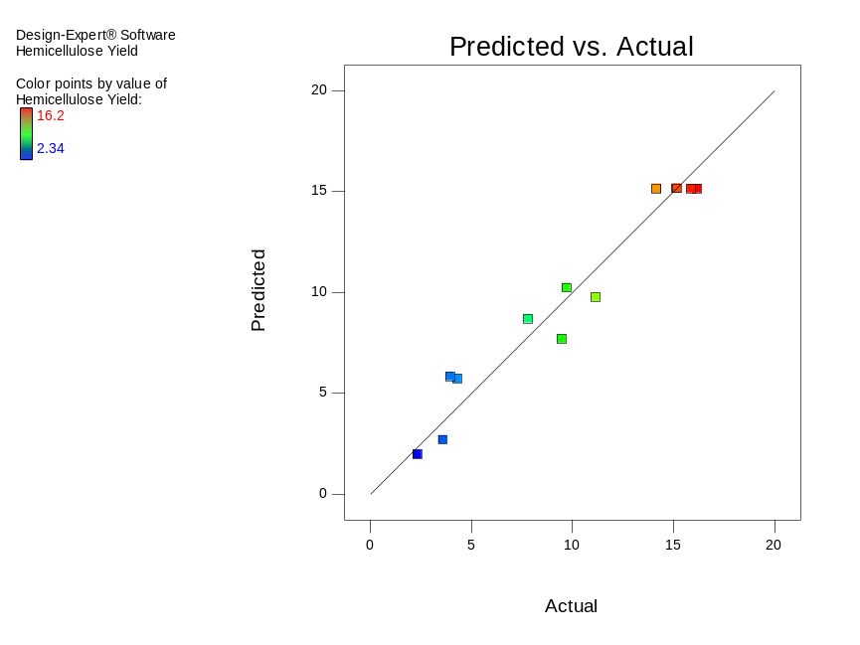
Figure 2. Predicted value vs. actual hemicellulose yield

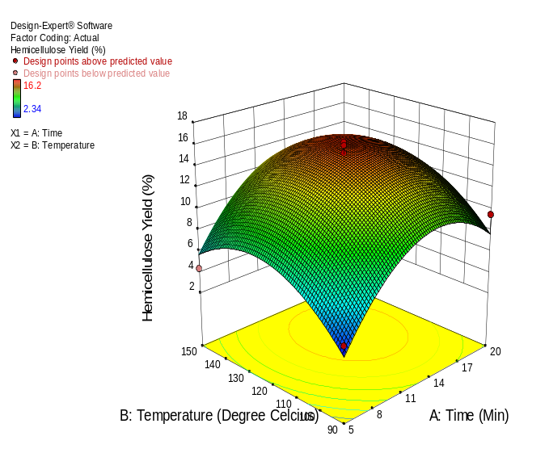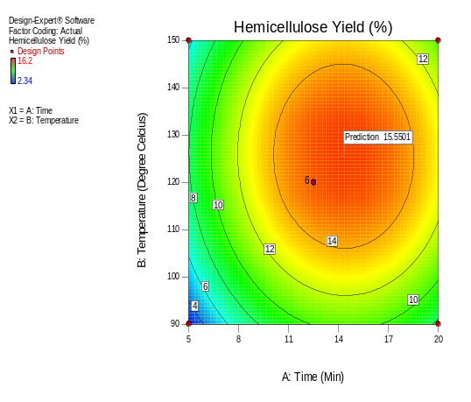
(a)
(b)
Figure 3. (a) 3D response surface plots showing combined effect of extraction time and temperature on hemicellulose yield (%); (b) 2D contour plot of hemicellulose yield against extraction time and temperature

Characterisation of extracted hemicellulose and pineapple peel: FTIR analysis
Molecules in biomass and extracted samples have specific functional groups, which help to characterise their identity. This identification is done quickly and accurately using FTIR. Figure 4 shows the FTIR spectra of both dried pineapple peel and extracted hemicellulose within the peel region of 4000–450 cm^{–1}. Numerous peaks corresponding to O-H and C=O were noted in both spectra, representing the common bonds found in hemicellulose [27]. The stretching vibration of O-H produced strong, broad peaks at 3395 cm^{–1} for both spectra. There was also a weak peak in both spectra at 2964 cm^{–1} from the vibrational stretching of C-H groups [28]. Acetyl and ester groups in hemicellulose or the ester linkage of the carboxylic group of ferulic and p-coumaric acids of lignin and hemicellulose are probably responsible for the absorption bands at 1607 cm^{–1} and 1609 cm^{–1} [29]. The peaks at 1416 cm^{–1} and 1412 cm^{–1} correspond to –COO- symmetric stretching of uronic acid carboxylate [5]. Carboxylic acid vibration from 4-O-methyl-α-D-glucuronic acid gave a peak at 1261 cm^{–1} [30]. The presence of arabinofuranosyl is associated with the peak at 1094 cm^{–1} [31]. The peaks at 1041 cm^{–1} and 1015 cm^{–1} are associated with C-O-C pyranose ring skeletal vibration. It should be noted that these peaks usually appear mainly due to the presence of C-O, C-C stretching or C-OH bending of hemicellulose [32, 33]. β-glycosidic linkages between sugar molecules are denoted by the peaks at 801 cm^{–1} and 800 cm^{–1} [34].

SEM analysis
The morphology of pineapple peel before and after microwave-assisted extraction treatment (125 °C, 14 min) was observed using a scanning electron microscope. Figure 5 depicts the SEM images of pineapple peel at 150× magnification. As presented in SEM images, different morphological structures of untreated and treated pineapple peel could be observed. The untreated pineapple peel exhibited less distortion compared to the treated pineapple peel. The breakage observed in the untreated pineapple peel sample might be due to the mechanical process of size reduction. The surface structure of the treated pineapple peel in a state of aggregation had irregular crevices and larger cell disruption. This indicates that the treatment removed external fibres, which in turn increased the surface area and resulting in higher extraction efficiency. The SEM results are in accordance with previous studies [30, 33, 35].

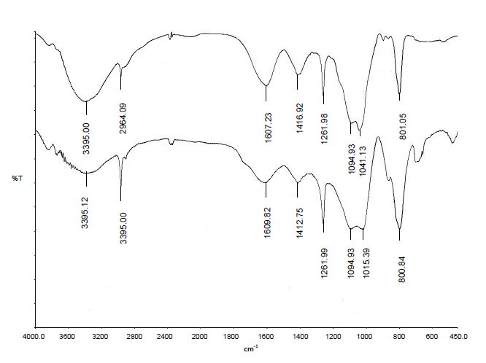
(b)
(a)
Figure 4. FTIR spectra of (a) untreated pineapple peel and (b) hemicellulose extracted via microwave assisted extraction process

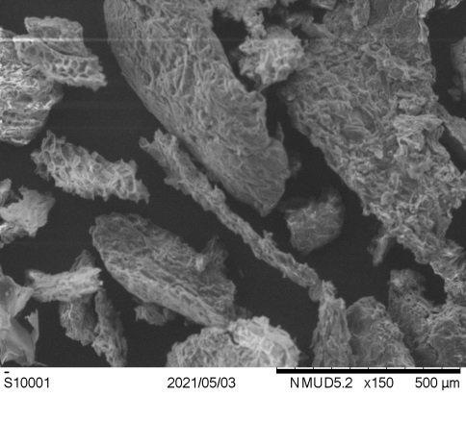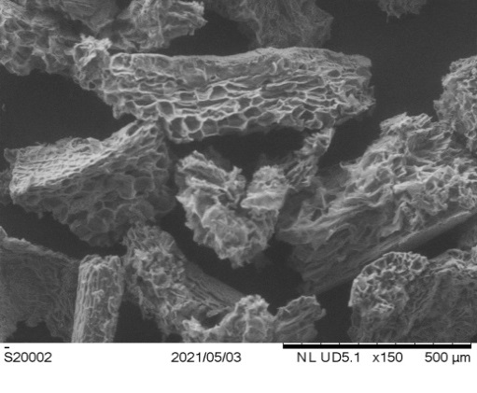
(b)
(a)
Figure 5. SEM images of pineapple peel. a) untreated pineapple peel; b) pineapple peel after microwave treatment at 125⁰C, 14 min; (magnification 150x)

Conclusion

In this study, microwave-assisted water extraction was used to obtain pineapple peel hemicellulose. RSM with CCD was applied to optimise the extracted pineapple peel hemicellulose yield. A quadratic model with extraction temperature of 125 °C and extraction time of 14 min was accepted as the best model for maximum hemicellulose yield. The predicted maximum yield of hemicellulose was 15.6%, whereas the actual yield obtained was 15.2%. Thus, in conclusion, the actual hemicellulose yield is in close agreement with the predicted yield recommended by the quadratic models of RSM with CCD. These findings demonstrate the potential applicability of optimisation of microwave-assisted extraction of hemicellulose using RSM to obtain high hemicellulose yield for the production of pineapple peel hemicellulose films.

Acknowledgement

The authors are grateful to Universiti Teknologi MARA, Malaysia for the financial support provided for this research by Geran Penyelidikan Khas, 600-RMC/GPK 5/3 (013/2020).

References
- Dai, H. and Huang, H. (2016). Modified pineapple peel cellulose hydrogels embedded with sepia ink for effective removal of methylene blue. Carbohydate Polymers, 148: 1-10.
- Kaur, N., Sharma, S., Kaur, S. and Khosla, E. (2016). Reverse micellar extraction of acid dyes from simulated textile effluent. Journal Chemistry Biology Pyhsics Sciences, 6: 180-197.
- Schieber, A., Stintzing, F. C. and Carle, R. (2001). By-products of plant food processing as a source of functional compounds—recent developments. Trends in Food Science & Technology, 12(11): 401-413.
- Madureira, A. R., Atatoprak, T., Çabuk, D., Sousa, F., Pullar, R. C. and Pintado, M. (2018) Extraction and characterisation of cellulose nanocrystals from pineapple peel. International Journal Food Studies, 7: 24-33.
- Banerjee, S., Ranganathan, V., Patti, A. and Arora, A. (2018). Valorisation of pineapple wastes for food and therapeutic applications. Trends in Food Science & Technology, 82: 60-70.
- Choquecahua Mamani, D., Otero Nole, K. S., Chaparro Montoya, E. E., Mayta Huiza, D. A., Pastrana Alta, R. Y. and Aguilar Vitorino, H. (2020). Minimizing organic waste generated by pineapple crown: A simple process to obtain cellulose for the preparation of recyclable containers. Recycling, 5(4): 24.
- Limayem, A. and Ricke, S. C. (2012). Lignocellulosic biomass for bioethanol production: Current perspectives, potential issuesand future prospects. Progress Energy Combustion Sciences, 38(4): 449-467.
- Sabiha-Hanim, S. and Siti-Norsafurah, A. M. (2012). Physical properties of hemicellulose films from sugarcane bagasse. Procedia Engineering, 42: 1390-1395.
- Mihiretu, G. T., Brodin, M., Chimphango, A. F., Øyaas, K., Hoff, B. H. and Görgens, J. F. (2017). Single-step microwave-assisted hot water extraction of hemicelluloses from selected lignocellulosic materials – a biorefinery approach. Bioresource Technology, 241: 669-680.
- Chen, J., Zhu, Y. and Liu, S. (2017). Biodegradation and utilization of hemicellulose. Functional Carbohydrate, 2017: 197-232.
- Thomas, E., Amidon, and Shi, J. L. (2009). Water-based woody biorefinery. Biotechnology Advances, 27: 542-550.
- Liu, C. G. and Wyman, C. E. (2005). Partial flow of compressed-hot water through corn stover to enhance hemicellulose sugar recovery and enzymatic digestibility of cellulose, Bioresource Technology, 96(18): 1978-1985.
- Tsubaki, S., Onda, A., Hiraoka, M., Fujii, S., Azuma, J. I. and Wada, Y. (2017). Microwave-assisted water extraction of carbohydrates from unutilized biomass. Water Extraction of Bioactive Compounds, 199-219.
- Jeya, M., Zhang, Y. W., Kim, I. W. and Lee, J. K. (2009). Enhanced saccharification of alkali-treated rice straw by cellulase from Trametes hirsuta and statistical optimization of hydrolysis conditions by RSM. Bioresource Technology, 100(21): 5155-5161.
- Oberoi, H. S., Vadlani, P. V., Nanjundaswamy, A., Bansal, S., Singh, S., Kaur, S. and Babbar, N. (2011). Enhanced ethanol production from Kinnow mandarin (Citrus reticulata) waste via a statistically optimized simultaneous saccharification and fermentation process. Bioresource Technology, 102(2): 1593-1601.
- Zulyadi, N. H., Saleh, S. H. and Sarijo, S. H. (2016). Fractionation of hemicellulose from rice straw by alkaline extraction and ethanol precipitation. Malaysian Journal of Analytical Sciences, 20(2): 329-334.
- Ioelovich, M. (2014). Structure and physicochemical properties of nitrogenated derivatives of cellulose. American Journal Biosciences, 2: 6-12.
- Browning, B. L. (1967). Methods of wood chemistry. Volume I & II. John Wiley & Sons. Interscience, New York.
- Teramoto, Y., Lee, S. H. and Endo, T. (2008). Pretreatment of woody and herbaceous biomass for enzymatic saccharification using sulfuric acid-free ethanol cooking. Bioresource Technology, 99(18): 8856-8863.
- Sukkaew, A., Boonsong, P., Thongpradistha, S. and Intan, M. (2017). Physical and chemical pretreatment of lignocellulosics in pineapple (Ananus comosus) peels dried for investment. AIP Conference Proceedings, 1868(1): 090001.
- Silveira, R., Stoyanov, S., Gusarov, S., Skaf, M. and Kovalenko, A. (2013). Plant biomass recalcitrance: Effect of hemicellulose composition on nanoscale forces that control cell wall strength. Journal of the American Chemical Society, 135: 19048-19051.
- Santos, T. M., Alonso, M. V., Oliet, M., Domínguez, J. C., Rigual, V. and Rodriguez, F. (2018). Effect of autohydrolysis on Pinus radiata wood for hemicellulose extraction. Carbohydrate Polymers, 194: 285-293.
- Yuan, Y., Zou, P., Zhou, J., Geng, Y., Fan, J., Clark, J. and Zhang, C. (2019). Microwave-assisted hydrothermal extraction of non-structural carbohydrates and hemicelluloses from tobacco biomass. Carbohydrate Polymers, 223: 115043.
- Yolmeh, M. and Jafari, S. M. (2017). Applications of response surface methodology in the food industry processes. Food Bioprocess Technology, 10: 413-433.
- Behera, S. K., Meena, H., Chakraborty, S. and Meikap, B. C. (2018). Application of response surface methodology (RSM) for optimization of leaching parameters for ash reduction from low-grade coal. International Journal of Mining Science and Technology, 28(4): 621-629.
- Shafi, J., Sun, Z., Ji, M., Gu, Z. and Ahmad, W. (2018). ANN and RSM based modeling for optimization of cell dry mass of Bacillus sp. Strain B67 and its antifungal activity against Botrytis cinerea. Biotechnology & Biotechnological Equipment, 32: 58-68.
- Palaniappan, A., Yuvaraj, S., Sonaimuthu, S. and Antony, U. (2017).Characterization of xylan from rice bran and finger millet seedcoat for functional food applications. Journal Cereal Sciences, 75: 296-305.
- Mandal, A. and Chakrabarty, D. (2011). Isolation of nanocellulose from waste sugarcane bagasse (SCB) and its characterization. Carbohydrate Polymers, 86(3): 1291-1299.
- Dai, H., Ou, S., Huang, Y. and Huang, H. (2018). Utilization of pineapple peel for production of nanocellulose and film application. Cellulose, 25(3): 1743-1756.
- Liu, H. M., Li, Y. R., Wu, M., Yin, H. S. and Wang, X. D. (2018). Two-step isolation of hemicelluloses from Chinese quince fruit: Effect of hydrothermal treatment on structural features. Industrial Crops and Products, 111: 615-624.
- Sun, S. L., Wen, J. L., Ma, M. G. and Sun, R. C. (2013). Successive alkali extraction and structural characterization of hemicelluloses from sweet sorghum stem. Carbohydrate Polymers, 92(2): 2224-2231.
- Haafiz, M. M., Hassan, A., Zakaria, Z. and Inuwa, I. M. (2014). Isolation and characterization of cellulose nanowhiskers from oil palm biomass microcrystalline cellulose. Carbohydrate Polymers, 103: 119-125.
- Singh, R. D., Bhuyan, K., Banerjee, J., Muir, J. and Arora, A. (2017). Hydrothermal and microwave assisted alkali pretreatment for fractionation of arecanut husk. Industrial Crops and Products, 102: 65-74.
- Buslov, D. K., Kaputski, F. N., Sushko, N. I., Torgashev V. I., Solov′eva L. V., Tsarenkov V. M., Zubets O. V. and Larchenko L.V. (2009). Infrared spectroscopic analysis of the structure of xylans. Journal Applied Spectroscopy, 76: 801-805.
- Dai, H. and Huang, H. (2017). Synthesis, characterization and properties of pineapple peel cellulose-G-acrylic acid hydrogel loaded with kaolin and sepia ink. Cellulose, 24: 69-84.

