

PURIFICATION OF XANTHORRHIZOL AND SCREENING OF SELECTED MICROBES FOR ITS BIOTRANSFORMATION

(Penulenan Xantorizol dan Pengesanan Mikrob Terpilih untuk Biotransformasinya)

Nurul Iman Aminudin¹*, Nadia Farhana Yahya¹, Zaima Azira Zainal Abidin², Deny Susanti¹, Muhammad Taher³

¹Department of Chemistry, Kulliyyah of Science

² Department of Biotechnology, Kulliyyah of Science

³ Department of Pharmaceutical Technology, Kulliyyah of Pharmacy

International Islamic University Malaysia, 25200 Kuantan, Pahang, Malaysia

*Corresponding author: nuruliman@iium.edu.my

Received: 5 September 2021; Accepted: 11 November 2021; Published: xx December 2021

Abstract

Xanthorrhizol is a bisabolene-type sesquiterpenoid and is present abundantly in the essential oil of Curcuma xanthorrhiza (temulawak). It was reported to possess various pharmacological activities, including antimicrobial, anti-inflammatory, antioxidant, antihyperglycemic, antihypertensive, and antiplatelet activities. To further evaluate its pharmacological potency based on the structure-activity relationship, a large amount of xanthorrhizol needs to be purified and subjected to chemical synthesis to yield xanthorrhizol analogues. Common approaches to synthesise the analogues are through chemical reactions. Biotransformation utilising microbes as biocatalysts is one of the green alternatives to replace chemical synthesis methods for producing xanthorrhizol analogues. In this study, xanthorrhizol was purified from the crude essential oil by utilising repetitive chromatographic separation and two-step chemical synthesis involving acetylation and hydrolysis reactions. The purification successfully yielded xanthorrhizol with a purity of 98.1%, as indicated by gas chromatography-mass spectrometry (GC-MS) analysis. The structure of xanthorrhizol was also characterised using nuclear magnetic resonance spectroscopy (NMR). Four selected microbes (Aspergillus niger, Streptomyces sp. K1-18, K3-20, and K7-11) were screened for the biotransformation of xanthorrhizol. The results from thin layer chromatography (TLC) and GC-MS showed that only A. niger could biotransform xanthorrhizol into its derivatives.

Keywords: xanthorrhizol, biotransformation, Aspergillus niger, Streptomyces sp., sesquiterpene

Abstrak

Xantorizol adalah seskuiterpen jenis bisabolen dan hadir dengan banyak di dalam minyak pati Curcuma xanthorrhiza (temulawak). Ia telah dilaporkan mempunyai pelbagai aktiviti farmakologi termasuk antimikrob, anti-radang, antioksidan, anti-hiperglisemik, anti-hipertensi dan antiplatlet. Untuk menilai lebih lanjut potensi farmakologi berdasarkan hubungan struktur-aktiviti, xantorizol dalam jumlah yang banyak perlu ditulenkan dan perlu melalui kaedah sintesis kimia yang membolehkan analog xantorizol dihasilkan. Pendekatan biasa untuk sintesis analog adalah melalui tindak balas kimia. Biotransformasi menggunakan mikrob sebagai biopemangkin merupakan satu alternatif hijau menggantikan kaedah sinstesis kimia yang boleh menghasilkan analog xantorizol. Dalam kajian ini, xantorizol telah ditulenkan daripada minyak pati mentah menggunakan pemisahan kromatografi berulang dan dua langkah sintesis kimia melibatkan tindak balas asetilasi dan hidrolisis. Proses penulenan telah berjaya menghasilkan xantorizol dengan ketulenan 98.1% seperti ditunjukkan oleh analisis gas-kromatografi-jisim spektrometri (GK-JS). Struktur xantorizol juga telah diperincikan menggunakan resonans magnetik nuklear (RMN) spektroskopi. Empat mikrob terpilih, (Aspergillus niger, Streptomyces sp. K1-18, K3-20 dan K7-11) telah disaring untuk biotransformasi xantorizol. Keputusan kromatografi lapisan nipis (KLN) dan JK-MS telah menunjukkan cuma A. niger berupaya melakukan biotransformasi xantorizol kepada terbitannya.

Kata kunci: xantorizol, biotransformasi, Aspergillus niger, Streptomyces sp., seskuiterpen

Introduction

Xanthorrhizol, a bisabolene-type sesquiterpenoid with a stereogenic centre at the benzylic position, is the most active and abundant component in the essential oil of Curcuma xanthorrhiza [1]. Out of 92% bisabolene-type sesquiterpenes and their oxygenated derivatives from the essential oil, 32% are xanthorrhizol, thus confirming that it is the most abundant compound in C. xanthorrhiza [2]. Xanthorrhizol possesses various pharmacological activities, including antimicrobial, anti-inflammatory, antioxidant, antihyperglycemic, antihypertensive, antiplatelet, nephroprotective and hepatoprotective, and estrogenic and antiestrogenic properties [3]. Due to the promising biological activities of xanthorrhizol, there is great interest in developing methods to obtain analogues or derivatives for an extensive structural-activity relationship (SAR) study. Conventional chemical manipulations are normally tedious, have harsh conditions, require multistep procedures, and incorporate expensive catalysts. The total synthetic routes are difficult, especially in introducing the stereogenic centre, thus hindering many conventional chemical manipulations. Nevertheless, partial synthesis involving remote functionalisation is available through the biotransformation process [4].

Biotransformation is a biochemical modification of a compound to a distinct product using biological catalysts, such as microorganisms, plant cell cultures, and enzymes [4]. Biotransformation is a useful tool in a synthesis toolbox to discover new compounds as it can produce reactions, including oxidation, reduction, hydrolysis, addition, ring rearrangement, and glycosidic transfer reaction that are not likely to happen through conventional synthetic methods [5]. Biotransformation remains unrivalled, especially due to its highly specific reactions (i.e., highly stereoselective, chemoselective, enantioselective, and regioselective) under mild and ambient reaction conditions, allowing the discovery of new compounds. A biotransformation reaction is a simple one-step reaction in aqueous media that uses non-hazardous and cheap chemicals to provide many valuable metabolites possessing different properties from one substrate in one pot. The most important advantage of biotransformation is that it practices the concept of green chemistry, where the products or metabolites produced are biodegradable compounds [6]. Among all kinds of biocatalysts, microorganisms especially microbes are widely utilised for biotransformation. Microbes can produce a variety of unique enzymes that are stable towards heat, alkali, and acids. These enzymes can also be produced in a short period of time by the microorganisms due to their nature to multiply. Their small size allows maximum metabolic rates as they have a larger surface-to-volume ratio that provides a high exchange of molecules and metabolites [6].

The establishment of a biotransformation reaction that can yield xanthorrhizol analogues for further SAR study is of particular interest because to the best of our knowledge, no study has been conducted yet. A method to yield xanthorrhizol with high purity is needed as a substrate for the biotransformation process. Suitable biocatalysts to conduct biotransformation of xanthorrhizol must also be explored through the screening process. In this study, four selected microbes (i.e., Aspergillus niger and Streptomyces sp. (K1-18, K3-20, and K7-11) were screened as the potential biocatalysts. Even though Streptomyces sp. [7-9] and A. niger [5, 10-11] are well-known biocatalysts, their ability as biocatalysts for the biotransformation of xanthorrhizol is not yet known.

Materials and Methods

Purification of xanthorrhizol from Curcuma xanthorrhiza’s essential oil

A fresh sample of C. xanthorrhiza (20 kg) was purchased from a local market. The sample was chopped and subjected to extraction using Turbo Extractor to yield approximately 212 mL of essential oil. The essential oil (9.25 g) was subjected to vacuum liquid chromatography (VLC) employing silica gel 60 (230–400 mesh) as the stationary phase and a mixture of n-hexane (n-hex): diethyl ether (Et₂O). The polarity of the solvent was increased by 1% from 200:0 to 190:10, 0.5% from 190:10 to 180:20, 5% from 180:20 to 100:100, and 50% from 100:100 to 0:200 to obtain four major fractions labelled as CXED10-1 until CXED10-4. The CXED10-3 fraction was further fractionated using VLC employing the same mobile phase to produce another six subfractions labelled as CXED11-1 until CXED11-6. The CXED11-3 subfraction with the presence of xanthorrhizol as the major compound was chosen to be analysed using GC-MS to determine its purity. The CXED11-3 subfraction was further purified through two-step chemical reactions of acetylation and hydrolysis. Acetylation produced xanthorrhizyl acetate as the major product, whereas the hydrolysis of xanthorrhizyl acetate produced xanthorrhizol with higher purity.

Acetylation of xanthorrhizol was done by adding Et₂O (10 mL), pyridine (3 mL), and acetic anhydride (3 mL) into the CXED11-3 subfraction (2.0 g). The reaction mixture was stirred for 24 h at room temperature. The acetylation process was monitored using TLC with n-hex: Et₂O of 4:1 as the solvent system. Distilled water (5 mL) was added to the reaction mixture and left for 10 min while stirring. The reaction mixture was washed with 1 M hydrochloric acid solution (20 mL) thrice, followed by saturated sodium bicarbonate solution (20 mL) thrice, and lastly with brine solution (20 mL) once using liquid-liquid extraction. The organic phase was dried with anhydrous magnesium sulphate to yield a yellow oil (1.77 g). The oil was subjected to column chromatography utilising silica gel (mesh 60–230) and a mixture of n-hex: Et₂O in a stepwise gradient as the stationary and mobile phases, respectively. A total of 431 fractions were obtained and pooled into six major subfractions labelled as AX3-1 until AX3-6. The TLC analysis on the AX3-2 subfraction showed a single spot, representing pure xanthorrhizyl acetate (0.79 g, 44.6%) as a colourless oil. The structure of xanthorrhizyl acetate was further characterised using nuclear magnetic resonance (NMR) and infrared (IR) spectroscopy.

Hydrolysis was done by adding anhydrous potassium carbonate (0.52 g), methanol (7 mL), and distilled water (1 mL) to xanthorrhizyl acetate (0.79 g) and stirred at room temperature for 18 h. Distilled water (5 mL) was then added to the reaction mixture and the organic phase was extracted with ethyl acetate (10 mL) thrice. The organic phase was dried using anhydrous magnesium sulphate, followed by evaporation to yield xanthorrhizol (0.07 g, 8.89%) as a yellow oil. The purity of xanthorrhizol was further monitored using GC-MS, whereas its structure was characterised using NMR spectroscopy.

Microbial culture

Four microbes were selected to be screened for the biotransformation of xanthorrhizol, namely Streptomyces sp. (Streptomyces sp. K1-18, K3-20, and K7-11) and A. niger (ATCC 16404). All Streptomyces sp. were isolated from Kuantan Mangrove Forest and maintained on starch-yeast extract (SYE) agar. Meanwhile, A. niger was obtained from the Department of Biotechnology, Kulliyyah of Science, International Islamic University of Malaysia, and maintained on actinomycete isolation agar (AIA). Both microbes were cultured in SYE broth prepared by the addition of starch (10 g), yeast extract (4 g), and peptone (2 g) in distilled water (1 L). The microbes were incubated at 28 °C with continuous shaking at 150 rpm to ensure homogeneous mixing and create the optimum conditions for microbial growth.

Screening procedure for biotransformation of Xanthorrhizol

A. niger, Streptomyces sp. K1-18, K3-20, and K7-11 from the agar plates were inoculated in five 250 mL flasks containing 150 mL of SYE broth. Four flasks were designated as reaction broth (RB) flasks and one flask was designated as the inoculum control (IC) flask. The RB flasks contained inoculated microbes in the SYE broth in the presence of xanthorrhizol as the substrate, whereas the IC flask contained inoculated microbes in the SYE broth without the presence of substrate. All flasks were shaken on a rotary shaker at 150 rpm and 28 °C for five days to ensure the full growth of microbes. On the 5th day, xanthorrhizol (5.5 µL) dissolved in acetone (500 µL) was added to the RB flasks and incubated for an additional 14 days for A. niger [12]. A similar incubation period (i.e., 14 days) was applied for all Streptomyces sp. to evaluate their potential in performing biotransformation at the sporulation stage [13].

After the incubation process ended, the broth from all flasks was centrifuged to remove any microbial suspension. The centrifugation process was done at 28 °C and 7,000 rpm for 10 min. After that, the supernatant layer was collected and extracted thrice with ethyl acetate (50 mL). The combined organic phase was dried with anhydrous magnesium sulphate to trap excess water. The solvent was then dried using a rotary evaporator to yield the crude products. TLC analyses were carried out with n-hex: Et₂O of 4:1 and chloroform (CHCl₃): methanol (MeOH) of 4.5:0.5 as the solvent system. The spots on TLC plates were visualised using a UV lamp (wavelengths of 254 and 365 nm). The plates were also sprayed with vanillin-sulphuric acid reagent and heated for visual colour detection of spots [14]. The spots observed from the IC flask originated from the metabolites produced by the microbes. Hence, these spots would be used as the reference compared to the new spots present from the RB flasks. The new spots produced from the RB flasks indicated the presence of biotransformation products. The presence of biotransformation products was further confirmed using GC-MS comparative analysis of the RB and IC crude extract.

Gas chromatography-mass spectrometry

GC-MS analysis was carried out using the GC-MS Perkin Elmer (ClarusTM 680/GC SQ8T/MS) equipped with Elite-5MS capillary column (30 m × 0.25 mm id, 0.25 µm film thickness; Perkin Elmer). The sample injection volume was 1 µL and the temperature programme was set from 60 °C (10 min) to 230 °C (10 min) at 3 °C min⁻¹.

Attenuated total reflectance – Fourier transform infrared

Attenuated total reflectance- Fourier transform infrared (ATR-FTIR) spectrum was recorded on a Perkin-Elmer spectrophotometer between 4000 and 600 cm⁻¹.

Nuclear magnetic resonance spectroscopy

NMR analysis was carried out at 500 MHz on Bruker Ultra Shield Plus spectrometer. Chemical shifts were obtained in parts per million (δ ppm) using tetramethylsilane (TMS) as an internal standard for spectra obtained in deuterated chloroform (CDCl₃).

Results and Discussion

Isolation and purification of xanthorrhizol

The isolation of xanthorrhizol from C. xanthorrhiza essential oil was done using chromatographic techniques (VLC and CC) and two-step chemical synthesis methods (acetylation and hydrolysis). Repetitive VLC determined the CXED11-3 fraction with the presence of xanthorrhizol as the major spot and a minor spot (impurities) on top of it based on the TLC analysis. GC-MS analysis was carried out on the CXED11-3 fraction to determine the percentage of purity of xanthorrhizol. Six peaks comprising one major peak (t_{R} = 45.9 min) and five minor peaks representing the impurities (t_{R} = 19.2, 39.9, 42.5, 44.2, and 46.8 min) were detected (Figure 1(a)). The MS spectrum (Figure 1(b)) of the major peak revealed that the molecular ion mass at m/z 218 was in agreement with the molecular weight of xanthorrhizol. The percentage area of the xanthorrhizol peak was 80.8%, indicating its percentage of purity. However, to perform the biotransformation of xanthorrhizol, it is best to obtain xanthorrhizol with a purity percentage higher than 90%. Thus, further purification steps need to be carried out on the CXED11-3 fraction.

The presence of a less polar minor spot (impurities) above the xanthorrhizol spot complicates the purification process using chromatographic techniques. Thus, acetylation (Figure 2) was employed to yield xanthorrhizyl acetate, which appeared as a less polar spot than the spot for impurities. The isolation of xanthorrhizyl acetate was easier and faster as it would elute earlier in the further isolation step using CC. The

structure of xanthorrhizyl acetate was further characterised by IR and NMR spectroscopy and the results are tabulated in Table 1 and 2, respectively. The presence of the acetate group was confirmed by the presence of carbonyl ester stretching at 1764 cm^{–1} in the IR spectrum (Table 1), the presence of carbon signal of carbonyl ester at δ 169.20 ppm and a singlet signal attributed to methyl from the acetyl group at δ 2.30 ppm (Table 2). Other spectroscopic data also agreed with the structure of xanthorrhizyl acetate and with the published data [15,16].

Hydrolysis was carried out on the isolated xanthorrhizyl acetate to yield xanthorrhizol (Figure 3). The reaction did not require further chromatographic separation. The GC-MS chromatogram (Figure 4) revealed that the purity of xanthorrhizol increased to 98.1%, as indicated by its peak area. The absence of a singlet signal attributed to the methyl protons from the acetyl group of xanthorrhizyl acetate at δ 2.30 ppm and carbon signal corresponding to the carbonyl ester indicated a successful hydrolysis reaction back to xanthorrhizol. Other ¹H NMR spectroscopic data (Table 2) also matched with the structure of xanthorrhizol and agreed with published data [17].

Screening of microbes for the biotransformation of xanthorrhizol

The ability of A. niger, Streptomyces sp. K1-18, K3-20, and K7-11 to perform biotransformation of xanthorrhizol was screened. The screening was conducted through biotransformation by incubating xanthorrhizol with each microbe in the SYE broth. The broths were supplemented with xanthorrhizol on the 5th day of incubation to ensure the process was conducted during the exponential phase of the microbial growth. TLC profiling was carried out to identify the presence of new products due to the biotransformation reaction after the incubation process was completed. This was done by comparing the TLC profiles of xanthorrhizol, the extracts from the IC and RB flasks, and starch soluble and yeast extract as the ingredients from the SYE broth. Two solvent systems (i.e., n-hex: Et₂O of 4:1 and CHCl₃: MeOH of 4.5:0.5) were employed to ensure all non-polar and polar compounds were observed in the TLC.

The TLC profile for the screening of biotransformation utilising A. niger is depicted in Figure 5. The spot of xanthorrhizol with R_{f} = 0.54 (n-hex: Et₂O of 4:1) could be seen under 254 nm. No xanthorrhizol spots could be observed for all RB extracts, suggesting that the biotransformation of xanthorrhizol by A. niger was completed within 21 days. A significant spot labelled as spot 1 (R_{f} = 0.67; n-hex: Et₂O of 4:1) was observed in the RB extracts, indicating a less polar biotransformation product than xanthorrhizol. In addition, another spot was observed in the TLC with R_{f} = 0.63 (CHCl₃: MeOH of 4.5:0.5), highlighting the presence of a more polar biotransformation product compared to xanthorrhizol. A comparative analysis between xanthorrhizol and the IC and RB extracts for the biotransformation by A. niger was performed using GC-MS to further confirm the qualitative results from the TLC analysis. The presence of spots 1 and 2 was confirmed by comparing all chromatograms (Figure 6). The chromatogram shows a peak of xanthorrhizol appeared at t_{R} = 45.7 min. This peak was not observed in the RB extracts, thus confirming the completion of biotransformation. Two peaks appeared at t_{R} = 53.3 and 55.3 min in the RB extract chromatogram and were not observed in the chromatogram of the IC extract. This further proved the presence of two biotransformation products by A. niger, which were also in accordance with the observation from the TLC analysis.

Meanwhile, the TLC analysis for Streptomyces sp. K1-18, K3-20, and K7-11 did not show any significant spots compared to the IC and RB extracts that could be recognised as possible biotransformation products. The spot of xanthorrhizol was still present in the RB extracts (Table 3), indicating that the reaction did not occur even after 14 days of incubation (i.e., sporulation stage) [13]. Thus, these three microbes were unable to perform biotransformation of xanthorrhizol and further analysis by GC-MS was not conducted.

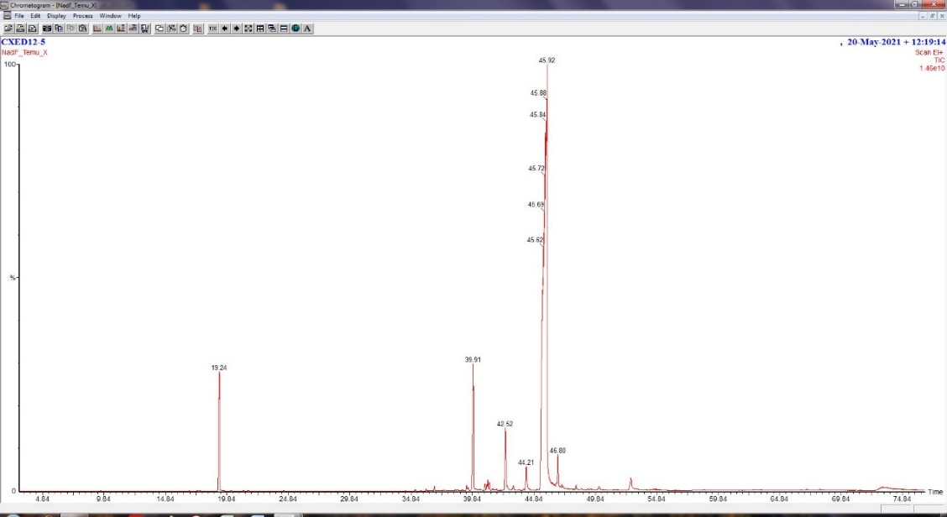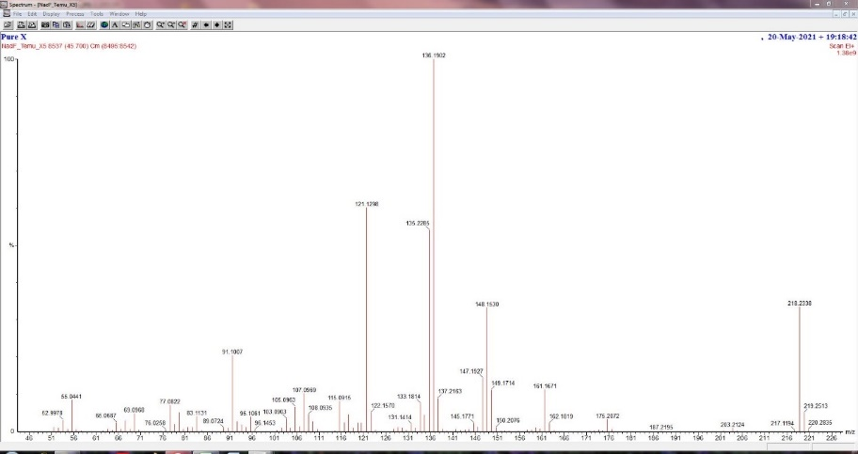
Xanthorrhizol
t_{R} 45.9 min
(80.8%)
M+ m/z 218
(a)
(b)
Figure 1. (a) GC-MS chromatogram of CXED11-3 fraction and (b) MS spectrum of xanthorrhizol

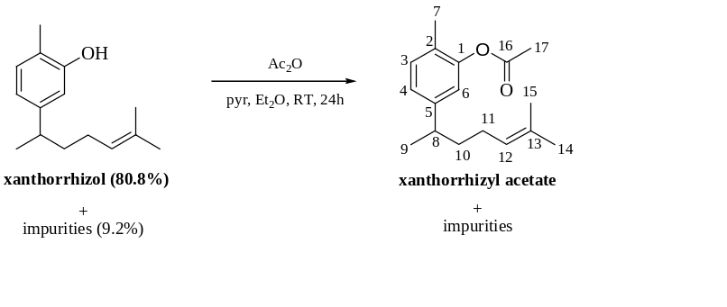
Figure 2. Reaction scheme of acetylation reaction of CXED11-3 fraction

Table 1. IR data of xanthorrhizyl acetate
Functional Group | υ_{max} (cm⁻¹)
sp³ CH | 2962, 2924
C=O ester | 1764
C-O ester | 1210

Table 2. NMR data of xanthorrhizyl acetate and xanthorrhizol
No. | Xanthorrhizyl acetate, δ (ppm) |  | Xanthorrhizol, δ (ppm)
No. | ¹H | ¹³C | ¹H | ¹³C
1 | - | 146.94 | - | 153.61
2 | - | 120.34 | - | 113.54
3 | 7. 13 (d, J= 7.7 Hz) | 149.29 | 7.02 (d, J= 7.8 Hz) | 147.25
4 | 6.96 (dd, J= 1.6, 7.7 Hz) | 124.71 | 6.67 (dd, J= 1.8, 7.8 Hz) | 120.79
5 | - | 130.83 | - | 130.76
6 | 6.81 (d, J= 1.6 Hz) | 124.38 | 6.61 (d, J= 1.8 Hz) | 119.42
7 | 2.13 (s) | 38.85 | 2.21 (s) | 39.04
8 | 2.66 (sext, J= 7.0 Hz) | 38.33 | 2.61 (sext, J= 7.0 Hz) | 38.38
9 | 1.21 (d, J= 7.0 Hz) | 26.07 | 1.20 (d, J= 7.0 Hz) | 26.16
10 | 1.54-1.60 (m) | 127.17 | 1.56-1.61 (m) | 124.52
11 | 1.85-1.91 (m) | 131.52 | 1.84-1.90 (m) | 131.43
12 | 5.05-5.09 (m) | 17.66 | 5.06-5.10 (m) | 25.71
13 | - | 25.69 | - | 15.31
14 | 1.50 (s) | 15.78 | 1.52 (s) | 22.38
15 | 1.66 (s) | 22.15 | 1.66 (s) | 17.68
16 | - | 169.20 | - | -
17 | 2.30 (s) | 20.83 | - | -

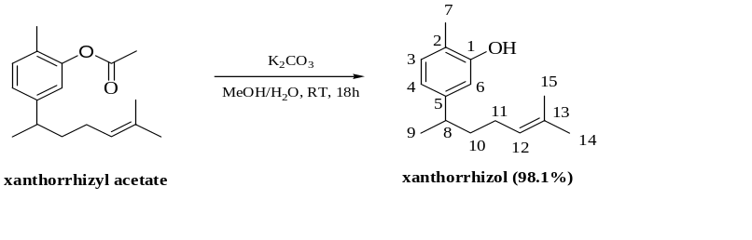

Figure 3. Reaction scheme of hydrolysis reaction of xanthorrhizyl acetate

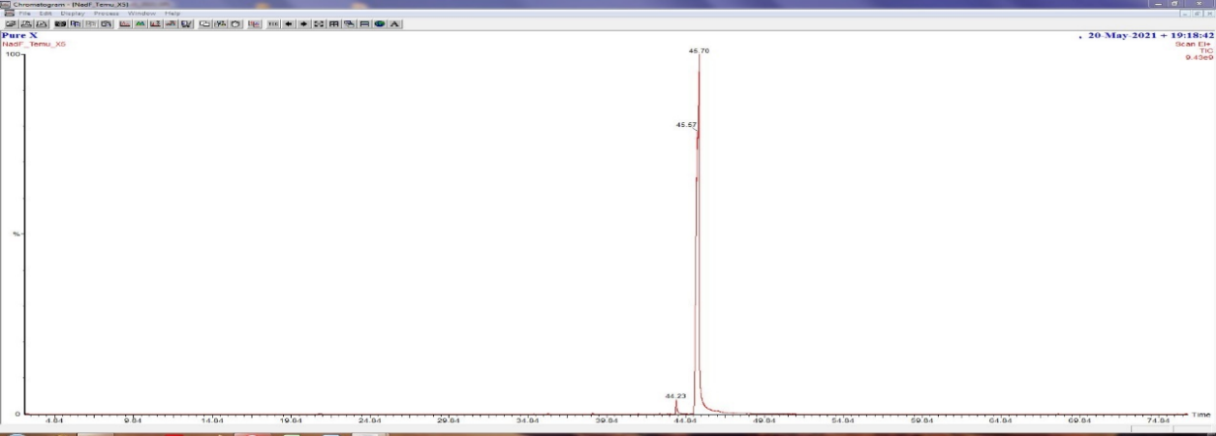
Xanthorrhizol
t_{R} 45.7 min
(98.1%)

Figure 4. GC-MS chromatogram of xanthorrhizo

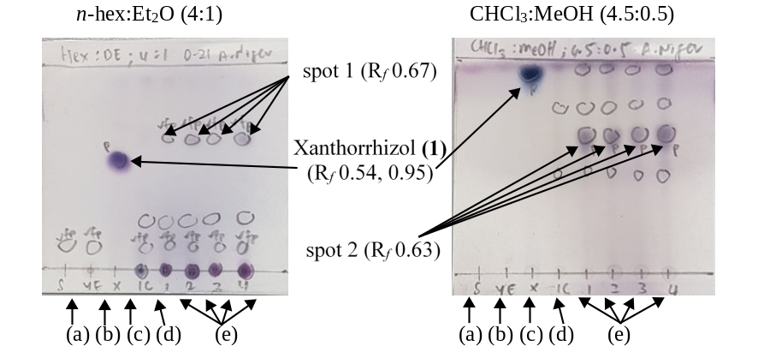
Figure 5. TLC profile of biotransformation of xanthorrhizol by A. niger; (a) starch soluble; (b) yeast extract; (c) pure xanthorrhizol; (d) IC extract; (e) RB extracts

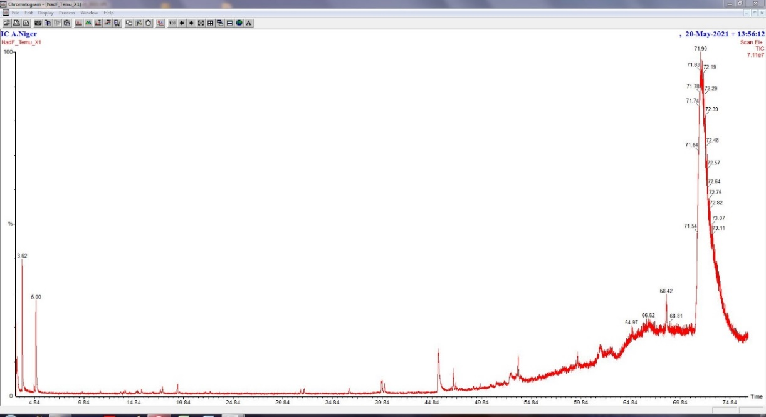
(a)

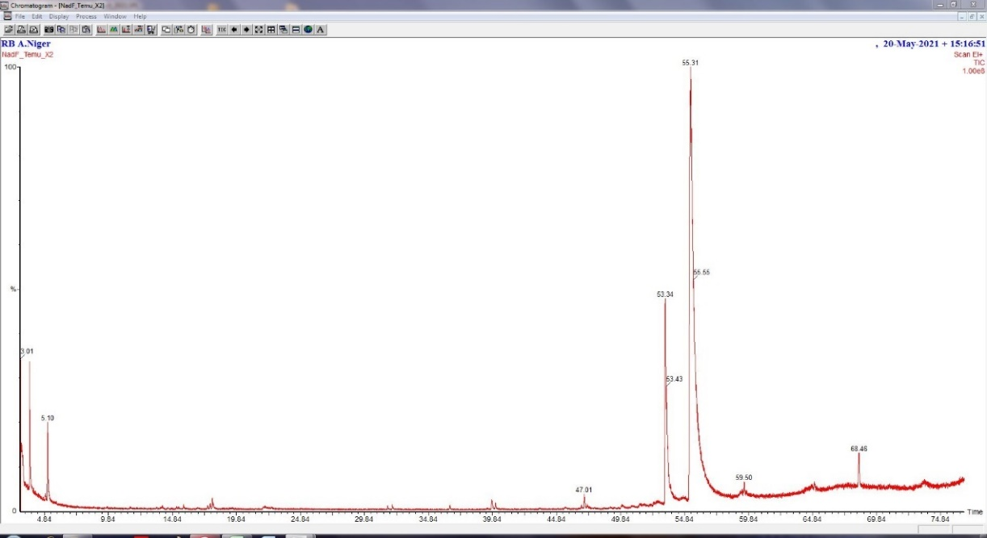

(b)

Figure 6. GC-MS chromatograms of (a) IC extract and (b) RB extract from biotransformation of xanthorrhizol by A. niger

Table 3. TLC profile of biotransformation of xanthorrhizol by Streptomyces sp.
Streptomyces sp. | TLC Solvent System
Streptomyces sp. | n-hex:Et₂O (4:1) |  | CHCl₃:MeOH (4.5:0.5)
K1-18 | 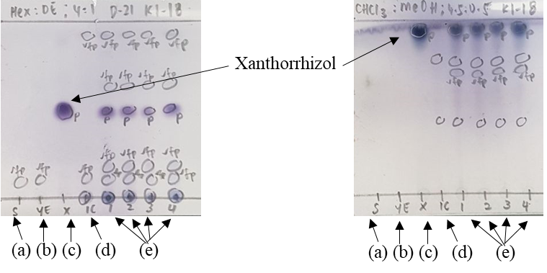
K3-20 |  | 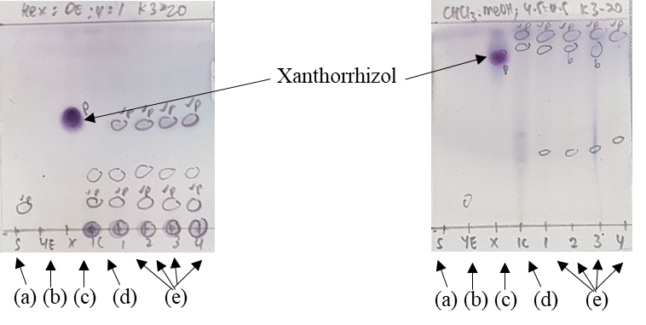
K7-11 |  | 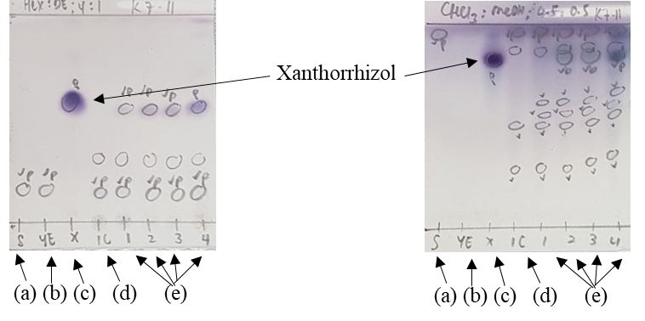
*(a) starch soluble; (b) yeast extract; (c) pure xanthorrhizol; (d) IC extract; (e) RB extracts

Conclusion

Xanthorrhizol was successfully purified from the essential oil of C. xanthorrhiza through the combination of chromatographic techniques and two-step chemical reactions. This method yielded higher purity of xanthorrhizol compared to only chromatographic techniques. The screening process revealed that only A. niger has the potential to be a biocatalyst to perform biotransformation of xanthorrhizol. This screening result will provide beneficial reference, especially in obtaining the new structure of xanthorrhizol analogues from preparative biotransformation for intended biological SAR studies.

Acknowledgement

The authors are thankful for this work’s funding from Ministry of Higher Education (MOHE) Malaysia through Fundamental Grant Scheme FRGS19-029-0637 (FRGS/1/2018/STG01/UIAM/03/3).

References
- Dosoki, N. S. and Setzer, W. N. (2018). Chemical composition and biological activities of essential oils of Curcuma Species. Nutrients, 10(1196): 1-42.
- Jantan, I., Saputri, F. C., Qaisar, M. N. and Buang, F. (2012). Correlation between chemical composition of Curcuma domestica and Curcuma xanthorrhiza and their antioxidant effect on human low-density lipoprotein oxidation. Evidence-Based Complementary and Alternative Medicine. 2012: 1-10.
- Shahid, M., Azfaralariff, A., Law, D., Najm, A. A., Sanusi, S. A., Lim, S. J., Cheah, Y. H. and Fazry, S. (2021). Comprehensive computational target fishing approach to identify xanthorrhizol putative targets. Scientific Reports, 11(1594): 1-11.
- Hegazy, M.-E. F., Elshamy, A. I., Mohamed, T. A., Hussien, T. A., Helaly, S. E., Abdel-Azim, N. S. Shams, K. A., Shahat, A. A., Tawfik, W. A., Shahen, A. M., Debbab, A., El Saedi, H. R., Mohamed, A. E.-H. H., Hammouda, F. M., Sakr, M., Paré, P. W. and Efferth, T. (2020). Terpenoid bio-transformations and applications via cell/organ cultures: A systematic review. Critical Reviews in Biotechnology, 40(1): 64-82.
- Aminudin, N. I., Ridzuan, M., Darnis, D. S. and Zainal A. Z. A. (2021). Biotransformation of sesquiterpenoids: A recent insight. Journal of Asian Natural Products Research, 2021: 1-44.
- Hegazy, M. E., Mohamed, T. A., ElShamy, A. I., Mohamed, A. E., Mahalel, U. A., Reda, E. H., Shaheen, A. M., Tawfik, W. A., Shahat, A. A., Shams, K. A., Abdel-Azim, N. S. and Hammouda, F. M. (2015). Microbial biotransformation as a tool for drug development based on natural products from mevalonic acid pathway: A review. Journal of Advanced Research, 6(1): 17-33.
- Chattopadhyay, P., Banerjee, G. and Sen, S. K. (2018). Cleaner production of vanillin through biotransformation of ferulic acid esters from agroresidue by Streptomyces sannanensis. Journal of Cleaner Production, 182: 272-279.
- Wu, C., Zhu, H., van Wezel, G. P. and Choi, Y. H. (2016). Metabolomics-guided analysis of isocoumarin production by Streptomyces species MBT76 and biotransformation of flavonoids and phenylpropanoids. Metabolomics, 12(5): 1-11.
- Zhang, D., Tao, X., Gu, G., Wang, Y., Zhao, W., Zhao, W., Ren, Y., Dai, S. and Yu, L. (2021) Microbial transformation of neo-clerodane diterpenoid, scutebarbatine F, by Streptomyces sp. CPCC 205437. Frontiers in Microbiology, 12(662321): 1-15.
- Parshikov, I.A. and Sutherland, J. B. (2014). The use of Aspergillus niger cultures for biotransformation of terpenoids. Process Biochemistry, 49(12): 2086-2100.
- Lima, M. A. S., de Oliveira, M. C. F., Pimenta, A. T. A. and Uchôa, P. K. S. (2019). Aspergillus niger: A hundred years of contribution to the natural products chemistry. Journal of Brazilian Chemical Society, 30(10): 2029-2059.
- Arturo, C.-F. and Guillermo, D. (2017). Sesquiterpene lactones by filamentous fungi. Cytotoxic evaluations. Chemistry & Biodiversity, 14(1): 1-12.
- Malek, N. A., Zainuddin, Z., Chowdhury, A. J. K. and Abidin, Z. Z. A. (2015). Diversity and antimicrobial activity of mangrove soil Actinomycetes isolated from Tanjung Lumpur, Kuantan. Jurnal Teknologi. 77 (25): 37-43.
- Spangenberg, B., Poole, C. F. and Weins, C. (2011). Quantitative thin-layer chromatography: A partial survey. Heidelberg, Berlin: Springer.
- Rahayu, M. D., Kusumaningrum, S. and Hayun, H. (2020). Synthesis of acetyl and benzoyl esters of xanthorrhizol and its oxidation products and evaluation of their inhibitory activity against nitric oxide production. International Journal of Applied Pharmaceutics, 12(1): 135-138.
- Aguilar, M. I., Delgado, G. and Villarreal, M. L. (2001). New bioactive derivatives of xanthorrhizol. Revista De La Sociedad Química De México, 45(2): 56-59.
- Ramdani, E. D., Marlupi, U. D., Sinambela, J. M. and Tjandrawinata, R. (2016). A new method of xanthorrhizol isolation from the rhizome extract of Curcuma xanthorrhiza. Scholars Academic Journal of Biosciences, 4(9): 732-737.

