

SYNTHESIS AND CHARACTERIZATION OF
4-CHLOROPHENOXYACETIC ACID HERBICIDE INTERCALATED INTO CALCIUM-ALUMINIUM LAYERED DOUBLE HYDROXIDE THROUGH CO-PRECIPITATION METHOD

(Sintesis dan Pencirian Herbisid Asid 4-Klorofenoksiasetik Diinterkalatkan dengan

Kalsium-Aluminium Hidroksida Dua Lapisan Melalui Kaedah Pemendakan Bersama)

Farah Liyana Bohari¹, Muhammad Alinsan Kamil Mukamil Hamzah¹,

Sheikh Ahmad Izaddin Sheikh Mohd Ghazali¹*, Nur Nadia Dzulkifli¹, Is Fatimah², Nurain Adam³

¹Material, Inorganic, and Oloechemistry (MaterInoleo) Research Group,

School of Chemistry and Environment, Faculty of Applied Sciences

Universiti Teknologi MARA Cawangan Negeri Sembilan Kampus Kuala Pilah, 72000, Negeri Sembilan, Malaysia

²Department of Chemistry, Faculty of Mathematics and Natural Sciences,

Universitas Islam Indonesia, Kampus Terpadu UII, J1. Kaliurang Km 14, Sleman, Yogyakarta, Indonesia

³Kontra Pharma (M) Sdn Bhd (90082-V)

Kotra Technology Centre (Block B) 1,2 &3, Industrial Estate,75250, Jalan Ttc 12, Malacca, Malaysia

*Corresponding author: sheikhahmadizaddin@uitm.edu.my

Received: 15 September 2021; Accepted: 10 November 2021; Published: xx December 2021

Abstract

Layered double hydroxide (LDH) or hydrotalcite-like compound is a material that can be used in agriculture as a support for controlled release formulations of herbicides such as 4-chlorophenoxyacetic acid (4-CPA). In this study, calcium-aluminium (Ca-Al) LDH host was prepared as a new herbicide delivery system by intercalating 4-CPA with Ca-Al LDH through a co-precipitation method. The synthesis was performed at pH 12 using different concentrations of Al(NO₃)₃.9H₂O, which were 0.025 M and 0.10 M. The successful intercalation was obtained using 0.025 M of Al(NO₃)₃.9H₂O and has been confirmed through several analyses. First, the results obtained from the powder X-ray diffraction (PXRD) pattern showed that the basal spacing for the 0.025M nanocomposites had increased from 8.54 Å to 9.98 Å, indicating the successful intercalation of 4-CPA into the Ca-Al LDH. Meanwhile, the basal spacing of the 0.1 M nanocomposite remains unchanged. This result was supported by the ATR-FTIR band, which showed that the nitrate peak disappeared and the carboxylate ion (COO⁻) band was present at 1634 cm⁻¹ unlike the nitrate peak for the 0.10 M nanocomposite, which remained at 1365 cm⁻¹. The nanocomposite synthesized has shown mesoporous-type material with a H3 hysteresis loop in the Brunauer-Emmett-Teller (BET) analysis. This study has demonstrated the potential of Ca-Al LDH as a safer agent for agrochemicals by reducing the dosage of herbicide in the agriculture field and protecting the herbicide through leaching and runoff into the water system.

Keywords: 4-chlorophenoxyacetic acid, intercalation, co-precipitation, layered double hydroxide, nanoparticles

Abstrak

Hidroksida dua lapisan (LDH) atau sebatian seperti hidrotalsit ini adalah bahan yang boleh digunakan sebagai sokongan bagi formulasi pelepasan terkawal untuk racun herba seperti asid 4-klorofenoksiasetik (4-CPA) dalam pertanian. Dalam kajian ini, perumah kalsium-aluminium (Ca-AL) LDH telah dihasilkan sebagai sistem hantaran racun herba yang baharu dengan menginterkalat 4-CPA ke dalam Ca-Al LDH melalui kaedah pemendakan bersama. Sintesis ini telah dilakukan pada pH 12 dengan kepekatan yang berbeza untuk Al(NO₃)₃.9H₂O iaitu 0.025 M dan 0.10 M. Interkalasi yang berjaya telah diperolehi dengan menggunakan 0.025 M Al(NO₃)₃.9H₂O dan telah disahkan melalui beberapa analisis. Pertama, keputusan yang diperolehi daripada pola serbuk belauan sinar-X (PXRD) menunjukkan bahawa penjarakan asas untuk komposit nano 0.025 M telah meningkat daripada 8.54 Å kepada 9.98 Å, membuktikan kejayaan interkalasi 4-CPA ke dalam Ca-Al LDH. Manakala penjarakan asas bagi komposit nano 0.10 M kekal sama. Keputusan ini telah disokong oleh jalur ATR-FTIR menunjukkan kehilangan puncak nitrat dan kewujudan jalur ion karboksilat (COO⁻) pada 1634 cm⁻¹ tidak seperti puncak nitrat pada 0.10 M yang kekal pada 1365.30 cm⁻¹. Komposit nano yang telah disintesis menunjukkan bahan jenis mesoliang dengan gelung hysteresis H3 dalam analisis Brunauer-Emmett-Teller (BET). Kajian ini telah membuktikan potensi Ca-Al LDH sebagai agen agrokimia yang lebih selamat dengan mengurangkan dos racun herba dalam bidang pertanian dan melindungi racun herba daripada melarut resap dan meleleh ke dalam sistem air.

Kata kunci: 4-klorofenoksiasetik, interkalasi, pemendakan bersama, hidroksida dua lapisan, zarah nano

Introduction

In plants, competition between other species occurs due to the availability of resources such as nutrients and sunlight to achieve maximum efficiency. Weeds are unwanted species that are not necessary because they have a negative biotic factor effect by reducing crop yields, making harvesting difficult, harbouring insects, and, at the end of the day, reducing the quality and marketability of agriculture production. An increasing number of herbicides found these days are the result of increases in the number of weed species, which have introduced significant crop safety and improved weed management. A good herbicide possesses good properties such as being effective at low doses, low-cost manufacture, and friendly to users, but most importantly is safe for the environment.

Layered double hydroxide, or LDH, is a two-dimensional nanosheet with the common formula of [M²⁺_{1-x} M³⁺_{x} (OH)₂]^{x+} (An⁻)x/n. mH₂O, where M²⁺ and M³⁺ are divalent and trivalent cations, respectively, and An⁻ is an organic and inorganic anion [1]. Ion exchange or precipitation methods can be used to introduce inorganic or organic anion between the interlayers of LDH [2]. The most important properties of LDH for this research are environmental capability, especially in agriculture, which are high uptake capacity [3], surface area, high anion-exchange capability, and flexible interlayer space [4–7]. The nature of the interlayer anion can also be freely selected while there are negative charged particles, and simultaneously, LDH is an interesting field to study, especially in agriculture, because it can be proved to support the movement of catalytic active anion between the interlayer regions [8–9]. To the best of my knowledge, only a few studies on this topic have been reported yet, especially on Ca-Al LDH intercalated with herbicide.

4-chlorophenoxyacetic acid, or known as 4-CPA, that is a selective herbicide that used to control the growth of broadleaf weeds [10]. This low cost, high efficiency, and good water solubility herbicide belongs to the chlorinated herbicide group, which is used as a plant growth regulator and is widely employed for thinning in peaches and inhibiting root growth in mung beans [11]. As the herbicide has high solubility, it can easily be absorbed into the surface or groundwater and lead to contamination [12]. 4-CPA, whose high solubility in water has become a concern, has been categorised by the US EPA as a priority pollutant and many studies have been done to overcome this problem [13].

The intercalation of 4-CPA into the interlayer of LDH can minimise and control the issues caused by the massive use of herbicide in water reservoirs due to the properties of LDH that are capable of anion exchange

capacity. Other than that, intercalation of 4-CPA into Ca-Al LDH also seems to reduce the amount of chemicals used for agriculture.

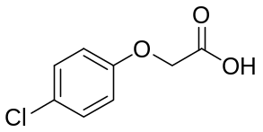
Figure 1. Formula structure of 4-chlorophenoxyacetic acid

Materials and Methods

Chemicals and reagents
The chemical used for the guest anion is 4-chlorophenoxyacetic Acid (4-CPA) from Sigma Aldrich to intercalate into the Ca-Al LDH. Meanwhile, the chemicals used to prepare the host were aluminium nitrate nonahydrate, Al(NO₃)₃.9H₂O and calcium nitrate tetrahydrate, Ca(NO₃)₂.6H₂O from R&M Chemical, and deionized water. 2 M of sodium hydroxide (NaOH) from the QreC brand is used to make the solution alkaline in the presence of nitrogen gas. The other chemical used in this experiment was absolute ethanol from R&M Chemical, to be diluted with the guest anion. All solutions were prepared using deionized water.

Synthesis of calcium-aluminium layered double hydroxide
The host of Ca-Al LDH was prepared by the co-precipitation method. For the precursors, 0.1 M of Ca(NO₃)₂.6H₂O and different concentrations of Al(NO₃)₃.9H₂O in the range of 0.025 M and 0.1 M were mixed together in a 250 ml conical flask filled with deionized water. 2 M of NaOH solution was added dropwise to the mixture with vigorous stirring to obtain a pH close to 13 [14]. The mixture was stirred vigorously to ensure the solids were completely dissolved under the purge of the nitrogen gas to prevent co-intercalation of CO₂. Later, the solution was aged in an oil bath shaker for 18 h at 70°C. Then, the precipitate was centrifuged at 300 rpm and washed with deionized water up to three cycles to remove the impurities. The precipitate was dried at 80°C in the oven for 72 h before further characterization using PXRD and Fourier-transformed infrared spectroscopy (FTIR) instruments

Synthesis of 4CPA-CaAl LDH by co-precipitation method
In a conical flask filled with deionized water, 0.1 M Ca(NO₃)₂.6H₂O were mixed together with 0.025 M and 0.1 M of Al(NO₃)₃.9H₂O. Next, 0.1 M 4-CPA guest anion was diluted with a ratio of 9:1 of absolute ethanol and deionized water. The diluted mixture of 4-CPA was gradually added into the aqueous mixture of Ca(NO₃)₂.6H₂O and Al(NO₃)₃.9H₂O followed by the addition of 2.0 M of NaOH with vigorous stirring. The solution was kept at a pH of around 13 ± 0.05 under the nitrogen atmosphere. The solution was aged for 18 h at 70°C, centrifuged, washed with deionized water, and filtered with a vacuum filter [14]. Lastly, the precipitate was dried in the oven at a temperature of 80°C for 72 h. The sample is kept in a vial for further use and characterization.

Characterization technique
X-ray powder diffraction (XRD) pattern in the 2θ range 5° to 90° was recorded with Panalytical model Empyrean (Panalytical, Almelo, Netherlands) operating at 40 kV and 35 mA using Cu Kα radiation (λ = 1.54059 Å). The FTIR spectra were recorded on Perkin-Elmer infrared spectrophotometer using ATR mode with a resolution of 4 cm⁻¹ in the range of 4000–650 cm⁻¹. The nitrogen adsorption-desorption of the nanocomposites was tested with Micromeritics Gemini 2375 for BET analysis.

Results and Discussion

Co-precipitation method

Figure 2 demonstrates the PXRD patterns for Ca-Al LDH host and 4CPA-CaAl LDH nanocomposite. From Figure 2(a), which is the Ca-Al LDH host, there is a sharp, high crystallinity, and intense peak that can be observed at 2θ = 10.35°. The basal spacing was calculated using the Bragg’s Law formula and the result obtained is 8.54 Å, indicating the interlayer gallery of the host is originally accommodated by water molecules and nitrates ion. By dint of extensive hydrogen bonding, water molecules adhering to nitrate and metal hydroxide can regularly break and form a new bond [15]. Apart from that, the amount of water molecules in the interlayer depends on some considerations such as counter anions distinctive, the water vapour pressure, and the surrounding temperature. The basal spacing of 8.54 Å is in good agreement with the sum of the anion NO₃⁻ (4.1 Å) and the brucite-like layer (4.8 Å) thicknesses [16].

For the 0.025 M 4CPA-CaAl LDH nanocomposite, based on Figure 2(b), the peak was slightly shifted downwards from 2θ = 10.35° to 8.85°. The peak displays a sharp, high-crystallinity, and symmetric peak with an increased basal spacing of 9.98 Å after the intercalation process took place. The expansion of the basal spacing signifies the inclusion of a new guest anion, 4-CPA into the interlayer. This also proves that the 4-CPA anion has higher affinity compared to the Ca-Al LDH host [15]. Thus, this intercalation was assumed to be a success since there was an absence of nitrate peak ion in the PXRD pattern. In contrast, as shown in Figure 2(c), the basal spacing of the 0.1 M 4CPA-CaAl LDH nanocomposite remained unchanged at 8.54 Å, indicating that the nitrate ion remained in the interlayer of the Ca-Al LDH host. Therefore, we can conclude that 4-CPA was not fully intercalated into the Ca-Al LDH host as there was the presence of a nitrate ion. The result is supported by the FTIR result.

Attenuated total reflectance Fourier transform infrared spectroscopy

Figure 3 shows three different infrared bands which were prepared using Ca(NO₃)₂.6H₂O and Al(NO₃)₃.9H₂O. The most important aspect to highlight is the presence of the nitrate group band in the range of 1350 to 1400 cm⁻¹. This peak should disappear or decrease in intensity to confirm the successful intercalation between Ca-Al LDH and 4-CPA. Figure 3(a) demonstrates the Ca-Al LDH host that has a broad peak corresponding to OH stretching at 3567 cm⁻¹, which appears as a bending vibration of the water molecule and the distortion mode of water. The anti-symmetric stretching vibration of nitrate is reflected by a sharp split peak at 1401 cm⁻¹ and 1354 cm⁻¹. These indicate the presence of the nitrate group in the interlayer gallery of Ca-Al LDH [17]. The absorbance 797 cm⁻¹ indicates the peak for chlorine. The intercalation process of 4-CPA into Ca-Al LDH host led to different spectra by comparing them to the spectra of pure 4-CPA and Ca-Al LDH host as they exhibited both spectra and characteristics.

As shown in Figure 3(b), for 0.025 M 4CPA-CaAl LDH nanocomposite, both nitrate peaks from the previous result, which disappeared at 1354 cm⁻¹, show the 4-CPA successfully intercalated with the layer of Ca-Al LDH host, implying that the nitrate ion, which was supposed to be the original anion between the Ca-Al LDH layer, were fully removed and replaced with 4-CPA. Furthermore, the peaks of the carboxylic group at 1732 cm⁻¹ and 1233 cm⁻¹ were diminished and a strong new peak, carboxylate ion (COO⁻), appeared at 1634 cm⁻¹. This peak belongs to the anionic form of 4-CPA, which is very necessary to confirm that the intercalation process took place [15]. This shows that the herbicide 4-CPA has a higher affinity than the nitrate toward the interlayer space of LDH. The present of O-H stretching at 3567 cm⁻¹ due to adsorbed and/or interlayer water [1], 1492 cm⁻¹ and 1411.23 cm⁻¹ correspond to C=C stretching vibration of the aromatic compounds. In addition, band 1236 cm⁻¹ was attributed to the C-O-C stretching vibration. In contrast, for 0.1 M 4CPA-CaAl LDH, the nitrate peak remained in the FTIR spectra at 1365 cm⁻¹, indicating that 4-CPA was not completely intercalated into the layer of Ca-Al LDH host.

Spatial orientation and molecular structure

Figure 4 shows the illustration of the molecular structure and the proposed spatial orientation of 4CPA-CaAl LDH nanocomposite. As we can observe from the increasing basal spacing of the nanocomposite, the gallery height of the interlayer region of the nanocomposite after being subtracted with the layer thickness of the Ca-Al LDH, which is 5.18 Å. This research can be deduced that the anions were oriented in a monolayer arrangement in between the interlayer region of the LDH due to consideration of the 4-CPA molecular structure and charge orientation. As shown in Figure 4(b), the interlayer space is much larger than the anion size, where the functional group of carboxylates is facing the hydroxide layer.

Surface properties

Based on Figure 5, the nitrogen adsorption-desorption describes the intercalated compound of 4-CPA anion with the LDH host. According to the IUPAC, the

intercalated compound and the host exhibited type IV sorption isotherms with a H3 hysteresis loop, which belongs to mesoporous materials [19]. These mesoporous materials are made up of plate-like materials with slit-shaped pores that agglomerate. The hysteresis loop of the intercalated nanocomposite portrays a wider adsorption branch compared to the host. This is due to the expansion of basal spacing during the exchange of nitrate ion with 4-CPA into the interlayer host. As observed for the LDH host, it showed slow adsorbate uptake at a relative pressure range of 0.0–0.8 with a maximum uptake of 7 cm³/g. Meanwhile, rapid adsorption can be shown for the intercalated nanocomposite, 4CPA-CaAl LDH with relative pressure ranging from 0.0–0.6, reaching the maximum adsorbate uptake at 184 cm³/g.

The average pore diameter for both Ca-Al LDH and 4CPA-CaAl LDH were all between 20 Å and 500 Å, indicating the presence of mesoporous materials. Based on the pore size distribution of the intercalated nanocomposite, it showed a broad distribution of pores with a maximum diameter of approximately 400–500 Å. A sharp peak can be observed at 475 Å for the intercalated nanocomposite. However, for the host, a sharp peak appeared at 625 Å with a pore volume lower than the intercalated nanocomposite, which is 0.04 cm³/g. The difference in pore size and the pore volume of both, the host and the intercalated compound might be due to the formation of the interstitial pores between the crystallites, aggregation during the intercalation process, and the particle size differences [16].

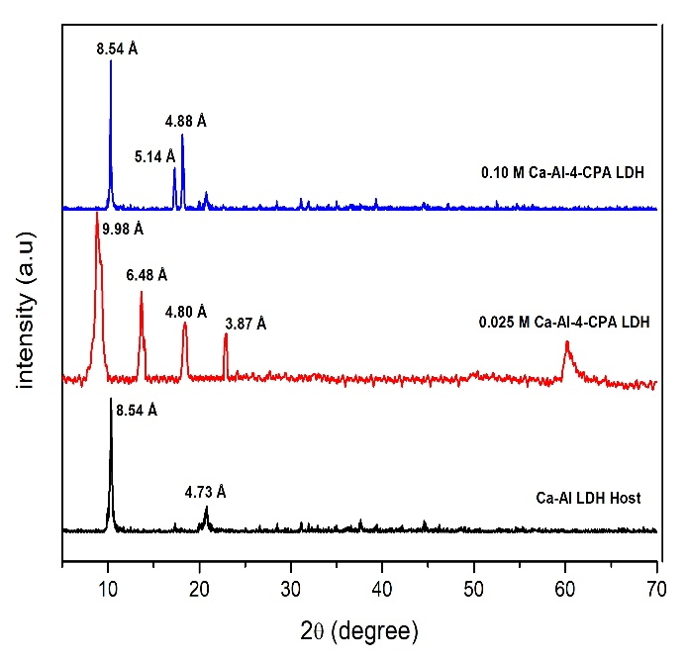
(b)
(c)
(a)

Figure 2. PXRD pattern for (a) Ca-Al LDH host, (b) 0.025 M 4CPA-CaAl LDH, (c) 0.10 M 4CPA-CaAl LDH

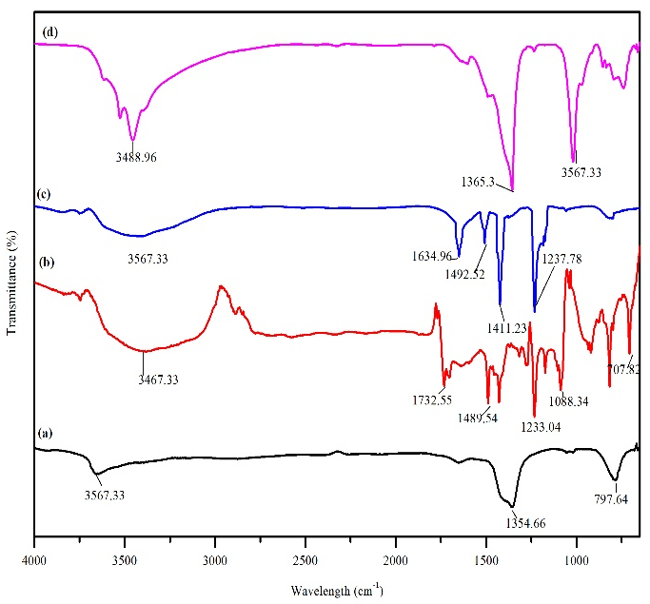
(a)

(b)

(c)

(d)

Figure 3. ATR-FTIR spectrum for (a) Ca-Al LDH Host, (b) Pure 4-CPA, (c) 0.025 M 4CPA-CaAl LDH, (d) 0.10 M 4CPA-CaAl LDH

(a)  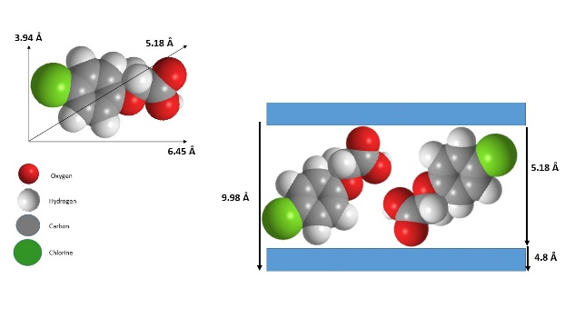 | 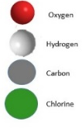 | (b)

Figure 4. Illustration of (a) molecular structure of 4-CPA and (b) spatial orientation of 4-CPA in between the LDH interlayer region

 | 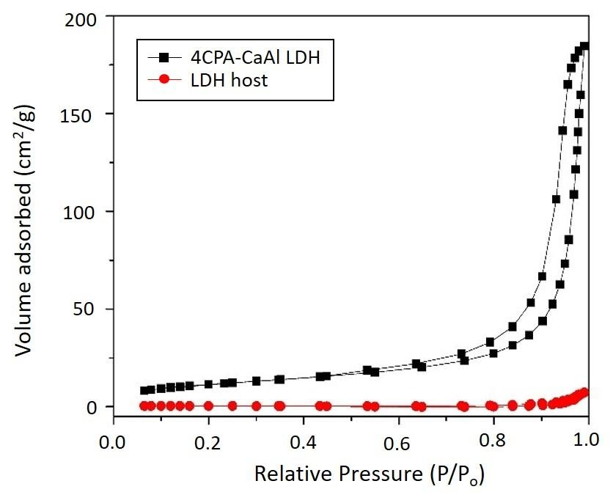 | 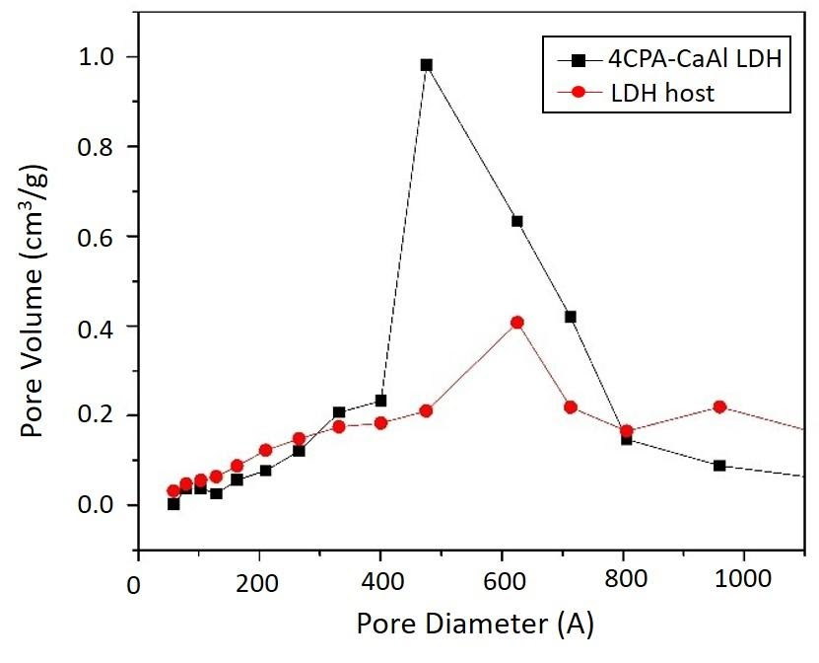  (Å)
 | Figure 5. Adsorption-desorption isotherm and pore size distribution of LDH host and 4CPA-CaAl LDH nanocomposite

Conclusion
In summary, the intercalation of 4-CPA into the interlayer regions of Ca-Al LDH host was successfully done via co-precipitation method at pH 12, by using the concentration of 0.025 M Al(NO₃)₃.9H₂O instead of 0.1 M. This can be deduced by the interpretation of the PXRD pattern that shows for 0.025 M 4CPA-CaAl LDH nanocomposite, the increase in basal spacing of the crystalline compound at 9.98 Å from 8.54 Å due to the inclusion of 4-CPA into the interlayer regions of the Ca-Al LDH host, but for 0.1 M 4CPA-CaAl LDH nanocomposite, the basal spacing remains unchanged. The ATR-FTIR band shows the absence of a nitrate peak from the Ca-Al LDH host and the presence of a new generation band such as at 1634 cm⁻¹ for COO⁻ and C=C stretching vibration of the aromatic compounds at 1492 cm⁻¹ and 1411 cm⁻¹. In the BET analysis, the adsorption-desorption isotherms have shown that the intercalated nanocomposite of the 4CPA-CaAl LDH is a mesoporous material with a H3 type hysteresis loop. In fact, the wider hysteresis loop for the synthesized nanocomposite proved that the anion of 4-CPA had intercalated into the interlayer host of LDH. Thus, this study proves that intercalated 4CPA-CaAl LDH has the potential to reduce the excess amount of herbicide to ensure a safe environment.

Acknowledgement

The assistance provided by Universiti Teknologi MARA (UiTM) and Ministry of Higher Education (MoHE) is greatly acknowledged and appreciated. The authors would like to thank the MoHE for financial support through the Fundamental Research Grant Scheme [600-IRMI/FRGS 5/3 (112/2019)] and everyone who has contributed upon the completion of this project.

References
- Prasad, C., Tang, H. and Liu, W. (2018). Magnetic Fe₃O₄ based layered double hydroxides (LDHs) nanocomposites (Fe₃O₄/LDHs): recent review of progress in synthesis, properties and applications. Journal of Nanostructure in Chemistry, 8(4): 393-412.
- Sarijo, S. H., Ghazali, S. A. I. S. M., Hussein, M. Z. and Ahmad, A. H. (2015). Intercalation,
physicochemical and controlled release studies of organic-inorganic–herbicide (2, 4, 5 tricholorphenoxy butyric acid) nanohybrid into hydrotalcite-like compounds. Materials Today: Proceedings, 2(1): 345-354.

- Valente, J. S., Tzompantzi, F., Prince, J., Cortez, J. G. and Gomez, R. (2009). Adsorption and photocatalytic degradation of phenol and 2, 4 dichlorophenoxiacetic acid by Mg-Zn-Al layered double hydroxides. Applied Catalysis B: Environmental, 90(3–4): 330-338.
- Matusinovic, Z., Lu, H., and Wilkie, C. A. (2012). The role of dispersion of LDH in fire retardancy: The effect of dispersion on fire retardant properties of polystyrene/Ca−Al layered double hydroxide nanocomposites. Polymer Degradation and Stability, 97(9): 1563-1568.
- Bernardo, M. P., Moreira, F. K. V., and Ribeiro, C. (2017). Synthesis and characterization of eco-friendly Ca-Al-LDH loaded with phosphate for agricultural applications. Applied Clay Science, 137: 143-150.
- Mills, S. J., Christy, G., Genin, J.-M. R., Kameda, T. and Colombo, F. (2012). Nomenclature of the hydrotalcite supergroup: natural layered double hydroxide. Mineralogical Magazine, 76(5): 1289-1336.
- Baikousi, M., Stamatis, A., Louloudi, M. and Karakassides, M. A. (2013). Thiamine pyrophosphate intercalation in layered double hydroxides (LDHs): An active bio-hybrid catalyst for pyruvate decarboxylation. Applied Clay Science, 75: 126-133.
- Jaśkaniec, S., Hobbs, C., Seral-Ascaso, A., Coelho, J., Browne, M. P., Tyndall, D. and Nicolosi, V. (2018). Low-temperature synthesis and investigation into the formation mechanism of high-quality Ni-Fe layered double hydroxides hexagonal platelets. Scientific Reports, 8(1): 4179.
- Bashi, A. M., Hussein, M Z., Zainal, Z., Rahmani, M. and Tichit, D. (2012). Simultaneous intercalation and release of 2,4-dichloro-and 4-chloro-phenoxyacetate into Zn/Al layered double hydroxide. Arabian Journal of Chemistry, 9: 1457-1463.
- Derylo-Marczewska, A., Blachnio, M., Marczewski, A. W., Swiatkowski, A. and Buczek, B. (2017). Adsorption of chlorophenoxy pesticides on activated carbon with gradually removed external particle layers. Chemical Engineering Journal, 308: 408-418.
- Baliyan, S. P., Rao, K. M., Baliyan, P. S. and Mahabile, M. (2013). The effects of 4-chlorophenoxy acetic acid plant growth regulator on the fruit set, yield and economic benefit of growing tomatoes in high temperatures. International. Journal Agriculture Science, 3(2): 29-36.
- Pirozzi, D., Sannino, F., Pietrangeli, B., Abagnale, M., Imparato, C., Zuccaro, G. and Aronne, A. (2017). Oxidative degradation of organic pollutants by a new hybrid titania-based gel-derived material with stable radical species. Chemical Engineering Transactions, 57: 769-774.
- Abdelhaleem, A. and Chu, W. (2017). Photodegradation of 4-chlorophenoxyacetic acid under visible LED activated N-doped TiO₂ and the mechanism of stepwise rate increment of the reused catalyst. Journal of Hazardous Materials, 338: 491-501.
- Songkhum, P., Wuttikhun, T., Chanlek, N., Khemthong, P. and Laohhasurayotin, K. (2018). Controlled release studies of boron and zinc from layered double hydroxides as the micronutrient hosts for agricultural application. Applied Clay Science, 152: 311-322.
- Ali, N. S. M., Hasanuddin, N. I., Azizan, N. A., Abdullah, A., Dzulkifli, N. N., Me, R., and Ghazali, S. M. (2017) Development of herbicide delivery system based on magnesium aluminium–4-chlorophenoxyacetic acid (MAC) nanocomposite. Journal of Engineering and Science Research, 1(2): 152-157.
- Ghazali, S. A. I. S. M., Hussein, M. Z. and Sarijo, S. H. (2013). 3,4-Dichlorophenoxyacetate interleaved into anionic clay for controlled release formulation of a new environmentally friendly agrochemical. Nanoscale Research Letters, 8: 362.
- Barahuie, F., Hussein, M. Z., Arulselvan, P., Fakurazi, S. and Zainal, Z. (2014). Drug delivery system for an anticancer agent, chlorogenate-Zn/Al-layered double hydroxide nanohybrid synthesised using direct co-precipitation and ion exchange methods. Journal of Solid State Chemistry, 217:31-41.

- Hussein, M. Z., Nazarudin, N. F. B., Sarijo, S. H. and Yarmo, M. A. (2012). Synthesis of a layered organic-inorganic nanohybrid of 4-chlorophenoxyacetate-zinc-layered hydroxide with sustained release properties. Journal of Nanomaterials, 5: 189-195.

- Megat, S., Mohsin, N., Hussein, M. Z., Sarijo, S. H., Fakurazi, S., Arulselvan, P. and Hin, T. Y. (2013). Synthesis of (cinnamate-zinc layered hydroxide) intercalation compound for sunscreen application. Chemistry Central Journal, 26(7): 1-12.

